**Identify a Native American artist (painter, potter, jewelry maker, musician, actor, etc.) identify tribal affiliation; comment on extent of reputation and bring an example of his or her art to class. (30 points) This will be an oral discussion and a show-and-tell. Bring artifacts, pictures, a powerpoint, web links, etc. to show in class. Plan no more than a 5 minute discussion.**

**My example: my high school art teacher, member of my church and neighbor to the family for whom I babysat on a daily basis was a Lakota artist who went on to be quite popular in the Southwest and Colorado area in the 1980s and 1990s. His name was Frank Howell.**

Born in 1937 in Sioux City, Iowa, the late Frank Howell spent his early childhood drawing sketches of the people and places around him. As an adult, his lyrical, artistic interpretations of faces and landscapes employed a visual representation of the wind as it sweeps across time: past, present and future. He viewed his images as universal symbols -- a kind of visual mythology that reaches out and spiritually awakens the observer. Perhaps influenced by his Lakota Sioux ancestry, much of Frank’s work reflected a love and respect for the Native American cultures.

As an extraordinarily skilled artist, Frank Howell widely exhibited at museums and galleries throughout the U.S., as well as Mexico. His work is included in numerous private and corporate collections all over the world. He has also been the subject of many magazine and newspaper articles, television profiles and documentaries. The country grieved when this Southwestern artist passed away in November of 1997. Frank’s art, in all its forms, is now sought by collectors and other admirers of his warm, symbolic expressions.

 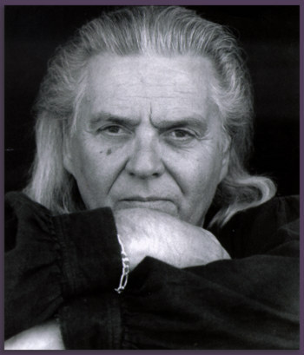 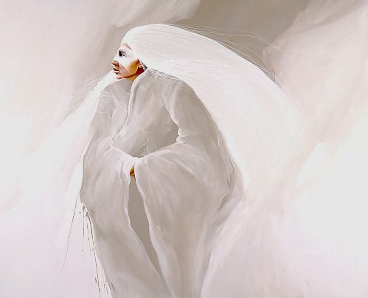  
<http://www.frankhowellgallery.com/artists/frank-howell>

