Metropolitan Community College
SOCI 1100 4A Fall, 2011

Weeks #9 Objectives
Read the Introduction to Part V and all six Articles. Then read the Introduction to Part IX and all six Articles there. After studying these chapters, you should be able to:
1. Determine how Native Americans represent themselves or make meaning of their lives and cultures as Native peoples is different from how the dominant culture has represented (mis-represented) them
2. Review the importance of clowns in many Indian religions for not only fun and laughter but also as ethical and moral compasses
3. Assess the impact of filmmaking in challenging stereotypes and misrepresentations of the past
4. Evaluate the reality that many Native societies in the Western Hemisphere were characterized by urbanism, as many continue to be today
5. Trace the historical development of Indian urban social and political activism
The previous weeks, we discussed stereotypes and discrimination. This unit discusses ways Native peoples are combating these ages-old barriers to their ways of life. In Part V the text reviews ways in which Native Americans represent themselves in the Media and in the Arts, both historically and in contemporary times. In Part IX the text focuses on Indians in urban settings. Contrary to the popular Euro-American perception of Indians as rural peoples exclusively, many Native peoples in the Western Hemisphere historically lived in large cities and urbanized areas, as they do today. And urban areas are focal points for social and political activism in Native communities. This has resulted in an effective way to combat discrimination.
Due November 10!!
In order to receive full credit, your assignments must:
1. Be written in your own words and in complete sentences,
2. Incorporate examples when possible,
3. Be typed (word processed) and double spaced,
4. Include an introductory statement and/or a concluding statement,
5. All content from text or other sources are to be appropriately
referenced and documented
6. Be generally grammatically correct, proofread for typing/spelling
errors and readable.
7. Include appropriately formatted reference citations
Read Theresa Harlan's article "Creating a Visual History" (p. 206) and write a short paper on the following issues. (20 points)
1) Why must we reject the reduction of Native images to sentimental portraits and stereotypes?
2) What does the author mean by "ownership of Native representations" from Native memories?
3) How can non-Native filmmakers covering Native topics work with this?
Read Emory Sekaquaptewa’s article “One More Smile for a Hopi Clown” (p. 322) and write a short paper answering the following; (20 points)
Explain what Sekaquaptewa means when he says “the heart of the Hopi concept of clowning is that we are all clowns”.
Find an example of clowning or humor from one or more other tribes, cite it and include whatever documentation and explanation you need. You will be presenting this example to the class.
Refer to the Introduction to Part IX (p. 399) Lobo and Talbot and answer all parts of the following questions (30 points):
(a) Discuss some of the stereotypes that continue to make Native people living in cities "invisible".
(b) What are some of the characteristics of ancient urban centers that have existed in the Western Hemisphere for centuries?
(c) What are some of the reasons that the history of these ancient Native cities and civilizations is not included in the curriculum of most secondary schools and at the college level in courses in American history?
After reading Jack D. Forbes article entitled "The Urban Tradition Among Native Americans" (p. 404) answer all of the following: (30 points)
1) What, in European-derived perspective, are some of the conceptual links between cities, civilization, and being a civilized person? What were some of the impacts for Native peoples when Europeans with these conceptual perspectives arrived in the Western Hemisphere?
2) Describe the characteristics of one of the ancient Native American cities.
3) One often reads or hears that the Mayan Indians "vanished" or that there is mystery surrounding "why the Mayas are a vanished race." Do you believe these are true statements? Why or why not?

Vocabulary quiz on November 10 -- see readings and class notes
American Indian film Institute (AIFI) Authentic Indian art
Buffalo Bill’s Wild West Show Digital divide
Hopi clowns Institute of American Indian Arts (IAIA)
National Museum of the American Indian (NMAI) identity crisis
Native history/American history Native image-making
Andean civilizations Cahokia
Chaco Canyon community builder
Mound builder relocation policy
Urban Indian centers urban stereotypes
W.O.R. (WithOut Reservation) termination policy
There will be terms, images and places from the notes in the quiz related to notes from October 25 – November 6

Identify a Native American artist (painter, potter, jewelry maker, musician, actor, etc.) identify tribal affiliation; comment on extent of reputation and bring an example of his or her art to class. (40 points) This will be an oral discussion and a show-and-tell. Bring artifacts, pictures, a powerpoint, web links, etc. to show in class. Plan no more than a 5 minute discussion.
My example: my high school art teacher, member of my church and neighbor to the family for whom I babysat on a daily basis was a Lakota artist who went on to be quite popular in the Southwest and Colorado area in the 1980s and 1990s. His name was Frank Howell.
Born in 1937 in Sioux City, Iowa, the late Frank Howell spent his early childhood drawing sketches of the people and places around him. As an adult, his lyrical, artistic interpretations of faces and landscapes employed a visual representation of the wind as it sweeps across time: past, present and future. He viewed his images as universal symbols -- a kind of visual mythology that reaches out and spiritually awakens the observer. Perhaps influenced by his Lakota Sioux ancestry, much of Frank’s work reflected a love and respect for the Native American cultures.
As an extraordinarily skilled artist, Frank Howell widely exhibited at museums and galleries throughout the U.S., as well as Mexico. His work is included in numerous private and corporate collections all over the world. He has also been the subject of many magazine and newspaper articles, television profiles and documentaries. The country grieved when this Southwestern artist passed away in November of 1997. Frank’s art, in all its forms, is now sought by collectors and other admirers of his warm, symbolic expressions.
 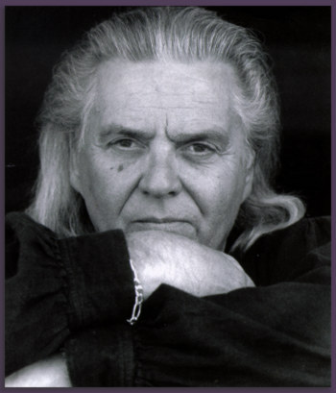 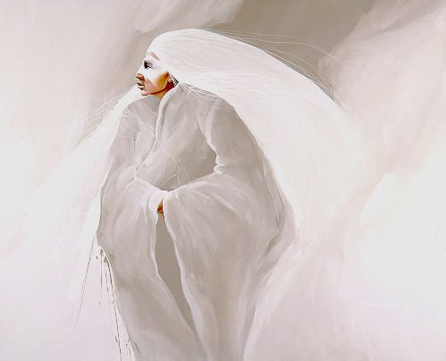
http://www.frankhowellgallery.com/artists/frank-howell

