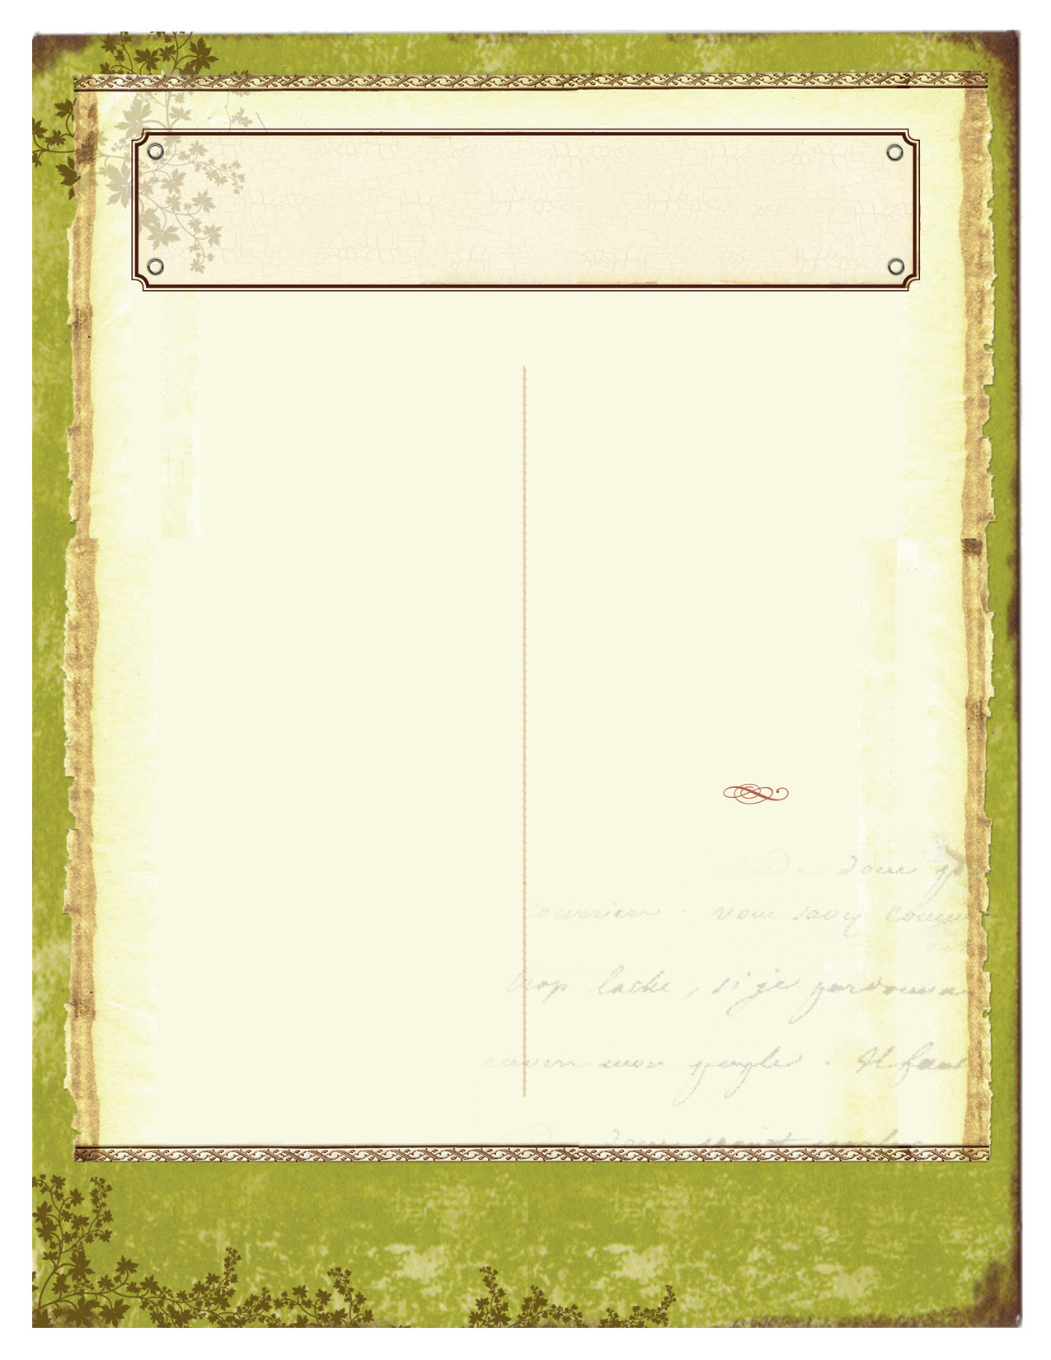

August/September 2011
What needs to be signed and returned?
- Your child should bring home the parent letter, class syllabus, and the safety contract which should be signed in all the appropriate places.
Is there homework this week?
- No, we will be doing the vocabulary and the review sheet for the quiz in class.
Monday—General Housekeeping of paperwork and getting an idea of how they should be organized and going over the Four Branches of Earth Science.

Tuesday—Scientific Method Notes and practice identifying the parts of scientific method.

Wednesday—Safety Quiz, and conducting an experiment with M&M’s

Thursday—constructing a chart with data, differences between inferences and observations.

Friday—Scientific method quiz, Hot wheels Lab



Be the change you wish to see in the world. ~Mahatma Ghandi

Mrs. Brumfield’s Earth Science
Week 1

VOL. #1 ISSUE # 1

