Names: _______________________ _______________________ AD MANIA!

_______________________ _______________________

Write the company / products that use these ad strategies:

______________________/____________________ Emotion - get a feeling

______________________/____________________ Rhetorical Question - ask a 'thinking' question

______________________/____________________Transfer - It worked for this, it will work for that

______________________/____________________Faulty Cause / Effect - not truthful claims

______________________/____________________Compare / Contrast - two similar companies

______________________/____________________Bandwagon - everyone does it

______________________/____________________Avante Garde - NEW and TRENDY

______________________/____________________Facts and Figures - Statistics

______________________/____________________Weasel Words- "Scientists say..."

______________________/____________________Magic Ingredients - new ingredient

______________________/____________________Patriotism - your country's values

______________________/____________________Plain Folk - ordinary people agree

______________________/____________________Snob Appeal - (Sneeches) BEST people know

______________________/____________________Bribery - gives you something EXTRA

______________________/____________________Testimonial - celebrities endorse

______________________/____________________Wit and Humor - get a laugh

______________________/____________________Simple Solutions - easy with this product

______________________/____________________Card Stacking - look at positive, not negative

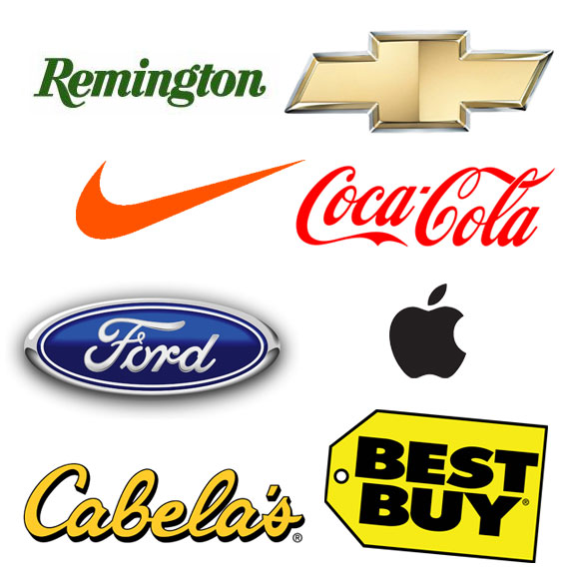
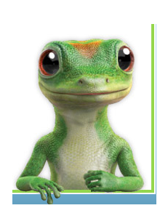
______________________/____________________Glittering Generality - change your life


