Learn to Use
Resume
Wizard

Add your information

Career Internship
Technology Workshop

Instructor:
Pamela Mowinkel

TAble of Contents
_________________________

What are resumes? 3

Why use Resume Wizard? 3

Where is the Resume Wizard Program found? 3

How do you open Resume Wizard? 3

How do you use the Resume Wizard? 5

Selecting the Style of the Resume 5

Entering your personal data 6

Adding and Arranging Headings 7

How do you finish the resume? 8

What are resumes?

The resume is a written self- portrait. Its content and appearance should reflect the image you wish to present to prospective employers. The major purpose of a resume is to capture the interest of the reader so he or she will want to speak to you about future employment opportunities.

Why use Resume Wizard?

Resume Wizard helps you create a personal resume with a professional appearance. It efficiently organizes your skills, education, and experience in a format that is appropriate for your job search.

Where is the Resume Wizard Program found?

This Microsoft Office tool is found on the Dell computers in the Elkhorn High School Computer Labs. Resume Wizard is found within the Microsoft Word program; therefore you must begin by opening a Microsoft Word program link.

Click once on the Start button to display the
Start toolbar.

Double click on the MS Word icon to open a
Word document.

How do you open Resume Wizard?

When the Word document opens - Click File on the Menu bar.
From the File menu …..Click New.

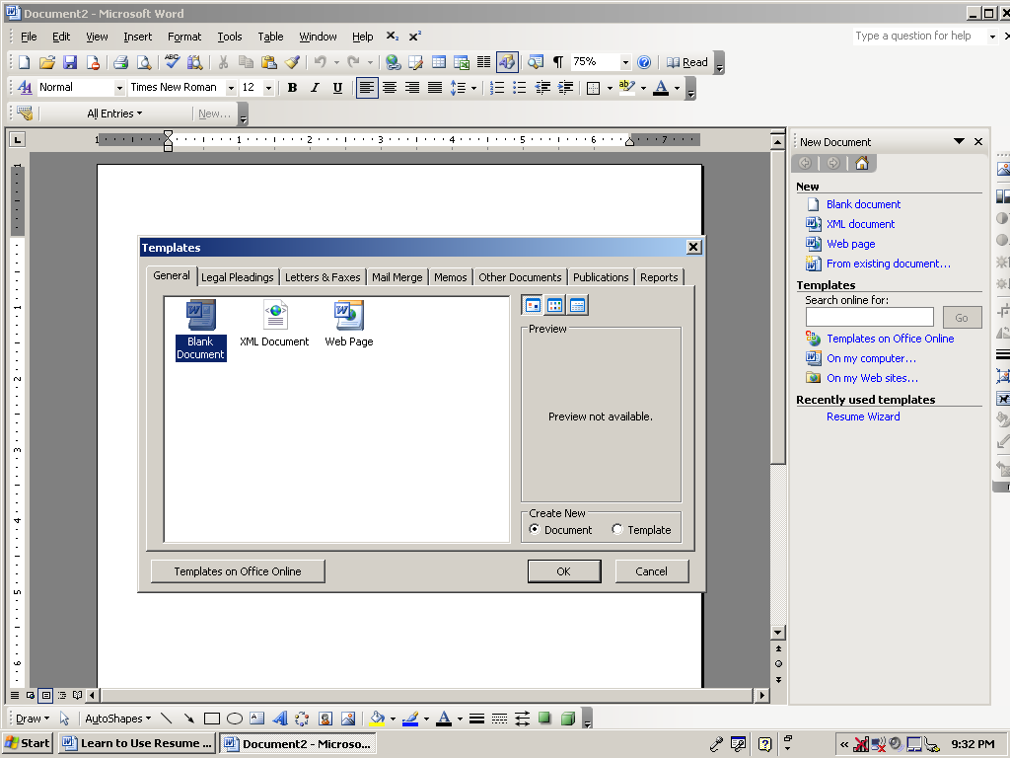
A Task pane will appear on the right hand side of your document.

Under the
Templates section –

Click the
On my computer link.

A Template dialog box will appear. Select the Other Documents Tab

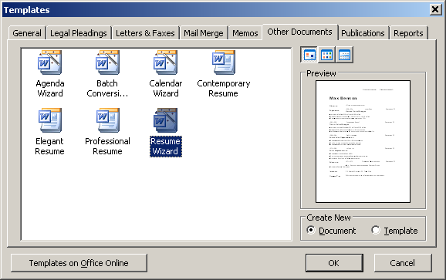

Select the
Resume Wizard icon, then click OK

How do you use the Resume Wizard?

This program is very user friendly. Simply follow the directions on the screen.
You may move forward from screen to screen by selecting Next.
In the event, you make a mistake or change your mind select Back.
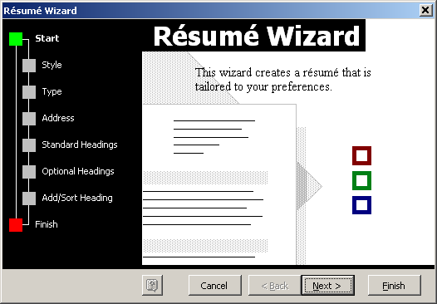

Selecting the Style of the Resume

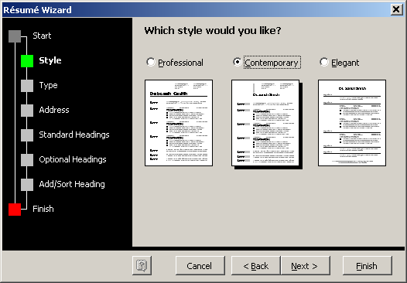

You must select the
Style of your Resume.

Place the pointer on
the dot in front of the
title of your style
choice and hit enter.

Next Slide You must also select the Type of Resume.
Place the pointer on the dot in front of Entry Level.

Entering your personal data

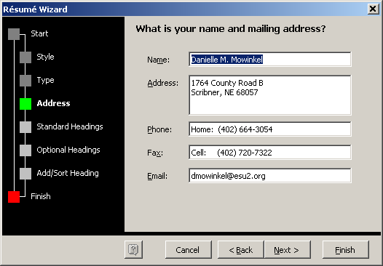
Type in your
Personal Information.

The information will appear on your resume in the EXACT same way
you enter it.

Double Check for Accuracy!!!

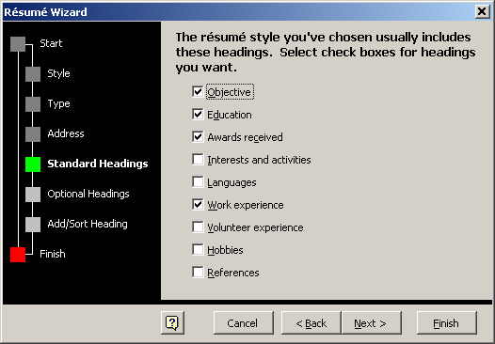

Select the Headings you wish to appear on your resume by clicking on the related boxes.

You MUST select at least Six Headings and the Objective and Education Headings.

Note: There are TWO slides of headings to select from. Pick those related to you!

Adding and Arranging Headings
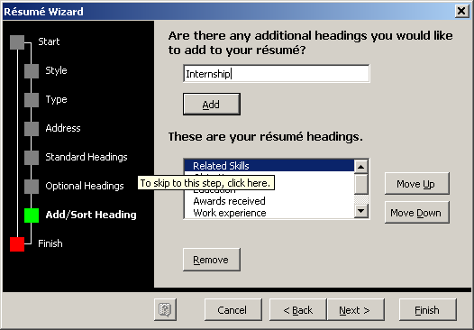

Add Internship
As a Heading

Arrange the Headings by moving each one UP or Down

See the list below to determine the order of your resume headings.

Put the Headings in this order at the TOP:

- Objective
- Education
- Internship

You may determine the order of the other headings.

Consider how they relate to the job you want and rank by order of importance.
Headings you may wish to use include the following:

- Work Experience
- Volunteer Experience
- Extracurricular Activities
- Awards Received
- Hobbies

How do you finish the resume?

When you have finished the Resume Wizard step by step instruction,
Select Finish and hit Enter

A resume template will be created in a Word document using the style, information and headings you entered as data.
Add your information
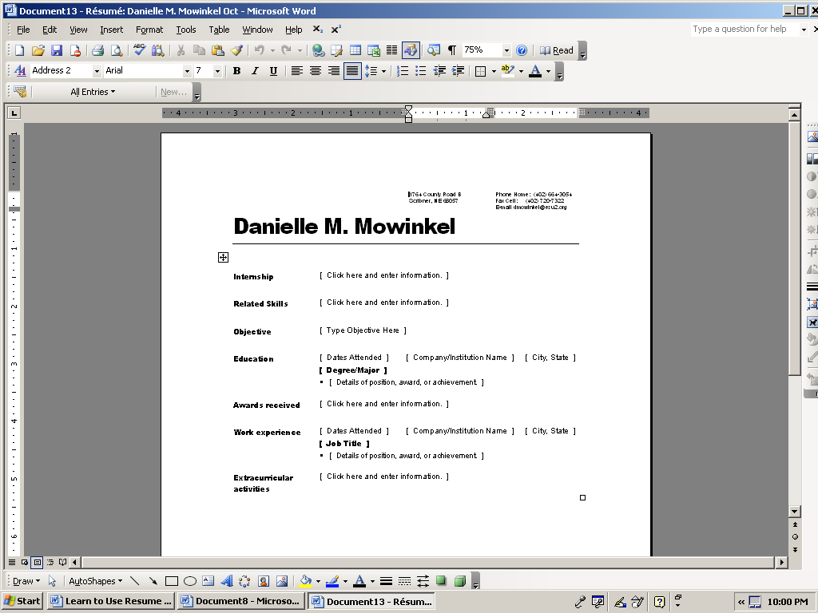

Type in your personal information in the data cells as directed in the template.

When finished entering all the information, Save and Print your resume.
It will be saved as a Word Document. It can be adjusted as needed.

