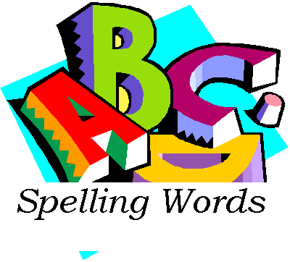
Use your spelling words to complete your weekly spelling contract. You may complete any combination of activities, but your points should add up to 100+ points. All words should be spelled correctly. Staple all sheets together when you are finished. Include a cover sheet with all activities and their point values listed. Add to find the total number of points you should receive. You will lose 5 points if a cover sheet is not included. Remember your cover sheet should have:
- Your Name
- Date
- Activities You Completed (include point values)
- Total Amount of Points

25 Point Activities:
- Write your words in ABC order 3 times each.
- Rainbow Spelling: Write your words 3 times each tracing over your words with 3 different colors.
- Use letters (ie: Cheez-it Scrabble) to spell your words and glue them on paper.
- Take a practice test with a parent and have them grade it. (Parent signature required on test)
- Scramble the letters in each word. Write the answer next to each word
- Type each spelling word making each vowel a different color. Print and turn in when due.
- 50 Point Activities:
- Make and complete a word search, hidden message OR crossword puzzle at www.puzzlemaker.com
- Write a story using all the spelling words. Circle the words that you use.
- Cut letters (not words) from a magazine or newspaper and glue them on a paper to spell your words.
- Make a picture dictionary using your words: Make a book out of paper, each page can show all the words that go with that letter, an illustration, and a definition. You may also choose to use a different page for each word. As long as you have done all your words in the correct ABC order, it’s fine.
- Choose 3 spelling words and make as many words as you can out of each. Don't combine all the letters from all 3 words. Take one word and make as many words out of it, then go on to your next spelling word and do the same.

75 Point Activities:
- Write a poem using 1/2 of your words in your best cursive handwriting. Give it a title and illustrate it.
- Make a game that uses all your words. Include instructions and be prepared to explain it to the class and play it with a classmate.
- Create a product on a poster you would like to sell and use 1/2 of your spelling words to advertise it. Your poster must include the product, name, illustration, and cost. Be creative and be ready to share.
- Make a mobile that displays all of your spelling words. Be creative. Each piece of your mobile should have your word and an illustration.
- Make a study bag: On index cards, write your word on one side and a
Sentence on the other. Put them all in the bag and have your parents quiz
you. They must ask you to spell it and be able to use it in a sentence.

Contract work is due EVERY FRIDAY without fail. If school is not to be held on a certain Friday, the work will automatically be due on Thursday. You will need to keep a copy of the contract in your agenda and/or homework folder for easy access. Contract work not turned in will result in loss of recess time until all work is caught up. A late notice will be sent home to parents notifying them of missing work. Have fun!!!!!

