

Project Planning
Module 3
Planning & Construction

PREPARED BY

Academic Services

August 2012

© Institute of Applied Technology, 2012

Module 3
Planning & Construction

Module Objectives
Upon successful completion of this module, students will be able to:

- Define the stages involved in project planning and construction.
- Conduct project analysis.
- Draw a rough sketch of your project.
- Draw the block diagram for your project prototype.
- Prepare the orthographic drawing for the prototype using AutoCAD or any other software.
- Prepare a Production Flowchart using Gantt Chart.
- Complete the Project Planning Report.

Module Contents:

 | Topic | Page No.
3.1 | Introduction to Project Planning & Construction | 3
3.2 | Production Flowchart using Gantt Chart | 11
3.3 | Project Planning Report Guidelines | 20
3.4 | Project Planning Report Scoring Guide | 21

3.1 Introduction to Project Planning & Construction
This module will focus on the Planning & Construction stage that will include project analysis,sketching, system diagram, circuit diagram, orthographic drawing and production flowchart. You will need to submit a Project Planning Report towards the end of this module.
Activity 10: Analysis
Answer the questions below to conduct a project analysis.
- What is the project challenge?
______________________________________________________
______________________________________________________
______________________________________________________
- Will the system control a sequence of operations? What are they?
______________________________________________________
______________________________________________________
______________________________________________________
- Is it a closed loop system?
______________________________________________________
______________________________________________________
- What inputs are required?
________________________________________________________
________________________________________________________
- What outputs are required?
________________________________________________________

- What type of control does the system need?
________________________________________________________
________________________________________________________
- What type of controller do you plan to use, and why?
________________________________________________________
________________________________________________________
- Are there any other special considerations?
________________________________________________________
Activity 11: Sketching
Imagine, and draw a rough sketch of your project prototype to demonstrate its appearance. Figure 3.1(a) shows the rough sketch for an elevator. The rough sketch could later be developed into an AutoCAD-orthographic drawing.
Figure 3.1: Rough Sketch of an Elevator

Draw a rough sketch for your prototype in the space provided below:

Activity 12: System Diagram or Block Diagram
Through the pictorial or graphical representation of the project, it is possible to provide a clear view of the sequence of action steps. Block diagrams are usually used by engineers to meet this purpose. The elevator block diagram is shown in Fig.3.2 as an example.
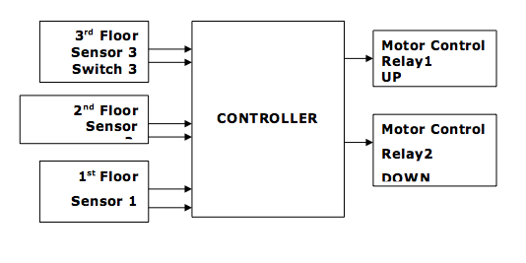
Figure 3.2: Block Diagram of a Water Level Control System
As an exercise, draw the block diagram for the water level control system by following the sequence of actions are listed below:
- A switch (pressed by the visitor) will turn on the circuit.
- The conductivity sensor will provide a feedback to the 555 timer.
- The timer will produce pulses with the required time delay.
- The pulses will turn the transistor driver ON and OFF repeatedly with the set time delay.
- The driver turns the relay ON and OFF, which in turn turns ON and off the pump.

Block Diagram for a Water Level Control System:

Now, list the sequence of steps and draw the block diagram for your project prototype.

Activity 13: Circuit Diagram
Once the block diagram is ready, draw the circuit diagrams for each block. The circuit diagrams for a Water Level Control System are given in figure 3.3 as examples.
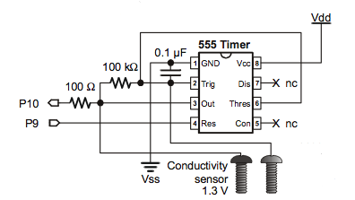
Figure 3.3(a): conductivity sensor and timer circuit
Figure 3.3(b): Pump Driver Circuit

Draw related circuit diagrams for your project prototype.

Activity 14: Orthographic Drawing
AutoCAD or any other software could be used to come up with a clear drawing of the intended prototype. Note that the exact dimensions need to be marked clearly and all details of the design and materials must be included in the drawing.
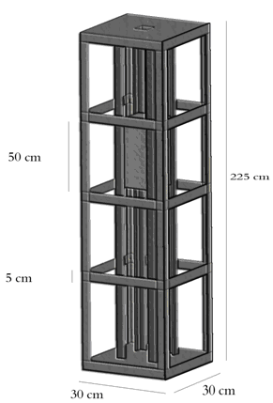
Figure 3.4: Orthographic Drawing Example
Activity 15: Production Flowchart
Prepare a production flowchart that includes the following:
- List of the order in which the main parts will be assembled such as procuring materials, marking out, cutting, soldering and so on;
- Indication of the time required to complete each task.
Note: Gantt Project Software could be used to prepare the production flowchart/Gannt Chart. Description of the procedure for using the Gantt Project software to prepare Gannt chart is given in section 3.2.

3.2 Production Flowchart Using Gantt Charts
Project management software often contains Gantt charts that graphically display theproject tasks and task durations. A typical Gantt chart is shown in figure 3.5.
In a Ganttchart, each task is represented by a separate bar. The top of the Gantt chart displaysdates in increments of days, weeks or months, depending on the length of the project.
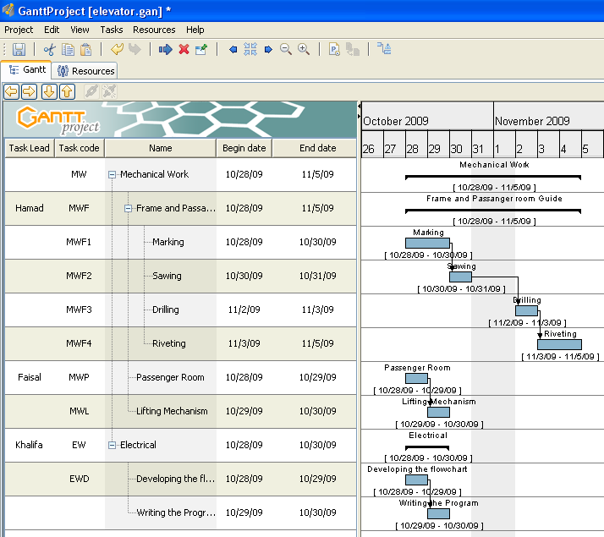
Gantt
Chart
Tasks
Pane
Figure 3.5: A Gantt chart sample.

The task duration is represented by the length of the horizontal bar. The left end of thetaskbar marks the task start date and the right end marks the task completion date.Tasks may be performed concurrently, they may overlap, or they may run sequentially ifthe start of one task is dependent on the completion of another.
Procedure for using GanttProject
This example demonstrates how to create a production flowchart/schedule for an elevator project.
- Double-click the GanttProject icon to display the GanttProject application window as illustrated in figure 3.6.
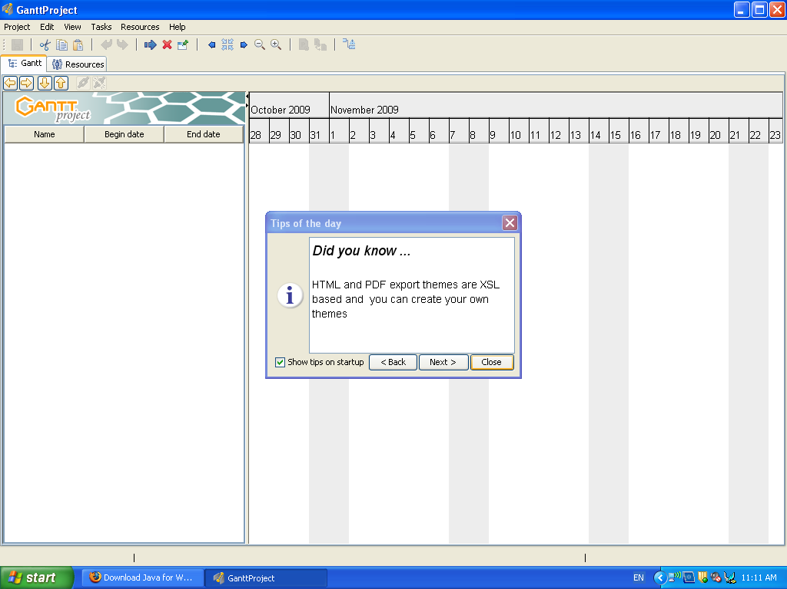
Figure 3.6:GanttProject application window.

- In the tool bar, click the New Task button to add a task to the tasks pane as shown in figure 3.7.
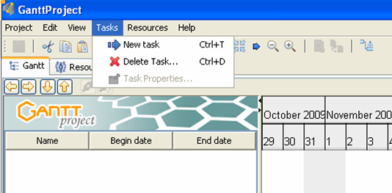
Figure 3.7: Adding a new task.

- In the Tasks pane, notice that the text in the Name column is selected, enabling you to name the task as illustrated in figure 3.8.
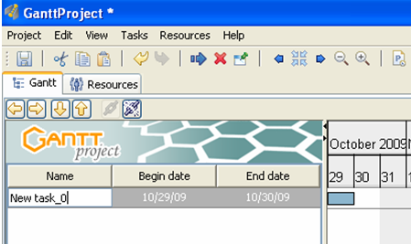
Figure 3.8: The task pane with the name column selected.

Type Mechanical, then press ENTER to specify the task name, notice also that a task bar appears in the Gantt chart reflecting the task you just created, and that the task start date defaults to today's date.
- Click the New Task button to add a second task to the Tasks pane. Type Frame and Passenger room Guide, press ENTER, and then click the Indent button in the Gantt tab toolbar as shown in figure 3.9.
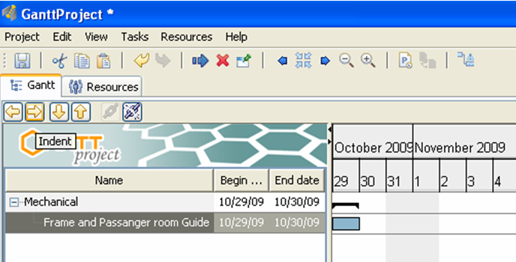

Figure 3.9: The indent button in the Gantt tab toolbar.

- With the Frame and Passenger room Guide task still selected, click the Task Properties button in the toolbar to display the Properties dialog box as shown in figure 3.10. Notice that the name you specified for the task in step 5 displays in the Name text box.
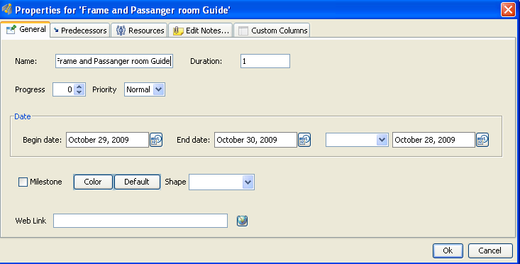
Figure 3.10: Shows a GanttProject Properties dialog box for task.

- Specify duration of 7 days, and then click OK.
- Click anywhere in a blank area of the Tasks pane to deselect any task.
- Click the New Task button to add a third task and specify a name of Passenger Room, press ENTER. With the third task still selected, click the Indent button to indent the task and make it the second subtask of the top-level task, Mechanical Work.
- With the Passenger Room subtask still selected, click the New Task button and specify a name of Lifting Mechanism. Notice that when you press ENTER, the task automatically displays as a subtask of Mechanical Work. This is because the previous subtask was selected when you created this new task.

- Click anywhere in an empty area of the Tasks pane to deselect any tasks, then click the New Task button. Specify a name of Electrical Work, and then press ENTER. Notice that because no task was selected and you did not click the Indent button, this task did not become a subtask of Mechanical Work as shown in figure 3.11.
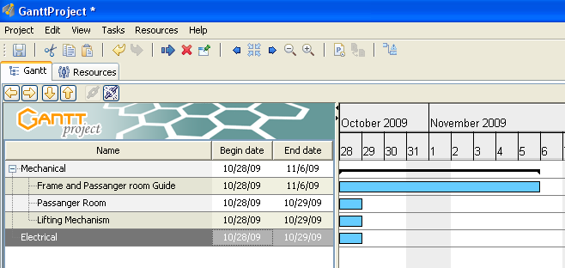
Figure 3.11: Tasks and subtasks
- Click anywhere in an empty area of the Tasks pane, then click on the New Task button. Specify a name of Developing the Flowchart, press ENTER and then click the Indent button. Notice that this task displays as a subtask of Electrical Work.
- With the Developing the Flowchart task still selected, click the New Task button and specify a name of Writing the Program. Notice that the task automatically displays as a subtask ofElectrical Work as shown in figure 3.12.
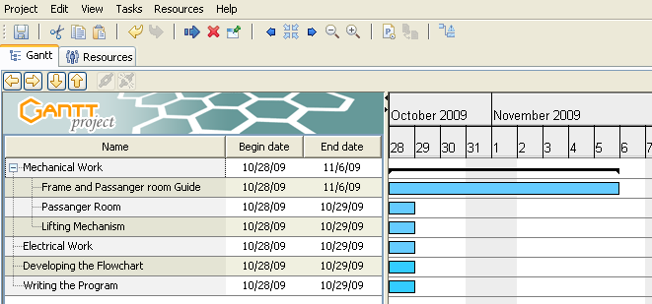
Figure 3.12: The subtasks under the Electrical Work main task.

- Add the subtasks and durations specified in Table 3.1 to the Frame and passenger room sub-task of the project schedule.
Table 3.1: Subtask title and duration
Sub-level Task | Duration
Marking | 3days
Sawing | 7days
Drilling | 7days
Riveting | 4days

- Review the data you entered in the application

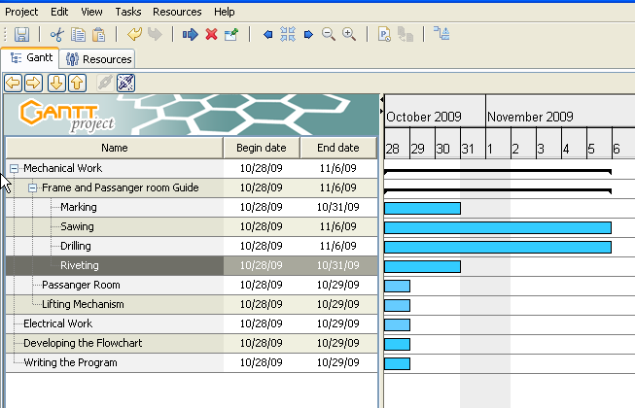

Figure 3.13: Subtasks

- Next, you will specify task dependencies. In the Gantt chart, click and hold the Gantt bar for Marking drag it to the Gantt bar for Sawing, then release the mouse button as shown in figure 3.14. This step specifies that the start of the second subtask is dependent on the completion of the first, and moves the start date of the second subtask forward three days.
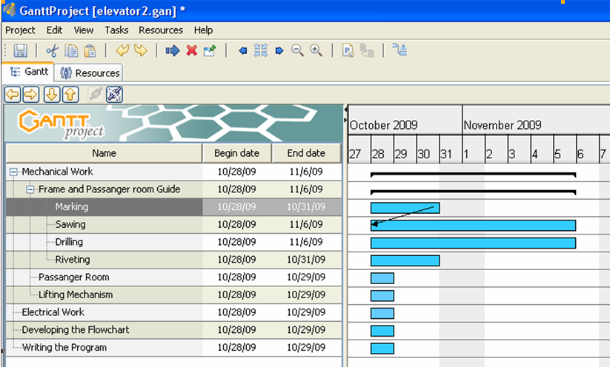
Figure 3.14: Task dependencies.
- Click and hold the Gantt bar for sawing, drag it to the Gantt bar for drilling, and then release the mouse button. This step specifies that the start of the third subtask is dependent on the completion of the second, and moves the start date of the third subtask as illustrated in figure 3.15.
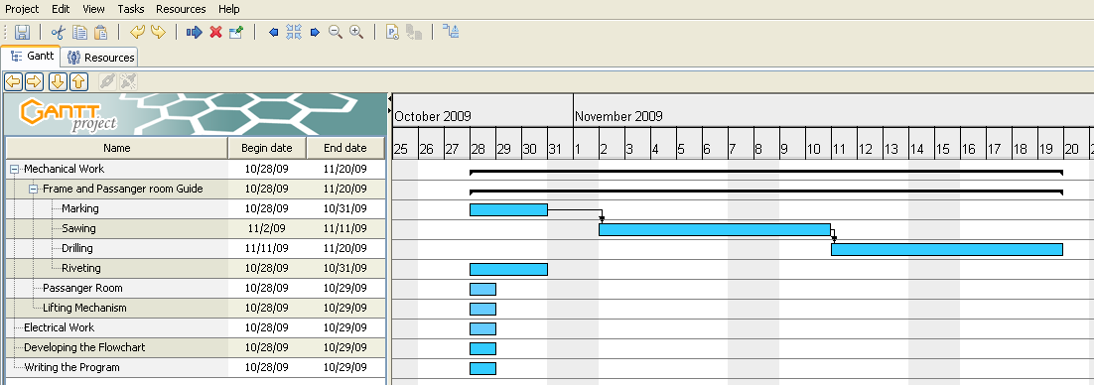
Figure 3.15: A sample of tasks dependencies.

- Continue to link the remaining Gantt bars so that the start of each task (or subtask) is dependent upon the completion of the previous task (or subtask).

- Finally, you will specify a new project start date. In the Tasks pane, select the top level task Mechanical and display the Properties dialog box.

- In the Date section, click the Show Calendar button next to the Begin Date box, click the first Monday following the current week, then click OK. Notice that the entire project moves forward to reflect the new project start date. Notice also that weekend dates in the project timeline are automatically bypassed as shown in figure 3.16.
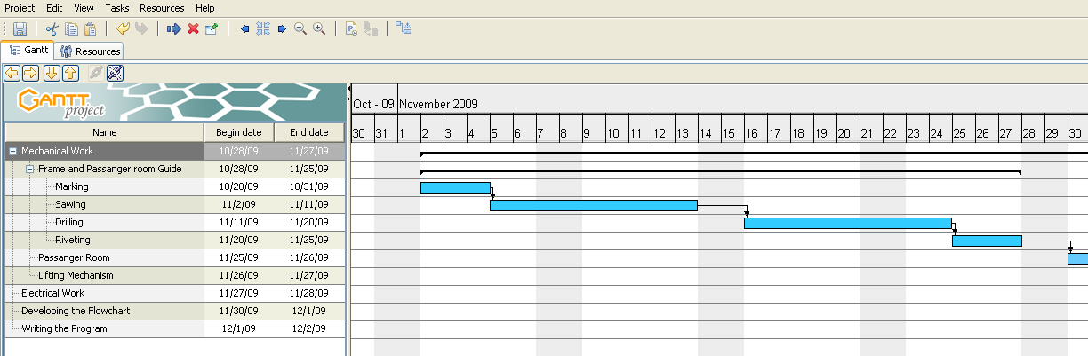
Figure 3.16: The project’s new start date.

- In the toolbar, click the Next button several times if necessary to shift the entire Gantt chart into view.
- In the toolbar, click the Zoom out button to view the tasks in weeks as shown in figure 3.17.
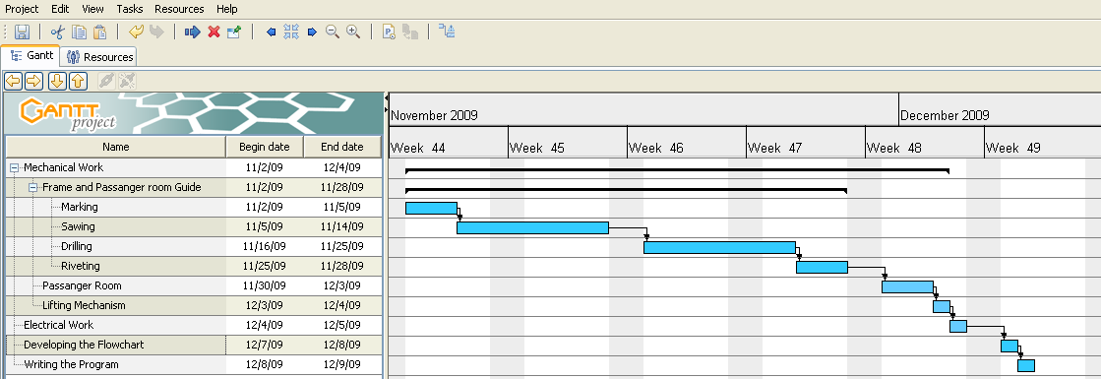
Figure 3.17: View of all tasks in weeks.
- In order to assign a Task Lead for every Task, right click on the task pane, and then choose New Custom Column as illustrated by figure 3.18.
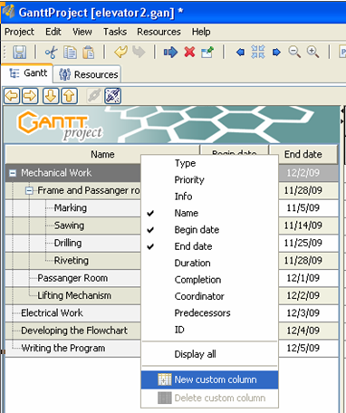
Figure 3.18: Creating a New Custom Column.
- In the Column name dialog box type the name Task Lead and choose the column type Text.
- Now assign each Task (activity) to the Task Lead as shown in figure 3.19.
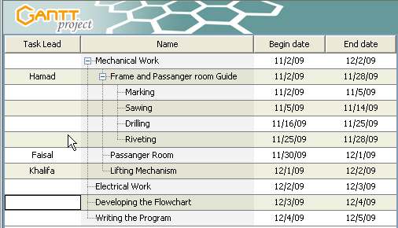
Figure 3.19: The Task lead column.
- The same procedures are to be followed to create a column for Task code.
- Exit GanttProject and save the project schedule.

3.3Project Planning Report Guidelines
Prepare a project planning report by including the following different stages of project work listed below.
- Problem Description
- Project Design
- Planning & Construction
- Production Flowchart

Project Planning Report Scoring Guide
______________________________

- Assignment Completion: 5 Marks

Component | Score
Report Completion | 3
Timely submission | 2

- Report: 45 marks
Content:40 marks; Language & Organisation:5 marks

Criteria | Poor | Satisfactory | Good | Excellent
Problem Description | 1 | 3 | 5 | 10
Design Specification | 1 | 3 | 5 | 10
Planning & Construction | 1 | 3 | 5 | 10
Production Flowchart | 1 | 2 | 3 | 10

Total Score: 50 marks

