WE ALL SCREAM FOR ICE CREAM!
MARKETING MIX WEBSITE COMPARISON
For this project you will go to three websites and fill in the answers to the questions regarding the Marketing Mix for each company. The websites are:
http://www.mayfielddairy.com/
http://www.bluebell.com/home./
http://www.benjerry.com/

 | Blue Bell  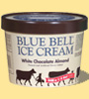 | Mayfield  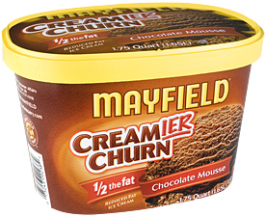 | Ben and Jerry’s  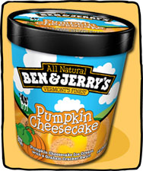
Product
(in detail describe packaging)

Product
How many flavors does each brand offer?

Product
Does the company sell other products besides ice cream? If so list.
(not counting T-shirts or anything with the company name on it)
Product
What is the slogan?

Product
Does the company identify its top flavors? If so, list the most popular flavors.

Place
Where are the dairies that make the ice cream located?

Place
List three stores where you can find this product?

Place
How is ice cream transported to the stores?

Price
How much does each product cost? (1/2 gallon & Pint)
You may have to fill in this question later by researching prices at a store.

Promotion  How did you like the website? List two strengths and two weaknesses of each | Strengths  Weaknesses | Strengths  Weaknesses | Strengths  Weaknesses
Promotion
Does the website offer any coupons?

Promotion
Does the company provide a tour of its facilities? What will visitors experience during the tour?
Promotion
Does the website include recipes? List at least three?
Promotion
Does the company support any causes or charity? If so, list them?

Promotion
Does the website offer games? If yes, List the types of games offered- then rate them on a scale of 1-5 for amount of fun. 1 being boring 5 being really fun!

