More Welded Sounds
You already know… Now to learn…
all
an
am

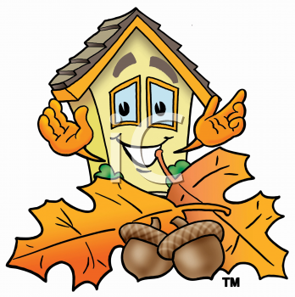

Syllabicate these words.

fan fall tall

sell ban can

moss jam Sam

shell hiss pan

