5 Digraphs

ch
ck
sh
wh
th

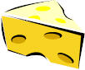
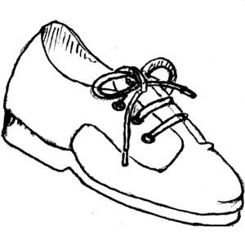
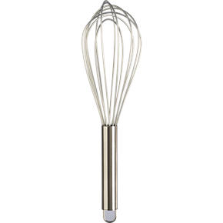
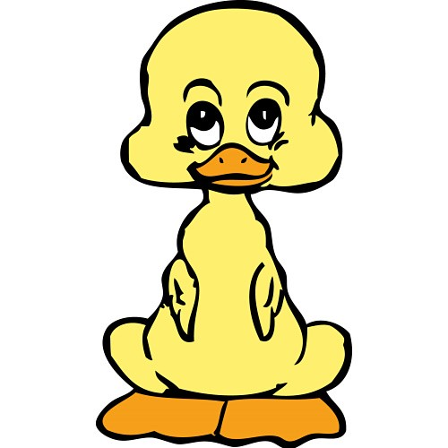


BUT
qu
“q” can’t go anywhere without “u”

Syllabicate these words. Remember to underline the blends.

Rick whip dash

math shut pack

kick lash sick

him back chin

