Short Vowel sounds

Vowel | Key Word | Picture
a | Apple | 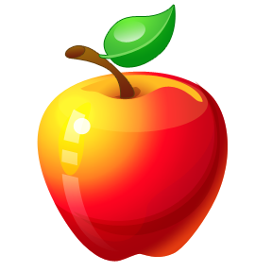
e | Egg | 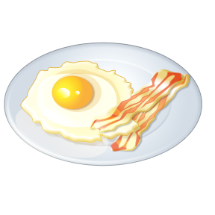
i | Igloo
o | Octopus
u | Up | 

Short Vowel sounds

Vowel | Key Word | Words
a | Apple
e | Egg
i | Igloo
o | Octopus
u | Up

