Welded Sounds & Bonus Letters

all
ll
ff
ss


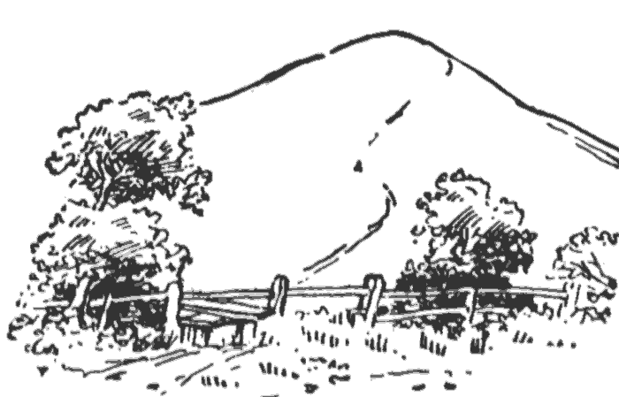

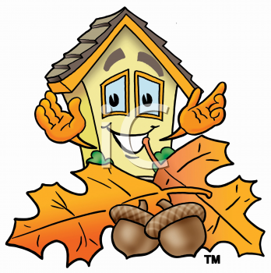

Syllabicate these words.

dull call mess

ball bath bill

moss chess miff

chug hiss mall

