**World History Honors – Unit 5 Test Imperialism Study Guide**

**Chapters 24 – sections 1-5**

* Identify the causes of the Sepoy Rebellion
* This is the overall effect of the Opium War on China
* Be familiar what effected to westernization of the Ottoman Empire

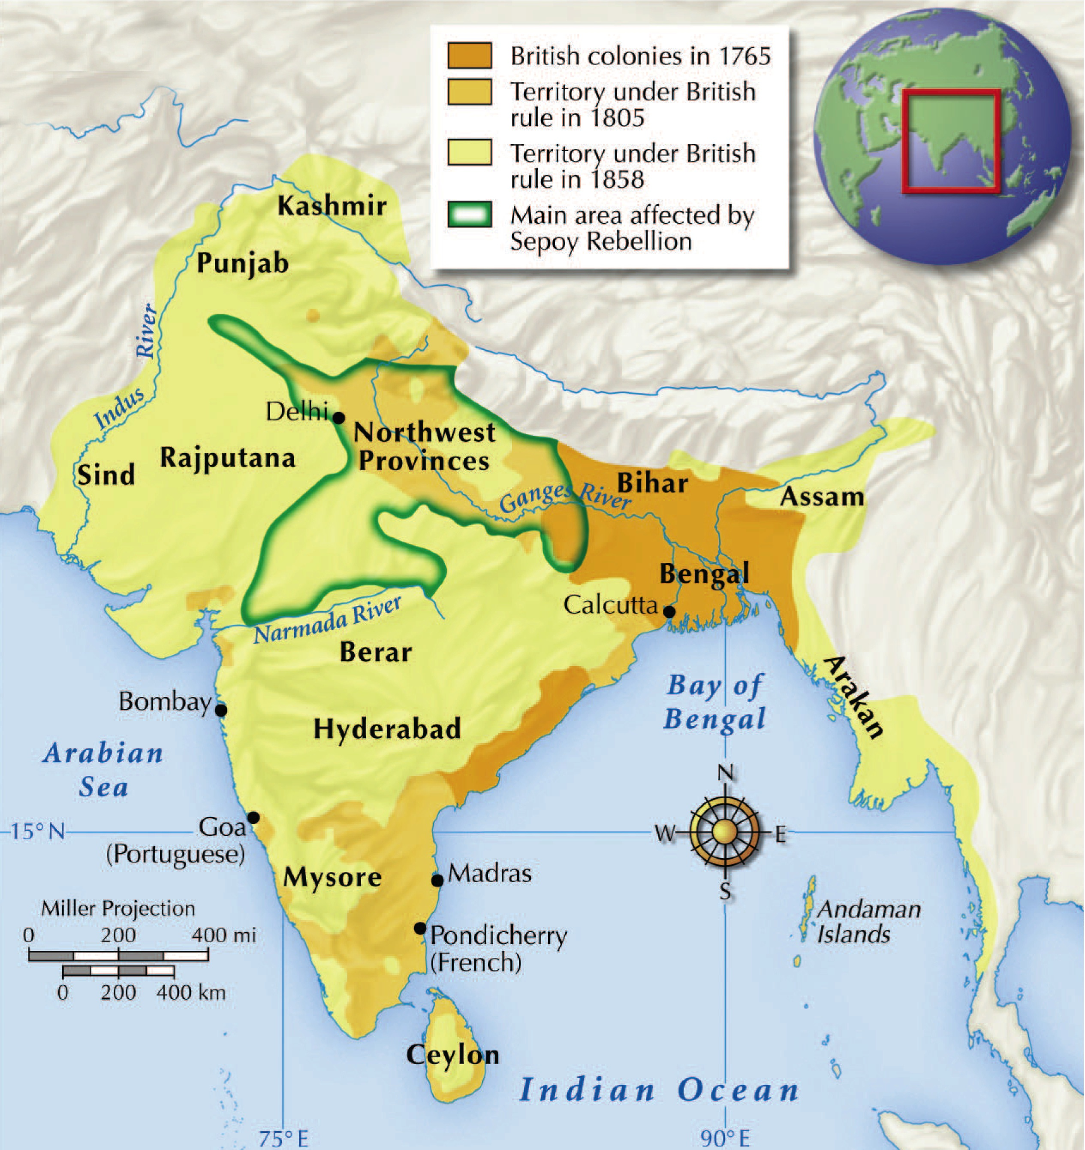

* Be familiar with what is being illustrated in the above map (same map on pg 583)?
* Be able to compare and contrast the following two maps:

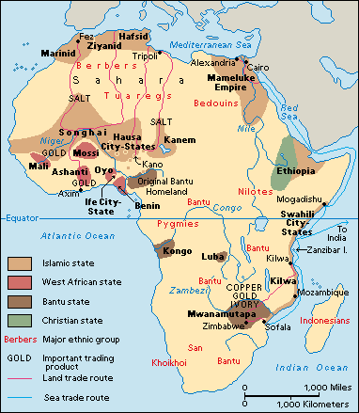

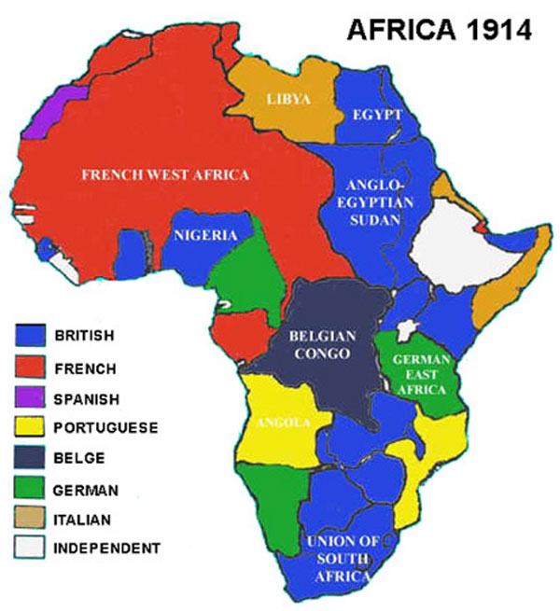

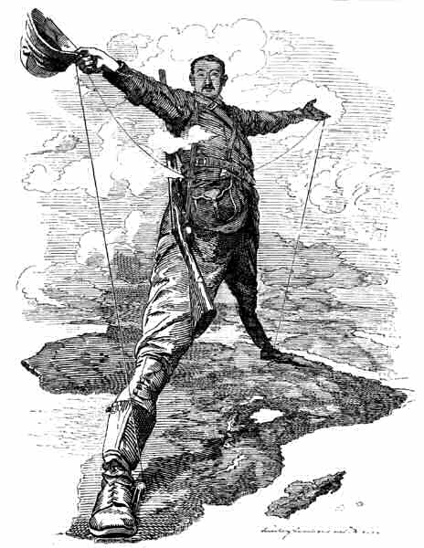

* Be able to give reasons for imperialism on the African continent based on the above cartoon

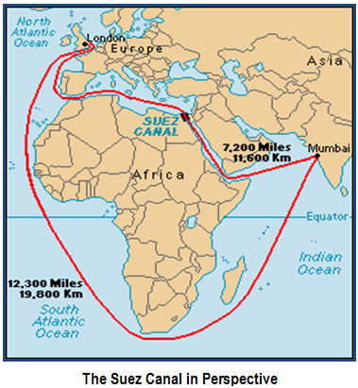

* Look at page 579 and discuss the significance the above map
* Be able to define and explain imperialism (its causes and effects).

**Document A:**

“The White Man’s Burden”

*Take up the White Man’s burden—*

*Send forth the best ye breed—*

*Go bind your sons to exile*

*To serve your captives’ need…*

*Take up the White Man’s burden—*

*The savage wars of peace—*

*Fill full the mouth of Famine,*

*And bid the sickness cease;*

*And when your goal is nearest*

*Take up the White Man's burden--*

*Have done with childish days--*

*The lightly proferred laurel,*

*The easy, ungrudged praise.*

*Comes now, to search your manhood*

*Through all the thankless years*

*Cold, edged with dear-bought wisdom,*

*The judgment of your peers!*

Source: Rudy Kipling, British poet, 1899

**Document B**:

*The guns that thundered off Manila and Santiago left us echoes of glory, but they also left us a legacy of duty. If we drove out a medieval tyranny only to make room for savage anarchy we had better not have begun the task at all. It is worse than idle to say that we have no duty to perform, and can leave to their fates the islands we have conquered. Such a course would be the course of infamy. It would be followed at once by utter chaos in the wretched islands themselves. Some stronger manlier power would have to step in and do the work, and we would have shown ourselves weaklings, unable to carry to successful completion the labors that great and high-spirited nations are eager to undertake."*

Source: Theodore Roosevelt, after the defeat of Spain in the Spanish-American War in 1899 and future president of the U.S.

|  |
| --- |
|  |

* Compare and contrast the above two Documents:

*Before becoming emperor of Ethiopia, Menelik II ruled the Shoa region in central Ethiopia. He ensured that he would succeed John IV as emperor by marrying John’s daughter. After John died in 1889, Menelik took the throne. Menelik used the profits from ivory sales to buy modern weapons. He then hired European advisers to teach his soldiers how to use the new guns. Menelik’s army conquered neighboring lands and owned a stunning victory over the Italians at Adowa. European nations rushed to establish diplomatic ties with Ethiopia. Around the world, people of African decent hailed Menelik’s victory over European imperialism.*

Source: Biography of Menelik II, King of Ethiopia during the late 19th century.

* What can be determined from your reading of the above passage:
* This would be a result of extreme Turkish nationalism by the late 19th century
* This would best describe Westerners views on Indian people in the 19th century

“We must at present do our best to form a class who may be interpreters between us and the millions whom we govern; a class of persons, Indian in blood and color, but English in taste, in opinions, in morals, and in intellect.”

Source: Thomas Babington Macaulay, a British statesman who lived in Calcutta India between 1834 and 1838 and served on the British "Supreme Council for India".This is an except from his *Minute on Education*, written in February 1835.

* What information can you determine about India by reading the above passage:
* This is what caused the Sepoy Rebellion.

*During the period known as the Canton trade system (1757–1842), hong merchants acted as exclusive liaisons between American traders and the Chinese. Holding the license to trade issued by the Chinese government, the hong merchants enjoyed considerable power. All foreign trade was required to be channeled through them. They purchased most of the imports, arranged for exports back to America, and made sure Westerners followed customs and duty regulations.*

Source: *A Chronicle of the China Trade* from the Historical Collections Exhibit, Harvard Business School. <http://www.library.hbs.edu/hc/heard/canton-trade.html>

* What information can you get after reading the above passage?:
* This is what caused the Taiping Rebellion of 1850 - 1864

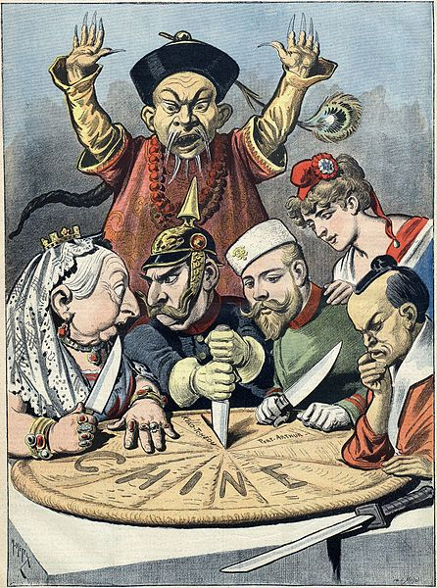

* This is the main idea of the political cartoon shown above
* This was a goal of the Boxer Uprising

“The [size] of China as a country is equal to that of India and the fertility of her land is superior to that of Turkey, but her conformity to the defective ways which have accumulated and her incapacity to stand up and reform make her also like a brother of these two countries…Whenever there is a flood or drought, communications are severed, there is no way to transport famine relief, the dead are abandoned to fill the ditches or are disregarded, and nine out of ten houses are emptied…The members of secret societies are scattered over the whole country, waiting for the chance to move. Industry is not developed, commerce is not discussed, the native goods daily become less salable…”

Source: Liang Ci’-ch’oa, an influential Chinese thinker, written in 1896.

* What information can be gathered from reading the above passage?
* What could the events most likely result in from the conditions described by the author?

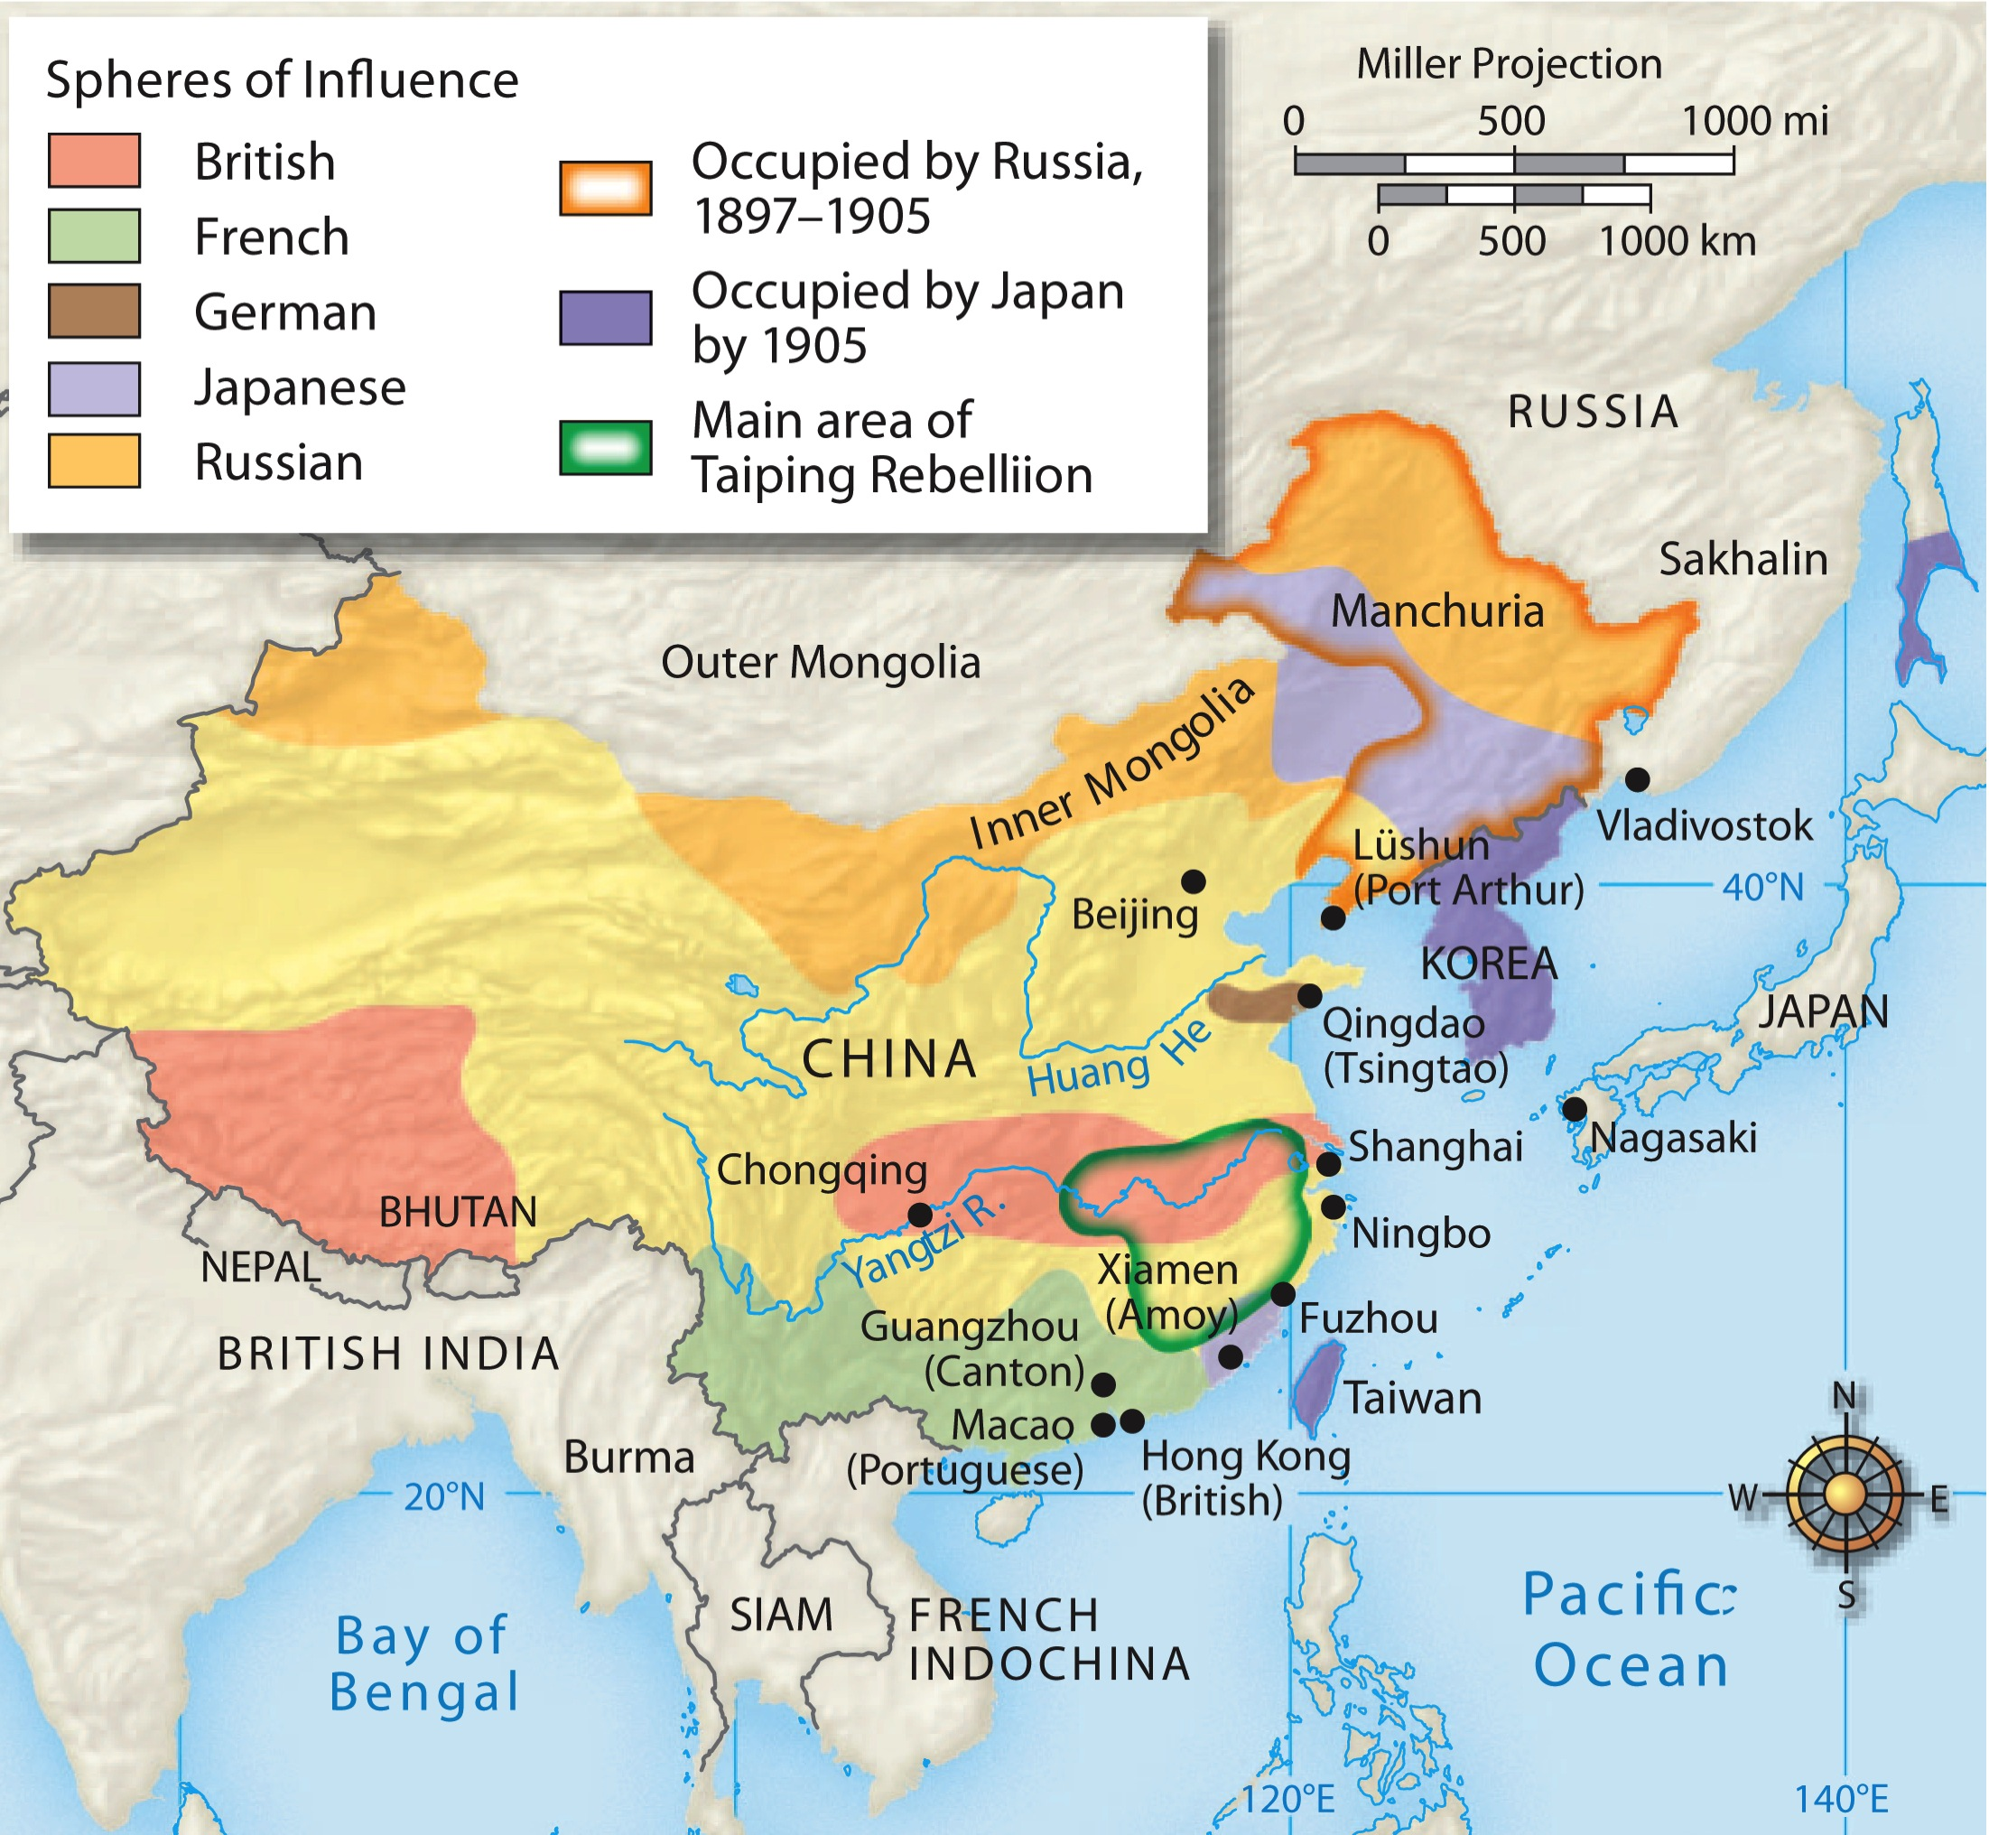

* Know the cause of the event illustrated in the map above
* Be familiar with term – extraterritoriality, know who benefitted from it in China