The Best %*@$#π?^” Regents Physics Review Sheet Ever!
Math, Graphs, and Vectors:
1. The fundamental SI Regents Physics units spell “MASK”: meters, amperes, seconds and kilograms
All other units are derived. In calculations, leave original units if not sure. ”Δ” means “final – initial”
2. W = work (energy) or watts. w = weight. m = mass or meters. P = power, but p = momentum.
J = impulse or joules. E = energy or electric field. T = tension or period. Time t must be in seconds!
3. Recognize quantities by units: distance d (in m), speed v (in m/s), acceleration a (in m/s²), mass m (in kg),
force F(in N), etc. Quantities with no units: coefficient of friction μ and refractive index n
Use equation to determine units. Ex: units for [Work] = [F][d] = [ma][d] = kg·m/s²·m = kgm²/s² = 1 J
4. Unless the answer is prefixed, get rid of prefixes, eg, the c in cm (except the k in kg) before a calculation.
5. Scalars have magnitude (size) only. Ex: distance, mass, time, speed, coefficient of friction, all energies, work, power, charge, resistance, potential difference, ρ, T, f, λ, θ, refractive index
6. Vectors = scalar (magnitude) + direction. Ex: displacement, velocity, acceleration, all forces, all fields, momentum, impulse, etc. Vector = arrow. Draw with ruler to scale. Draw the arrow tip!
7. Add vectors A and B using either:
a/ tip-to-tail: Resultant from tail b/ parallelogram:
A
B
R
A
B
R
of A to tip of B Resultant is diagonal.
8. Magnitude of R depends on angle between the two vectors being added. See diagram 1.
At 0⁰: mag. of R = A + B. At 180⁰: mag. of R = A - B. At 90⁰, mag. of R = √(A² + B²).
From the sum (max.) to the difference (min.) is the total range of possible resultant magnitudes.
9. Any vector can be resolved (broken down) into an infinite number of paired components.
10. “Show your work” means: equation, substitution with units, answer with units
11. Plot points. If a straight line, use a ruler. Use best-fit line (not data points) to calculate slope.
Find what slope represents by forming ratio: y-quantity/x-quantity, then look in PhysRT.
Ex: Plot a vs. F. What does slope represent? a/F =? See PhysRT, where a/F = mass m
Kinematics (Study of Motion):
12. distance d = Δposition. DVD ~ 10⁻³ m thick, your finger ~ 10⁻² m wide, and DVD ~ 10⁻¹ m wide
displacement d (vector) = distance (scalar) + direction. Distance is the magnitude of the displacement.
13. speed v = the rate of change in distance. Average v = d/t. Speed is the magnitude of the velocity.
velocity v = rate of change in displacement → velocity v (a vector) = speed (a scalar) + direction
14. Add v’s as vectors: resultant v_{plane} w.r.t. ground = v_{plane} w.r.t. air + v_{air} w.r.t. ground
15. acceleration a = time rate of change in velocity. a is a vector. a has same direction as Δv.
16. a/ The slope of the distance-time graph = speed. Greater speed → greater slope.
b/ The slope of the velocity-time graph = acceleration. Greater acceleration → greater slope.
c/ The area under the velocity-time graph = displacement. Positive area → positive d (right or up).
17. Uniform motion = constant velocity → a = 0
d
t
t
v
t
a
Pattern: Graphs:

18. Accelerated motion = constantly changing velocity → acceleration = constant for Regents Physics
d
t
t
v
t
a
Pattern: Graphs:

19. Word clues: Starts from rest: v_{i} = 0; comes to rest: v_{f} = 0; average v_{avg} = (v_{i} + v_{f})/2 (not in PhysRT)
Use v_{avg} for v in d = vt. Positive is up or right, negative is down or left.
20. If a and v are same direction, speed is increasing. If a and v are opposite direction, speed is decreasing.
21. Free fall (no air resistance): a = -g = -9.81 m/s² (independent of mass and speed).
22. For a dropped object: v_{i} = 0, d = -4.9t² and v_{f} = -9.8t. → Falls d = -4.9 m in 1st second (NOT -9.8!)
23. Projectile fired straight up: Remember the symmetry between times and speeds going up and down.
speeds v_{up} = v_{down}, t_{up} = t_{down} = ½ t_{total}, v_{top} = 0, BUT a_{top} = -9.81 m/s². It is still in free fall!
24. Horiz. fired project.: v_{i} is horiz.: v_{i} = v_{ix} = const., v_{iy}= 0, and v_{y} = -gt. a = a_{y} = -9.8 m/s^{2.} See diagram 4.
Rate of fall is indep. of v_{i} and same as for dropped object. Dropped and fired hit at same time!
Parabolic trajectory. Velocity v tangent to path. F_{net} = weight = downwards, so is a. F_{x} and a_{x} = 0.
25. Projectile fired at angle θ with initial speed v_{i}: Symmetry as in straight-up case. See diagram 4.
Velocity is tangent to path. F_{x} and a_{x} = 0. F_{net} = F_{g} = weight downward, so a is also. Still free fall.
Horiz. comp.: v_{ix}=v_{i}cosθ stays same. Use TOTAL time to find range: d_{x} = v_{ix} x t_{total}
Vert. comp. v_{iy}=v_{i}sinθ, Use v_{iy} as initial speed and solve problem as a ball thrown straight up
Speeds v_{up} = v_{down}, t_{up} = t_{down} = ½ t_{total}, BUT v_{top} = v_{ix} and is ≠ 0. As before, a_{top} = -9.81 m/s²
Trajectory is parabolic. With air resistance, range and max. height are less and no longer parabolic
Max. range if θ = 45⁰. Max. height and max. time if θ = 90⁰. Complementary angles (eg, 20⁰ & 70⁰)
have the same range, but higher angles have longer t_{total} and reach a higher max. height.

Forces, mass, Newton’s Laws and Gravity:
26. A force F is a push or pull. Forces are vectors: F = magnitude (strength of force) + direction.
27. Forces measured in newtons, N (derived). 1 N = 1 kg·m/s² = weight of a stick of butter or small apple
28. Two basic types: a/ contact: normal, tension, friction. b/ at a distance: weight & other field forces
29. Isolate all forces with a free-body diagram. Draw only forces (no v, p, etc) acting on the object.
Resultant force depends on angle between vectors: Add if 0⁰, Subtract if 180⁰, etc, as in #7-8 above.
Resolve into x- and y-components with: F_{x} = Fcosθ and F_{y} = Fsinθ. See diagram 5.
30. All mass has the property (not a force) inertia = resistance to Δvelocity. More mass → more inertia.
Convert masses to kg before any calculations! 1$ bill ~ 10⁻³ kg, butter or apple ~ 10⁻¹ kg, student ~ 50 kg
31. Newton’s 1st: No net force needed for motion. Otherwise known as the Law of Inertia:
“An object at rest tends to stay at rest, and an object in motion tends to stay in motion.”
In other words: Net force = 0 ←→ object is in equilibrium ←→ a = 0 ←→ constant velocity
In equilibrium: up and down (y) forces balance, right and left (x) forces balance. See diagram 5.
If forces are balanced (F_{net} = 0), object may be at rest OR moving with constant velocity.
32. Equilibrant force (-R) is equal in magnitude but opposite to the resultant vector (R). See diagram 2.
33. Newton’s 2nd: a = F_{net}/m. Rearrange: F_{net} = ma. a has same direction as the net F.
A net, unbalanced force (object not in equilibrium) MUST produce acceleration. F’s cause a’s.
To find a: Find net F by adding force vectors. Divide by mass (not by the weight!).
34. Elevator: Accelerating up → F_{N} (what scale shows) increases; accelerating down → F_{N} decreases
35. Newton’s 3rd: A exerts force F on B. B exerts force –F on A. These equal and opposite forces always are same type, but act on different objects. Forces, NOT the accelerations, must have equal magnitude.
Note: If F₁ = your weight of 600 N. Then reaction to F₁ = You pull up on Earth with a 600-N gravity force.
36. Gravity and Weight: All masses attract each other with a gravitational force F_{g} (weakest force)
F_{g} = Gm₁m₂/r² Ex: 2r → ¼ F, 3r →1/9 F, etc, 2m → 2F, 3m→3F, 2m AND 2r → F/2, etc
(inverse square) Stronger as you move closer: (1/2)r → 4F, (1/3)r → 9F, etc
37. G = universal gravitational constant is NOT the same as g = the acceleration due to gravity.
38. Weight (in N) w = mg = F_{g} = force of Earth’s gravity acting on object. If g ≈ 10 m/s², then w ≈ 10mass.
39. A gravitational field g exists around every mass. g is radial and inward for a point mass. See diagram 7.
40. g = F_{g}/m = strength of gravitational field (in N/kg) = acceleration a due to gravity (in m/s²) = w/m
g is proportional to 1/r², so weight = mg is also 1/r². Note: 2R_{E} above surface is tripling the distance!
On or near the surface of a planet, g is constant as long as you don’t get too far away. See diagram 7.
41. Mass m is same everywhere. Weight w changes, b/c g changes: w = mg. Eg, g_{Moon} = (1/6)g_{Earth}

Uniform Circular Motion, Momentum, Impulse, Friction:
42. Centripetal forces F_{c} can be provided by a string, road friction, a seat, air, etc. In absence of centripetal force, objects fly off on a tangent to the circle (NOT directly away from the center of the circle).
43. Centripetal F_{c} (a net force and ≠ 0) and a_{c} are directed toward the center of the circle. See diagram 8.
44. Velocity vector is tangent to the circle, but changes direction, so it accelerates alhough speed is constant.
45. Both a_{c} and F_{c} are directly prop. to v², and inversely prop. to r. F_{c} (NOT a_{c}!) is directly prop. to m.
46. Momentum p = mv is a vector in same dir. as v. Objects can have inertia (mass), but no p if v = 0.
47. Changes in p: Δp = mv_{f} – mv_{i} = m(v_{f} – v_{i}) = mΔv. Elastic (hit & bounce) collisions → greater Δp
48. Impulse J = F_{net}t = Δp → same units: 1 N·s = 1 kg·m/s (but ≠ newton). J is a vector w/same dir. as F_{net}
In plot of F vs. t, area = J. Impulse F_{net}t = Δp → Maximize Δp by increasing F or t (follow through)
49. Momentum is conserved in all isolated (from friction) systems. For collisions/explosions, use:
(before) m₁v₁ + m₂v₂ + … = m₁v₁' + m₂v₂' + … (after) (v’s can be negative!)
If objects start from rest, both left-hand v’s = 0. Ex: Spring between masses is released.
If objects collide and come to rest, the right-hand v’s = 0.
Hit and stick (inelastic) collisions: Both m’s have the same final speed v₁' = v₂' = v'
50. Friction F_{f} is a force usually opposite to v. It converts KE into internal (heat) energy.
51. F_{f} depends on 1/ the nature of the two surfaces (see table of μ’s) and 2/ the normal force, F_{N}:
F_{f} = μF_{N}. Sliding friction is roughly independent of surface area and speed.
52. Kinetic friction is < maximum static friction. (It takes more force to start it moving .)
53. Coefficient of friction μ has different values for object at rest (static μ_{s}) or moving (kinetic μ_{k}).
54. Normal force F_{N} = weight = mg (NOT mass alone) for horizontal flat surfaces with no extra forces.
55. Inclined plane: Components of weight w: w_{perp} = wcosθ and w_{ll} = wsinθ. See diagram 3.
Increasing θ increases w_{ll} and decreases w_{perp} but does not change w itself.
56. In equilibrium, w_{perp} = F_{N} and w_{ll} = F_{f} or any other force(s) holding object up the incline.
If no friction, F_{net} = w_{ll}, and object accelerates down incline at a rate: a = gsinθ.
Energy:
57. W = Fd. This is true only for component of F in dir. of motion. No W if d = 0 or if F perp. to d.
Work = area under the F (y-axis) vs. displacement (which can be d, Δh, or x) graph. See diagram 6.
58. Power P is the rate at which energy is converted from one form to another. Like W, P is a scalar.
Units of P: watts, W. “Watt? Don’t worry, joule get it in a second!” 1 W = 1 J/s → 1 J = 1W·s
59. Potential energy PE is stored in system, eg, chemical, gravity, spring, in E or B fields. Units: joules, J
60. Gravitational PE = work done in lifting an object to a height h above a reference level.
Path does not matter, only Δh. ΔPE = mgΔh is directly proportional to m, g and height raised Δh.
61. Hooke’s Law: For ideal spring, stretch (compression) x is proportional to the applied force: F_{s} = kx
62. Spring constant k is the slope of F(y axis) vs. x plot. Stiffer spring → steeper slope → bigger k
63. Elastic PE_{s} = ½kx² equals work done in stretching or compressing a spring = area under F-x graph
64. Kinetic energy is proportional to m and v²: KE = (1/2)mv² = work done to accelerate a mass
65. Work done on system increases its energy W = Fd = ΔE_{T} = ΔKE + ΔPE + ΔQ (Δ internal E).
Work & ALL energies have same units: joules: 1 J = 1 N·m = kg∙m/s² ∙m = kg∙m²/s² = raise apple 1 m
Work can change each of these separately depending on how it is done:
a/ On a horizontal surface: W = Fd = ΔKE = ½mv² (Work → changing v)
b/ At constant speed: W = Fd = ΔPE = mgΔh or ½ kx² (Work → stored PE)
c/ On a surface with friction: W = Fd = Δinternal energy (Work → heat)
66. Mechanical energy is the sum of the potential and kinetic energy of an object: E_{mech} = PE + KE
67. Law of Conservation of Energy. See diagram 9. In a system isolated from friction (ΔQ = 0), energy can be converted from one form to another but not destroyed! E_{T} = constant:
(before) PE + KE = PE' + KE' (after)
→ If there is friction, total “after” mech. energy (PE' + KE') is less b/c energy is converted to heat (internal E)
68. E_{T} does not change for a free falling mass, a swinging pendulum, or a mass compressing a spring (Ignore friction). KE ← → PE. If KE decreases, PE increases by same amount, and vice versa.
Ex: Free fall a height h from rest or pendulum, PE becomes KE: mgh = (1/2)mv². Solve for v=√(2gh)
Static Electricity:
69. Charge q on an electron or proton = 1 elementary charge = e = 1.60 x 10⁻¹⁹ C. Not always stated!
Milliken’s oil drop experiment found q on electron was the smallest possible (a quantum).
70. Removing electrons (e⁻, not e) from an object makes it more positive; adding them makes it more neg.
Net charge is the excess. It can be measure in e's or in coulombs, C. 1 C = 6.25 x 10¹⁸ e.
71. Like q's repel, opposite q's attract. The closer the charges, the stronger the electrical force.
If object A is attracted to a charged object B, A could be neutral or charged oppositely to B.
If object A is repelled by a charged object B, A must have the same charge as B.
72. Charge is conserved. The sum of charges before = the sum of charges after. Always.
(before) q₁ + q₂ + … = q₁' + q₂' + … (after) Signs matter!
73. One’s objects loss in charge = other object’s gain. Ways to charge objects (see diagram 11):
a/ Friction: rub two insulators → charges are directly moved from one object to other
b/ Contact: Two metals touch → excess charge is spread out over both metals b/c charges repel
In metals: e⁻'s can move, so excess e⁻'s repel and spread themselves out on outside surface.
Ex: If 2 identical metal spheres touch, divide TOTAL charge by 2 to find q on each.
c/ Induction: Bring “+” object near neutral conductor, ground opposite side, conductor becomes “-“
74. Coulomb’s Law: Every two q’s exert an electric force F_{e} on each other: F_{e} = kq₁q₂/r² (inverse square)
Ex: 2r → ¼ F, 3r →1/9 F, etc, 2q → 2F, 3q→3F, 2q and 2r → F/2, etc
As you move charges closer, F increases: (1/2)r → 4F, (1/3)r → 9F, etc
75. An electric field E = F_{e}/q exists around every charge q. See diagram 10. Units: [E] = [F_{e}]/[q] = N/C.
76. E is a vector with direction given by the direction of the electric force F_{e} on positive test charge q.
77. E = 0 inside a conductor, even if there is charge q on conductor. Safe in a metal car hit by lightning.
78. E field lines: Lines of electric F; closer lines → stronger E; lines don’t cross; F_{e} is tangent to lines
79. E field of 1 charge is radial and 1/r². Lines are out of a positive q, but into a negative q
E fields of 2 charges is similar to the B field around two magnets. See diagram 10.
80. E field of 2 parallel plates: constant, equally spaced lines except near edges, out of + and into – plate
F_{e} on q between plates has same mag. and dir. everywhere because F_{e} = qE, and E is constant.
Proton between plates feels same mag. F_{e} as electron, but opposite dir. Proton a is less b/c more m.
81. Potential difference V = W (work or energy)/q = energy needed to move a charge q in a E field.
Units are volts, V. If W in J, then q in C. If W in eV, then q in e. 1 V = 1 J/C = 1 eV/e
An electronvolt eV is a tiny energy (NOT a voltage) unit. To convert: 1 eV = 1.60 x 10⁻¹⁹ J.

Current and Circuits:
1 or 5 A
82. Current I is the rate of charge q passing a point. Need a complete circuit
3 A
2 A
and potential difference. Conservation of charge at a node (junction): I_{in} =I_{out.}
83. I = Δq/t Charge q in coulombs, C, I is in amperes, A. If q is given in electrons, convert to C first.
84. Potential difference (voltage) sources: batteries (DC), generators (AC), etc, all supply energy
85. Electrons e⁻ move most easily. Conventional I is positive and moves from high to low potential.
86. Electron collisions make drift velocity slow compared to actual e⁻ speed between collisions.
87. Conductors (metals, ionized gases, etc) have e⁻ free to move. Insulators: e⁻ and free and hard to remove.
88. Resistivity ρ values given in PhysRT are used to calculate R for metals. Smaller ρ → smaller R.
Units: Ohm·meters: Ω·m. In the equation with ρ, area A = πr² with r in meters for wires.
89. R = ρL/A → Short, thick, cold silver wires make the best conductors.
90. Ohm's Law: Resistance R = V/I = slope of V (y-axis) vs. I graph. Units: ohms 1 Ω = 1 V/A
If graph of V vs. I is straight → ohmic. True for most metals at constant temperatures.
91. For given voltage: If no R → short circuit (danger). Higher R → less I. If R = ∞, I = 0 → open circuit.
92. Voltage represents energy used to push electrons around. Assume no voltage loss along circuit wires.
Voltage is “across” two points, but current is the charge passing “through” circuit element.
93. Series circuits: More resistors → more total R → less I → less power P.
(see PhysRT V divides up in direct proportion to the R of each part.
for equations) I is the same in all parts of circuit, UNLESS you change the circuit!!!!
See diagram 12. Disconnecting one part of series circuit makes I = 0 in the entire circuit.
94. Parallel circuits: More resistors → LESS total R → more I → more P → faster power drain
(see PhysRT Current divides up in inverse proportion to the R of each part.
for equations) V is the same across all branches of the circuit.
See diagram 12. If one parallel element is disconnected, rest of circuit is NOT affected.
95. Series resistors: R_{eq} = sum = bigger than biggest R. For n equal series resistors R: R_{eq} = nR
Parallel resistors: R_{eq} = smaller than smallest R. For n equal parallel resistors R: R_{eq} = R/n
96. Voltmeters are hooked up across (in parallel). Ammeters are hooked up in series. See diagram 12.
97. Electrical energy W and power P: Add W or P for each part of circuit, regardless of series or parallel.
Magnetism and Electromagnetism (E&M):
98. Magnetism is caused by current I. A magnetic field B exists around every I (any moving q).
99. Direction of a magnetic field (B) = the direction that the N pole of a compass points.
100. B field lines point from the N pole to the S pole outside the magnet and from S to N inside the magnet.
101. In iron, nickel and cobalt, magnet domains are lined up. This can be randomized by raising temperature.
102. B field of bar magnet: Lines out of N, into S pole. Denser lines → stronger field. Lines don’t cross.
B force is tangent to the B field lines. Strongest near poles. Every N has a S pole (no monopoles).
103. Like poles repel, opposite poles attract. Know the B Field of two bar magnets. See diagram 13.
104. Earth’s B field is like a bar magnet, drifts and flips occasionally, and is a S pole near geographic North.
105. Solenoid (coil) B is like a bar magnet and stronger with more I or more wire turns or adding an Fe core.
106. Electromagnetic induction: Relative motion v betw. conductor and B field induces voltage in conductor.
Either conductor or magnet can move. Max. voltage V if angle between v and B is 90⁰, minimum if 0⁰.
107. Motors and generators both use the force that a B field exerts on moving charges: same hardware.
motors: electrical energy to mechanical generators: mechanical energy to electrical.
Vibrations and Waves:
108. Period T = time to complete one cycle = time for a wave to travel one wavelength λ.
109. Frequency f = number of vibrations or waves per second. 1 Hertz hz = 1/s = s⁻¹ = 1 cycle per second.
110. T = 1/f → T is the inverse of f and vice versa. Period T must be in seconds.
111. Amplitude A = displacement from equilibrium (half of peak-to-peak value). See diagram 14.
112. Simple (small A) pendulum: T increases (and f dec.) with length, independent of bob mass and A
113. Resonance occurs when an object is forced to vibrate at its natural frequency. The result is an increase
in the A (NOT the f!) of vibration. Ex: bridges, wine glasses, air in tubes, strings, swings, etc
114. Vibrations cause pulses and waves. A pulse = single disturbance of medium. Repeated pulse = wave.
A wave is a periodic disturbance of a medium that transports energy, but NOT mass.
115. medium (pl. media) is what a pulse or wave propagates through: vacuum, gases, water, solids, liquids, etc
116. wavelength λ = distance d between successive identical points on a wave = d that wave travels in 1 T
117. phase: how much a wave is shifted relative to reference point or another wave
phase angles: 1 λ = 360⁰, ¾ λ = 270⁰, ½λ = 180⁰, ¼λ = 90⁰
118. Longitudinal: wave v and medium v are parallel. Transverse: wave v perpendicular to medium v
119. For transverse waves: Leading edge points move up, trailing edge points move down. See diagram 14.
120. Wave v depends on properties of medium (for example temperature, density, etc), not on amplitude
Wave speed v = d/t or v= fλ (= λ/Τ). Units: m/s = Hz·m.
121. If v remains constant, increasing f decreases λ and vice versa.
122. Interference: Two or more waves in same medium at same time. Interference is a wave property.
Superposition: Add 2 or more waves algebraically to get a resultant wave. See diagram 15.
123. Constructive interference → Resultant amplitude is greater. Sounds louder or appears brighter.
Waves are in phase. Phase difference Δλ = 0, 1λ, 2λ, … or 0⁰, 360⁰, 720⁰, …
124. Destructive interference → Resultant amplitude is less. Sounds quieter or appears dimmer.
Waves are out of phase. Phase difference Δλ = ½λ, (3/2)λ, (5/2)λ, … or 180⁰, 540⁰, 900⁰, …
Total destructive interference: Waves have equal amplitudes and are completely out of phase.
Resultant is zero. Sound (noise) or light cancels out completely.
125. Standing waves: interference of two waves with same A, speed and f, but opposite directions.
Nodes = no movement, destructive interference. Antinodes = constructive interference. See diagram 16.
126. Diffraction = bending of wave behind an obstacle or opening. Diffraction inc. as λ inc. or as size d of
opening or obstacle dec. Diffraction is a wave property. Same λ and v behind obstacle. See diagram 19.
127. Double-slit experiment combines diffraction and interference from 2 waves. See diagram 15.
128. Doppler effect: Change in observed f of wave due to relative motion between source S and observer O If S and O are approaching: higher f (higher pitch or bluer light) and shorter λ. Same v for both.
If S and O are receding: lower f (lower pitch or redder light) and longer λ. Same v for both.
The source f remains constant! The faster the relative motion, the more the Δf. See diagram 17.
If relative motion is at constant v, Δf remains constant. If motion accelerated, Δf will change.
Sound vs. Light waves:
129. Sound waves are longitudinal, mechanical waves that need a medium. Sound does not travel in a vacuum. The amplitude A = loudness (energy), and frequency = pitch (bass or treble to ultrasound).
130. When charged particles are accelerated, electric E and magnetic B fields are induced. The fields are
perpendicular to each other and to the wave velocity. This electromagnetic (E&M) radiation travels at
v = c (3.00 x 10⁸ m/s) in a vacuum. c is the maximum speed limit for any object in the universe.
131. Visible light and the E&M spectrum (radio, microwave, IR, UV, x-ray, gamma rays) are transverse.
132. Wave model of light: Amplitude A = energy = brightness, but frequency f = color (visible light).
133. Light is about a million times faster than sound. See the PhysRT page 1 for actual speeds.
Sound v increases as density of medium increases, but light v decreases with increasing density.
Reflection (valid for all waves, but mostly applied to light). See diagram 20.
134. At any boundary between 2 media, light can be a/ reflected back into original medium, b/ refracted
(bent) into the second medium, or c/ absorbed (increases internal energy).
135. All angles in wave problems are measured with respect to the normal and in degrees!
136. Law of Reflection: θ_{i} = θ_{r} Incident and reflected waves have same v, λ and f (color)
137. A corner reflector returns the ray parallel to the incident ray.
138. Images in plane mirror are ALWAYS the same size as object and same distance away as object is!
139. Regular (specular, mirror) reflection occurs at smooth surfaces. Diffuse reflection at rough surfaces.
Law of reflection is obeyed in diffuse reflection, but normals are not parallel, so light is scattered.
Refraction and Snell’s Law. All angles in degrees. Degrees are units! See diagrams 21 and 22.
140. Absolute index of refraction n = c/v (no units). Snell’s: n₁sinθ₁=n₂sinθ₂. n₂/n₁ = v₁/v₂=λ₁/λ₂
141. Bigger n ➔ slower speed v. In new medium f (color) and T of light remain the same. Since v
changes but f constant, λ changes. Relative index n₂/n₁ → factor by which v slows and λ decreases
142. Refraction is the bending of light (or any wave) that occurs as it enters another medium. To refract, it
must enter a/ obliquely (at an angle other than 0⁰) and b/ change speed. Bigger Δn → more bending
143. Decrease angle (towards normal), decrease speed. Increase angle (away from normal), increase speed.
144. For a rectangular prism, light leaving the prism is parallel to the ray entering the prism, but shifted.
145. Total internal reflection: Only for slow to fast v change. At critical angle, wave is refracted at 90⁰.
146. Dispersion is the separation (splitting up) of white light into its different frequencies (colors). A prism or raindrop produces a rainbow because blue slows more, so it bends more than red (n_{blue} > n_{red}). See diagram 18.

Modern Physics: See diagrams 23.
147. A quantum is the smallest possible particle of something. Ex: a photon (particle of light) or the e⁻ charge
148. Duality: Light can act like a wave (interferes or diffracts) or a particle (photoelectric effect or collisions).
149. A photon is a particle of light with energy (no mass!) directly proportional to its frequency f and inversely proportional to its wavelength λ. Convert E in eV to joules before calculating f or λ!!!
f
E
λ
E
E_{ph} = hf
slope = h

E_{ph} = hc/λ

h = Planck’s constant

Bright light→ more photons than dim light. Blue light → higher f (more energy) than red light.
Photoelectric Effect: Photons kick e⁻'s out of metal only if photon f big enough. UV works, but not red.
150. Duality: Matter can act like a wave (diffracts or interferes, used in an e⁻ microscope) or a particle.
151. Rutherford discovered tiny “+” nucleus by firing alpha particles at gold-foil: A few bounced back!
152. Bohr model: “solar system” with discrete e⁻ orbits around positive nucleus: Energies are quantized.
Photon absorbed → e⁻ moves up. Subtract e⁻ energy levels (ignore negative signs) to get E_{ph}
Photon emitted → e⁻ moves down. Subtract e⁻ energy levels (ignore negative signs) to get E_{ph}
Photon energy MUST match Δenergy of e⁻ exactly, except during ionization (see next line).
Energy needed to remove e⁻ = ionization potential (any extra energy goes into the KE of e⁻)
For hydrogen: transitions to n = 2 → visible lines (each line represents one e- transition)
transitions to n = 1 → more E_{ph} → higher f of light → UV lines
transitions to n = 3 → smaller E_{ph} → lower f of light → IR lines
One e⁻ transition can produce multiple photons. Ex: n = 3 to n = 1 → 3 photons: 3→1, 3→2 and 2→1
→Problems w/ Bohr: e⁻ accelerates, radiates, spirals in, should be a continuous spectrum, but was discrete!
153. Energy can be converted to mass and vice versa: Use E = mc² (mass is kg) OR 1u = 931 MeV.
More mass means more energy. Slope of E vs. m equals c².
m
E
slope = c²
c² is simply a conversion factor, and does not imply motion.

154. 1 universal mass unit u = (1/12) mass of C-12 nucleus. Masses can be given in u or in kilograms.
155. In fission or fusion, “missing mass” is converted into energy (E = mc²)
reactant 1 + reactant 2 + …. → product 1 + product 2 + … + ENERGY
Add up reactants, add up products, then subtract → represents energy released (aka “mass defect”)
156. Matter-antimatter annihilation: mass + antimass → 2 photons. Each photon E_{ph} = (mass)c²
Pair production: 1 photon → mass + antimass. The photon E_{ph} must be at least = 2(mass)c²
157. Total mass-energy is conserved, but mass and energy by themselves are NOT, b/c m ← → E
158. Only charged particles can be accelerated in a particle accelerator. Energy gained is W = qV.
159. Only integer multiples of e = 1.60 x 10⁻¹⁹ C can be found on any particle. (Except quarks.)
160. Quarks: charge = (+2/3)e or (-1/3)e, with opposite charges for antiquarks.
161. Matter m with charge q has antimatter with same mass m but opposite charge –q. See diagram 24.
162. All matter is either a/ a lepton or b/ a hadron. Hadrons are either: a/ mesons (qq) or b/ baryons (qqq).
Quarks are never found alone. That is why it is ok that they have charge that is a fraction of e.
Add up charge on all quarks in particle to find total charge on particle, which must be an integer.
163. The antiparticle of a meson qq is qq. The antiparticle of a baryon qqq is qqq. Same m, but opposite q.
164. Protons (uud) and neutrons (udd) are made of up and down quarks because those two quark flavors
are the most common and the least massive flavors. More massive quarks are formed at higher energies.
165. The 4 Fundamental Forces (excluding dark energy):
1. Strong nuclear (strongest)→ always attractive and very short range → holds the nucleus together
Protons are attracted to other protons (and to neutrons) if close enough by this force!
2. Electromagnetic → between q’s → attractive OR repulsive, 1/r², and infinite range
3. Weak nuclear → important during radioactive decay (don’t need to know for Regents Physics)
4. Gravity (weakest)→ always attractive, 1/r², and infinite range. Important b/c planets are neutral.
90⁰
R =diagonal
Diagrams:
180⁰
0⁰
1. R depends on direction between vectors:
R = sum
= maximum
R = difference
= minimum

w_{ll} = wsinθ
2. Equilibrant: 3. Inclined plane:
F₁
F₂
R
-R = equilibrant

w_{perp} =
wcosθ

θ
w
θ

4. Projectile Motion: In both cases: parabolic trajectories and F and a are down!
v_{top} ≠ 0

F_{net} =
w
a_{x}=0a_{y} =
-g

fired with
a certain v_{i}
fired with a speed 2v_{i}
dropped ball

5. Forces:
F
F_{N}
At rest:
string
F_{x} = Fcosθ
F_{y} = Fsinθ
θ
F
F_{net} = 0 a = 0
at rest OR const. v
F_{net} ≠ 0
a to right
vel. can be
pos. or neg.

w = F_{N}
w = T
F_{N} =
w + F

d
W = F_{x}d
= Fcosθ d
F
θ
F
F
d
F
W = Fd
6. Work:
W = 0
b/c θ = 90⁰

W = Fd

d
d
Earth
w
F_{g} (weight) or g as a function of distance from Earth:
1R_{e}
2R_{e}
1R_{e}
2R_{e}
3R_{e}
4R_{e}
3R_{e}
4R_{e}
5R_{e}
← from center
w
4
w
9
w
16
w
25
← from surface
7. Gravitational
g ~ 1/r² for a
point mass:
fields g:
g = 9.81 m/s² is
constant at
Earth’s
surface:

8. Uniform circular motion:
CW
v
F, a
v
v
F, a
F, a
F, a
CCW
F, a
v
v
F, a
v
F, a
v
F, a
9. Conservation of Energy for a freely falling
object or a pendulum with no friction:

PE
KE
E_{T}
E
E_{T} = PE + KE = constant
Loss of KE → gain of PE
Loss of PE → gain of KE

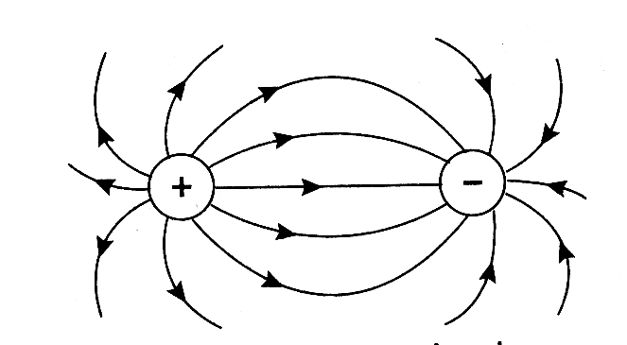
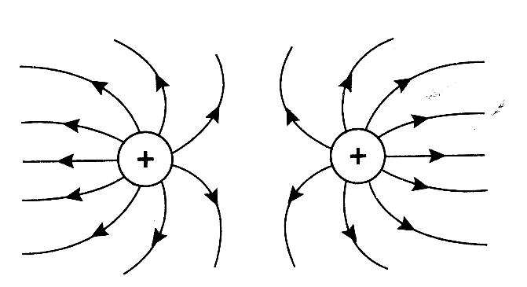
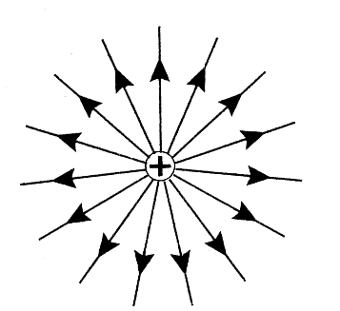
10. Electric fields:
negatively
charged
object:
positive
charge:

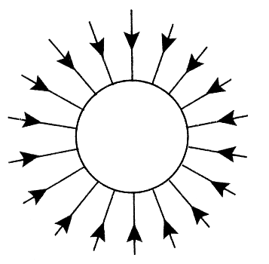
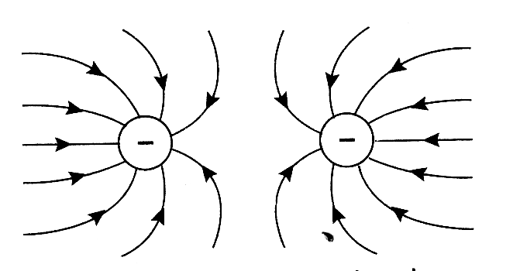
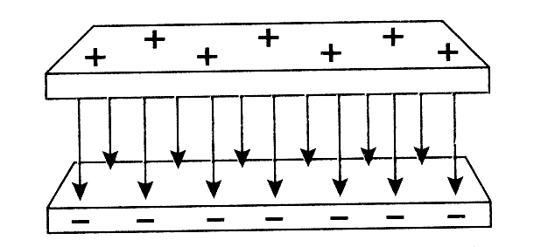
slightly
curved
at edges

11. Charging (all diagrams could have all charge signs reversed):
a/ by contact:

neutral
conductor
Touching – equal q on each.
(If 1 sphere bigger → more q)
separate
charged
conductor

b/ by induction:
Remove ground,
then remove the
charged object.
Note: charges now
opposite original
charged object.

neutral
conductor:
charges
separate
ground
charged
object

12. Circuits:
Series:
I same
V = V₁ + V₂
Parallel:
V same
I = I₁ + I₂

A
A
A
A
V
V
V
A
A
V
V
V

A in series anywhere, but V across different elements.
V across anywhere, but A in series with different elements.
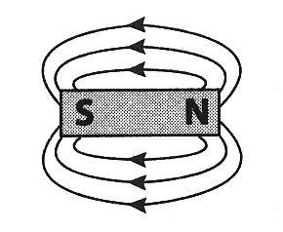
NP of compass
= direction of B
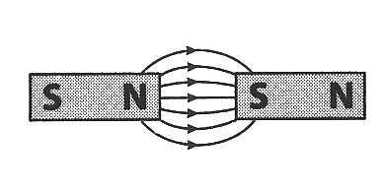
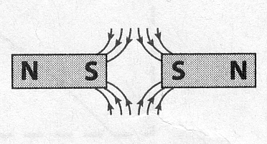
13. Magnetic fields around magnets and a broken magnet:

S

N

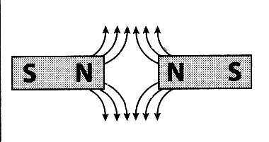
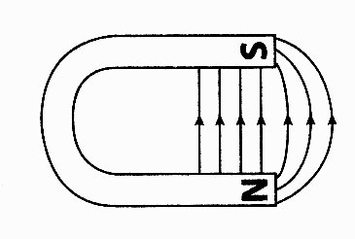
break magnet:
S

N

N

S

14. Pulses and waves
pulse

A
B
C
D
E
F
G
H
I
In phase (1λ): AE, BF, CG, DH, EI, and AI (2λ)
Completely out of phase (1/2 λ): AC, BD, CE, DF, EG, FH, GI. Also (3/2 λ): AG, BH, CI

λ
wave:

Transverse wave
velocity to right:
Transverse wave
velocity to left:
Up and down arrows are
velocity of medium.
Troughs and leading edges
are always moving up.
Peaks and trailing edges are always moving down.

A

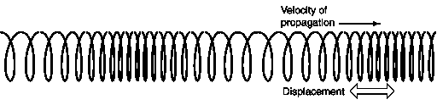

compressions

rarefactions

2-slit diffraction and interference:

constructive:
destructive:
15. Interference:
complete
destructive:

= destr.
Δλ = 0, ½ λ, 3/2 λ, …

= constr.
Δλ = 0, 1λ, 2λ, …

16. Standing Waves

Ν

Α

Α

Ν

Ν

Α

Α

Α

Ν

Ν

Ν

Ν

L = 1λ:

L

L = 3λ:
2

L

L = λ:
2

L

Α

Ν

Ν

red

violet

source v

18. Dispersion:
rain drop:

17. Doppler
Effect:
glass
prism

white

red

violet

higher f (blue)
shorter λ
same v

lower f (red)
longer λ
same v

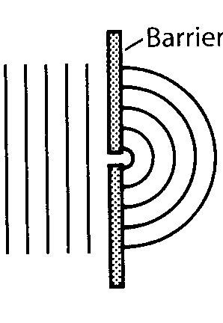
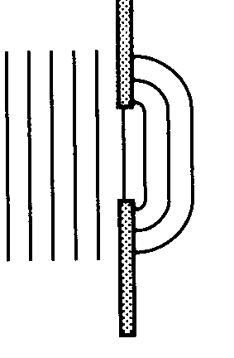
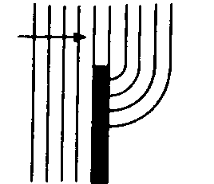
19. Diffraction:
around an
obstacle:

around a
corner:

Through an
opening:

always
same λ as
on other side
of barrier
d

Bigger λ or smaller d:
→ More diffraction

Smaller λ or bigger d:
→ Less diffraction

20. Reflection:
Images
in a flat
mirror m:
Same size
Same distance

m

o

i

specular:

wave-
fronts:

rays:

θ_{i} = θ_{r}

θ_{i}
θ_{r}

diffuse:

21. Wavefronts entering a new medium in which its speed is slower v₁ > v₂ (a wave traffic jam):
boundary
λ₁
λ₂
v₁
v₂
n₁
n₂

incident waves
with v₁, f₁, A₁
(reflected wave
not shown)

transmitted waves
with v₂, f₂, A₂

Compare: v₁ > v₂ (given), n₂ > n₁, A₁ > A₂ (some reflected), λ₁ > λ₂, but f₁= f₂ (same frequency!)
22. Refraction of Light:
If rays 1 and 2 are parallel, then n₁ = n₂ (same v)
slowest
1
2
1
2
fastest
faster
slower
smaller n
bigger n

wavefronts:
Bigger angle, faster v, and vice versa. Same angle, same v:
fastest
slowest
same
same
fastest

23. Photon-electron collisions (Compton Effect)
→ Light acting like a particle:
hadrons & leptons (which occur by
themselves)

24. Standard model: All matter is made of…
e⁻ at
rest
photon
at v = c
e⁻ now has KE
E_{ph} is less,
so λ longer,
but v still = c
s
u
u
d
u
Before:
baryon:
After:

meson:
su = (-1/3)e + (-2/3)e
= -1e

uud = (+2/3)e + (+2/3)e + (-1/3)e = +1e (a proton)

The antiparticles are: uud = -1e and su = +1e
They have the same mass as their antimatter.

Some of photon E and momentum are transferred to e⁻.
E_{T} and p_{T} are conserved→ e⁻ gains what photon loses

