WE ALL SCREAM FOR ICE CREAM!
MARKETING MIX WEBSITE COMPARISON
For this project you will go to three websites and fill in the answers to the questions regarding the Marketing Mix for each company. The websites are:
www.breyers.com
http://www.haagendazs.us/
http://www.benjerry.com/

 | Breyers   | Haagen Das  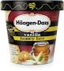 | Ben and Jerry’s  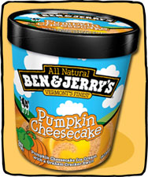
Product
(describe packaging)

Product
How many flavors does each brand offer?

Product
Does the company sell other products besides ice cream? If so list.
(not counting T-shirts or anything with the company name on it)
Product

What is the slogan?

Product

Does the company identify its top flavors? If so, list the most popular flavors.

Place
Where are the dairies that make the ice cream located?

Place
What stores are these products sold in?

Place

How is ice cream transported to the stores?

Price
How much does each product cost? (list at least 4 products for each company)
You may have to fill in this question later by researching prices at a store.

Promotion  How did you like the website? List strengths and weaknesses of each | Strengths  Weaknesses | Strengths  Weaknesses | Strengths  Weaknesses
Promotion

Does the website offer any coupons?

Promotion

Does the company provide a tour of its facilities? Take one tour of each company. Rate the tour from 1-10

Promotion

Does the website include recipes?

Promotion

Does the company support any causes or charity?

Promotion

Does the website offer games? If yes, List the types of games offered- then rate them on a scale of 1-5 for amount of fun. 1 being boring 5 being really fun!

Name __________________________________________

