Brain Games: Liar Liar Name :_____________
Pre- Video Questions
- What is a lie?

- Form a small group and complete the following.
- Discuss some of the reasons that you think people lie and list some of your ideas below.

- Discuss whether you think that any of these reasons justify lying? Explain.

- Give examples of when telling a lye can be dangerous

Watch the video Brain Games :Liar Liar (Time: 25 mins) and answer the following questions
Can you spot a liar?
- (i) Which suspect(s) to you think is lying? _______________________
- Give a reason for your choice.______________________________________________________________
____________________________________________________________________
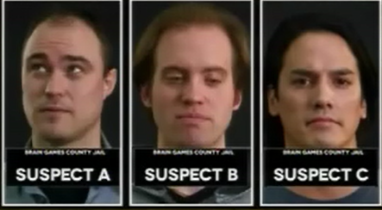
- Does eye contact or where people avert their eyes when questioned inform us about whether or not they are lying?

______________________________________________________________________________

- Daniel Ribacoff, polygraph expert, suggests a number of reasons that people may lie. Jot down any of the reasons that your group did not come up with when completing the introductory questions.
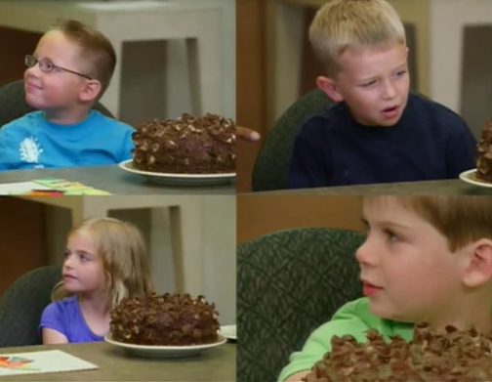

Kids and Cake Experiment
In this experiment a child is left alone in a room with a cake and told not to eat or touch it. Will they be tempted and will they lie about their actions?
A B

C D

- Which( if any) of the children do you think was lying?(list as many or few as you need to)
- Controlled experiments investigating lying showed that:

- ____ % of children will lie about having done something they were told not to do.
- ____ % percentage of these will lie about it.

- Small lies begin at about what age? _______________________________________________

- What does lying at an early age show? _____________________________________________

- Give an example of “lying” or “deception” by
- A baby?
_____________________________________________________________________________
- An animal?
______________________________________________________________________________
- In primate studies, what relationship was found between brain size and deceptiveness?
______________________________________________________________________________
- Give some examples of games/pastimes/pursuits where deception is rewarded
______________________________________________________________________________
______________________________________________________________________________

Can you Spot a liar?
A lie detection technique called “Ground Truth” involves having a subject answers only “NO” to a series of questions. The first question is one that the person using the technique knows will result in a lie.(eg are you wearing a shirt to someone who obviously is). They use this response (the lie) to look for and identify a “tell”.
- a) In the context of lying, what is a “tell”?
______________________________________________________________________________
______________________________________________________________________________

b) What was Mavis’s “tell”?
______________________________________________________________________________
Sometimes people act strangely when lying. The brain regulates our behaviour and lying puts our brain into overdrive. When lying we are basically multitasking and carrying out two cognitive tasks simultaneously.
- What are the two cognitive tasks we are carrying out when lying.
We are:
______________________________________________________________________________
______________________________________________________________________________
Lying involves multitasking and trying to do two things at once, which can result in a change in behaviour or demeanour.
The lying game
- Complete the game board described in the video and record your time for game 1 and game 2? (say the answers in your head not out loud)
Game1: ______
Game2: ______

- Which look more time? Briefly explain why.
______________________________________________________________________________
______________________________________________________________________________

Non-verbal lying
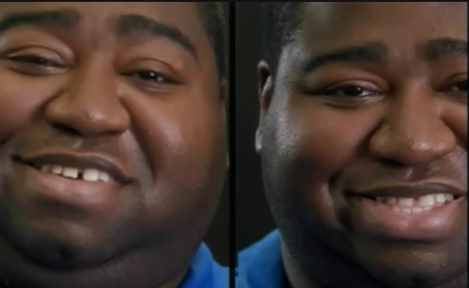
- Which of these smiles is fake?
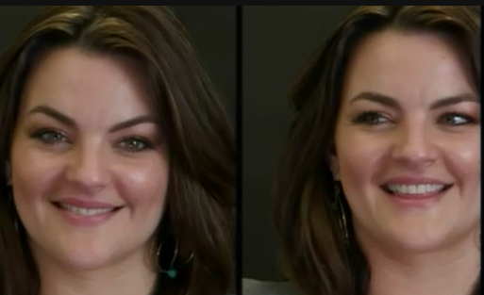
- a) What is a Duchenne smile?

______________________________________________________________________________

b) How can you tell if a smile is genuine?
______________________________________________________________________________
______________________________________________________________________________

- It terms of brain activity how do fake and genuine smiles differ?

______________________________________________________________________________

______________________________________________________________________________

______________________________________________________________________________

Let’s play lie detector
Watch the video of actor Steve telling us about his favourite sport.
- a) Which story is the truth and which is a lie?
Basketball is my favourite! ______
Soccer is my favourite! _________

b) Give at least one reason for you choice.
______________________________________________________________________________
______________________________________________________________________________
______________________________________________________________________________

List the famous liars spotted in the video and if you can remember their famous lie

