Understanding DICOM Plain and Simple  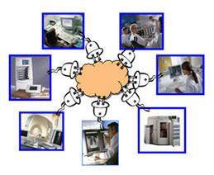  A revised 2008 edition, written for those who have little or no understanding of the topic DICOM.  by Mr. Thoma  s A. Giordano |  |  |  | My Bookmark  DICOM in Action  Last Page Viewed  About the Author  Notes to the Learner  This CE activity may be available in multiple formats (online, directed readings, etc.) or from different sponsors. The ARRT does not allow CE activities to be repeated for CE credit at any time.  The time needed to complete this activity will vary depending on prior knowledge, reading speed, Internet connection, etc. The CE approver is responsible for determining the CE credits awarded, not Philips.  The Learning Center content is for information and continuing education only. The content is not intended to provide medical advice, diagnosis, or treatment.
 |  | Learning Objectives
Once the student has completed the course he/she will be able to:

- Discuss how networks function.
- Describe the reasons why medical imaging networks exist.
- Describe the fundamentals by which images are transferred through hospital networks.
- Explain the importance of networking standards.
- Describe the basic services of DICOM.
- Recognize the importance of DICOM in the entire hospital IT infrastructure.

Understanding DICOM Plain and Simple: Study Content
About the Author


Tom Giordano is a 28 year veteran of Philips Medical Systems. He retired in 2005 as Vice President of Marketing, where he was responsible for 240 marketing professionals and several billion dollars in product. Through his career, Tom held a wide variety of positions of increasing responsibility at Philips, starting in engineering, progressing to product management, then marketing management and finally senior level business leadership. In 2004, he was awarded the prestigious Presidential Award from Philips for forming a new entrepreneurial business unit that tripled sales in 18 months. Tom played a key role as a course developer and instructor in the management development and executive training efforts within Philips, most recently with the Philips High Potential Development Center.
Tom continues to serve in an advisory capacity to the President of Philips Medical Systems North America. In addition, he is an adjunct marketing professor with the graduate business school of the University of New Haven in Connecticut and the University of Washington in Seattle.
Prior to joining Philips in 1977, Tom was a project engineer with CBS laboratories in Stamford, Connecticut for four years. Before that, he served as a U.S. Army officer.
Tom holds a BS in Electrical Engineering from Drexel University in Philadelphia and a MS degree in Engineering from the University of Florida.

Understanding DICOM Plain and Simple: Study Content
Introduction
This is an introductory course on DICOM and one of several in the “Plain and Simple” series. It is written for those who have little or no understanding of the topic. With IT (Information Technology) and networking becoming a central part of our everyday lives in the healthcare environment, it is helpful to understand the fundamental principles upon which devices communicate and send information and images to and from one another.
The entire IT (Information Technology) system for the radiology department in a hospital or clinic is called PACS (Picture and Archiving System). There are four major functions of any PACS system:
ACQUISITION ... Medical imaging modalities, such as MR, CT, Ultrasound devices, acquire images and send them to a PACS.
COMMUNICATION ... Images and Information are sent and received from the various devices on the PACS network. The size of the data and the speed at which it is sent is often a key part of the communication process within the PACS system.
STORAGE ... Images and Information is stored safely on the system so that it can be recalled in the future. This storage function simulates the film rooms and file storage areas in many hospitals.
VIEWING ... Images and Information are viewed on image displays for review. This viewing function simulates the film light boxes and auto-alternators of many healthcare environments.
A more detailed treatment of PACS is addressed at length in the PACS, Plain and Simple Course. This course will focus on the language by which all the devices on a PACS network communicate.
DICOM (Digital Imaging and Communication in Medicine) is a standard for the handling of medical images on a network. This standardized method for handling images allows the hospital or imaging center to connect devices from different vendors and have them all operate as an integrated system (interoperability).

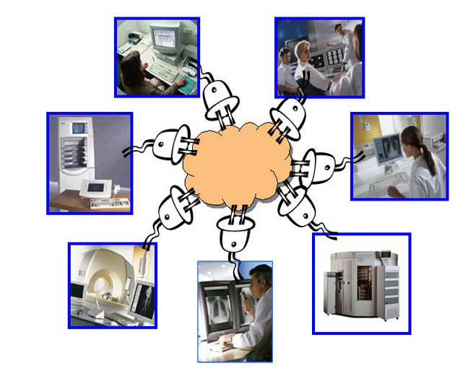

You are currently on page 3 of 50 (10% Complete)
Understanding DICOM Plain and Simple: Study Content
The Good Old Days
In the days before digital imaging, analog film formed the basis for radiological imaging. Sending images to referring physicians was a simple matter of taking the film and sending it to the physician. Image Intensifiers formed the basis for fluoroscopic imaging. Film based 35 mm cameras recorded the images and provided the medium by which physicians reviewed procedures and made diagnosis. There were no digital outputs, no storage media, no networks.

You are currently on page 4 of 50 (10% Complete)

Understanding DICOM Plain and Simple: Study Content
The Digital Era
In the last decades almost all imaging modalities have become digital. Computed Radiography (CR) has replaced standard radiographic imaging. Digital Radiography (DR) has replaced chest stands and bucky tables. Digital flat plates have replaced Image Intensifiers in RF systems and Cardiovascular Systems (CV). And new modalities such as MR and CT have been designed from the start as digital devices. All these require some mechanism for sending and receiving images to one another. Each needs some mechanism for storing images. Each needs some mechanism for reviewing images. These functions were provided by basic film in the past.
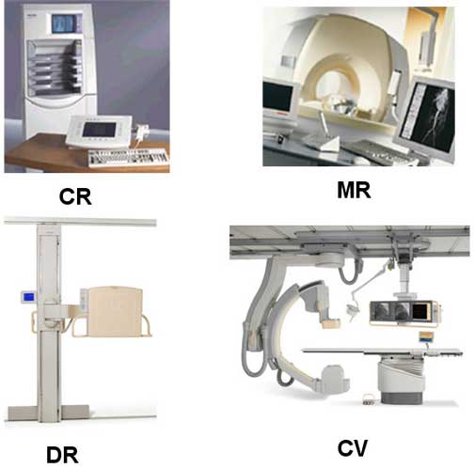

Understanding DICOM Plain and Simple: Study Content
The Communication Gamble
It is not a simple task to plug two of these devices together and assume that they will work properly. In the early stages of introduction of digital imaging devices, each manufacturer designed their own proprietary interfaces which only worked with their own equipment. This meant that devices from different vendors could not share images. Since most healthcare institutions rarely purchase all their imaging devices from one vendor, this rapidly became a serious problem. These institutions gambled when they attempted to interface the two devices.


Understanding DICOM Plain and Simple: Study Content
Plug and Pray
This problem even existed in the early stages of DICOM development. Many described these early days as “Plug and Pray”, which was a play on the words “Plug and Play” implying very easy interfacing.
And so the providers of the various pieces of equipment decided to agree on a standard communication language by which they can all talk with one another and communicate information and images. This was the starting point of the DICOM standard.


Understanding DICOM Plain and Simple: Study Content
Foundation

In order to fully understand the power of DICOM, it is important first to review a few general networking topics to provide a firm foundation for the DICOM concepts and standards, which will follow. This foundation is broken into several parts:
- The need for networks
- The need for standards
- The 7 layer concept of network protocols and finally
- The client server concept in networking.
Understanding DICOM Plain and Simple: Study Content
The Analogy

Sometimes it helps to leverage from something we know, to learn something we don’t. The most fundamental concepts of networking can be illustrated by a short analogy.

Understanding DICOM Plain and Simple: Study Content
Step 1: The Physical Connection
Let’s assume that a person named Tom on earth was trying to sell some stock to Marty who lives on another planet in the universe. Assuming that they both have telephones, the first order of business is for Tom to know the phone number of Marty and to dial it. Once he dials the number, the local telephone service does all the work of connecting both Tom and Marty. It all may be done via wires, optical cable, satellite links etc. All of this is transparent to Tom and, in fact, Tom really does not care, as he simply wants to make the call. If the number is correct, Marty’s phone rings. This is Step #1 in the communication process … the physical connection between both Tom and Marty is made and both are “connected”.
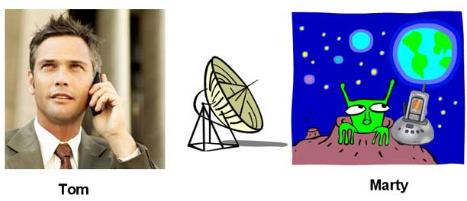

Understanding DICOM Plain and Simple: Study Content
Step 2: The Language
Step #2 … Tom now prepares to make his big sale and says “Would you like to purchase some stock in my new company?” Of course, Marty has no idea what Tom is saying because he does not speak English. And therefore even though the physical connection is made through the marvels of modern communication, there is no conversation taking place because there is no common language.


Understanding DICOM Plain and Simple: Study Content
Step 3: Understanding the Message
Steps #1 and #2 are pretty straightforward and are somewhat intuitive. But Step 3 is the real point of this protocol discussion and also the important role of DICOM. In the third step, let's assume that Tom and Marty, in fact, do understand English. So once again, Tom calls Marty; the phone rings and Tom asks Marty if he wants to buy stock and Marty clearly understands the words that Tom is speaking ... but there is still something missing. Marty, being from another planet never poured his hard earned money into stocks because there is no such thing where he lives. Marty has never heard of stock. He has no concept of stock. So interestingly enough, even though the physical connection is made (Step #1) and Tom and Marty speak the same language (Step #2), the communication is still incomplete because Marty has absolutely no concept of what “stock” is.

This rather primitive example drives at the heart of the network communication process and specifically DICOM. If an Ultrasound device sends an image to a remote device to be printed, the receiving device must clearly be connected to the network (Step #1), speak the same protocol (Step #2) and most of all be capable of printing the ultrasound image in color at the resolution that it was scanned (Step #3). If the printer is an old black and white printer for printing letters it will be of little use to the Ultrasound device... or the doctor for that matter who has to read the image.


Understanding DICOM Plain and Simple: Study Content
The Need for Networks
Why do networks exist in the first place? When computers were first introduced into the home and business markets, they were generally simple devices connected directly to peripherals, such as printers. Each computer had a printer that was dedicated solely to that operator. From the computer operator's perspective, this was very nice because the printer was always available to that operator when he or she wanted to print a document.
On the other hand, the printer was probably not occupied 90 to 95% of its time, when it could have been printing documents from other users. This was not very efficient. In addition, as computers began to populate places of work, companies were unwilling to pay for so many printers that spent most of their time idle.
And so there was a need to share printers among several people.
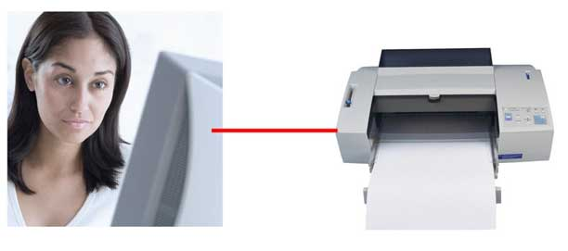

Understanding DICOM Plain and Simple: Study Content
Sharing of Peripherals
The first motivation for the creation of networks was the sharing of expensive peripherals, so that many users could access the same peripheral, such as a printer. It is not simply a case of being to “plug” each computer into the printer because the printer has only one connector. And even if there were some way to physically connect all the connectors, the system would not work because the software in both the computer and the printer was designed only for a “one-to-one” connection.
To solve this problem, engineers designed a system whereby many computers and peripherals can be connected to the same wire … to a network. In order to make this system work, there needs to be a “traffic cop” on the network that tells when computers can use the network and when the printer is free. This “traffic cop” function is at the core of any modern network. It allows a multitude of devices to share the same wire.
In a well designed network the user will “perceive” that he has full ownership of the printer. When they send jobs to the printer, it is printed rapidly. Interestingly, all the users of the network, think they have full access to the printer … that the printer is connected to their computer alone. Printers or workstations or archives or a variety of other peripherals can be shared on the network with the users “thinking” it is directly connected to their computer.
This traffic cop function is accomplished with network software. A typical example of a network in common use today is Ethernet (physical connection) with TCP/IP software (traffic cop).
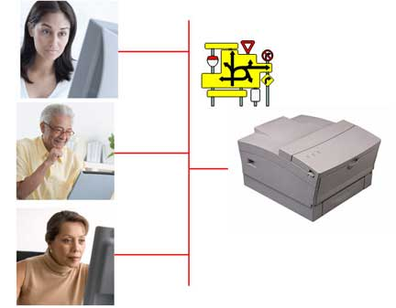

Understanding DICOM Plain and Simple: Study Content
Common Language
When two devices on the network want to communicate with one another there needs to be a physical connection (Step #1), there needs to be a network common language (Step #2) but the final, and most important step is the common understanding of the message itself (Step #3). In our business computer example, let’s assume that Susan has created a document in Microsoft Word that she would like to send to Mary. Both Susan and Mary are connected to the network. Both share the same language, so they understand one another.
But Mary does not have Microsoft Word installed on her Macintosh computer. She is an analyst and has only installed Microsoft Excel on her computer. So Sue sends the Word document and Mary tries to open it up and only sees garbage on her screen, as her computer struggles to figure out how to decode the strange document. Sue becomes frustrated. She wishes she would have known in advance because she spent all this time on the document and it is useless.
This is exactly why DICOM was defined for the healthcare environment. DICOM provides all the homework that is required to make sure that both devices can understand each other and properly interpret all the data and messages. How frustrating it would be for a radiographic technologist to create a beautiful digital radiographic chest image only to find out that there is no device on the network that can print a 14”x17” film.
DICOM provides this common language (or protocol) by which devices can exchange information.
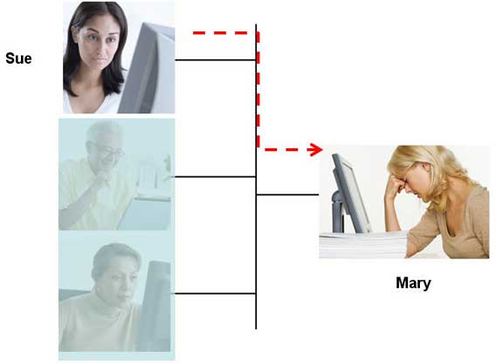

The Need for Standards
Without protocols ... without standards, there is chaos ... a Tower of Babel.
Think about the facsimile (fax) machine. A document can be sent from one end of the world to the other in an instant. A fax machine from any vendor can be connected to the phone line and expected to work flawlessly. Users never think about whether the fax machine on the other end of the line has the proper software to understand and decode the fax document. It just happens … over and over again… without user interaction.
This is a good example of where standards have played a significant role in isolating the user from all the gory details of faxing information back and forth across the globe.
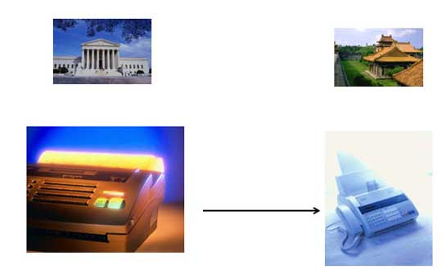

Understanding DICOM Plain and Simple: Study Content
The Common Keypad
Have you ever entered data into your computer keyboard with the keypad and then had to dial a number on your telephone? Did you dial the number on the phone correctly?
Chances are that you had to stop and think. The keypads on both these devices are completely reversed. The number “1’” is in the upper left hand corner of the phone keypad. But on the computer keyboard this position is occupied by the number “7”.
This is a good example where a very common function, entering data into a keypad, is not standardized. There are probably many good reasons for this as both came out of different industries. But from the users point of view, it would have been nice for both of these to be the same.
Common standards are key to an easy life. And that is exactly what DICOM is about.
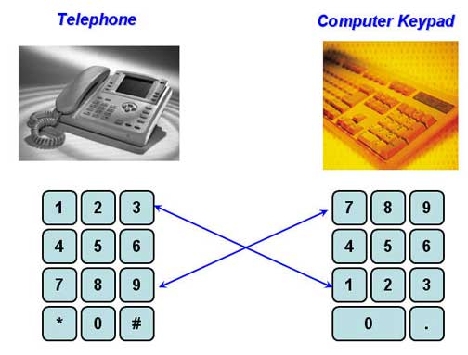

Understanding DICOM Plain and Simple: Study Content
Birth of the DICOM
In the late 1980s, a team sponsored by the American College of Radiology (ACR) and the National Electrical Manufacturers Association (NEMA) was created to begin formulation of common standards for the communication of medical imaging through networks.
The very first standard, ACR-NEMA 1.0, was very primitive. It defined a special plug to be used by all those who conformed to the standard and was primarily targeted at the "point-to-point" applications (no network).
The next version, ACR-NEMA 2.0, adopted in the early 90's, was the first real beginning of a networking standard. It began outlining the core concepts of protocols for the communication in healthcare networks.
The ACR-NEMA specification was designed from the start as a radiology standard. It clearly defined objects and functions for the radiology department:
- communication
- archiving
- viewing of radiographs
At the same point in time cardiology was wrestling with the same networking and standardization problem. International organizations were also beginning to adopt standards. And so it was decided that instead of creating different standards for different countries and different “ologies,” that one common flexible standard was needed to assure compatibility across countries and “ologies”. And thus was born the third and final revision of the ACR-NEMA specification, ACR-NEMA 3.0. The "A" in ACR-NEMA and the "R" in ACR-NEMA had to be changed to address this new audience and so the term DICOM (Digital Imaging and Communications in Medicine) was born to address this wider audience.
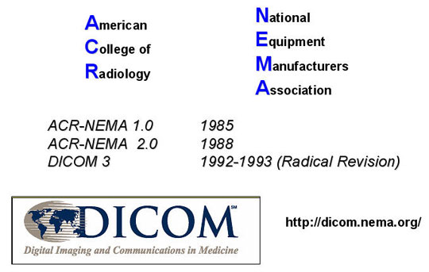

Understanding DICOM Plain and Simple: Study Content
Network 7 Layer Cake
Fortunately there was a network framework defined in other non healthcare industries from which the DICOM committee could build their standard. This more general OSI (Open System Interconnect) standard was built on a 7 layer framework. Some in the industry refer to it as the 7 layer cake. The three generalized layers of DICOM fit into this 7 layer framework well. The bottom layers deal with the physical connection. The middle layers deal with the traffic cop and language. The top layers deal with the actual content of the message itself.
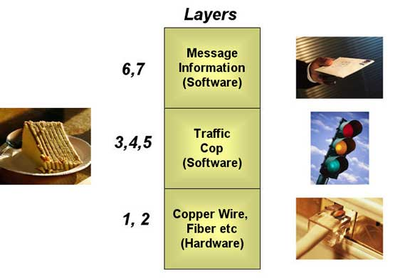

Understanding DICOM Plain and Simple: Study Content
Messaging with DICOM
Here is an example of how this layered protocol of DICOM would work in an actual healthcare network.
Suppose that a Computed Tomography (CT) scanner wants to send an image set to a workstation for reading. It first encapsulates the image into the DICOM message, similar to a letter into an envelope. This message then gets handed off to the traffic cop for breakup into pieces and transmission over the network. Once the message is "parsed", it is sent over the physical connection, e.g. the copper wire or fiber to the network. The workstation, which is also on the network, detects that the message was sent to it and accepts it. It then begins reconstructing the DICOM message from all the bits and bytes on the network. It now knows how to display the image set properly. The most important part of this entire process is the upper DICOM layer, which contains all the information for packing and unpacking the image set and displaying it properly. It's that simple.
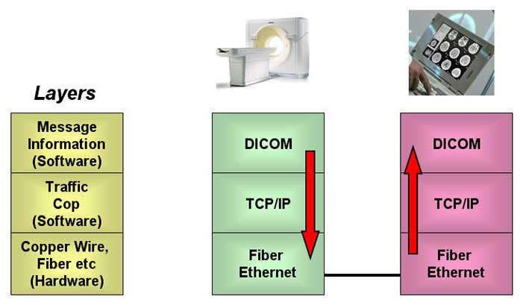

Understanding DICOM Plain and Simple: Study Content
Interoperability
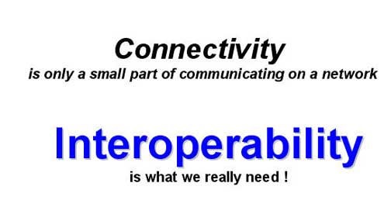

To finish off this section, we need to introduce one new term ... Interoperability. While it is possible to connect many devices on a network, the key to having them work together in a useful manner requires all seven layers to be defined and compatible. So connectivity is not enough. We refer to the ability of two devices to operate together as one as having interoperability. That is what DICOM is all about.

Remember Tom and Marty from the previous example? They need to be connected (connectivity), speak the same language and most importantly understand the concept of the message (DICOM).
Today, standard networks have _______ layers of protocols.
(Note: You will be given 2 tries to answer this question, then the answer will be provided.)
4
5
6
7

Understanding DICOM Plain and Simple: Study Content
Client Server Model
There is one final networking concept that needs to be introduced before digging into the specifics of DICOM. We have reviewed the importance of the physical connection, the language and the upper layer DICOM messages. We have reviewed the 7 layer OSI model concept and how DICOM fits into that. We need now to introduce one final concept… the client server model.
All is pretty much straightforward if it is clear that the device on the network is a sender (for example, a CT scanner) or a receiver (for example, a printer). But what happens when a device (for example a workstation) can be both a sender of images (for example to an archive device) and a receiver of an image set (for example, a CT scanner). To deal with this problem, the client server architecture permeates the entire DICOM specification and all modern non hospital networks as well.
Understanding DICOM Plain and Simple: Study Content
SCU and SCP
Once again, relating this complicated concept to a real world experience would be helpful. So, let's start with a new actor, Joe. Joe is a homeowner, and like any homeowner, he needs services to make his home run. Joe needs telephone service, trash pickup, electricity, water and so on. So Joe, the homeowner, uses these services. He uses the services of the telephone company, the trash company, the electric company and the water company.
This makes him the USER of services. In DICOM he is called the Service Class User (SCU). The electric company, the telephone company, etc., are all providers of the service. DICOM calls them Service Class Providers (SCP). Pretty straightforward. The User and the Provider of services.
To jump ahead a few steps to the Medical Imaging world ... a laser printer might be the provider of print services and an MRI device would be the user of those services.
All devices on the network either use or provide services.
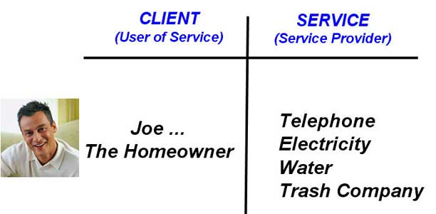

Understanding DICOM Plain and Simple: Study Content
Another Analogy
Now to complicate the analogy a bit.
The trash company needs trash trucks to pick up the trash. So although the trash company provides trash services to Joe, they use the services of a truck and perhaps the leasing company who owns the truck and the gasoline station that provides the truck fuel. In one instance the trash company is a service provider … providing services to Joe. And in the next instance, the trash company is a service user, using the services of the dump, the leasing company and fuel. The trash company is a SCP (service class provider) and a SCU (service class user) depending on which operation they are performing.
To extend the analogy even further, Joe, the homeowner, may drive the truck !!! Think about that! Even Joe who was at the top of the heap using services, can be the provider of services if he drives the truck. The point here is that it is important to understand up front which “mode” the device (service) is providing or using.

In the Medical Imaging world there are various classes of services. Sometimes the network devices provide services and sometimes they use services, and the network (actually the DICOM protocol) keeps track of all of this as the various devices keep changing their identity.
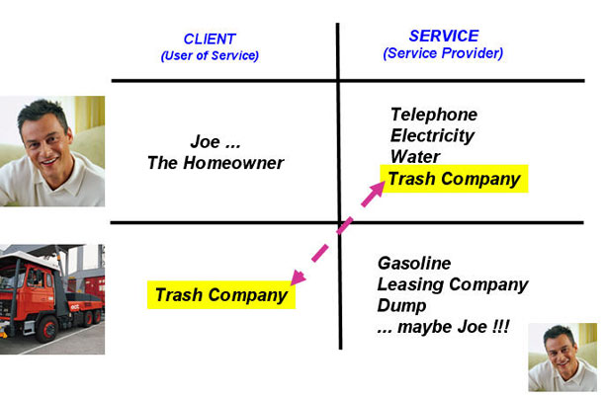

Understanding DICOM Plain and Simple: Study Content
Basic Commands of DICOM
In the lower left corner is the class of devices that replaced our dark rooms. These devices print high quality images on film. More and more today, these are going away, but they still perform an important function especially in many of today's smaller hospitals.
And finally, in the upper left hand corner is a class of systems with which many may not be familiar. These systems do not handle images, they handle patient data ... such as patient ID number, billing information, etc. In the radiology department it’s called a RIS (Radiology Information System). Many hospitals also have a HIS (Hospital Information System) which contains overall patient records including such information as pharmacy data.

With an understanding now of network protocols and an introduction to the Client-Server model, we are ready to apply them to this world of medical imaging.
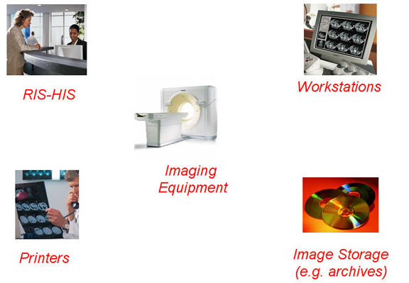

Understanding DICOM Plain and Simple: Study Content
Basic Commands of DICOM: Image Storage
One of the most basic operation in DICOM is to send an image from one device to another. One might have expected that the “Image Send” be called just that … Image Send. But for a number of curious reasons the nomenclature “Image Storage” was used in DICOM instead of the more intuitive “Image Send”. In fact, the Image Storage command seldom has anything to do with image archiving as it is a general command for sending images all over the network for a variety of different reasons.
But the standard is the standard and whenever one hears the word "Image Storage" in the context of DICOM, think Image SEND.
The SOP class language associated with this Image Storage would look like this for sending an image from a CT scanner to a workstation.
In this figure the CT scanner is sending an image to the workstation. This is the “CT Image Storage” SOP Class. In the background of course, DICOM is making sure that the CT image arrives intact, that the workstation is capable of displaying the image and storing it.
Why is all this communication necessary? Let’s suppose the CT was sending a 1024x1024 image to the workstation and the workstation had only a 512x512 monitor. This means the workstation does not have the capability of displaying the entire CT image in its full spatial resolution. In addition, it may not have the tools on it to work with 3 dimensional data for multiplanar reconstruction and 3D rendering. So this interchange between the "sender" and the "receiver" assures that the image not only gets there (connectivity), but also can be viewed and interpreted (interoperability).
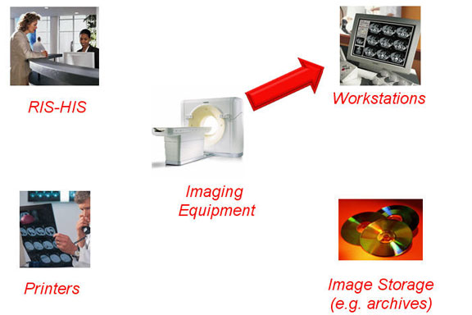

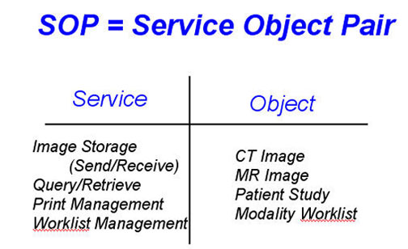
Understanding DICOM Plain and Simple: Study Content
Basic Commands of DICOM: Image Storage Example
Let's take another example of the Image Storage DICOM function. This time with an angiographic image. In this example, the cardiovascular equipment is sending an image, or series of images, to an archive for image storage. This is the "XR Image Storage" SOP in DICOM. Before the image gets sent we would want to assure ourselves that the archive device has enough storage space for the image set. Again, the key here is interoperability ... that of not only communicating, but also doing it in an intelligent fashion.
So in this Image SOP Class, the object is the angiographic image and the service is store (send).
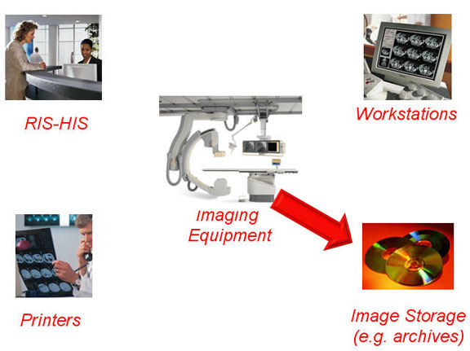

Understanding DICOM Plain and Simple: Study Content
Basic Commands of DICOM: Query - Retrieve
The second basic function of DICOM is the Query/Retrieve Function. This function is most often used from the workstation. Most of medical imaging is comparative imaging. The doctor compares a left and right image ... or maybe a current image with a previous one. So it is essential that we be able to pull up old images (films) from the archive and display them next to the new images for viewing an interpretation.
With this SOP class, the operator of the workstation may want to pull up "prior" images before the new image set is taken, so that they are available for viewing on the workstation. The workstation sends a "query" to the archive that might look something like "Do you have any prior chest images for John Doe with a patient ID of 1234?" The archive would answer back "Yes, I have two prior images from 2003". The workstation issues a "retrieve" command to retrieve them (send them to the workstation).
In a typical medical imaging network, there may be many different archives on the network. There may be one large terabyte optical jukebox in a central area and a multitude of high performance (fast) archives on each of the floors of the hospital. Maybe the hospital has a relationship with a clinic and the images are in fact stored on the clinic’s archive. Or maybe, the workstation is in the middle of the battlefield around the other side of the world and the central archive is in an army base near Washington, DC. The DICOM Query Retrieve command is robust enough to handle all of those options when configured properly.
In this SOP Class, the Patient Study is the object and Query Retrieve is the service. In this example, the workstation is the user of the service so it is called the SCU (service class user) and the Archive is the provider of the images/service so it is call the SCP (service class provider).
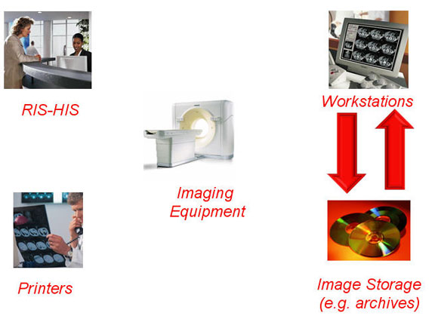

Understanding DICOM Plain and Simple: Study Content
Basic Commands of DICOM: Print Management
The third DICOM command is Print Management. In these days of the filmless hospital, this command is being used less and less because the majority of images are being reviewed on workstations and not film. But from time to time film is necessary and DICOM needs to support this function.
There are three broad categories of devices that can send images to the film printer.
The first is the imaging modality itself. In this case, the patient exam has been completed and reviewed on the local workstation attached to the imaging device (in our example the CT scanner). If a decision is made that those images needed to be filmed immediately, then a command is given from the CT workstation to a specific printer on the network to begin filming the study. The system can be designed that the CT puts out a request to print out the images on any available printer capable of printing CT studies or it could ask for a specific printer that may be local to the scanner.
The second normal scenario for a print management command is from the workstation. In this particular scenario, the user has reviewed the images and wants to print the complete study, a subset of the study or maybe what is just on the monitor. A command from the workstation sends these images to the printer for printing.
The third typical scenario is from the archive. The archive is a direct replacement for the old film storage areas. There may be cases where a physician requests copies of old or prior images for a patient. Another scenario might be to create a teaching file from a number of different cases. In this case an electronic terminal attached to the archive can allow the user to execute a Print Management function for selected images or studies.
Figure 3-4 shows three different entities that can send images to be printed. Modalities can send images directly to a network printer after processing on the local workstation at the modality. Workstations can send images to be printed after, for instance, 3D reconstruction on its independent console. And in the final case, a referring physician may ask for a copy of a film that is in the film library (central archive). A control station on the archive can call up the image and send it to the printer for printing.
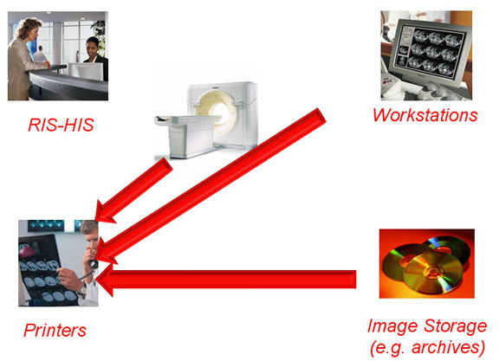

Understanding DICOM Plain and Simple: Study Content
Basic Commands of DICOM: DICOM Image Descriptors
Along with the command to print an image there is much additional information that needs to be sent along with the image in addition to the bits and bytes of the image itself. These attributes are “descriptors” in the image header of the DICOM command. The imaging device will want to tell the printer the details about the image such as:
* What film type to be used
* Print resolution of the image on the film
* Print in black and white or color
* Position of the various images on the film
* Where the patient information should be placed on the film
* The proper orientation of the image (right/left – top/bottom)
And one that is particularly important … the proper contrast and brightness for the image.
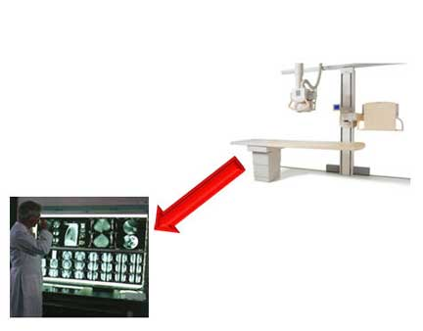

Understanding DICOM Plain and Simple: Study Content
Basic Commands of DICOM: DICOM Grayscale Image Display
Proper grayscale (contrast/brightness) adjustments have historically been a significant problem for initial DICOM and PACS users.
As users transition from film based environment to a totally filmless environment, there is a constant tendency to compare film based images and workstation monitor based images. In the early days the contrast and brightness of the same image, if viewed on a monitor and if viewed on the film, were very different. This was due to several issues. Firstly, monitors in the PACS environment were not calibrated so even images on various workstations looked very different. Secondly, when images were processed on the workstation and sent to be printed, the processed image parameters were not and therefore the film-based images looked very different from the monitor images. This is the exact reason for the existence of the grayscale Standard Display Function in the DICOM standard.
Normally all monitors within the healthcare environment are first calibrated to emit the same level of brightness and contrast from a standard electronic pattern. This will assure the users that all monitors will display the same image identically. Secondly, the DICOM standard requires that the sending device pass along with the image the contrast/brightness function that was used to view the original image (probably the image from which the diagnosis was made). The electrical device in a computer which creates this function is called a Look Up Table (LUT).
Technically speaking, the LUT does far more than brightness and contrast because it can perform non linear mapping of all grayscale values, but that is beyond this course.
The DICOM Grayscale Standard Display function assures the user that the image as seen on the sending monitor will appear on the receiving device (workstation, printer etc) with the exact same quality.


Understanding DICOM Plain and Simple: Study Content
Worklist Management
As PACS networks within hospitals matured, a duplication of certain processes surfaced. It is particularly important in the healthcare environment to make sure that the proper patient name and information is linked with the proper patient. It is also important that any given electronic patient file folder only contain the images of that patient. Within the closed circle of DICOM and the PACS network this was usually pretty closely controlled.
An issue surfaced when a patient’s name was typed one way when they entered the hospital and spelled a different way when the patient was scheduled for a radiographic exam. This arises because the patient's name and data is manually entered into the hospital patient registration system (called a RIS-HIS) and then again manually when the patient arrives at the image modality. The HIS is the Hospital Information Systems and the RIS is the Radiology System.
This is obviously ripe for errors as patient names, Social Security numbers, dates of birth are entered into the hospital system twice because the RIS and PACS did not communicate well together. This is the issue that attempts to be solved by DICOM Worklist Management.
With DICOM worklist management, the days worklist of patients and their corresponding demographics and scheduling information is downloaded into the various imaging modalities on the hospital network. This means that the patient information is transferred electronically from the RIS to the PACS and imaging modalities. This means no more double entry of patient information . It is entered once and that is in the RIS.
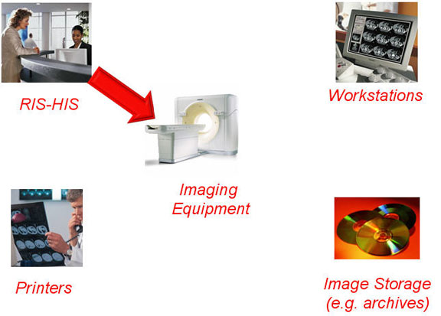

You are currently on page 32 of 50 (60% Complete)
Understanding DICOM Plain and Simple: Study Content
Worklist Management
As PACS networks within hospitals matured, a duplication of certain processes surfaced. It is particularly important in the healthcare environment to make sure that the proper patient name and information is linked with the proper patient. It is also important that any given electronic patient file folder only contain the images of that patient. Within the closed circle of DICOM and the PACS network this was usually pretty closely controlled.
An issue surfaced when a patient’s name was typed one way when they entered the hospital and spelled a different way when the patient was scheduled for a radiographic exam. This arises because the patient's name and data is manually entered into the hospital patient registration system (called a RIS-HIS) and then again manually when the patient arrives at the image modality. The HIS is the Hospital Information Systems and the RIS is the Radiology System.
This is obviously ripe for errors as patient names, Social Security numbers, dates of birth are entered into the hospital system twice because the RIS and PACS did not communicate well together. This is the issue that attempts to be solved by DICOM Worklist Management.
With DICOM worklist management, the days worklist of patients and their corresponding demographics and scheduling information is downloaded into the various imaging modalities on the hospital network. This means that the patient information is transferred electronically from the RIS to the PACS and imaging modalities. This means no more double entry of patient information . It is entered once and that is in the RIS.
The Worklist Management function within DICOM sees that the patient is entered only once (at the RIS) and the RIS transmits that information electronically to the medical imaging network.
(Note: You will be given 2 tries to answer this question, then the answer will be provided.)
True False

Understanding DICOM Plain and Simple: Study Content
RIS-HIS and HL7
The Worklist Management function is complicated by the fact that the protocol standard for the RIS and HIS systems is not DICOM. The RIS-HIS and the image-based words never really touched one another until digital imaging and PACS was mature. The various modalities, the workstations, the archive devices and the printers all speak one common language and that is DICOM. On the other hand, the RIS-HIS system standards were defined independent of the imaging world of DICOM because the requirements of both are very different. The RIS-HIS do not contain images. All the information in the RIS is related to the patient demographics and scheduling information. Therefore this RIS – HIS industry came up with a specification called HL7 (for Healthcare Level seven). The 7 stands for the 7 layers of the standard networking layer cake previously discussed in this course.
Before the DICOM worklist management function can be implemented, some mechanism needed to be designed to make both of these independent systems speak to one another. A “language translator” called a DICOM broker provides this functionality. The DICOM broker is an independent box that translates all the communication back and forth between the DICOM and RIS-HIS systems. Only one is needed per PACS system.
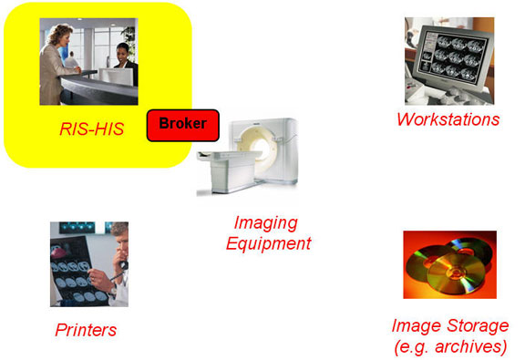

Understanding DICOM Plain and Simple: Study Content
Modality Perform Procedure Step (MPPS)
The worklist management function pushes the worklist from the RIS to the appropriate imaging modality. Early versions of the HL7 to DICOM worlds were one way. Data was pushed from the RIS to the modalities.
As this interface between the RIS and the DICOM world matured, there quickly surfaced information that the RIS needed from the modality, requiring a push of data from the modality to the RIS (the so-called two-way interface). Specifically, the RIS-HIS systems contain all the patient scheduling information. In addition, it is responsible for accurate billing of the patient for the procedure. Therefore, the RIS really needs to know when the examination is complete so that it can bill for it. Without this signal, the “exam complete” message is normally a manual process (nurse calls billing). This certainly opens up lots of opportunities for errors and missed billings.
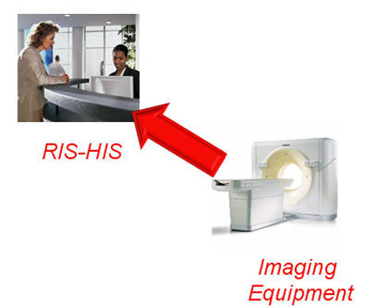

Understanding DICOM Plain and Simple: Study Content
HL7 and MPPS
In summary there are two DICOM commands that are related to the HL7-DICOM communication.
- The first is DICOM worklist management, in which the RIS downloads a list of scheduled patients to the imaging modalities.
- The second is Modality Perform Procedure Step (MPPS), in which the modality sends a signal to the RIS that the exam is complete and the study can be billed.
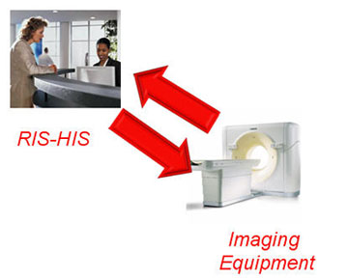

Understanding DICOM Plain and Simple: Study Content
Storage Commit
The Storage Commit service is a rather new function. With the advent of very large images, such as DR (Digital Radiography) and large image series (64-slice CT scanner) the need for significant amounts of disk space has increased dramatically. There is nothing worse than sending over a very large set of CT images to be archived and then find out that the receiving device (like the CD ROM or juke box) is full and cannot accept the entire series. It is a waste of network traffic at best. In the worse case, the sending device may send the image series to the archive and delete it from its local storage only to find out that the series never got to the archive.

The Storage Commit function was designed to eliminate this problem. Before an image or series is sent to a storage device, it "requests" space. The storage device then sends a signal back to the imaging device indicating that it has enough space to store the image or maybe it tells the imaging device "No, I don't have space, don't send the image". The archive can send a signal to the operator of the archive requesting to "clean off" some old images so that the new ones can be stored. The Storage Commit service then is an assurance that is given to the sending device that it has enough free capacity and is prepared to receive and store the image.

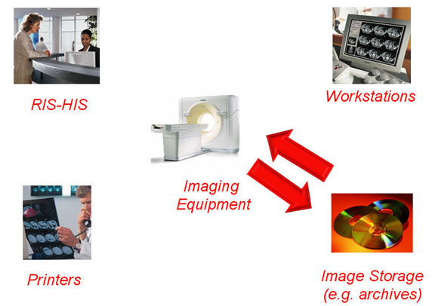

Understanding DICOM Plain and Simple: Study Content
DICOM in Action
Now that we have reviewed the five basic DICOM commands, let’s try and use them in a typical hospital working environment.
Understanding DICOM Plain and Simple: Study Content
Step 1 - Worklist Management
Step 1:
Dr. Smith is Sally’s primary care physician. Dr. Smith has recommended that Sally get a MR study performed to confirm a diagnosis that he has made. Dr. Smith calls ahead to get an appointment for Sally at the nearby imaging clinic. On Monday, Sally appears at the imaging clinic (or hospital). The receptionist types Sally’s name into the HIS to see that all patient information, particularly billing and coverage information, is in the system. The receptionist sees that Sally is scheduled for an MR exam today and that the RIS (which is a subset of the HIS) knows that her appointment is at 10 AM.
This demographic, scheduling and exam information is downloaded to MR Scanner #1 (DICOM Modality Worklist Management). (In some cases the RIS will now download the information to a particular MR scanner but provide a list of patients scheduled for that day and allow any scanner to service that patient as the MR scanners become available). For the purpose of this example, let’s assume that the information is downloaded to the scanner that will actually perform the exam.
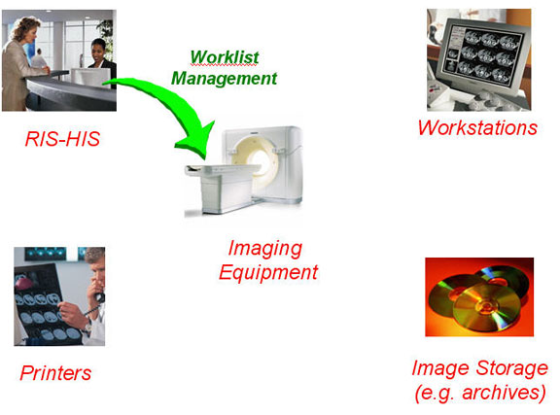

Understanding DICOM Plain and Simple: Study Content
Step 2 - Image Storage
Step 2:
It is 10 AM and Sally’s MR Imaging procedure is started. All of her information appears on the operator console and does not have to be reentered. The technologist performs the MR exam and does a quick quality check to make sure that the images look ok and they are in the format that the radiologist is comfortable reading.
The technologist now wants to send this image set to the workstation from which the radiologist will read the images, make the diagnosis and the report. A “Send” button on the operator console issues the DICOM Image Store command and pushes Sally’s image set to the workstation in the main reading room.
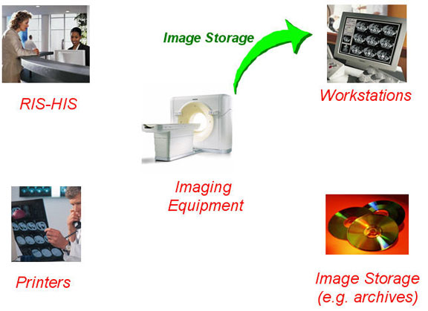

Understanding DICOM Plain and Simple: Study Content
Step 3 - Query-Retrieve
Step 3:
The radiologist would like to see the same exam that Sally had performed last year as well as the current exam to see if there have been any changes. He (or the person preparing the “image folder” folder for him) pushes a button to ask the main archive if there are any prior images for Sally.
In most cases, since the workstation (via the RIS) knows that Sally will be coming in today and the doctor wants to review the prior images, this request for prior images will probably be done the night before. In the PACS circles this is called “pre-fetching” of exams. But for the purpose of our scenario we will assume that this has not been done and the user of the workstation has to issue this query command to see if any of the archives on the PACS system contains Sally’s prior images.
The image archive reports back to the workstation that it does, in fact, have some prior images for Sally. These images are then retrieved from the archive and sent to the workstation using the DICOM Query Retrieve command.
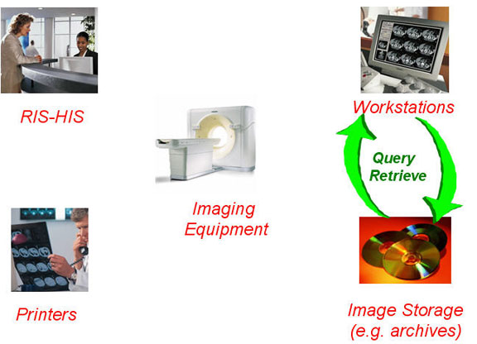

Understanding DICOM Plain and Simple: Study Content
Step 4 - Storage Commit
Step 4:
The radiologist reads the images, makes the diagnosis and dictates the report. The report is handled by the DICOM structured reporting function which will be discussed later in this course. The workstation now issues a command to the archive to archive those images from which the diagnosis was made (diagnostic images). The workstation does not release (delete) the images locally until it hears back from the archive that the images have been successfully stored, and perhaps even backed up on another media. Once the workstation gets the signal back from the archive (DICOM Storage Commit) that the images have been successfully stored, it releases the images locally.
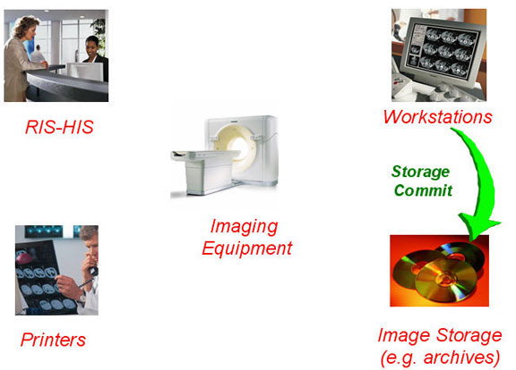

Understanding DICOM Plain and Simple: Study Content
Step 5 - MPPS
Step 5:
Once the report has been completed, the system (either the archive or workstation) sends a signal (DICOM Modality Perform Procedure Step) back to the RIS that the exam has been completed. The RIS and HIS work together to bill the patient/insurance company for the imaging exam.
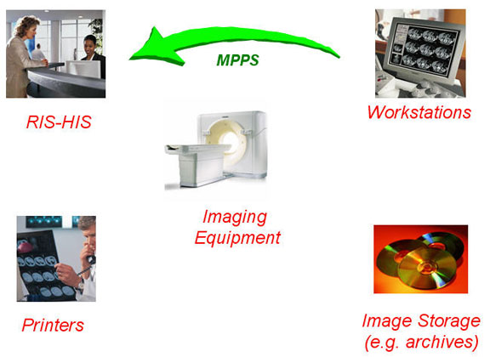

Understanding DICOM Plain and Simple: Study Content
DICOM Conformance Specifications
As described in the Introduction of this course, one of the major objectives of the DICOM Specification is to assure that two devices from two different vendors can operate with each other. The services specified by DICOM are increasing on a daily basis as the medical imaging technology advances. Think about the fact that multiline CT scanners did not even exist when the DICOM specification was written. Instead of having different releases of the base specification itself, advances are handled by additions to the services in the already existing general DICOM spec. Because of this, a mechanism is needed whereby each vendor specifies which services he is implementing. This is done through a document called a "DICOM Conformance Statement".
DICOM conformance specifications are very technical and complicated. Generally they can be understood only by an IT engineer. In the beginning days of DICOM, claiming DICOM conformance was not enough to assure that two devices on the medical imaging network could interoperate with one another. It was critical that an engineer manually review the DICOM conformance statements of the two devices that were to interoperate with one another. These days, most vendors fully support the DICOM conformance spec and two devices claiming DICOM conformance will most likely interoperate with each other.
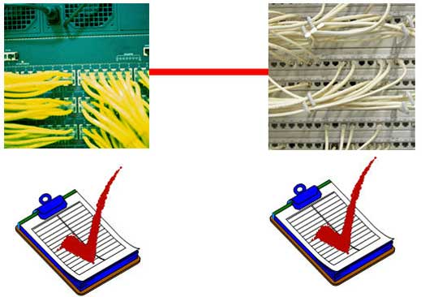

Understanding DICOM Plain and Simple: Study Content
Conformance Statement Example
This is an example of one of the tables from a typical DICOM conformance statement. This one happens to be from a Philips MR scanner. This entire conformance statement is available publicly from the Philips web.
Hopefully there are several items in this statement that sound familiar. On the top of the chart under the heading “Transfer”, the DICOM name MR Image Storage can be seen. This conformance statement claims that this particular MR device is both a Service Class User (SCU) and a Service Class Provider (SCP) of the MR Image Storage SOP (Service Object Pair). This means that this device can send MR images and receive them as well.
Under the Query/Retrieve heading we can see that this MR machine has the ability to query other devices for the patient data (SCU) but does not support the function of being queried by other devices on the network. So if an external workstation down the hall from this MR asks if it has any images for a particular patient, the MR will send back a “no can do” message. This makes sense as patient data should be queries from the central database (RIS) and not from a MR scanner.
Similarly under the workflow management section we can see that this MR supports Storage Commit and Modality Perform Procedure Step. It also has the ability to send images for printing.
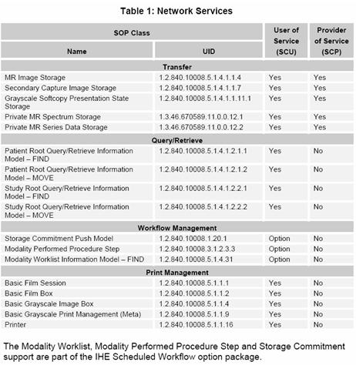

Understanding DICOM Plain and Simple: Study Content
Security Mechanisms
Patient image and data security within the hospital network is extremely important. Patient privacy issues permeate all aspects of this IT world today. No one wants their private records disclosed to anyone without
their prior knowledge and permission.
The Health Insurance Portability and Accountability Act (HIPAA) of 1996 put strong rules in place to protect patient privacy. See: http://www.hipaa.org/
PACS, RIS, HIS, EHR, IHE have mechanisms in place to assure data security. Who access PACS and what parts of patient information they can access is strictly controlled through passwords, biometric access controls (fingerprints) and the like. Within hospitals there are firewalls and security mechanisms to assure security.
The only point in which DICOM plays a role in security is in the communications of sensitive data in the Internet non secure environment. There are many standard techniques for encoding and encrypting information. Our military and other government agencies encrypt information all the time. So the DICOM specification allows for the use of standard encrypting algorithms to encrypt data and even electronic signatures. The DICOM conformance specification is the place to look to see what type of encryption is used and implemented by both entities trying to communicate with one another over the network.


Understanding DICOM Plain and Simple: Study Content
DICOM Exchange Media
All of this course has concentrated on the communication of DICOM images over hospital networks. There are certain instances when DICOM information is exchanged via external exchange media; for example, a CD. There is a section of DICOM that deals directly with this issue. It is important to understand that DICOM is a communication standard. Therefore it does not standardize the exchange media itself but only the format of the data that it contains. The reason for highlighting the distinction here is that there is really no such thing as a DICOM archive. DICOM never defines what kind of media should be used or how big an archive is. DICOM defines the format of the data and how it is to be exchanged.
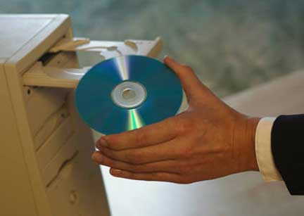

Understanding DICOM Plain and Simple: Study Content
Current State of DICOM
The DICOM Standard is in a constant state of evolution as new modalities and concepts get added. There is no such thing as revision levels of the core document as there are in many documents. Sections of the document are added, subtracted, or changed as the specification grows. The major section of the 2007 version of the DICOM specification is shown here. The entire document itself can be downloaded, free of charge from the DICOM website: http://www.dclunie.com/dicom-status/status.html
PS 3.1: Introduction and Overview
PS 3.2: Conformance
PS 3.3: Information Object Definitions
PS 3.4: Service Class Specifications
PS 3.5: Data Structure and Encoding
PS 3.6: Data Dictionary
PS 3.7: Message Exchange
PS 3.8: Network Communication Support for Message Exchange
PS 3.9: Retired (formerly Point-to-Point Communication Support for Message Exchange)
PS 3.10: Media Storage and File Format for Data Interchange
PS 3.11: Media Storage Application Profiles
PS 3.12: Storage Functions and Media Formats for Data Interchange
PS 3.13: Retired (formerly Print Management Point-to-Point Communication Support)
PS 3.14: Grayscale Standard Display Function
PS 3.15: Security and System Managment Profiles
PS 3.16: Content Mapping Resource
PS 3.17: Explanatory Information
PS 3.18: Web Access to DICOM Persistent Objects (WADO)
Understanding DICOM Plain and Simple: Study Content
DICOM and IHE
There are a couple of very important healthcare IT initiatives that are tied closely with DICOM. The first is IHE (Integrated Healthcare Environment). The IHE initiative was initially focused at providing a tighter integration between HL7 and DICOM. From a user's perspective this is all one large system that should be helping the healthcare institution to provide higher quality and more efficient (e.g. better workflow) healthcare. Even though the HL7 and DICOM specifications have been designed in two different worlds, it is critical that they be tightly integrated if the institution is to see any benefit at all. And so the industry wide IHE was formed for just that reason. Since it was formed the IHE scope has widened a bit, but its focus continues to be the improvement on how healthcare connects. The IHE initiatives have grown into many other areas, other than radiology such as cardiology, laboratory, eye care, and radiation oncology. The DICOM committee is actively involved in the IHE initiative.
The IHE mission as defined on its web site is:
“IHE is an initiative by healthcare professionals and industry to improve the way computer systems in healthcare share information. IHE promotes the coordinated use of established standards such as DICOM and HL7 to address specific clinical needs in support of optimal patient care. Systems developed in accordance with IHE communicate with one another better, are easier to implement, and enable care providers to use information more effectively. Physicians, medical specialists, nurses, administrators and other care providers envision a day when vital information can be passed seamlessly from system to system within and across departments and made readily available at the point of care. IHE is designed to make their vision a reality by improving the state of systems integration and removing barriers to optimal patient care.” (source: IHE web site)
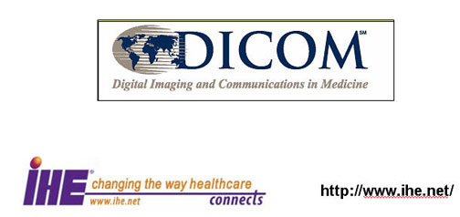

Understanding DICOM Plain and Simple: Study Content
DICOM and EHR
There are a number of active initiatives to standardize an electronic version of the standard patient chart. The formal name for this chart is Electronic Healthcare Record (EHR). DICOM, HL7, IHE and another society HIMSS (Healthcare Information and Management Systems Society) are all focused on standardizing the EHR. If anyone has moved from one doctor to another or from one end of the country to another, they realize the frustration in not being able to bring their healthcare records with them. Anyone who witnessed the catastrophe of Hurricane Katrina in New Orleans, appreciates the frailness of paper and film-based patient records. In most other industries this central repository of information has been solved. The healthcare industry is beginning to wrap its arms around this complex problem. The DICOM committee is an integral player in this effort.
The definition of the EHR from the HIMSS web site is:
“The Electronic Health Record (EHR) is a longitudinal electronic record of patient health information generated by one or more encounters in any care delivery setting. Included in this information are patient demographics, progress notes, problems, medications, vital signs, past medical history, immunizations, laboratory data and radiology reports. The EHR automates and streamlines the clinician's workflow. The EHR has the ability to generate a complete record of a clinical patient encounter - as well as supporting other care-related activities directly or indirectly via interface - including evidence-based decision support, quality management, and outcomes reporting.” (source: HIMSS website)
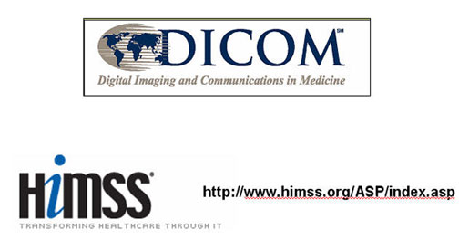

Understanding DICOM Plain and Simple: Study Content
Summary
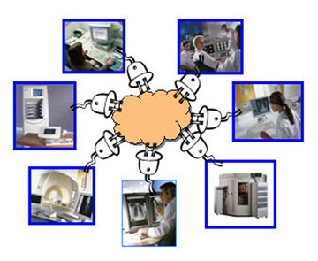

The analog days are gone. The digital days are here to stay. The evolution of imaging modalities from analog to digital has brought with it a host of benefits that were not possible in the analog world. But with these benefits comes a need to standardize and invent new ways of performing old tasks and to think about new ways of providing higher patient care; quality patient care that is more secure, more efficient, and ideally less cost than ever before.
This course has reviewed the basic concepts of networking in general and those pieces that are fundamental to DICOM. DICOM forms the foundation for all communication in PACS. All vendors of imaging equipment have agreed to this specification so that equipment from different vendors can not only connect with one another, but also have a high level of interoperability. Through a number of analogies and examples, this course has strived to present some of the more complex concepts in DICOM in a simple, understandable way.
DICOM is an ever evolving specification as the technology matures and new modalities are added. DICOM does not stand alone. It interfaces with HL7 based systems, such as the RIS-HIS, driven by the IHE initiative. It will continue to evolve and become a core part of the future Electronic Healthcare Record.
As we all come to understand DICOM better and its role in the hospital of the future, we can all contribute to making our healthcare system better for patients, better for physicians and better for hospitals.

