
Multimeter
Sim Lab 2.1
Semiconductor testing
Electronics
Bates College
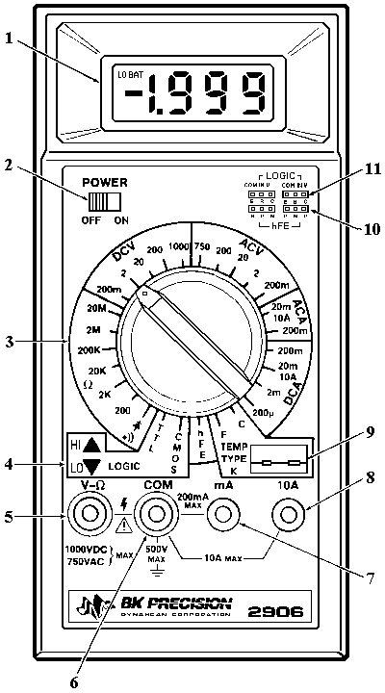

NAME:_____________________________

DATE_____________________________

In this lab you will learn how to test semiconductors in circuit, begin trouble shooting techniques, and begin reading schematic diagrams.

  - Turn on your multimeter and set to in the diode test setting.

  - Using the Ohm sim board pictured below, measure the diodes and transistors listed below in the parts list. Place the readings on the provided schematic next to each component tested or behind the parts list.

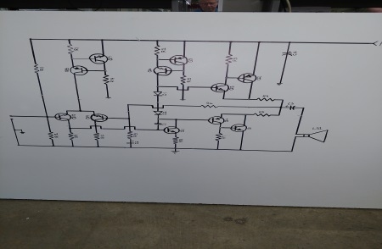

Measuring across each component listed below, record the readings on the schematic provided. When all the diode test values are found, use results for the quiz on the Quia Testing Equipment page, “transistor sim test”.
Good readings should be around .600 and OL on your meter, bad parts may read .000 or near that value.
Q1
Q2
Q3
Q4
Q5
Q6
Q7
Q8
Q9
Q10
Q11
D1
D2

