
Multimeter
Sim Lab 2.3
Electronics
Bates College
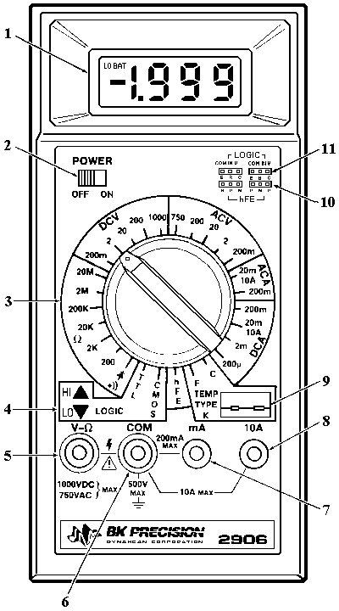

NAME:_____________________________

DATE_____________________________

In this lab you will learn how to take OHM readings in circuit, begin trouble shooting techniques, and begin reading schematic diagrams.

  - Turn on your multimeter and set to in the Ohms setting.

  - Using the Ohm sim board pictured below and the schematic on the back page, measure the in circuit ohm values for the listed items.

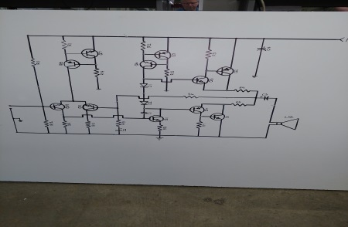

Measuring across each component listed below, record the ohm readings on the schematic provided. When you have all the ohm values are found turn in completed work sheet.
- Measure from ground to emitter of Q1 =________

- Measure from base of Q11 to the collector of Q10 =________
- Measure from the ground side of R12 to the power supply side of R11 =________

- Measure from the emitter of Q5 to the base or Q9 =________

- Measure from the ground side of the speaker LS1 to the base of Q9 =________

