
Multimeter
Sim Lab 2.0
Electronics
Bates College
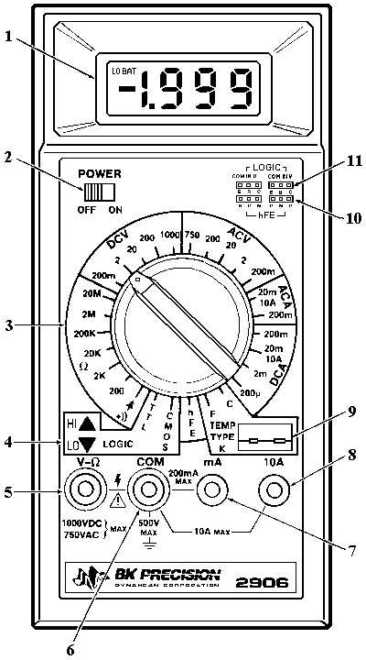

NAME:_____________________________

DATE_____________________________

In this lab you will learn how to take OHM readings in circuit, begin trouble shooting techniques, and begin reading schematic diagrams.

  - Turn on your multimeter and set to in the Ohms setting.

  - Using the Ohm sim board pictured below, measure the in circuit ohm values for the listed parts list. Place the readings on the provided schematic next to each component tested.

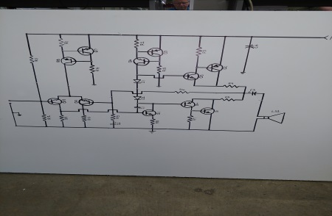

Measuring across each component listed below, record the ohm readings on the schematic provided. When all the ohm values are found, enter them into the Quia Testing Equipment page, “Ohm sim test.
R1
R2
R3
R4
R5
R6
R7
R8
R9
R10
R11
R12
R13
R14
R15
LS1

