COMPUTER BASICS

Hardware Components (Parts of the Computer):
Part | Function | What type of device?  Check one
Part | Function | Input | Storage  (Memory) | Output
Keyboard
Flash Drive
Printer
DVD/CD Rom
Mouse
Monitor
Speakers
Hard Drive
Scanner
Projector
Microphone
Copyright 2004 Tim Jansen (www.tim-jansen.com).

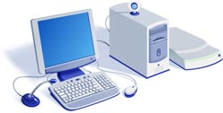

Label the components of the computer:
How Memory Works (Storage):
To process information, computers need to be able to store it. Otherwise, information would come and go before anything could be done with it. They store the information you give them, instructions from the software you're using, plus the instructions they need to operate. There are three types of storage. What are the two (2) types of active storage that a computer uses to process information? What is the third type of storage that is inactive?

Active Storage (used to process information) |  | Inactive Storage
Long-Term/To Operate | Temporary/Anything I want to do
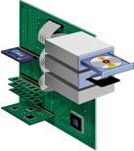

Label the storage and the processing devices in the computer:

Computer Software:
Notes: _________________________ _________________________ _________________________

Software | Definition | List Two Examples
- Word Processing
- Spreadsheet
- Presentation
- Database
- Drawing
- Educational
- Communication

