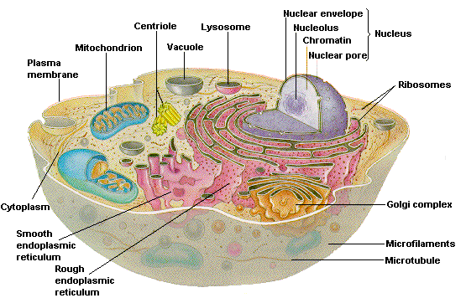/

cell sites

The following sites have activities and information that will be helpful in learning the information for Chapters 1-6. Try some out and practice with the activities.

Site URL | Site Description
http://www.cellsalive.com/cells/cell_model.htm | Cells Alive!-shows cell parts and descriptions of each part
http://www.biology4kids.com/files/cell_main.html | Biology 4 Kids.Com-overview and illustrations to each part of both the plant and animal cell
http://video.yahoo.com/video/play?vid=40408&fr= | Yahoo! Video-shows an animated flight through a cell
http://users.rcn.com/jkimball.ma.ultranet/BiologyPages/  A/AnimalsCells.html | Animal Cells-Representation of an animal cell
http://darwin.nmsu.edu/~molbio/cellgame/cellpin.html | Virtual Pinning-Click on cell part name and drag pin to correct cell part. Great Site for Review.
http://sun.menloschool.org/~cweaver/cells/ | Welcome to Cell Page-site put together by other students from Menlo Park, CA. Interactive review of parts.
http://www.enchantedlearning.com/subjects/  animals/cell/jello/ | Jello 3-D Animal Cell hands-on activity
http://library.thinkquest.org/5420/cellsani.html | "Excell" at Cells-Review of cells

Page constructed by Anissa G. Bloom
Wetmore Academic Center
Created July 20, 2007
Not responsible for other sites attached to these sites.

