**Name ____________________ Class __________ Date __________**

# Economic Choices and Systems Key Terms Crossword Puzzle

Directions: Complete the crossword puzzle.

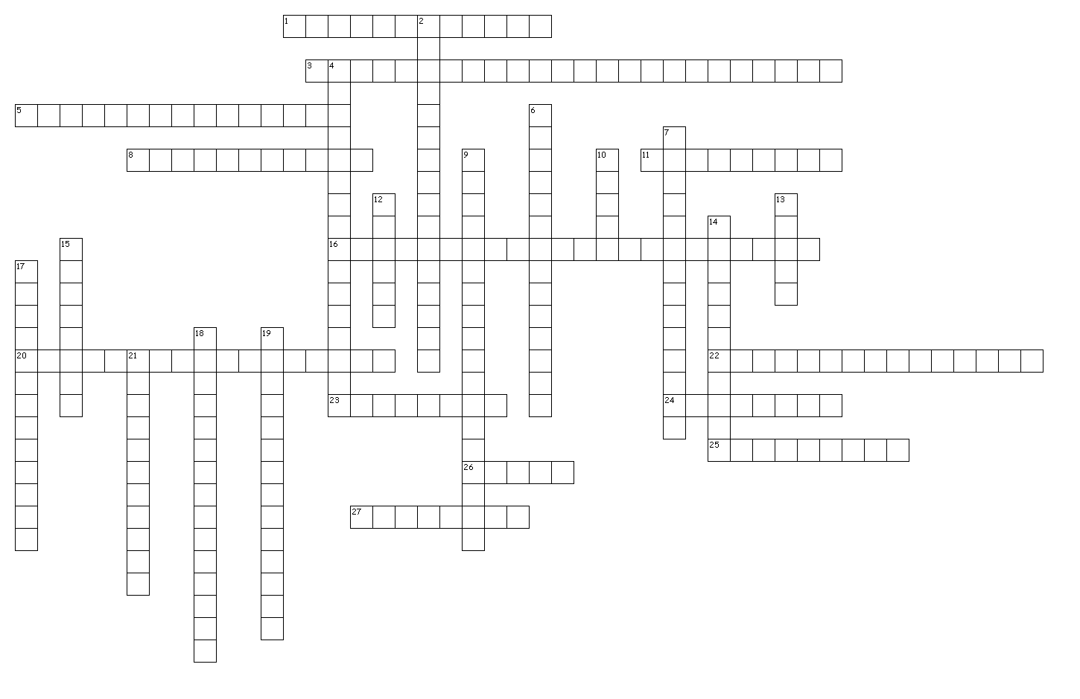

# Economic Choices and Systems Key Terms Crossword Puzzle

**Across**

1. Combines elements of the command and market economies

3. The initiative to combine natural, human, and capital resources

5. Value of the next-best alternative that is forgone to produce or obtain another product

8. Businesses that offer the same goods to the same customers

11. Individuals and organizations that determine which goods and services will be available for consumption

16. Process of choosing which needs or wants will be satisfied

20. Means from which goods and services are produced

22. Right to purchase, use, and discard of things of value

23. Activities that can be consumed at the time of purchase to satisfy needs and wants

24. Condition that exists when wants or needs exceed resources available

25. Study of the decisions made for production, distribution, and consumption of goods and services to satisfy needs and wants

26. Necessities required for living

27. Buys and uses the goods and services

**Down**

2. Goods and money used in the production of goods and services

4. Raw materials supplied by nature

6. People using efforts, knowledge, and skills at work to produce goods and services

7. Economic system which freedom to consume and produce goods and services exists

9. Economic system in which decisions are based on customs and centered on family

10. Items that can be purchased to satisfy needs and wants

12. Money left after selling goods and services and costs of operating a business have been paid

13. Goods that are purchased to add comfort or pleasure to life

14. Anywhere goods and services exchange hands

15. Process of giving up something for gaining something else

17. Goods and services are owned and controlled by the people

18. Opportunity to make choices of goods and services and accept consequences of decisions

19. Economics system in which the government owns resources and dictates what is produced

21. The point where supply and demand are equal