Latin Procedure
Extra Help: I am available for extra help one period as well as either before or after school each day. If you do not need help, but simply to take a quiz or test, you may do so (a) any period in room 215 (b) any day before or after school.
- Resource period (room 215) mods 1/2
- After school (until 3:00) Monday and Thursday
- Before school (after 7:15) Tuesday, Wednesday and Friday
Stamps: stamps are how the entire world language department measures class participation. Basically, stamps are earned by participation and lost for infractions. The grade will be determined on a scale. This scale will be posted in Home Logic with your score.
- Earn: volunteer correct answer, work well in groups or independently, be prepared
- Lose: late to class, disruptive, unprepared
Breaks: physically being in class is integral to doing well. You have until we begin going over the warm-up to go to the bathroom, your locker or get a drink. Just take a pass and leave quietly. Once class begins, you may not leave.
Homework
- Homework is given nightly, either written or preparing for a specific assessment
- Assignments are posted (a) on Quia (b) projected with procedure, materials, etc on daily plans. In the case that homework is missing from one of these places, check the other. You have work every night. Omission is accidental.
- Written homework is generally graded on accuracy as opposed to mere completeness. Homework done through Quia may be attempted thee times with the highest score being the one that “counts”.
- I do not accept late work. If it is not done before class, you will not receive credit unless you were absent.
- No assignments will be dropped, but those who never miss an assignment for the term will receive a bonus percentage point in their marking period grade.
Absence
- DO NOT walk in after an absence saying, “did we do anything?” or “what did I miss?”. Homework is posted on Quia, worksheets or quizzes are found in the “while you were out” folder above the hall passes. If you need further clarification or information, see me during an extra help time or send an email.
- School policy is two days extension for HOMEWORK per day absence.
- Quizzes, projects and tests assigned before your absence are due upon returning to school.
- If you miss a quiz or test day, you must make-up (a) outside of class-time (b) within a week. Too much leniency with this policy has caused several people simply to never take a test.
- Once “ABS” goes to “0”, work may not be made up.
- I will not remind you about work owed. That is what Home Logic is for.
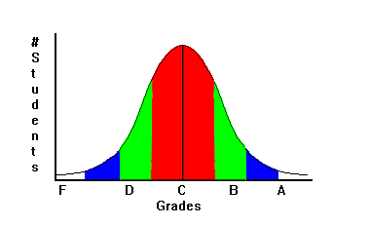
Bell Curves: homework, quizzes, projects and paradigms will never be curved. However, long-range assessments like a final, quarterly or unit exam may receive a bell curve. The way I determine a curve is based on several factors:
- highest score is an “A”
- approximately same number of “A”s as “F”s, “B”s as “D”s
- median score is a “C”
- the majority of the class is in the “C” range.
When a curve is applied, my scoring will be posted on Home Logic. I will only curve assessments when it will benefit most students. There may be a very rare instance where a curve may lower a few students’ grade. This will frequently happen in college. However, no one will ever fail who scores above 65%.

