Lord of the Flies vocabulary, Part I
For each word, write the definition and a sentence.

efflorescence
decorous
bastion
hiatus
ebullience
recrimination
vicissitudes
declivities
tacit
leviathan
clamor
mutinously
impervious
glowered
demure

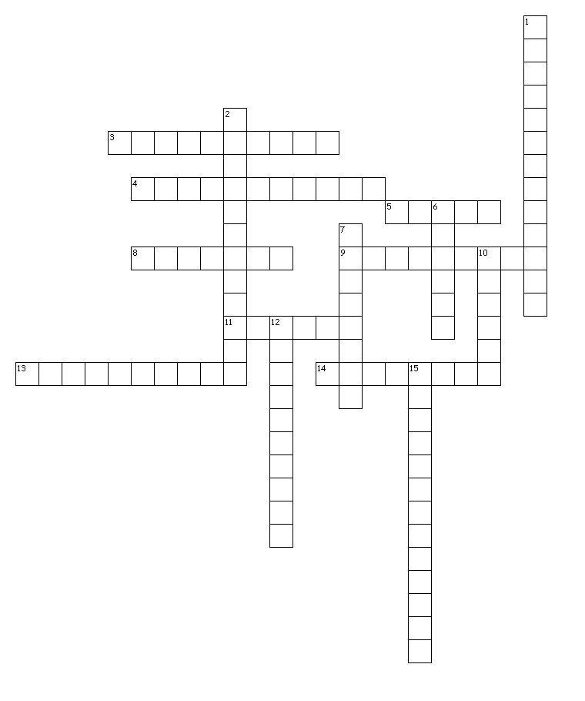
Across
3. zestful or spirited enthusiasm
4. downward slopes, as of a hill
5. not spoken; implied by actions or statements
8. a stronghold or fortification
9. something very large; giant sea creature in the Bible
11. modest and reserved in manner or behavior
13. incapable of being penetrated or affected
14. exhibiting appropriate behavior or conduct
Down
1. blooming of flowers, state of flowering
2. a change or variation; unexpected changes
6. a loud outcry; great expression of discontent
7. looked at or stared at angrily
10. a gap or interruption in continuity; a break or pause
12. unruly; insubordinate
15. the act of accusing in return; opposing another charge

