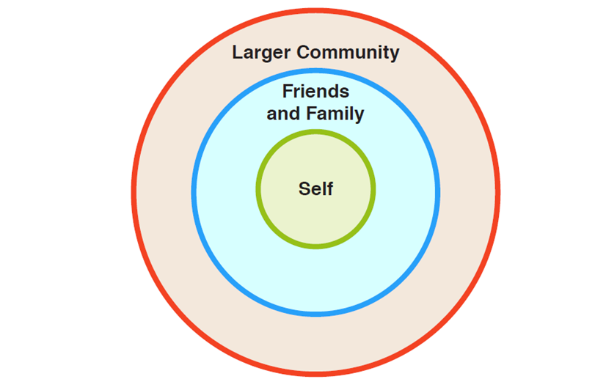
I get permission to post photos of others.
I post my opinions respectfully.
I keep my private information private.
I protect my passwords.
I stand up to cyberbullying.
I give credit for information I find online.

