Goal Setting and Time Management

PERSONAL TIME SURVEY

168

168 is the immutable, unchanging reality of time as we keep it. Presidents and queens, the rich and famous, business people, the poor and downtrodden, each and every one of us live with the reality that no matter what, there are never more than 168 hours in a week.

Understanding how you are currently spending your time is the first step in effectively utilizing this nonrenewable resource.

Step 1: List the amount of time per week for each activity (arrive at a daily average and multiply by 7; account for weekend differences):

- Class time (# of hours in class each week) |  | __________________
- Job/Work |  | __________________
- Socializing (hanging out, IM’ing, dating, etc |  | __________________
- Commuting/transportation time |  | __________________
- Athletics/Exercise |  | __________________
- Extracurricular Activities  - Family Responsibilities |  | __________________
(cleaning, cooking, shopping, etc.) |  | __________________
- Sleeping |  | __________________
- Eating |  | __________________
- Personal Hygiene (bathing, hair, make-up, etc.) |  | __________________
- Other ______________________________ |  | __________________
 |  | 168
Step 2: Add together a.-k. for a SUBTOTAL: |  | __________________
Step 3: Now subtract your subtotal from 168 for a TOTAL: |  | ___________________

Step 4: Divide your total by 7. This is the average number of hours per day you have left for studying
or free time ___________________

If the number in your TOTAL line is negative, you have committed more time than there is in a week.
YOU ARE IN TROUBLE. If you have time left over, ask yourself what choices there are for your time.
Do you have time for more sleep? Volunteering? Friends?

SMART Goal Worksheet

S.M.A.R.T. | Questions…
Specific | Does your goal clearly and specifically state what you are trying to achieve?  If your goal is particularly large or lofty, try breaking it down into smaller, specific SMART goals.
Measurable | How will you (and others) know if progress is being made on achieving your goal? Can you quantify or put numbers to your outcome?
Attainable | Is achieving your goal dependent on anyone else?  Is it possible to reframe your goal so it only depends on you and not others?  What factors may prevent you from accomplishing your goal?
Relevant | Why is achieving this goal important to you?  What values in your life does this goal reflect?  What effect will achieving your goal have on your life or on others?
Time-bound | When will you reach your goal?  Again, if your goal is particularly large, try breaking it down into smaller goals with appropriate incremental deadlines.

Today’s Date: _______________
Date by which you plan to achieve your goal:
What is your goal in one sentence? (What’s the bottom line?)
__________________________________________________________________________________________ __________________________________________________________________________________________
__________________________________________________________________________________________

The benefits of achieving this goal will be…
__________________________________________________________________________________________
__________________________________________________________________________________________
__________________________________________________________________________________________
______________________

Verify that your goal is S.M.A.R.T.

Specific: What exactly will you accomplish?
__________________________________________________________________________________________
__________________________________________________________________________________________
__________________________________________________________________________________________

Measurable: How will you (and others) know when you have reached your goal?
__________________________________________________________________________________________
__________________________________________________________________________________________
__________________________________________________________________________________________
____________
Attainable: Is attaining this goal realistic with effort and commitment? Do you have the resources to achieve this goal? If not, how will you get them?
__________________________________________________________________________________________
__________________________________________________________________________________________
__________________________________________________________________________________________
______________________

Relevant: Why is this goal important to you? Hone in on why it matters.
__________________________________________________________________________________________
__________________________________________________________________________________________
__________________________________________________________________________________________
______________________

Time-bound: When will you achieve this goal?
__________________________________________________________________________________________
__________________________________________________________________________________________

ACTION PLAN
What specific steps must you take to achieve your goal?
This action plan may just get you started. Feel free to create a more detailed step-by-step plan.
Task / to-do item | Expected completion date | Date actually completed

OBSTACLES / CHALLENGES
What obstacles stand in the way of you achieving your goal?
Obstacle | How will you address the challenges if/when they arise?
Network of Support & Accountability

When working towards achieving a goal, it is helpful to have a one or two people whom you agree to check in with on a regular basis. Keeping others informed on your progress can be a useful external motivator!
Who can you can share your goal with?
- Talk with one or two individuals who will genuinely want to see you succeed in achieving your goal.
- Explain to them why achieving this goal is important to you.
- Ask if they will support you and hold you accountable in reaching your goal.
- Select and agree upon future dates/times you will report updates on your progress.
Contact’s signature | Frequency of updates on progress  (i.e. weekly, bi-weekly, monthly?)  List future dates/times you will report your progress | Agreed upon method of communication (i.e. face to face, phone, email updates…)

Date your goal is ACHIEVED

Congratulations on creating a SMART goal and sticking with it!
Be sure to share your achievement with your network of supporters and find a way to celebrate your success.

Priority Matrix
Instructions
- Select several weekly activities
- Use one of these examples of a priority matrix or create your own to decide how to prioritize items from your week
- Interpret the results
Example 1:
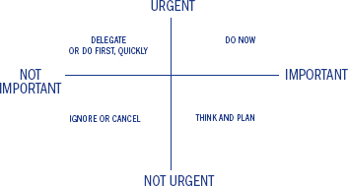
Example 2:
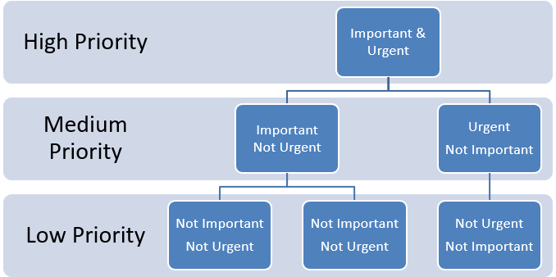

Studying and Test Taking Skills


The VARK Questionnaire – English Version (version 3)
How Do I Learn Best?
This questionnaire aims to find out something about your preferences for the way you work with information. You will have a preferred learning style and one part of that learning style is your preference for the intake and output of ideas and information.
Choose the answer which best explains your preference and circle the letter next to it. Please circle more than one if a single answer does not match your perception.
Leave blank any question which does not apply, but try to give an answer for at least 10 of the 13 questions
When you have completed the questionnaire, use the marking guide to find your score for each of the categories, Visual, Aural, Read/Write and Kinesthetic. Then, to calculate your preference, use the Scoring sheet (available in the “advice to teachers” section of the VARK web site).
- You are about to give directions to a person who is standing with you.
She is staying in a hotel in town and wants to visit your house later. She has a rental car. I would:
  - draw a map on paper
  - tell her the directions
  - write down the directions (without a map)
  - collect her from the hotel in my car
- You are not sure whether a word should be spelled 'dependent' or 'dependant'. I would: a. look it up in the dictionary.
  - see the word in my mind and choose by the way it looks
  - sound it out in my mind.
  - write both versions down on paper and choose one.
- You have just received a copy of your itinerary for a world trip. This is of interest to a friend. I would:
  - phone her immediately and tell her about it.
  - send her a copy of the printed itinerary.
  - show her on a map of the world.
  - share what I plan to do at each place I visit.
- You are going to cook something as a special treat for your family. I would:
  - cook something familiar without the need for instructions.
  - thumb through the cookbook looking for ideas from the pictures.
  - refer to a specific cookbook where there is a good recipe.
- A group of tourists has been assigned to you to find out about wildlife reserves or parks. I would:
  - drive them to a wildlife reserve or park.
  - show them slides and photographs
  - give them pamphlets or a book on wildlife reserves or parks.
  - give them a talk on wildlife reserves or parks.
- You are about to purchase a new stereo. Other than price, what would most influence your decision?
  - the salesperson telling you what you want to know.
  - reading the details about it.
  - playing with the controls and listening to it.
  - it looks really smart and fashionable.
- Recall a time in your life when you learned how to do something like playing a new board game. Try to avoid choosing a very physical skill, e.g. riding a bike. I learnt best by:
  - visual clues -- pictures, diagrams, charts
  - written instructions.
  - listening to somebody explaining it.
  - doing it or trying it.
- You have an eye problem. I would prefer the doctor to:
  - tell me what is wrong.
  - show me a diagram of what is wrong.
  - use a model to show me what is wrong.
- You are about to learn to use a new program on a computer. I would:
  - sit down at the keyboard and begin to experiment with the program's features.
  - read the manual which comes with the program.
  - telephone a friend and ask questions about it.
- You are staying in a hotel and have a rental car. You would like to visit friends whose address/location you do not know. I would like them to:
  - draw me a map on paper.
  - tell me the directions.
  - write down the directions (without a map).
  - collect me from the hotel in their car.
- Apart from the price, what would most influence your decision to buy a particular textbook:?: a. I have used a copy before.
  - a friend talking about it.
  - quickly reading parts of it.
  - the way it looks is appealing.
- A new movie has arrived in town. What would most influence your decision to go (or not go)? a. I heard a radio review about it
  - I read a review about it.
  - I saw a preview of it.
- Do you prefer a lecturer or teacher who likes to use:?
  - a textbook, handouts, readings
  - flow diagrams, charts, graphs.
  - field trips, labs, practical sessions.
  - discussion, guest speakers.

The VARK Questionnaire – English Version Scoring Chart

Use the following scoring chart to find the VARK category that each of your answers corresponds to. Circle the letters that correspond to your answers
e.g. If you answered b and c for question 3, circle R and V in the question 3 row.
Question

a category

b category
c category
d category

3
A
R
V
K

Scoring Chart
Question |  | a category | b category | c category | d category
1 | V |  | A | R | K
2 | R |  | V | A | K
3 | A |  | R | V | K
4 | K |  | V | R
5 | K |  | V | R | A
6 | A |  | R | K | V
7 | V |  | R | A | K
8 | A |  | V | K
9 | K |  | R | A
10 | V |  | A | R | K
11 | K |  | A | R | V
12 | A |  | R | V
13 | R |  | V | K | A

Calculating your scores
Count the number of each of the VARK letters you have circled to get your score for each VARK category.

Total number of Vs circled =
Total number of As circled =
Total number of Rs circled =
Total number of Ks circled =

Calculating your preferences
Use the “Scoring Instructions” sheet (available in the “advice to teachers” section of the VARK web site) to work out your VARK learning preferences.

Pop Quiz – Byte Back History
- In what year was Byte Back founded?
  - 1776
  - 1993
  - 1997
  - 2001

- Where was Byte Back almost opened?
  - Israel
  - Honduras
  - Haiti
  - Denmark

- What was the phrase that inspired the name “Byte Back?”
  - Fight Back
  - Bike Rack
  - Bite Snacks
  - Tight Slacks

- What is the name of the similar organization that provides tech training to Ethiopian Jewish immigrants in Israel?
  - Byte Back Israel
  - Tech Training Inc.
  - Tech Careers
  - Organized Tech

- Who were the founders of Byte Back?
  - Glenn Stein and Barbra Altman
  - John Smith and Bonnie Atkins
  - Gary Solomon and Brenda Axel
  - Greg Kinnear and Bruce Willis

Electronic Etiquette
Email Worksheet
Instructions
Activity 1:
In pairs, rewrite the following email so it sounds more professional

To: Bob Pope
From: Gabrielle Mendes Subject: Job?
Hey Bob, We talked a couple weeks back at the chamber of commerce event. (I was the one looking for a summer internship and had a zit on my lip that could have passed for a cold soar. Lol. Whew. It was not. You’re probably like, “uh.. What?” Maybe that helps you recall, maybe not. Not completely important, I suppose.
I’d really like to come work for you at your IT business. You seemed like a cool person to work for, I liked ur striped pants. I’m available to start working on Monday, but I am taking my driver’s test in June and have to study and go an hour and half away to take it at an easier place cause I’m not a great driver so I’ll miss a few days. I am also going to the beach with friends for a week in July. Oh, and my grandmother has bad gas (OMG IT’S TERRIBLE) and sometimes I have to take her to the doctor.
I’ve attached my resume, it’s the bomb dot com. Let me know if you have a job opening for me. I can’t wait to play on some computers. If I don’t respond to your email, I’m always on FB, snapchat or insta!

Peace out, Gabrielle Mendes

Email:
Instructions
Activity 2:
You just interviewed for a job that you are very excited about.
On your own, draft a sample email thanking your interviewer

Email:

Wellbeing
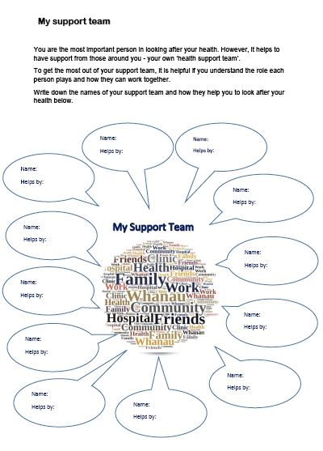
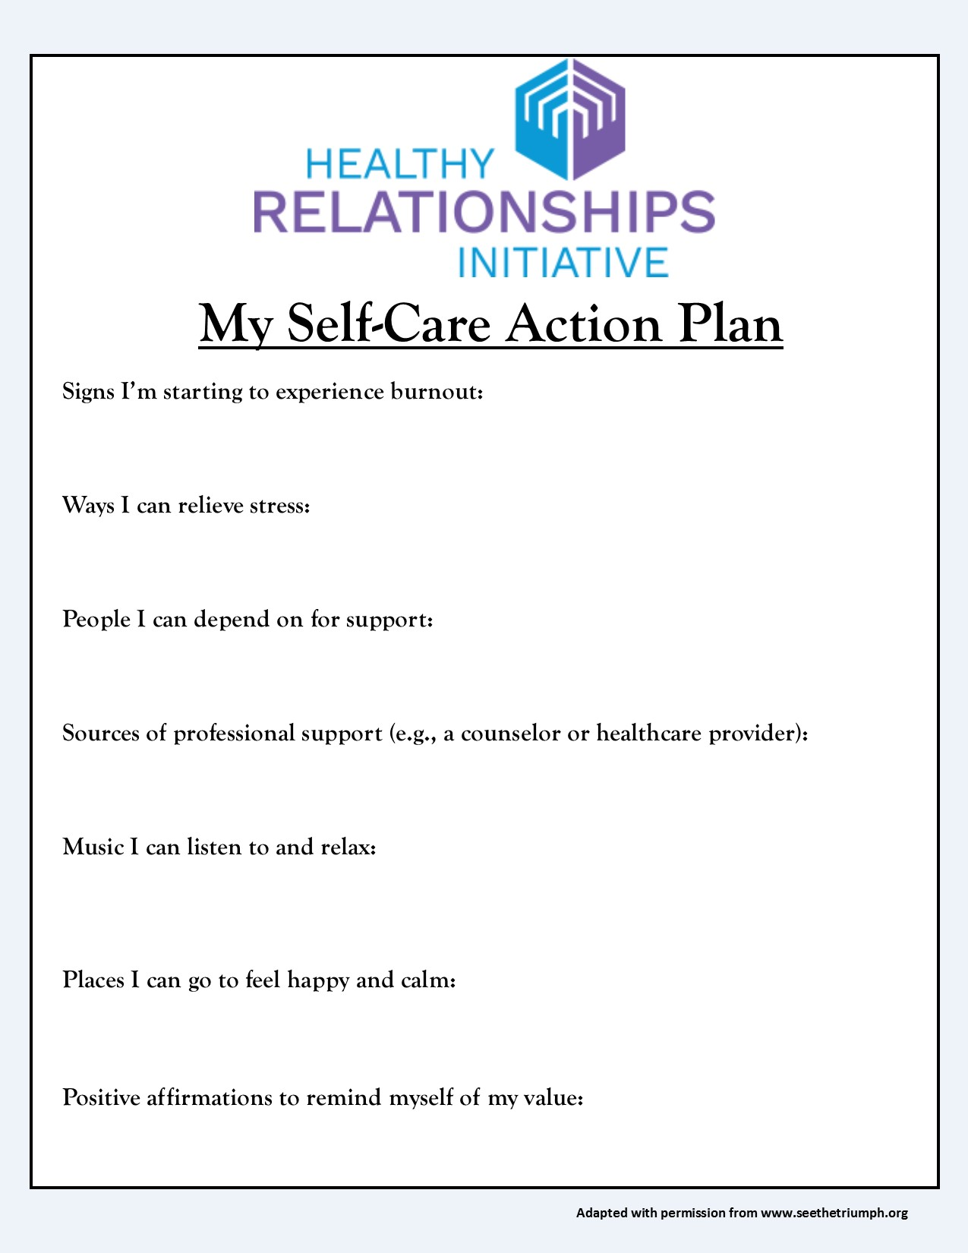

Professional Writing
Memo Worksheet
Instructions

You are the owner of a small company. You are organizing a ballgame and picnic in two weeks’ time for your employees and their families. There are many fun activities that you have planned for the children and adults including a three-legged race, kite-flying, and bingo. You are providing all the food and drinks, so your employees do not need to bring anything.

Write a memo requesting that employees attend the picnic. Ask your employees to let you know at least one week in advance whether they are coming or not, and how many guests they are bringing. Include any other information you think is relevant.

Memo:

Main Idea Worksheet
Exercise 1  Directions:  - Read the passage  - Create a title for the passage related to the main idea.  - Accurately summarize the text.  - Your summary must describe all key ideas from the text.  - Do not include opinions or personal info in your summary.  - Highlight or underline key ideas in each passage. | 
Picture this: a herd of elephants flies past you at sixty miles per hour, followed by a streak of tigers, a pride of lions, and a bunch of clowns. What do you see? It must be a circus train! One of the first uses of the circus train is credited to W.C. Coup. He partnered with P.T. Barnum in 1871 to expand the reach of their newly combined shows using locomotives. Before circus trains, these operators had to lug around all of their animals, performers, and equipment with a team of more than 600 horses. Since there were no highways, these voyages were rough and took a long time. Circuses would stop at many small towns between the large venues. Performing at many of these small towns was not very profitable. Because of these limitations, circuses could not grow as large as the imaginations of the operators. After they began using circus trains, Barnum and Coup only brought their show to large cities. These performances were much more profitable and the profits went toward creating an even bigger and better circus. Multiple rings were added and the show went on. Today, Ringling Bros. and Barnum and Bailey Circus still rely on the circus train to transport their astounding show, but now they use two.

- Passage Title:

- Main Ideas:

- Summary:

Exercise 2

Directions:

- Read the passage
- Create a title for the passage related to the main idea.
- Accurately summarize the text.
- Your summary must describe all key ideas from the text.
- Do not include opinions or personal info in your summary.
- Highlight or underline key ideas in each passage.

Electric trolley cars or trams were once the chief mode of public transportation in the United States. Though they required tracks and electric cables to run, these trolley cars were clean and comfortable. In 1922, auto manufacturer General Motors created a special unit to replace electric trolleys with cars, trucks, and buses. Over the next decade, this group successfully lobbied for laws and regulations that made operating trams more difficult and less profitable. In 1936 General Motors created several front companies for the purpose of purchasing and dismantling the trolley car system. They received substantial investments from Firestone Tire, Standard Oil of California, Phillips Petroleum, and other parties invested in the automotive industry. Some people suspect that these parties wanted to replace trolley cars with buses to make public transportation less desirable, which would then increase automobile sales. The decline of the tram system in North America could be attributed to many things—labor strikes, the Great Depression, regulations that were unfavorable to operators—but perhaps the primary cause was having a group of powerful men from rival sectors of the auto industry working together to ensure its destruction. Fill it up, please.

- Passage Title:

- Main Ideas:

- Summary:

Public Speaking and Active Listening
Bad Listening Habits

Below is a list of ten bad listening habits. Check the bad listening habits that apply to your own interactions. Be honest with yourself.

- I interrupt often or try to finish the other person’s sentence.
- I jump to conclusions.
- I am often overly parental and answer with advice, even when not requested.
- I make up my mind before I have all the information.
- I am a compulsive note taker.
- I don’t give any response afterward, even if I say I will.
- I am impatient.
- I lose my temper when hearing things I don’t agree with.
- I try to change the subject to something that relates to my own experiences.
- I think more about my reply while the other person is speaking than what he or she is saying.

How do you feel about the boxes you checked?
c
c
c
c

Which of these habits do you feel are particularly bad?
c
c
c
c

How do you feel when you are not listened to?
c
c
c
c

What can you do to be a better listener?
c
c
c
c

Conflict Resolution

Conflict Management Style?


Instructions: Listed below are 15 statements ‐ Each statement provides a possible strategy for dealing with a conflict. Give each
statement a numerical value – answering as you actually behave, not
as you think you should!
1=Always, 2=Very often, 3=Sometimes, 4= Not very often, 5= Rarely, if ever.)

____ a. I argue my case with peers, colleagues and coworkers to demonstrate the merits of the
position I take.
____ b. I try to reach compromises through negotiation.
____ c. I attempt to meet the expectation of others.
____ d. I seek to investigate issues with others in order to find solutions that are mutually
acceptable.
____ e. I am firm in resolve when it comes to defending my side of the issue.
____ f. I try to avoid being singled out, keeping conflict with others to myself.
____ g. I uphold my solutions to problems.
____ h. I compromise in order to reach solutions.
____ i. I trade important information with others so that problems can be solved together.
____ j. I avoid discussing my differences with others.
____ k. I try to accommodate the wishes of my peers and colleagues.
____ l. I seek to bring everyone's concerns out into the open in order to resolve disputes in the best possible way.
____ m. I put forward middles positions in efforts to break deadlocks.
____ n. I accept the recommendations of colleagues, peers, and coworkers.
____ o. I avoid hard feelings by keeping my disagreements with others to myself.

Scoring: The 15 statements you just read and rated are listed below under five categories. Each category contains the letters of three statements. Record the number you placed next to each statement. Calculate the total in each category by completing the column on the far right
Style |  |  |  | Total
Competing/Forcing Shark | a. _____ | e._____ | g. _____ | ______
Collaborating Owl | d. _____ | i. _____ | l. _____ | ______
Avoiding Turtle | f. _____ | j. _____ | o. _____ | ______
Accommodating Teddy Bear | c._____ | k. _____ | n. _____ | ______
Compromising Fox | b. _____ | h. _____ | m. _____ | ______
Results: My dominant style is _________________________________ ( Your LOWEST Score)
and my back‐up style is_______________________________ (Your second Lowest score)

Conflict Management Styles

The Competing Shark
- Sharks use a forcing or competing conflict management style
- sharks are highly goal‐oriented
- Relationships take on a lower priority
- Sharks do not hesitate to use aggressive behaviour to resolve conflicts
- Sharks can be autocratic, authoritative, and uncooperative; threatening and intimidating
- Sharks have a need to win; therefore others must lose, creating win‐lose situations
- Advantage: If the shark's decision is correct, a better decision without compromise can result
- Disadvantage: May breed hostility and resentment toward the person using it

- Appropriate times to use a Shark style
  - when conflict involves personal differences that are difficult to change
  - when fostering intimate or supportive relationships is not critical
  - when others are likely to take advantage of non‐competitive behaviour
  - when conflict resolution is urgent; when decision is vital in crisis
  - when unpopular decisions need to be implemented

The Avoiding Turtle
- Turtles adopt an avoiding or withdrawing conflict management style
- Turtles would rather hide and ignore conflict than resolve it; this leads them uncooperative and unassertive
- Turtles tend to give up personal goals and display passive behaviour creating lose‐lose situations
- Advantage: may help to maintain relationships that would be hurt by conflict resolution
- Disadvantage: Conflicts remain unresolved, overuse of the style leads to others walking over them

- Appropriate times to use a Turtle Style:
  - when the stakes are not high or issue is trivial
  - when confrontation will hurt a working relationship
  - when there is little chance of satisfying your wants
  - when disruption outweighs benefit of conflict resolution
  - when gathering information is more important than an immediate decision
  - when others can more effectively resolve the conflict
  - when time constraints demand a delay

The Accommodating Teddy Bear
- Teddy bears use a smoothing or accommodating conflict management style with emphasis on human relationships
- Teddy bears ignore their own goals and resolve conflict by giving into others; unassertive and cooperative creating a win‐lose (bear is loser) situation
- Advantage: Accommodating maintains relationships
- Disadvantage: Giving in may not be productive, bear may be taken advantage of

- Appropriate times to use a Teddy Bear Style
  - when maintaining the relationship outweighs other considerations
  - when suggestions/changes are not important to the accommodator
  - when minimizing losses in situations where outmatched or losing o when time is limited or when harmony and stability are valued

The Compromising Fox
- Foxes use a compromising conflict management style; concern is for goals and relationships
- Foxes are willing to sacrifice some of their goals while persuading others to give up part of theirs
- Compromise is assertive and cooperative‐result is either win‐lose or lose‐lose
- Advantage: relationships are maintained and conflicts are removed
- Disadvantage: compromise may create less than ideal outcome and game playing can result

- Appropriate times to use a Fox Style
  - when important/complex issues leave no clear or simple solutions
  - when all conflicting people are equal in power and have strong interests in different solutions
  - when there are no time restraints

The Collaborating Owl
- Owls use a collaborating or problem confronting conflict management style valuing their goals and relationships
- Owls view conflicts as problems to be solved finding solutions agreeable to all sides (win‐win)
- Advantage: both sides get what they want and negative feelings eliminated
- Disadvantage: takes a great deal of time and effort

- Appropriate times to use an Owl Style
  - when maintaining relationships is important
  - when time is not a concern
  - when peer conflict is involved
  - when trying to gain commitment through consensus building
  - when learning and trying to merge differing perspectives

