EXERCISE 36b-MULTIPLE SORT IN TABLES TUTORIAL (Starts at Step 4 on page 3)
Before we start- things to remember:
- What does sort mean?
- What kind of sorted information can we do in a table?
- What is a multiple sort?
- What is ascending and descending?
- What is a header row?
START WITH EXERCISE 33- HOW TO INSERT A TABLE TUTORIAL-(Steps (1-3)-pgs(1-2)
Step 1- First you need to insert a table. Go to the INSERT TAB/TABLE GROUP
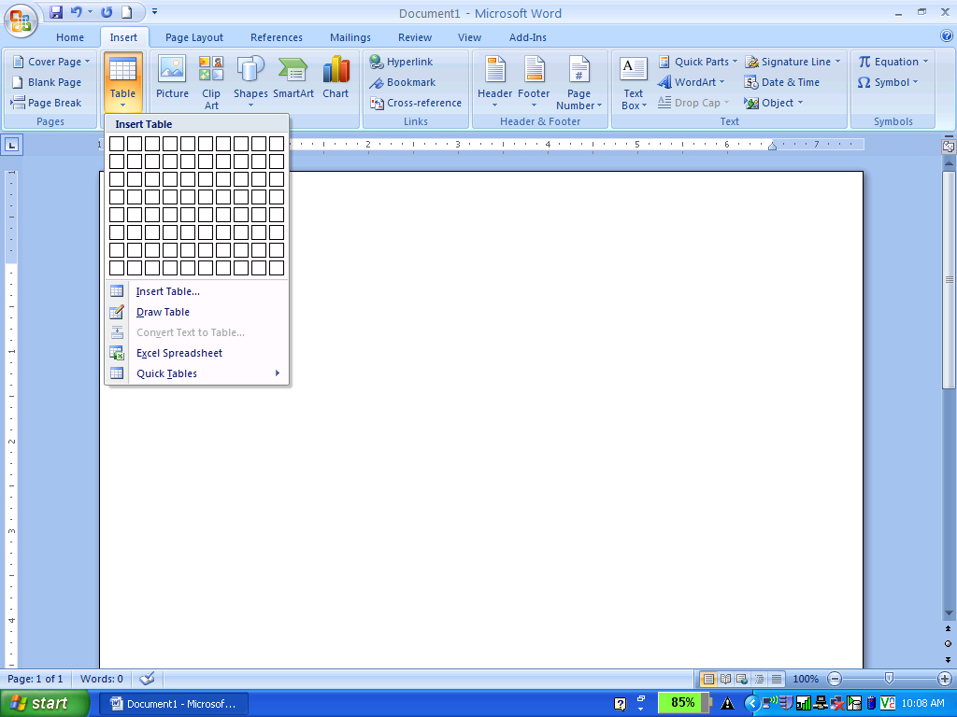
Step 2(One Option)- You can use the Grid to set the table- Here is a 5x4 Table.
5 x 4 is 5 Columns and 4 Rows- Remember Columns are Vertical and Rows are Horizontal
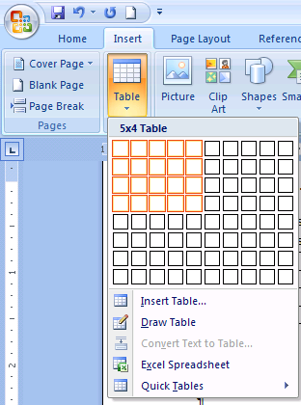
Step 2(Another Option)- You can also use the Insert Table button to enter your number of columns and number of rows.
- When you click on the Insert Table Button the Insert Table Dialog Box will Appear
- Enter your number of Columns and number of Rows then Click OK
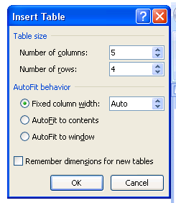

Step 3- Finished- Your table will appear and this is what it will look like.
Now you can begin to SORT or MULTIPLE SORT information in the table.
 | Student A | Student B | Student C | Student D
Practice Quiz #1 | 10 | 6 | 5 | 8
Practice Quiz #2 | 8 | 4 | 7 | 2
Practice Quiz #3 | 5
Total Sum | 18

Step 4- First Highlight the column in the Table that you want to sort. This will allow the Table Tools Tab to appear, then go to the Layout Tab.
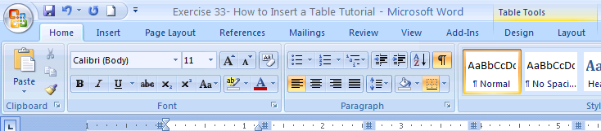

Step 5- In the Table Tools/Layout Tab find the SORT Button. You need to click on the SORT Button for sorting the data. There is only one button.
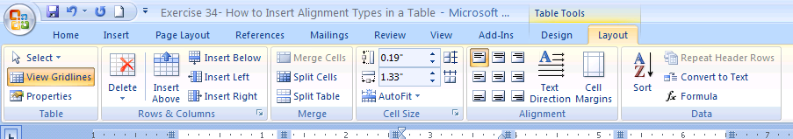

Step 6 - The Sort Dialog Box appears. You need to decide how you want to Sort. Try with the Whole Grains Bread Table Example.

Basket includes: | Regularly Priced:
1 bottle all natural white grape juice | $6.59
1 dozen specialty muffins | $15.99
1 tin granola | $10.99
2 8-ounce all natural fruit preserves | $12.99
5 organic pears | $5.99
TOTAL | $52.55

The SORT Dialog Box allows you to Multiple Sort. You can sort by Column 1 then by Column 2. Make sure to include the type and if you want ascending or descending. Also include that your table has a header row so that it doesn’t sort the header row.
