EXERCISE 45b- EDITING AN OUTLINE

Before we start- things to remember:

- Edit an Outline
  - How can we edit an outline?
  - What are Headings and Levels(1-9)?
  - What does promote and demote mean? Where are these buttons?
  - What does body text mean? Where are these buttons?
- Collapse and Expand an Outline
  - What does collapse and expand mean?
  - Where are the collapse and expand buttons?
- Number an Outline
  - What does it mean to number an outline?
  - Where is the number an outline button?
Step 1- First you need to create an outline. If you don’t know how to create an outline go back and review Exercise 45a MiniTutorial.
HOW TO PROMOTE/DEMOTE A LEVEL
In an Outline there are Levels(1-9). Level 1 is the highest and Level 9 is the lowest.
- To promote a level is to bring it up a level so Level 2 to Level 1 is a promotion.
- To demote a level is to bring it down a level so Level 1 to Level 2 is a demotion.
Notice that the first line of text is always Level 1. Also notice that to Demote a Level you have to click on the right arrow. To Promote a Level you have to click on the left arrow.
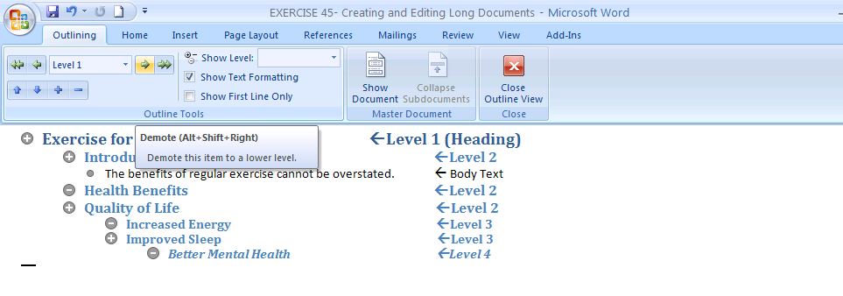
If you click on the double left arrow it turns the line of text into Level 1- Heading 1 the highest level.
If you click on the double right arrow it turns the line of text into Body Text with a bullet.
SYMBOLS IN AN OUTLINE

There are three outline symbols that are in front of each line of text:
an addition (+)
a subtraction (-),
and a bullet( • )

Each symbol has a meaning. Can you guess the meanings?
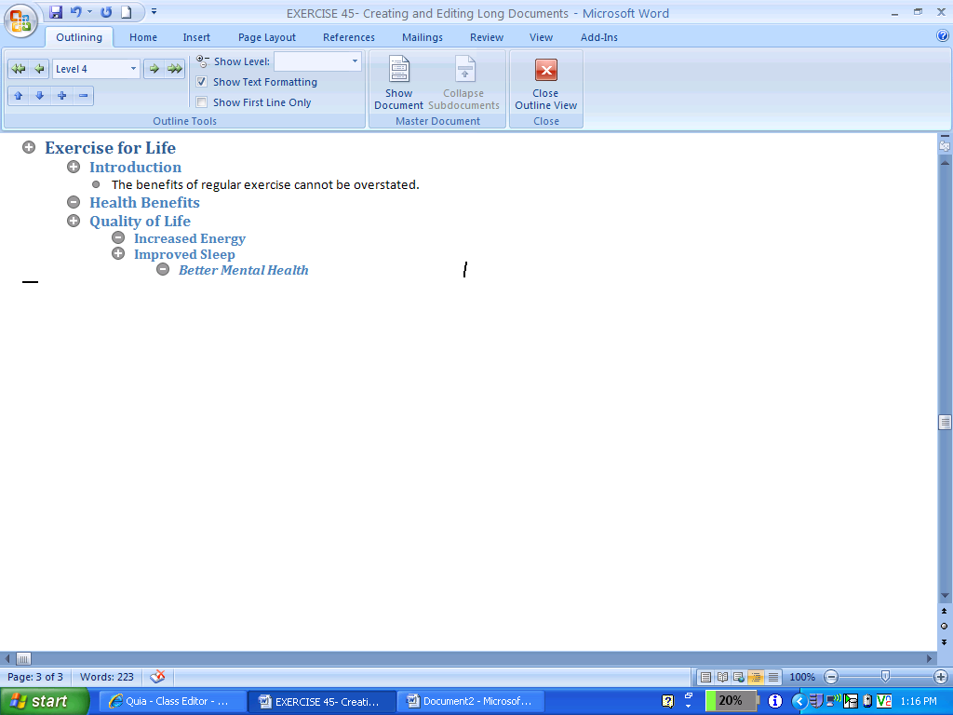

The (+) symbol means that the Level is a Heading because it has a sub level that is part of the level below it. If it has a (-) symbol it DOES NOT have a sub heading. See above and below.
- Increased Energy
+ Improved Sleep
- Better Mental Health
The bullet symbol ( • ) means that the line is a Body Text. Body Text is in black font by default.

