EXERCISE 33- HOW TO INSERT A TABLE TUTORIAL
Step 1- To insert a table go to the INSERT TAB/TABLE GROUP
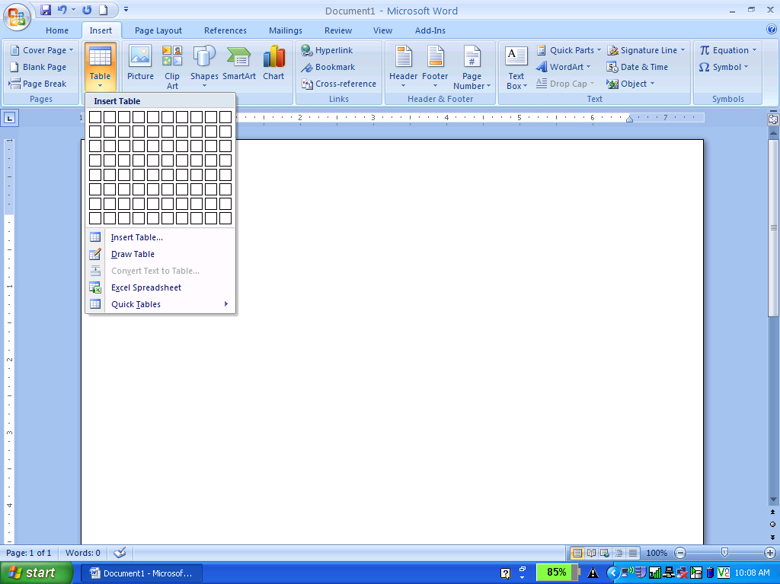
Step 2- You can use the Grid to set the table- Here you are opening a 5x4Table.
5 x 4 is 5 Columns and 4 Rows- Remember Columns are Vertical and Rows are Horizontal
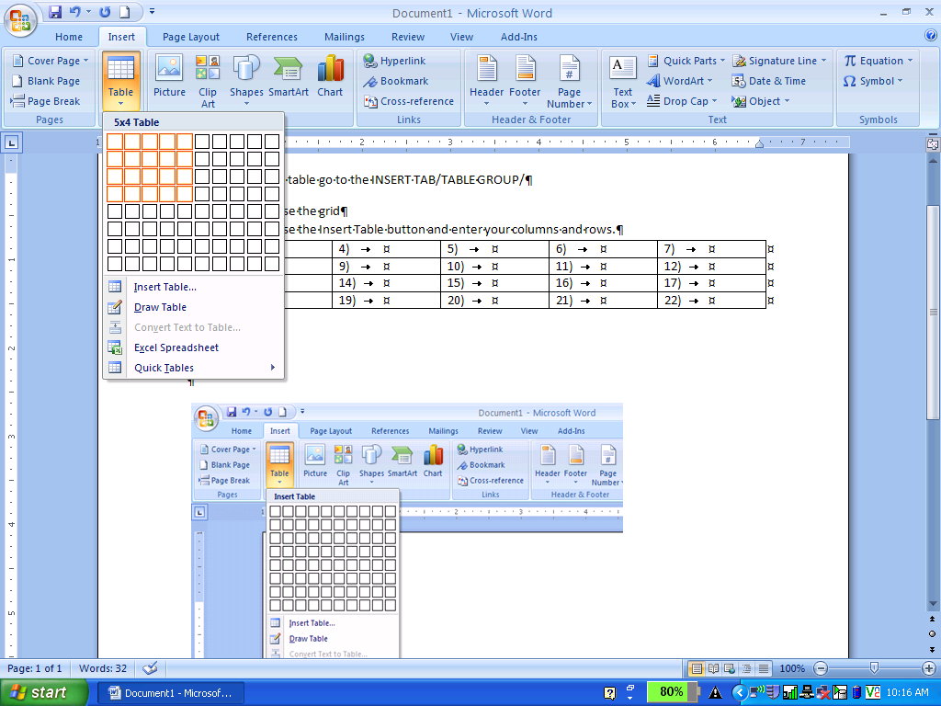
Step 2- You can also use the Insert Table button to enter your number of columns and number of rows.
- When you click on the Insert Table Button the Insert Table Dialog Box will Appear
- Enter your number of Columns and number of Rows then Click OK
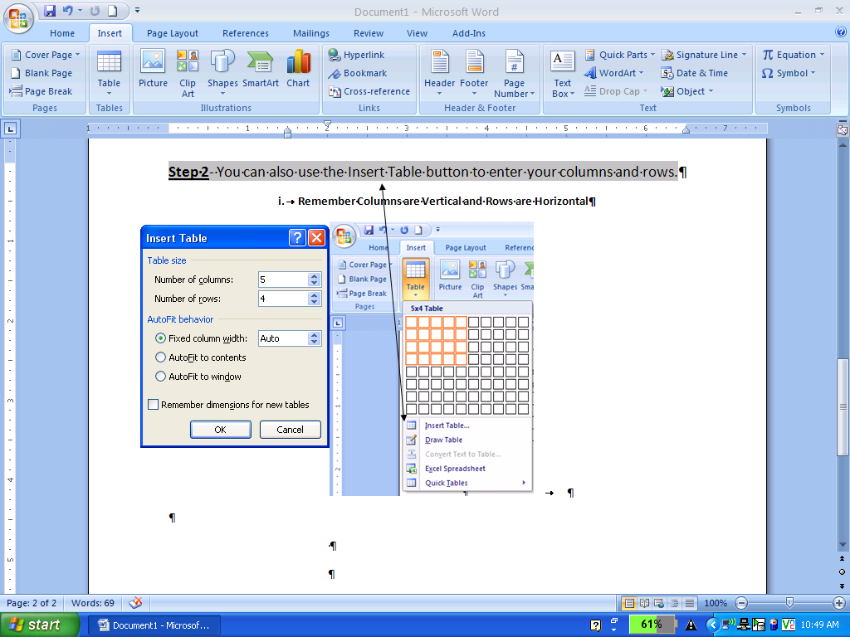

Step 3- Finished- Your table will appear and this is what it will look like.
Now you can begin to enter information in each cell of the table.

