EXERCISE 34- HOW TO CHANGE ALIGNMENT TYPES in a TABLE
Step 1- You must have a table already created. The table below is a 5x4 table. You must move the insertion point and click in a cell, or a row, or a column, or the whole table to have the Table Tools Tab appear on the Ribbon.

Step 2- Go to the Table Tools Tab on the Ribbon. Choose the Table Tools/Layout Tab.
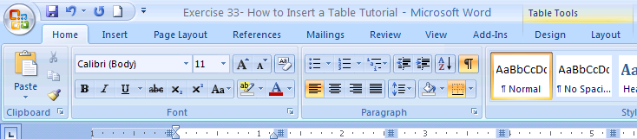
Step 3- Here is how you find the alignment buttons. In the Table Tools/Layout Tab find the Alignment Group. Here are the Nine Types of Alignments. There are nine buttons.
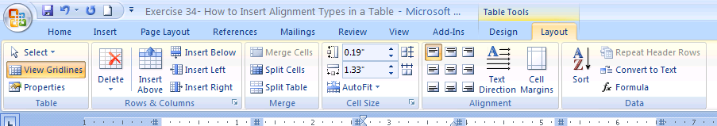
Last Things to Remember
- Decide what part of the table you want to align and highlight that part. (cell, row, column, whole table)
- Decide what alignment you want. Then click on that alignment button. (Top Left, Top Center, Top Right, Center Left, Center Center, Center Right, Lower Left, Lower Center, Lower Right)
- Alignments can be changed for one cell, one column, one row, or the whole table. This will align all of your information in that part of the table.

