EXERCISE 34b- HOW TO SET CELL MARGINS IN A TABLE
Some things to remember:
- Margins are the amount of empty space that is on a page or a cell at the top, bottom, left or right.
- Cells are the squares in a table.
- Cell Margins are the empty space on the top, bottom, left or right of a cell in a table.
- Question: What is the cell margin default measurements in a table?
Step 1- You must have a table already created. The table below is a 5x4 table. You must move the insertion point and click in a cell where you want to change the margin so that the Table Tools Tab appears on the Ribbon.

Step 2- Go to the Table Tools Tab that is now on the Ribbon. Choose the Table Tools/Layout Tab.
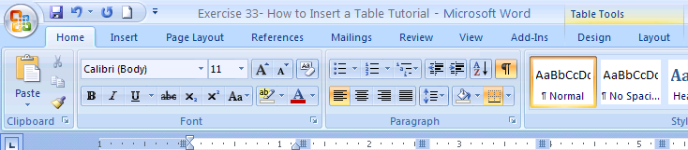
Step 3- Here is how you find the cell margins button. In the Table Tools/Layout Tab find the Alignment Group. Here is the button for adjusting the Cell Margin. There is only one button.
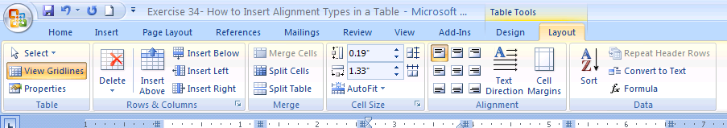
NEXT STEP-→ NEXT PAGE
Step 4 – When you click the following Cell Margin Dialog Box will appear. Make the changes to the margin sizes that you want then click OK to set these new margins for your cell. FINISHED!
