EXERCISE 34c- HOW TO ALIGN THE WHOLE TABLE ON A PAGE
Some things to remember:
- This only aligns the table to the left, center or right on the horizontal of the page. We will learn about vertical alignment in a later lesson.
Step 1- You must have a table already created. The table below is a 3x4 table. You must move the insertion point and click in a cell on the table so that the Table Tools Tab appears on the Ribbon. This table is aligned to the left of the page at this moment.

Step 2- Go to the Table Tools Tab that is now on the Ribbon. Choose the Table Tools/Layout Tab.
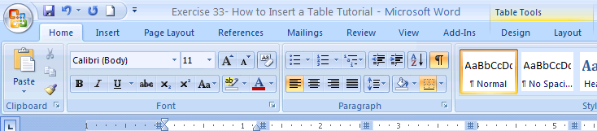
Step 3- Here is how you find the button to Align a Table on a Page. In the Table Tools/Layout Tab find the Table Group. You need to click on the Table Properties button for adjusting the whole Table. There is only one button.
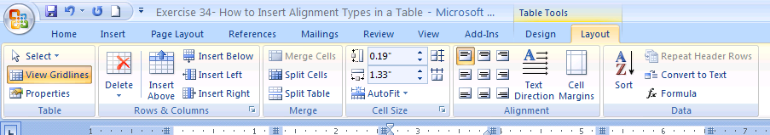

NEXT STEP-→ NEXT PAGE
Step 4 – When you click the button the Table Properties Dialog Box will appear. To align the whole Table to the (Left, Center or Right) of the page choose the alignment that you want then click OK to set.
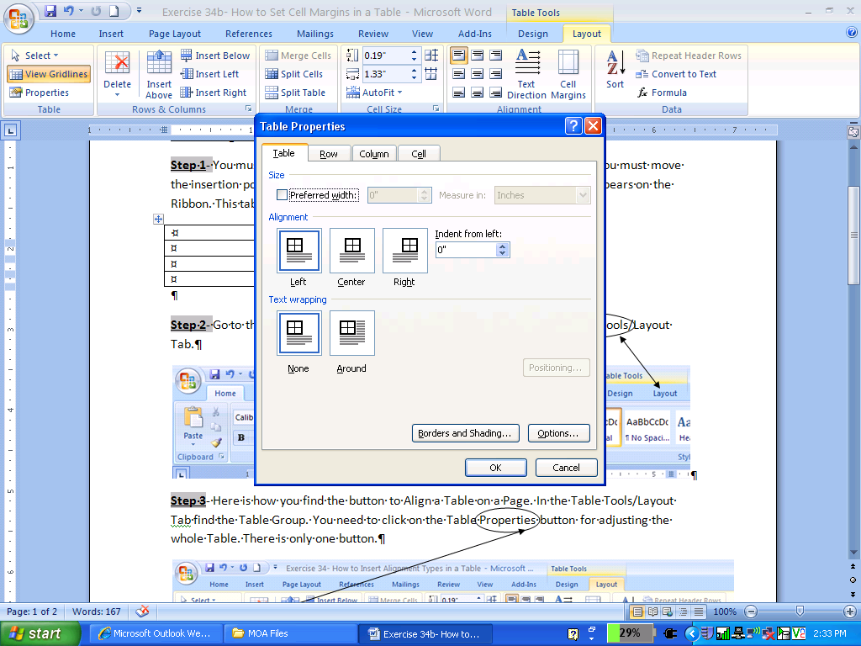
FINISHED! The Table from before is now Centered on the Page.

