EXERCISE 34d- HOW TO ADJUST THE COLUMN WIDTH AND ROW HEIGHT OF A TABLE
Some things to remember:
- Rows are horizontal and have a row height that increases or decreases depending on the amount of text that is in the cell on that row.
- Columns are vertical and the column width does not change.
- Row dividers are horizontal lines that divide rows.
- Column dividers are vertical lines that divide columns.
- You can also drag the dividers to do this lesson but this does not give you a precise width or height.

Step 1- You must have a table already created. The table below is a 3x4 table. You must select the row that you want to change. Then adjust the row height. After you must select the column that you want to change, then adjust the column height.
Question: What column width would change and what row height would change if we were changing the shaded area?

Step 2- Go to the Table Tools Tab that is now on the Ribbon. Choose the Table Tools/Layout Tab.
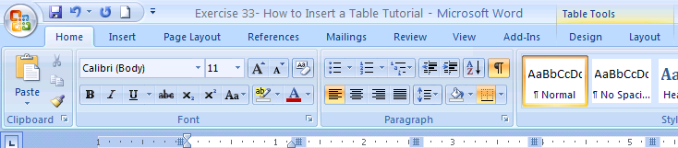

NEXT STEP-→ NEXT PAGE

Step 3- Here is how you find the button to adjust the number of the row height or column width. In the Table Tools/Layout Tab find the Cell Size Group. You need to click on the number itself or the up/down arrow to adjust the level.
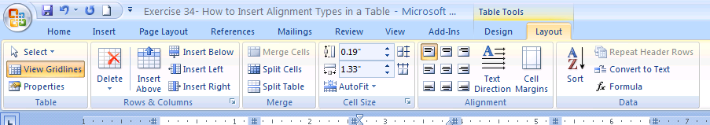

FINISHED! The Table from before now has a row height of 1.1 and a column width of 1.1 By the way this changed only the first row and second column.

