EXERCISE 35a- HOW TO DRAW A NEW TABLE OR IN AN EXISTING TABLE
Some things to remember:
- Tables don’t need to be drawn this is just another option.
Step 1- To draw a table go to the INSERT TAB/TABLE GROUP
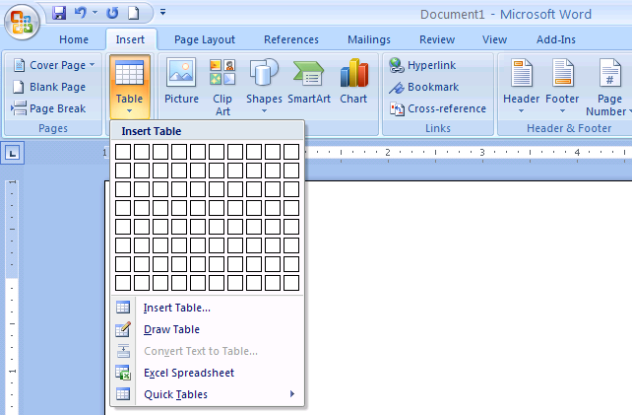
Step 2- Click on the Draw Table Button. This will change your insertion point to look like a pencil. Begin to draw the size of your table. Then draw down in a vertical motion to draw column dividers and draw across in a horizontal motion to draw row heights.

Step 3- To draw inside of an existing table. Click inside the table. Go to the Draw Table Button. This will change your insertion point to look like a pencil. Begin to draw the dividers inside the table.

EXERCISE 35b- HOW TO MOVE or RESIZE A TABLE

Step 1- To move a table, (like the one below) the table must already exist. The table below is a 4x3 or 4 columns/3 rows. The table has a table anchor and a sizing handle. Notice the boxes.

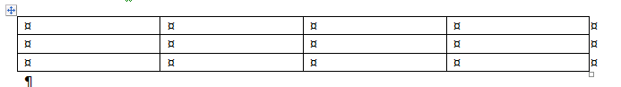
- To move a table (left- click on the table anchor and hold the mouse then release the table to the new position.
- To resize a table left click on the sizing handle and hold the mouse then release the mouse for the new size.

EXERCISE 35c- HOW TO MERGE/SPLIT CELLS IN A TABLE
Things to remember:
- Cells have dividers, when you merge two or more cells you are combining them or uniting them to become one cell.
Step 1-
- A table must already be created. Refer to Lesson 33 if you don’t know how to make a table. If you want to merge the shaded cells of the first row you will unite them.
- Click in the table to active the Table Layout button
- Select the cells that you want to merge.
- Follow Step 2 on the next page.
Step 2- Go to the Table Tools Tab on the Ribbon. Choose the Table Tools/Layout Tab.

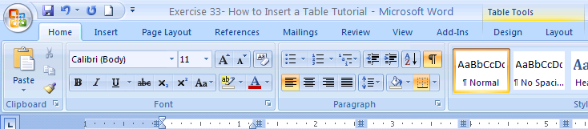

Step 3- Locate the Merge Button on the Merge Group. Notice that this button will only be activated if you highlight the cells that you will merge.
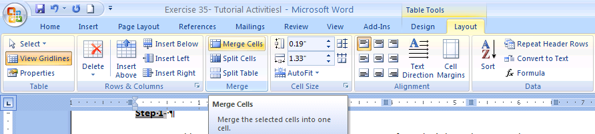
FINISHED- The table now has the two shaded cells merged as one.
FINISHED- To return to two squares from one repeat the same step as before. Except click on split cells and decide how many rows and columns you want from the Split Cells Dialog Box that appears.
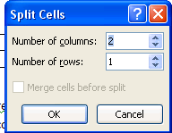 In this case to have the c ells return to the normal appearance you need 2 columns and 1 row. But it does not always happen this way.
EXERCISE 35d- HOW TO ROTATE TEXT IN CELLS OF A TABLE
Things to remember:
- You must click on the cell where you want to rotate the text.
Oooooo

Step 1- Go to the Table Tools Tab on the Ribbon. Choose the Table Tools/Layout Tab.

Step 2- Go to the Text Direction Button in the Alignment Group in Layout. Everytime you click this button it changes the direction of the text that will be typed. There are only three directions. After you change the direction start typing. FINISHED!

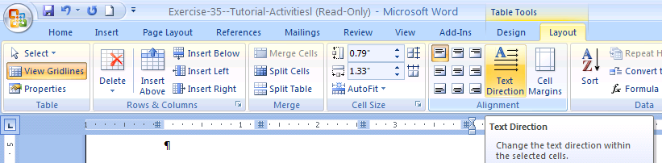

EXERCISE 35e- HOW TO WRAP TEXT AROUND A TABLE
Things to remember:
- You must create the Table so that you can then wrap text around it.

Step 1- Go to the Table Tools Tab on the Ribbon. Choose the Table Tools/Layout Tab.

Step 2- Go to the Properties button in the Table Tools Layout Tab and this will show the
Table Properties Dialog Box. Click Around to have Text Wrapping to go around the Table. Then Click Ok.
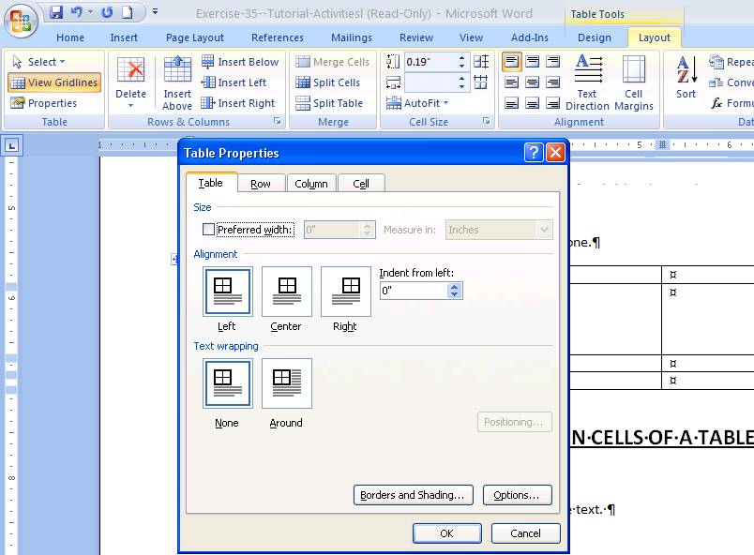FINISHED

