EXERCISE 36-HOW TO DO CALCULATIONS IN TABLES TUTORIAL
(Starts at Step 4 on page 3)
START WITH EXERCISE 33- HOW TO INSERT A TABLE TUTORIAL-(Steps (1-3)-pgs(1-2)
Step 1- First you need to insert a table. Go to the INSERT TAB/TABLE GROUP

Step 2(One Option)- You can use the Grid to set the table- Here is a 5x4 Table.
5 x 4 is 5 Columns and 4 Rows- Remember Columns are Vertical and Rows are Horizontal
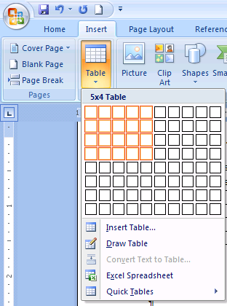
Step 2(Another Option)- You can also use the Insert Table button to enter your number of columns and number of rows.
- When you click on the Insert Table Button the Insert Table Dialog Box will Appear
- Enter your number of Columns and number of Rows then Click OK
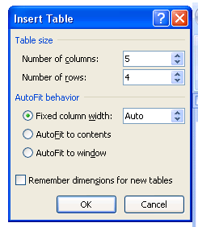

Step 3- Finished- Your table will appear and this is what it will look like.
Now you can begin to enter information in each cell of the table.

Step 4- First Click in the Table at the cell where you want the total to display. This will allow the Table Tools Tab to appear, then go to the Layout Tab.
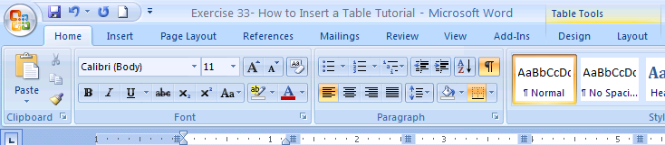
Step 5- In the Table Tools/Layout Tab find the Formula Button. You need to click on the Formula Button for entering the Formula. There is only one button.
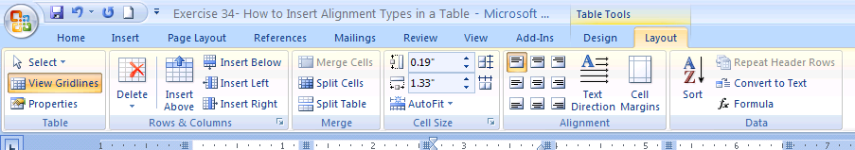
Step 6 - The Formula Dialog Box appears. You need to enter the Formula after the equal sign.
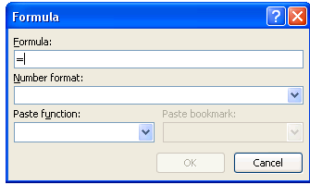
Step 6 – To enter the formula for ADDING go to the Paste Function Drop Down Menu at SUM.
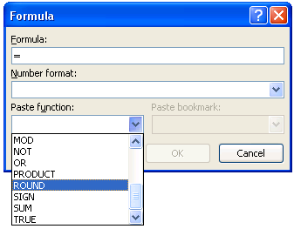
Step 7 – When you click on SUM it will take you back to the Formula section. You see SUM()
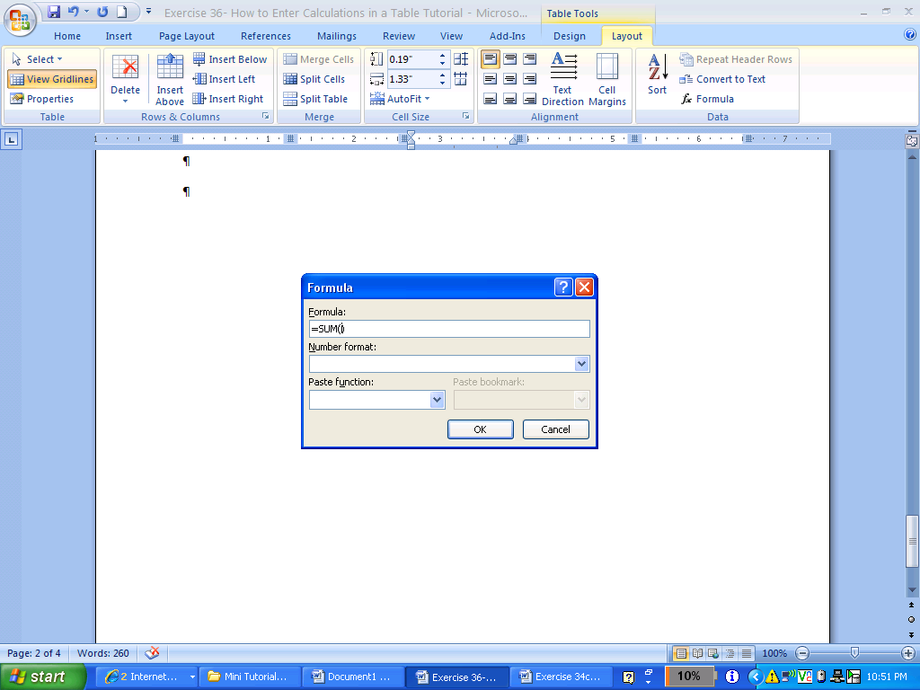
Step 7 – Here you need to enter the positions of the cells that you want to add. You need to understand how basic spreadsheets from Excel work with the position of cells in a Table.
Each Column is labeled with a letter. Column A is (1), Column B is (2), Column C is (3), Column D is (4), Column E is (5). Each Row is a number Row 1, Row 2, Row 3, Row 4.
This is like a Spreadsheet in Excel.

Recall that the table we created before had 5 Columns and 4 rows. Like the Spreadsheet above.
Question: If we want to add the two Quiz Grades for Student A to have a total, what will be the two cells that we will add up?
 | Student A | Student B | Student C | Student D
Practice Quiz #1 | 10 | 6 | 5 | 8
Practice Quiz #2 | 8 | 4 | 7 | 2
Total Sum | 18

You enter = SUM(B2:B3) This function tells you that you will sum the positions of B2 and B3. Word may give you = SUM(ABOVE) This also works.
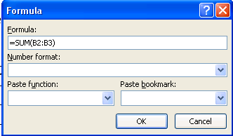
Step 8 – If you enter another Quiz Score Row and you want to Update the Total you need to
Right Click on the Total Cell and Choose update Field. Look at the Picture Below. Do it Here.
 | Student A | Student B | Student C | Student D
Practice Quiz #1 | 10 | 6 | 5 | 8
Practice Quiz #2 | 8 | 4 | 7 | 2
Practice Quiz #3 | 5
Total Sum | 18

