EXERCISE 45a- CREATING AN OUTLINE
Before we start- things to remember:
- Create an Outline
  - What is an outline?
  - Where is the outline view?
Step 1- First you need to go to outline view. There are two ways to do this. FIRST
Click View Tab on the Ribbon. See Below.
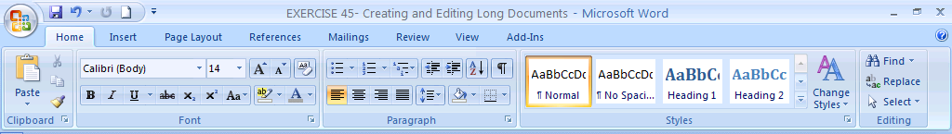
On the View Tab click on Outline View. See Below.
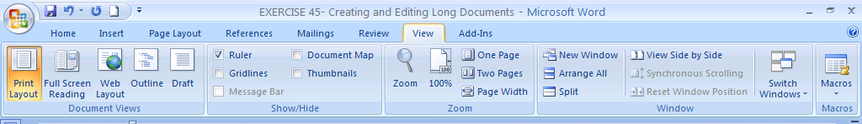
The Outline View Ribbon will Appear. It looks like the ribbon below. Can you see a Outline Tab?
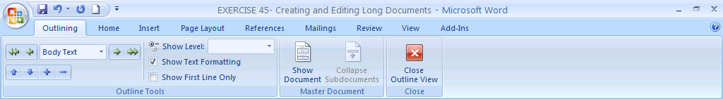
To Close the Outline View and return to the Normal View Click the Red X Button. Now we will see the Second Way.
SECOND WAY TO OPEN OUTLINE VIEW
When you open a new document or saved document it opens in the default mode view of Print Layout. Click the Outline Icon on the Status Bar to change view to Outline View. See Below.
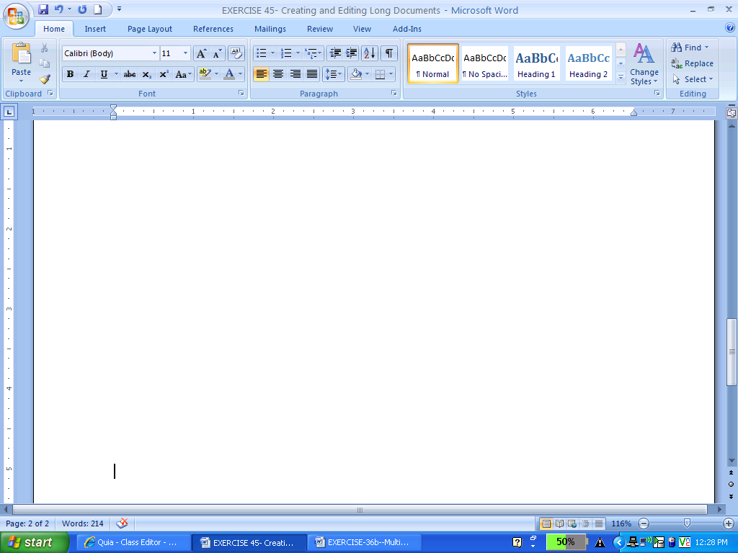

In the Outline View you can create outlines like the one below. This is also in your book on page 253
.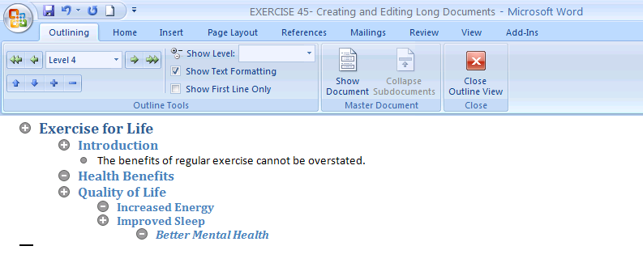
When you create an Outline in Outline View the text can also be viewed on the document in the Normal View. Notice how the same Outline from above looks in Normal View below.

Exercise for Life

Introduction
The benefits of regular exercise cannot be overstated.

Health Benefits

Quality of Life

Increased Energy

Improved Sleep

Better Mental Health

