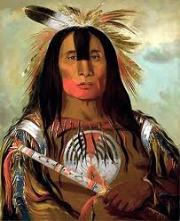

Learn about them today!

Natives American of the East
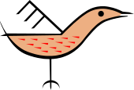
Native Americans
of the East


Mrs. Kushner
Mrs. Farrar
Design By:
Read on to find out exciting information about our group.
Caption describing picture or graphic.

Caption describing picture or graphic.

This area can be used as a summary or an important/interesting fact that you would like to share with your reader.

Lifestyle
Write important information here…

Native Americans of the East

Food
Write important info here….

Housing
Write important info here….

