Make Your Own Slime
- Fill one small cup with water and add a spoonful of Borax powder. Stir. Set to the side.
- Fill the other cup with about 1 inch of glue.
- Add 3 tablespoons of water to the glue and stir.
- Add 3 drops of food coloring and stir it up until mixed.
- Add 1 tablespoon of the Borax solution you made earlier and stir well. Watch the slime form!
- After the slime forms, let it sit for about 30 seconds and then pull it off the spoon and play with it!
Make Your Own Oobleck
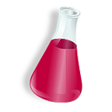
- Put 4 tablespoons of cornstarch in your cup.
- Add 2 tablespoons of water to your cornstarch and stir.
- Add 3 drops of food coloring to your mixture and stir.
- Play with your Oobleck, but try to keep it over the cup as much as possible.

