The Early Cold War

Useful Websites for The Cold War:
1) http://www.spartacus.schoolnet.co.uk/ColdWar.htm
2) http://www.gilderlehrman.org/teachers/module20/index.html
3) http://www.course-notes.org/US_History/Unit_Notes/Unit_Nine_1940_1960
4) http://www.course-notes.org/Vocabulary/Chapter_39_The_Cold_War_Begins
5) http://www.course-notes.org/Vocabulary/Chapter_40_The_Eisenhower_Era

Enduring Understandings:

Students will understand that …

1. International conflict often leads to strong disagreements regarding isolation and intervention.
2. The government often reinterprets the rights and liberties of citizens when the nation faces a major threat.
3. American foreign policy is motivated by both pragmatism and idealism.

Essential Questions:

1. How did America become a superpower?
2. What impact do challenges abroad have on Americans at home?
3. Did America’s involvement in World War II and the Cold War move it closer or further away from its founding
ideals?

Knowledge:

All Students will know …

1. How did American become a superpower?
a. Origins of the Cold War and the advent of nuclear politics.
b. The Cold War was an ideological conflict where the United States and the Soviet Union did not fight
each other directly but tried to block each other’s goals around the globe.
c. U.S. response to communism in China, Korea, and Cuba, including the Cuban Missile Crisis.
d. Change from confrontation to coexistence between the Soviet Union and the United States.

2. What impact do challenges abroad have on Americans at home?
a. Military experiences and how they fostered American identity and interactions among people of diverse
backgrounds.
b. The rise and fall of McCarthyism, its effects on civil liberties, and its repercussions.

3. Did America’s involvement in World War II and the Cold War move it closer or further away from its founding
ideals?
a. How the ideals of liberty, equality, opportunity, rights and democracy were exemplified or contradicted
during this time.

Advanced Students will know …
1. George Kennan and the policy of Containment.
2. Growth in the military industrial complex.

Cold War Conflicts
(Chapter 18 and Chapter 20, Section 1)

Source: The Americans Power Point Cd-Rom

Overview:
The Cold War and the danger of nuclear war define international affairs especially after the Korean War. Fear of
communism in the U.S. leads to accusations against innocent citizens.

I. Section 1: Origins of the Cold War

The United States and the Soviet Union emerge from World War II as two “superpowers” with vastly different
political and economic systems.

Superpowers: “The world powers after WWII created a new balance of power. These superpowers
consisting of the United States, the Soviet Union, and Great Britain began proceedings
such as the Yalta and Potsdam. Conferences represented the superpowers and their
importance in postwar reconstruction.”
(http://www.course-notes.org/US_History/Unit_Notes/Unit_Nine_1940_1960/Origins_of_the_Cold_War)

“Although relations with the Soviet Union were already strained, Roosevelt’s death and the beginning of Truman’s presidency brought new tensions to the relationship. Russia’s traditional paranoia led to the establishment of a communist satellite buffer zone around the USSR. The spread of communism into Asian and South American countries fueled anticommunist feelings in the United States and added to the pressure for increased buildup of defensive (military) forces.” (http://www.course-notes.org/US_History/Unit_Notes/Unit_Nine_1940_1960/Origins_of_the_Cold_War)

A. Former Allies Clash
1. U.S.-Soviet Relations
a. U.S., U.S.S.R. have very different economic, political systems
b. U.S. suspicious of Stalin because he had been Hitler’s ally
c. Stalin resents that U.S. delayed attacking Germany and hid atom bomb

2. The United Nations
a. 1945, United Nations established as new peacekeeping body
b. UN becomes arena where U.S., U.S.S.R. compete

3. Truman Becomes President
a. Harry S. Truman succeeds FDR as president
b. As vice-president, Truman was not included in policy decisions
- was not told about atom bomb
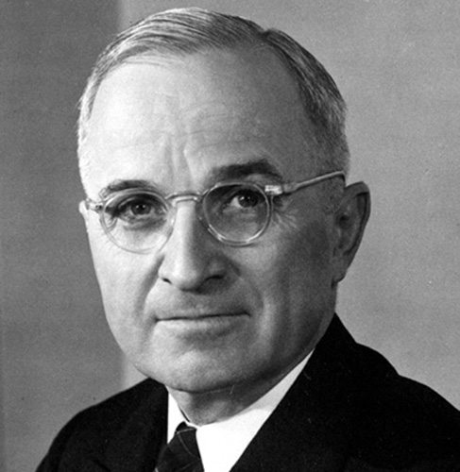 President Harry S. Truman
4. The Potsdam Conference
a. July 1945 conference with U.S., Great Britain, Soviet Union
b. Stalin does not allow free, multiparty elections in Poland
- bans democratic parties

B. Tension Mounts
1. Bargaining at Potsdam
a. Truman becomes convinced that U.S., Soviet aims deeply at odds
b. Soviets want reparations from Germany; Truman objects
c. Agree to take reparations mainly from own occupation zones
d. U.S. emerges from war as great economic power
- wants Eastern European raw materials, markets
2. Soviets Tighten Their Grip on Eastern Europe
a. Soviet Union also has great economic, military strength
b. Unlike U.S., Soviet Union suffered heavy devastation on own soil
c. Installs communist rule in satellite nations, countries it dominates

1. satellites: The countries surrounding the Soviet Union created a buffer zone between
Russia and the rest of Europe. These "satellites" were nations conquered by the Soviet Union during the counteroffensive attack of the Russians against the Germans during WWII.” (http://www.course-notes.org/US_History/Unit_Notes/Unit_Nine_1940_1960/Origins_of_the_Cold_War)

d. 1946, Stalin announces war between communism, capitalism inevitable

3. United States Establishes a Policy of Containment
a. U.S. policy of containment—measures taken to prevent spread of communism
1. creator was George F. Kennan, Foreign Policy Advisor to the President
a. “theory of containment was accepted by the U.S. government and was demonstrated
through the domino theory and US actions in Vietnam and Korea”
(http://www.course-notes.org/US_History/Unit_Notes/Unit_Nine_1940_1960/Origins_of_the_Cold_War)

b. Churchill describes division of Europe as iron curtain

Primary Source: A Speech by Winston Churchill At Fulton, Missouri, March 1946

“From Stettin in the Baltic to Trieste in the Adriatic, an iron curtain has descended (fallen) across the continent. Behind that line lie all the capitals of the ancient states of Central and Eastern Europe – Warsaw, Prague, Vienna, Budapest, Belgrade, Bucharest and Sofia. All these lie in the Soviet Sphere and all are subject to a very high and increasing measure of control from Moscow.” (http://www.palgrave.com/masterseries/lowe/questions/Q12.htm)
A British cartoon of March 1946 showing Winston Churchill trying to peer under Joseph Stalin's 'iron curtain'. (http://www.palgrave.com/masterseries/lowe/questions/Q12.htm)
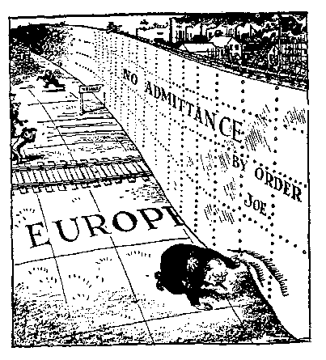

C. Cold War in Europe

1. The Truman Doctrine
a.1945–1991 Cold War—conflict between U.S., U.S.S.R.
- neither nation directly confronts the other on battlefield

b. Truman Doctrine—support against armed minorities, outsiders
1. “From Truman’s address to Congress on March 12, 1947, the president announced that the United States would assist free people resisting "armed minorities or...outside pressure." Meant as a offer for aid against communism the Truman Doctrine established the United States as a global policeman, a title proved by US actions in the UN, Vietnam, Korea and Egypt. The Truman Doctrine became a major portion of Cold War ideology, a feeling of personal responsibility for the containment of communism.” (http://www.course-notes.org/US_History/Unit_Notes/Unit_Nine_1940_1960/Origins_of_the_Cold_War)

c. U.S. replaces British aid to Greece, Turkey; reduce communist threat

Primary Source: A Speech by President Truman in March 1947

“One way of life is based upon the will of the majority with free institutions, elected
government, free elections, guarantees of individual liberty …
The second way of life is based upon the will of the minority forced upon the majority. It
relies upon terror and repression, a controlled press and radio, fixed elections …
I believe that it must be the policy of the USA to support free peoples who are resisting
the attempt by armed minorities or by outside pressure to control them.”
(http://www.palgrave.com/masterseries/lowe/questions/Q12.htm)

2. The Marshall Plan
a. 1947, Sec. of State George Marshall proposes aid to nations in need
1. “Truman's Secretary of State George C. Marshall proposed massive economic aid to Greece and Turkey in 1947 after the British told the US they could not afford to continue assistance to the governments of Greece and Turkey against Soviet pressure for access to the Mediterranean. The Marshall Plan was expanded to mass economic aid to the nations of Europe for recovery from WWII. Aid was rejected by communist nations. The Marshall Plan also hope to minimize suffering to be exploited by communist nations.” (http://www.course-notes.org/US_History/Unit_Notes/Unit_Nine_1940_1960/Origins_of_the_Cold_War)

b. Marshall Plan revives 16 nations; Communist parties less appealing

D. Superpowers Struggle over Germany

1. The Berlin Airlift
a. 1948, Stalin closes highway, rail routes into West Berlin
b. Berlin airlift—Britain, U.S. fly food, supplies into West Berlin
c. 1949, Stalin lifts blockade
d. Federal Republic of Germany, German Democratic Republic form

2. The NATO Alliance
a. Fear of Soviets leads to North Atlantic Treaty Organization (NATO)
b. European nations, U.S., Canada pledge mutual military support
1. “on October 1948, Denmark, Italy, Norway, and Poland joined the Canadian-US negotiations for mutual defense and mutual aid. The North Atlantic Treaty was signed in Washington on April 4, 1949 creating the North Atlantic Treaty Organization. The organization considered an attack against one member of the alliance, an attack on all.” (http://www.course-notes.org/US_History/Unit_Notes/Unit_Nine_1940_1960/Origins_of_the_Cold_War)

II. Section 2: The Cold War Heats Up

After World War II, China becomes a communist nation and Korea is split into a communist north and a democratic south.

A. China Becomes a Communist Country

1. Nationalists Versus Communists
a. Chinese Communists battle nationalist government of Chiang Kai-shek
b. U.S. supports Chiang, but his government is inefficient, corrupt
c. Communists, led by Mao Zedong, work to get peasant support
d. Peasants flock to Red Army; by 1945, communists control north China

2. Renewed Civil War
a. 1944–47, U.S. sends military aid to Nationalists to oppose communism
b. 1949, Nationalists flee to island of Taiwan
c. Communists establish People’s Republic of China in mainland
d. U.S. does not recognize Communist Chinese government

3. America Reacts to Communist Takeover
a. U.S. public stunned by Communist takeover
b. Conservatives blame Truman for not sending enough aid

B. The Korean War

1. A Divided Country
a. 38th parallel (38° N latitude) divides Japanese surrender in Korea
b. North of 38th parallel surrenders to U.S.S.R.; south to U.S.
c. Republic of Korea, Democratic People’s Republic of Korea founded

2. North Korea Attacks South Korea
a. 1950, North Korea invades South, begins Korean War
b. South Korea calls on UN to stop invasion; Security Council approves
c. MacArthur put in command of South Korean, U.S., other forces

C. The United States Fights in Korea

Summary: Korean War, limited war

“After Japan's defeat in 1945, Korea was divided at the 38th parallel between Soviet troops to the north and the People's Democratic Republic and US troops to the south. June 24, 1950 North Korean troops attacked the Republic of Korea, provoking war. US gained UN approval to stop the considered communist domino. The "limited" war was to hold the 38th parallel without beginning WWIII. A cease fire was installed on July 26, 1953.”
(http://www.course-notes.org/US_History/Unit_Notes/Unit_Nine_1940_1960/Origins_of_the_Cold_War)

1. MacArthur’s Counterattack
a. North Korea drives south, captures Seoul
b. UN, South Korean troops forced into small defensive zone
c. MacArthur attacks North Koreans from 2 sides, pushes into north

2. The Chinese Fight Back
a. China sends troops to help North Korea; push south, capture Seoul
b. Fighting continues for 2 more years

3. MacArthur Recommends Attacking China
a. MacArthur calls for war with China; Truman rejects request
b. Soviet Union, China have mutual assistance pact
c. UN, South Korea retake Seoul, advance north to 38th parallel

4. MacArthur Versus Truman
a. MacArthur continues to push for invasion of China; Truman fires him
b. Public outraged over hero’s dismissal
c. Congressional committee investigation concludes Truman right

5. Settling for Stalemate
a. 1951, Soviet Union suggests cease-fire
b. 1953 armistice: Korea still divided; demilitarized zone established
c. Lack of success, high human, financial costs help elect Eisenhower

III. Section 3: The Cold War at Home

During the late 1940s and early 1950s, fear of communism leads to reckless charges against innocent citizens.

A. Fear of Communist Influence

1. American Sentiments (Feelings/Beliefs)
a. Communist takeover of Eastern Europe, China fuel fear of its spread
b. 100,000 in U.S. Communist Party; some fear may be loyal to U.S.S.R.

2. Loyalty Review Board
a. Truman accused of being soft on Communism
b. Sets up Federal Employee Loyalty Program to investigate employees
c. 1947–1951 loyalty boards investigate 3.2 million, dismiss 212

3. The House Un-American Activities Committee (HUAAC)
a. House Un-American Activities Committee investigates Communist ties
1. “FDR established this organization to serve as a platform to the denunciation of the New Deal and communism growth in the U.S. Used to investigate and expose communist influence in America and blurred the line between dissent and disloyalty. It also brought about hysteria and caused blacklisting to occur so that people considered to be "communists" never found work.”
(http://www.course-notes.org/US_History/Unit_Notes/Unit_Nine_1940_1960/McCarthyism)

b. Investigates Communist influence in movie industry
c. Hollywood Ten refuse to testify, sent to prison
d. Hollywood blacklist—people with Communist ties, cannot get work

4. The McCarran Act
a. Act—unlawful to plan action that might lead to totalitarianism
1. “Required all organizations that were believed to be communist by the attorney general to submit a roster of the members and financial statements to the Department of Justice. It also excluded communists from working in defense plants, passports to communists and deported aliens suspected of subversion.”
(http://www.course-notes.org/US_History/Unit_Notes/Unit_Nine_1940_1960/McCarthyism)

b. Truman vetoes, says violates free thought; Congress overrides veto

B. Spy Cases Stun the Nation

1. Alger Hiss
a. Alger Hiss accused of spying for Soviet Union; convicted of perjury
b. Congressman Richard Nixon gains fame for pursuing charges

2. The Rosenbergs
a. 1949, Soviets explode atomic bomb sooner than expected
b. Physicist Klaus Fuchs admits giving information about U.S. bomb
c. Ethel, Julius Rosenberg, minor Communist Party activists, implicated
d. Rosenbergs sentenced to death; Supreme Court upholds conviction

C. McCarthy Launches His “Witch Hunt”

Summary: “As a result of the recent escalation of the Cold War and the spread of communism throughout the world, domestic paranoia concerning communist infiltration increased. This laid the foundation for the investigations of the House Un-American Activities Committee. Taking advantage of this "Red Scare" was Senator Joseph McCarthy who used the fear and panic of United States citizens to advance his own interests. Though many Americans believed the investigations were wrong, few said anything.”
(http://www.course-notes.org/US_History/Unit_Notes/Unit_Nine_1940_1960/McCarthyism)

1. McCarthy’s Tactics
a. Senator Joseph McCarthy a strong anti-Communist activist
b. Ineffective legislator; needs issue to win reelection
c. McCarthyism—attacking suspected Communists without evidence
d. McCarthy claims Communists in State Department
e. Few Republicans speak out; think he has winning strategy for 1952

2. McCarthy’s Downfall
a. 1954, McCarthy accuses members of U.S. Army
b. Televised hearings show him bullying witnesses
c. Loses public support; Senate condemns him for improper conduct

3. Other Anti-Communist Measures
a. States, towns forbid speech favoring violent overthrow of government
b. Millions forced to take loyalty oaths, are investigated
c. People become afraid to speak out on public issues

IV. Section 4: Two Nations Live on the Edge

During the 1950s, the United States and the Soviet Union come to the brink of nuclear war.

A. Brinkmanship Rules U.S. Policy

1. Race for the H-Bomb
a. H-bomb—hydrogen bomb—nuclear weapon more powerful than atom bomb
b. 1952, U.S. explodes first H-bomb; 1953, Soviets explode one

2. The Policy of Brinkmanship
a. John Foster Dulles, secretary of state under Dwight D. Eisenhower
b. Dulles proposes brinkmanship policy:
1. willingness to risk nuclear war to prevent spread of communism
a. “caused considerable controversy during the Cold War. Dulles declared that the United States must be prepared to "go to the brink" of war in order to attain its objectives. This stance was labeled brinksmanship.”
(http://www.course-notes.org/US_History/Unit_Notes/Unit_Nine_1940_1960/Eisenhower_and_the_1950s)

c. Nuclear threat unlike any before: millions can die; nation prepares

B. The Cold War Spreads Around the World

1. Covert Actions in the Middle East and Latin America
a. Central Intelligence Agency (CIA) uses spies to gather information
b. CIA helps oust Iranian prime minister, reinstate Shah
c. CIA helps depose Guatemala’s president; army leader becomes dictator

2. The Warsaw Pact
a. U.S.-Soviet relations thaw after Stalin’s death in 1953
b. West Germany’s entry into NATO scares Soviets
c. Form Warsaw Pact—military alliance with 7 Eastern European countries
1. “Treaty unifying communist nations of Europe signed May 1955 by: Russia, Albania,
Bulgaria, Czechoslovakia. East Germany. Hungary, Poland, and Romania after the
signing of the NATO treaty in 1949. Communist China dedicated support but did not
sign the treaty.” (http://www.course-notes.org/US_History/Unit_Notes/Unit_Nine_1940_1960/Origins_of_the_Cold_War)

Visual: The Warsaw Pact and NATO (http://hubpages.com/hub/US-History-cold-war)

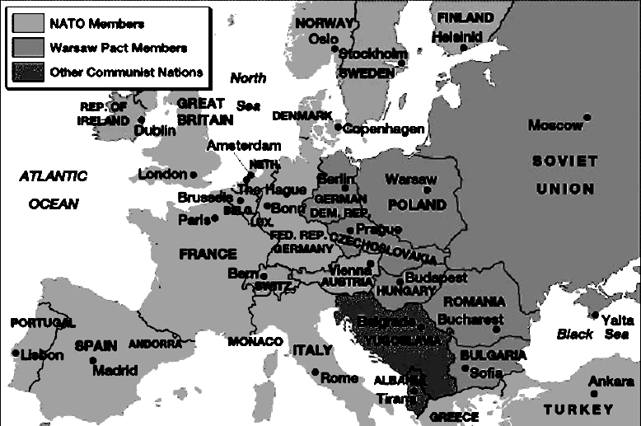

3. A Summit in Geneva
a. Eisenhower meets Soviets in Geneva, proposes “open skies” policy
b. Soviets reject proposal; “spirit of Geneva” seen as step to peace

4. The Suez War
a. Gamal Abdel-Nasser plays U.S. against Soviets over Aswan Dam
b. Dulles withdraws loan offer; Nasser nationalizes Suez Canal
c. Israel, Britain, France send troops; UN intervenes
d. Fighting stops; Egypt keeps canal; others withdraw

5. The Eisenhower Doctrine
a. Soviet prestige in Middle East rises because of support for Egypt
b. Eisenhower Doctrine—U.S. will defend Middle East against communists
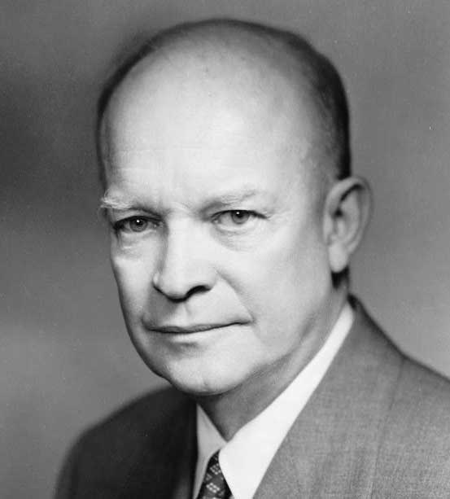 President Dwight D. Eisehower
6. The Hungarian Uprising
a. 1956, Hungarians revolt, call for democratic government
b. Imre Nagy, Communist leader, forms government, promises elections
c. Soviet army fights Hungarians in streets; overthrow Nagy
d. U.S. does not help Soviet satellite; Soviets veto action by UN

C. The Cold War Takes to the Skies

1. A New Soviet Leader
a. Nikita Khrushchev emerges as new Soviet leader; favors:
1. peaceful coexistence and economic, scientific competition
a. “A term applied to the actions of the US under Eisenhower and USSR under Khrushchev for maintaining peace and reducing the possibility of war between the two nations. The implementation of the phrase is seen in the Geneva Summit where the "spirit of Geneva" was one of peace and collaboration to create a secure and peaceful world. March 1959 the USSR and the U.S agreed to suspend atomic testing.” (http://www.course-notes.org/US_History/Unit_Notes/Unit_Nine_1940_1960/Origins_of_the_Cold_War)
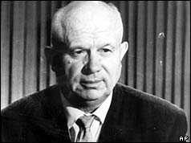 Soviet leader Nikita Khrushchev

2. The Space Race
a. October 1957, Soviets launch Sputnik, first artificial satellite
b. Shocked Americans pour money into own space program

3. A U-2 Is Shot Down
a. CIA makes secret high-altitude flights with U-2 to spy on Soviets
b. Eisenhower wants flights discontinued before Krushchev summit
c. Francis Gary Powers shot down on last flight over Soviet territory

4. Renewed Confrontation
a. Eisenhower first denies, then concedes U-2 was spying
b. Agrees to stop flights, refuses to apologize as Khrushchev demands
c. U-2 incident renews tension between superpowers; summit cancelled

Chapter 20

I. Section 1: Kennedy and the Cold War

The Kennedy administration faces some of the most dangerous Soviet confrontations in American history.

A. The Election of 1960

1. The Televised Debate Affects Votes
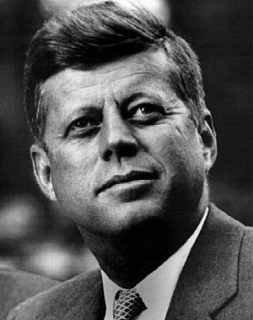
a. Americans fear U.S. falling behind Soviets militarily
b. John F. Kennedy discusses Catholicism openly, allays public worries
c. First televised presidential debate between Kennedy, Richard Nixon
d. Nixon is foreign policy expert
e. Kennedy coached by TV producers, comes across better than Nixon

2. Kennedy and Civil Rights
a. JFK takes stand on arrest of Martin Luther King, Jr; wins black vote
President Kennedy (above)

B. The Camelot Years

1. The Kennedy Mystique
a. Kennedy wins presidency in close election
b. Critics argue his smooth style lacks substance
c. Kennedy White House known as Camelot for its glamour, culture, wit
d. First Lady admired for her elegance; constant articles about family

2. The Best and the Brightest
a. JFK’s advisers called “the best and the brightest”
b. Brother Robert Kennedy named attorney general

C. A New Military Policy

1. Defining a Military Strategy
a. JFK believes must redefine nation’s nuclear strategy
b. Flexible response—fight conventional wars, keep nuclear arms balanced
c. JFK increases defense spending in three areas:
- strengthens conventional forces
- creates army Special Forces (Green Berets)
- triples nuclear capabilities

D. Crises over Cuba

1. The Cuban Dilemma
a. Revolutionary leader Fidel Castro declares himself communist
- seizes U.S. properties; Eisenhower cuts off diplomatic relations
b. 10% of Cuban population goes into exile; mostly to U.S.

2. The Bay of Pigs
a. Cuban exiles, CIA plan invasion to topple Castro
b. Plans go wrong; exile forces killed, taken prisoner
c. JFK pays ransom in food, medicine; mission is public embarrassment

3. The Cuban Missile Crisis
a. Nikita Khrushchev sends weapons to Cuba, including nuclear missiles
b. JFK warns Soviets that missile attack will trigger war on U.S.S.R.
c. Soviets avoid confrontation at sea; reach agreement with U.S.
Visuals:
The image to the left is a newspaper that is covering the conflict. The image to the right shows JFK and Khrushchev in a high-stakes contest. Notice JFK’s finger is lingering over “the button” (to launch nukes).
(http://www.squidoo.com/cubanmissilecrisis)
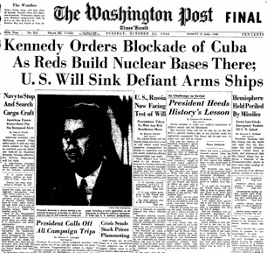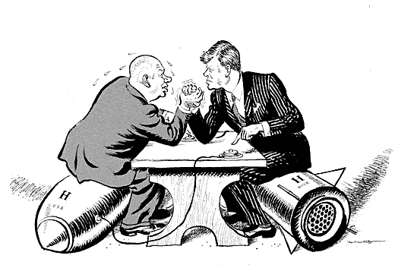
4. Kennedy and Khrushchev Take the Heat
a. Khrushchev’s prestige severely damaged in U.S.S.R.
b. JFK criticized for brinkmanship, also for not ousting Castro
c. Cuban exiles switch to GOP; Castro bans flights to and from Miami

E. Crisis over Berlin

1. The Berlin Crisis
a. By 1961 20% of Germans flee to West Berlin; economic drain on East
b. Khrushchev wants to close access roads to West Berlin; JFK refuses
c. Soviets isolate West Berlin from East Germany with Berlin Wall

2. Searching for Ways to Ease Tensions
a. Khrushchev, Kennedy conscious of danger of quick decisions
b. Establish hot line—direct phone between White House, Kremlin
c. Limited Test Ban Treaty bans nuclear tests in atmosphere

BIG CONCEPTS/IDEAS WORTH REMEMBERING – “The Early Cold War”

A. Identify the four (4) most important big concepts or ideas that you will take away from this unit. Remember, you are

identifying the topics, themes, and lessons learned from this unit that you believe you should remember for the rest of

your life because they are useful, because they are important, and, potentially, because they are relate to topics and

situations beyond a study of American history.

1.

2.

3.

4.

