Creating a new authorization in guiding Care

CHOICE Education Department February 2017

Creating A New Authorization in Guiding Care 2
Begin by checking an authorization does not already exist 2
• From the Care Management Portal 2
• From the Utilization Portal 3
Create A New Authorization 3
• Add Authorization icons 4
• Completing the Accordion sections of the authorization 4
• Eligibility Verification 4
• Provider Details 5
• Auth Basic Details 6
• Diagnosis and Service Codes 8
• Financial Details 9
• Additional Details 9
• Auth Owner, Status, Status Reason 10
Next Steps: if re-assigning an authorization 10
• Documents Tab 10
• Letters 11
• Notes Tab 13
Re-Assigning Auth to Someone Else 14
• Auth Entry tab 14
• Changing the Owner 14

Creating A New Authorization in Guiding Care

Begin by checking an authorization does not already exist

From the Care Management Portal

There are multiple ways to go to the Member Record. This guide will show via Search option.

From the Dashboard, search for member using Member ID number (V#). Select magnifying glass to obtain results (Fig 1).
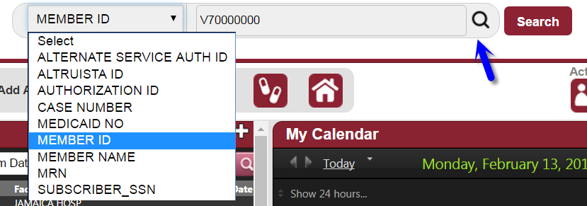 (Fig 1)

Selecting radio button will bring you to the Member Summary Page (Fig 2).
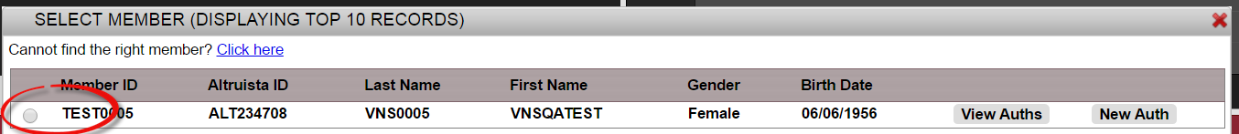 (Fig 2)

Select the Authorizations tab on left (1). This will display all Authorizations for the member. The newest items should be on top of list by date (2). Be aware member may have multiple pages of authorizations (3). (Fig 3)
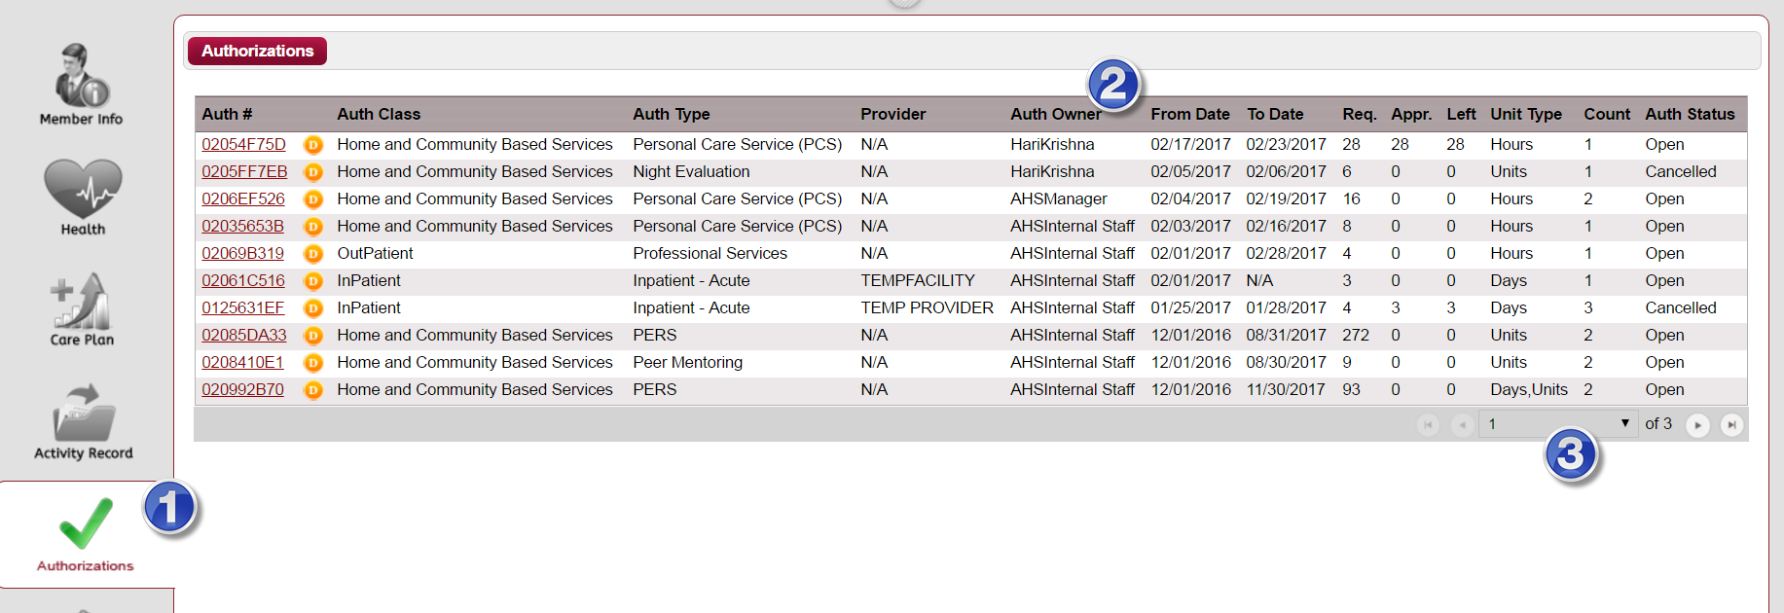 (Fig 3)

If you have determined the authorization does not already exist, then you can create a new authorization. See section Create New Authorization.

From the Utilization, Portal

If user is already in an Authorization for the member, user can check if an authorization already exists.

Select the Summary tab on left (1). This will display all Authorizations for the member. The newest items should be on top of list by date (2). Be aware member may have multiple pages of authorizations (3). (Fig 4)
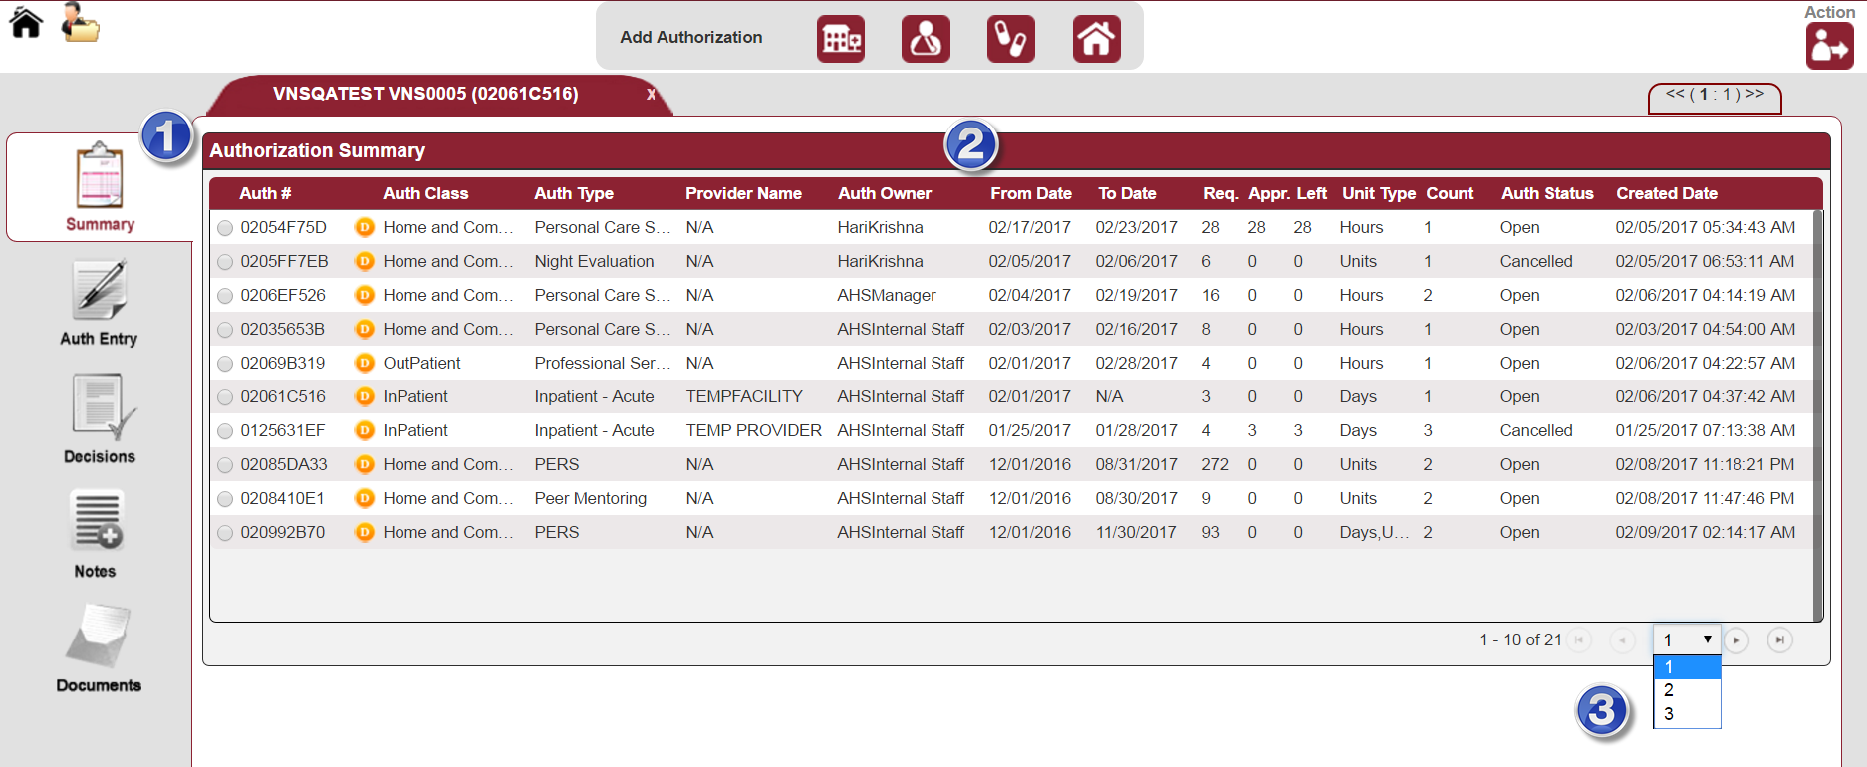
(Fig 4)

If you have determined the authorization does not already exist, then you can create a new authorization. See section Create New Authorization.

Create A New Authorization
Note: This guide will use Inpatient for the example. All authorizations have the same appearance. The type of authorization will drive the dropdown menus. For example, an Inpatient auth will pertain to Inpatient Acute, Inpatient Long Term Care Facility, and Inpatient SNF. Outpatient authorizations will have many different options such as Medical Supplies, DME, Radiology and more. An Inpatient auth will ask for Admission Date/Time which is not applicable for an Outpatient auth.
Be sure to check an authorization does not already exist before creating a new auth.

Add Authorization icons

Select appropriate icon at top of page to create a new authorization.

Hover over each icon to identify the type of authorization (Fig 5)

Currently the options are:

Inpatient, Outpatient, Pharmacy, Home and Community Based
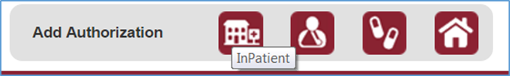(Fig 5)

Completing the Accordion sections of the authorization

Eligibility Verification

Provider Details

Auth Basic Details

Diagnosis and Service Codes

Financial Details

Additional Details

Auth Owner, Status, Status Reason

Eligibility Verification
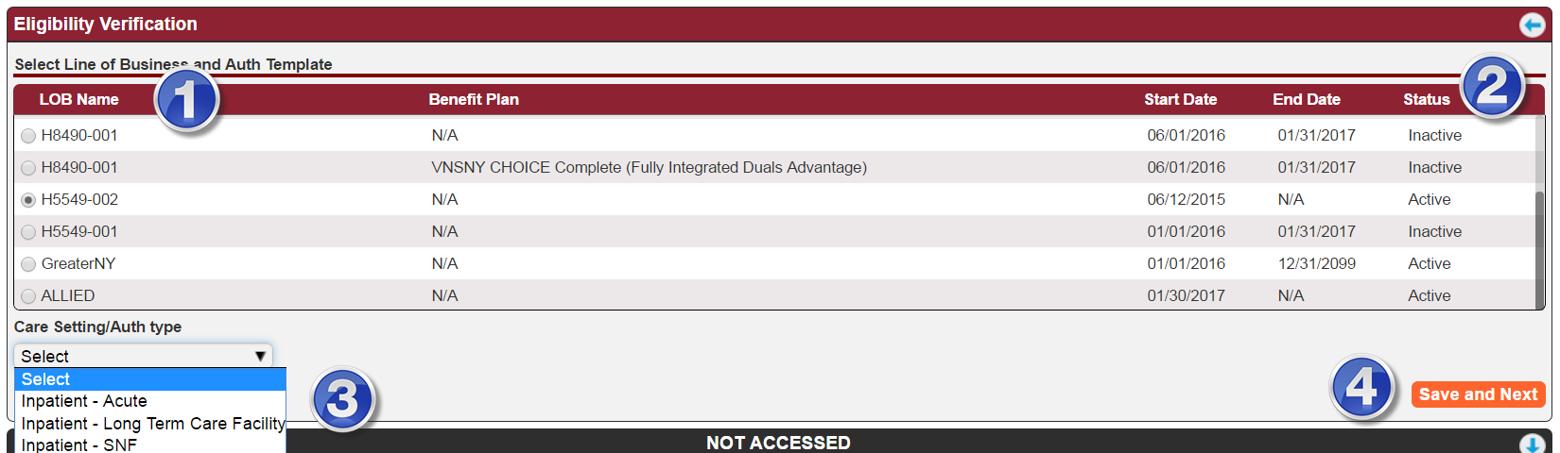 (Fig 6)

Select appropriate LOB.

Check that the status of LOB is Active.

Select appropriate Care Setting/Auth type from the dropdown menu.

After completing each accordion select Save and Next. This will collapse the current accordion and open the next one. You must complete the accordions in order.

Provider Details
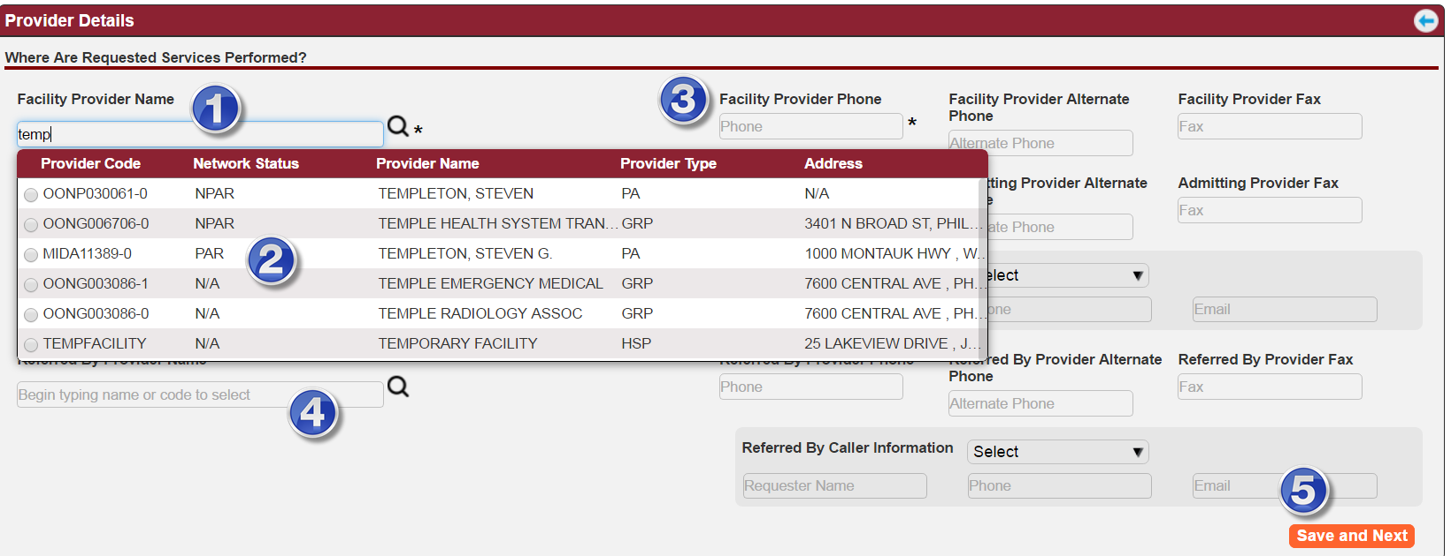
(Fig 7)

Provider Name: As you begin typing the system will begin searching

You will see the red banner when system in searching. You will know the search is finished when you see the results or it says “No Records”.

Select appropriate Provider.

Be aware of those that are In Network and Out of Network. Follow your department workflow for Out of Network.

Phone number should auto populate. Follow your department workflow if it remains blank.

Referred by Provider: Many departments complete the Referred by Provider name.

For instance, MLTC enters the same Provider so it populates on the members Care Plan.

Save and Next. Select this to save and move to next accordion.

Auth Basic Details
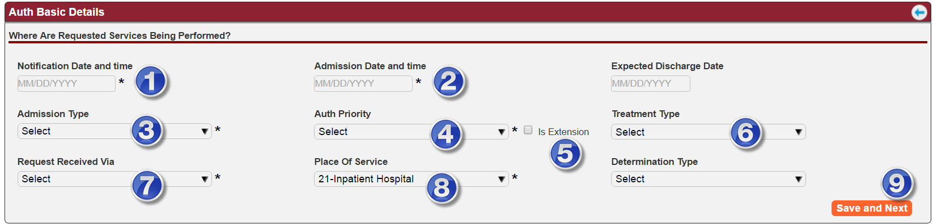 (Fig 8)
Note: Auth Basic Details is the section that determines Turn Around Time (TAT) for authorizations. It is based on the date and time the request was received, the type of auth (Standard/Expedited) and if an extension is given. It is important the information is entered correctly for the system to calculate accurately.

Notification Date and Time: Enter the date and time the agency was notified of the this request. This could be when the phone call came in or the date/time stamp on the fax etc.

Be sure to enter the Time the agency was notified (Fig 9).
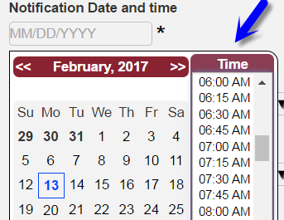 (Fig 9)

Admission Date and Time: Enter date and time of when services will begin.

This field may not be present for other auth types.

Admission Type: Select from the dropdown menu.

This field may not be present for other auth types.

Auth Priority: Select appropriate priority. Standard, Expedited etc.

Select appropriate LOB if you see more than one option i.e. MA, MLTC, FIDA (Fig 10)
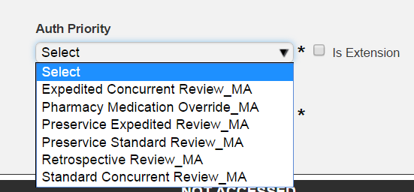 (Fig 10)

Is Extension: is used when an extension is needed.

Users must return to this section and check the box to force the system will recalculate the Turn Around Time TAT.

Reviews of expedited and standard reviews of prior approval and concurrent review requests may be extended an additional 14 days if:
    - The provider requests an extension; or
    - After the 3rd request for clinical information the provider indicates it has been sent, will be sent or additional clinical information is required to make a determination (both requests for clinical and extension must be faxed to provider and uploaded to Guiding Care).

Notice to members (extension letter) regarding an extension initiated by VNSNY CHOICE must include:
    - The reason for the extension.
    - An explanation of how the delay is in the best interest of the member.
    - A description of any additional information that VNSNY CHOICE requires to make its determination.
    - Information regarding the member's right to file a complaint regarding the extension.
    - The process for filing a complaint and the time frames within which a complaint determination must be made.
    - The member's right to designate a representative to file a complaint on his/her behalf.
    - Information regarding the member's right to contact the New York State Department of Health, including a toll-free number.

Treatment Type: Select appropriate response from the dropdown menu.

This field may not be present for other auth types.

Request Receive: Select appropriate response from the dropdown menu.

Place of Service: Select appropriate response from the dropdown menu.

Save and Next: Select this to save and move to next accordion.

Diagnosis and Service Codes
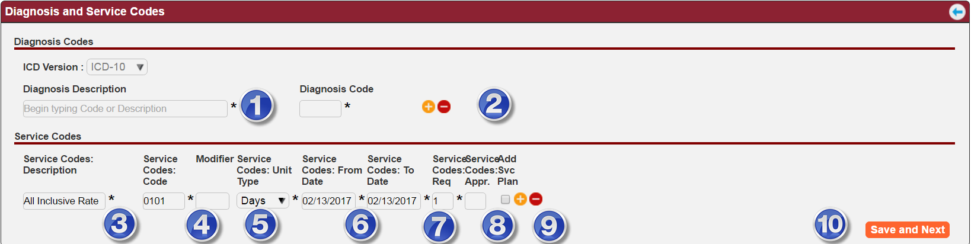 (Fig 11)

Diagnosis Description: Enter appropriate Diagnosis. Can enter the words or the ICD-10 Code.

Add/Remove symbol: Use the Plus/Minus symbols to add or remove additional lines.

Enter the Service Description: For Inpatient the 0101 Service code is used. For other auth types enter the CPT or HCPC code.

Modifier: This is used to identify RT or LT side of body, or Rental identifiers such as KH, KI, KJ etc. Follow your department workflow for modifiers.

Unit Type: Select appropriate response from dropdown menu

Service From and To Dates: Enter the dates service.

For PCS authorizations, additional information is required such as hours, days, weeks of service (Fig 12).
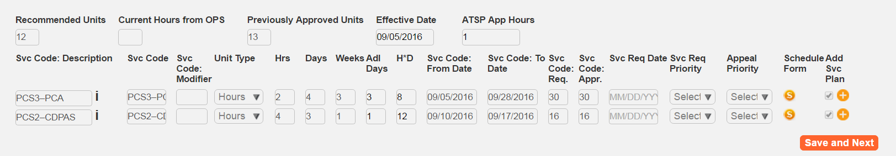 (Fig 12)

Service Code Req: For Inpatient and PCS this will auto populate based on dates entered. For DME/Supplies enter the number of items ordered .

Add Svc Plan: Check this box if the authorization needs to be part of the member’s service plan. This will auto populate for PCS items.

See your department rules for this.

Add/Remove symbol: Use the Plus/Minus symbols to add or remove additional lines.

Save and Next: Select this to save and move to next accordion.

Financial Details
See your department workflow process for Financial Details.

Additional Details
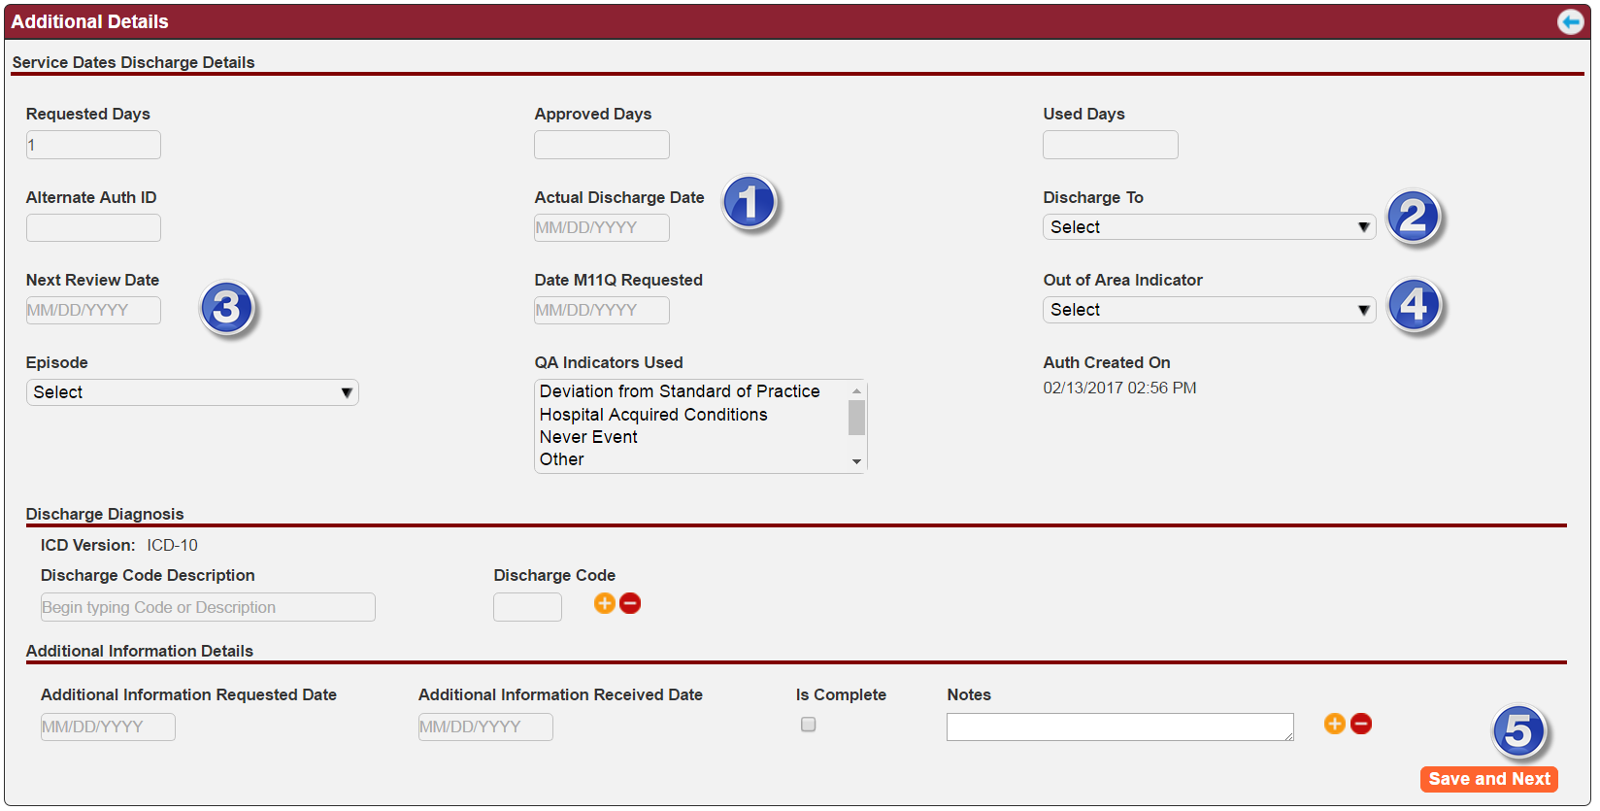
(Fig 13)
Additional Details also changes based on type of authorization. Shown here is Inpatient. Some items prepopulate such as Requested Days and Auth Created on.
Some areas that you may need to complete are:

Actual Discharge date. Users will return here when member is discharged from a facility.

Discharge To: Select from dropdown menu.

Next Review Date: This is required for Inpatient Concurrent reviews.

Out of Area Indicator: Ask if your department is using this when patient is out of the area.

Save and Next: Select this when you make any changes to this section.

Auth Owner, Status, Status Reason
(Fig 14)

Owner: Your name appears here. Change the name if you want someone else to work on the authorization. That person will receive the auth in the Request Received section of the dashboard.

The auth will remain in your Open Authorization section of the dashboard until the new owner Accepts the request.

Status: it will default to Open when you are creating the authorization.

Status Reason: Select appropriate response from the dropdown menu.

Save: Select Save to save changes made to the section.

Next Steps: if re-assigning an authorization

You can continue to work on this authorization as per your workflow process. However, before re-assigning an authorization to someone else you should complete the following steps.

Documents Tab

Upload any documents related to this authorization. This includes but not limited to Clinical documents or Letters such as attempts to obtain clinical.

Documents Tab (Fig 15).

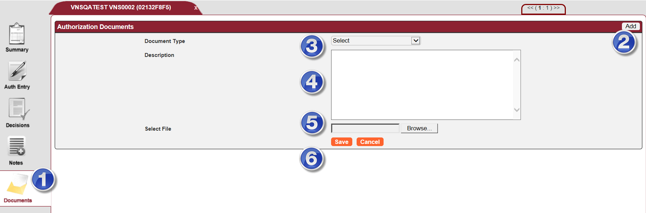 (Fig 15)

Select Documents tab on left panel

Select Add on upper right corner

Select Document Type from the dropdown menu

Enter a description

Browse to locate the document you want to upload

Select Save to complete the process

Letters

Part of your workflow process may be to Request for Information. If so then do this before assigning the authorization to another user.

Use the Action icon on upper right and Select Add letter (Fig 16)

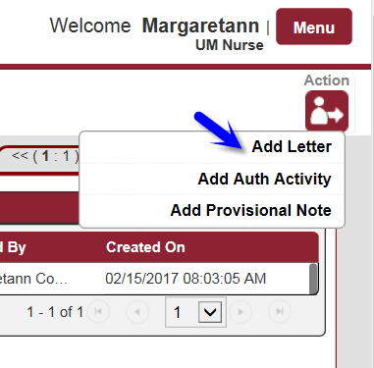 (Fig 16)

This is open the Letters window (Fig 17)
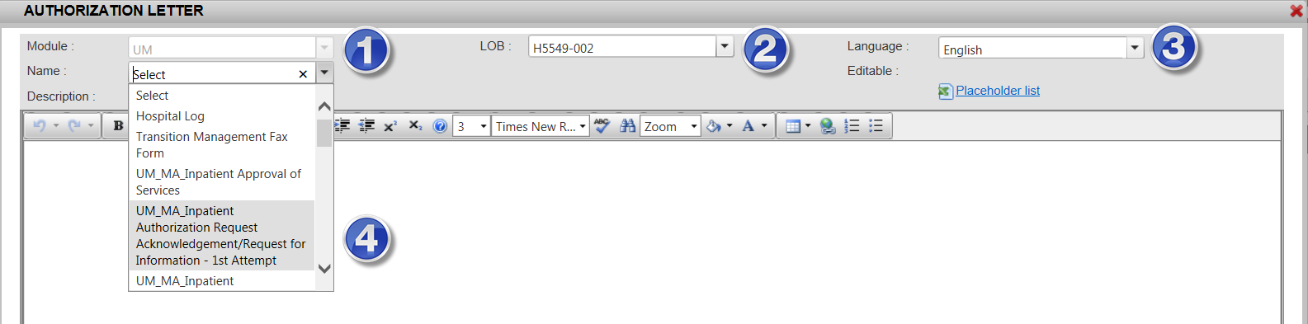 (Fig 17)

Module. You can only add UM letters to UM Portal. For CM letters, such as Summary of Auth used by MLTC, you must be in the CM Portal

Select appropriate LOB

Language. Select language.

You may be required to generate 2 letters if member speaks a language other than English. Follow your department workflow on languages.

Select from the dropdown menu the letter you want to generate.

The letter will generate (Fig 18)

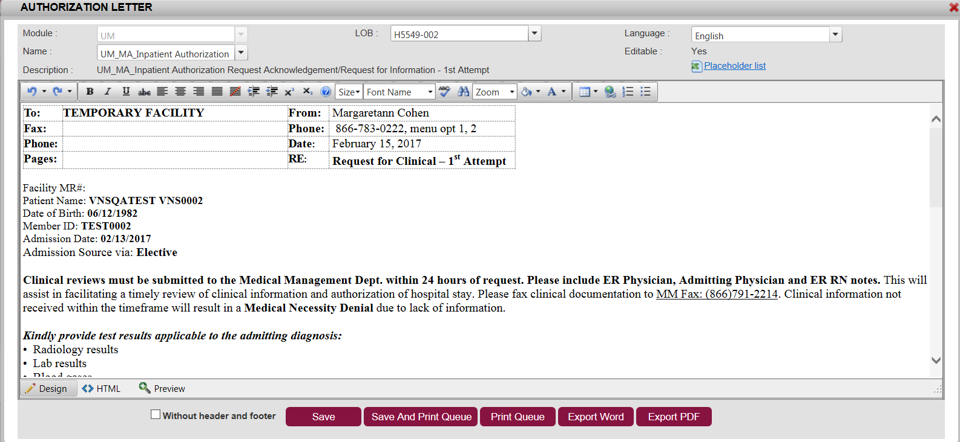 (Fig 18)

It is your responsibility to be sure the letter is accurate. Some items will prepopulate and some items will require editing by you. Follow your department workflow processes for editing the different letters.

Selecting Save will Save the letter in the Document tab

Selecting Save and Print Queue will Save the letter in the Documents tab and send the letter to be printed.

You can also Export the Letter as a Word or PDF document. Follow your department workflow on when to use these options.

If you selected one of the Save options, you will receive a green message from Guiding Care if it has been save successfully or a red message if there are errors (Fig 19).
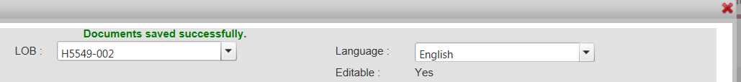 (Fig 19)

When finished with the letter you can exit the letter window using the red x in upper right corner of letter window (Fig 19).

If you used one of the Save options, the letter will appear in the Documents tab. You may need to refresh the tab if you do not see it (Fig 20).
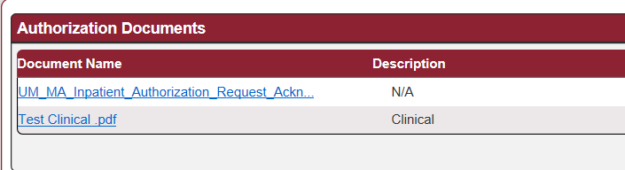 (Fig 20)

Notes Tab

Enter any notes related to this authorization (Fig 21).
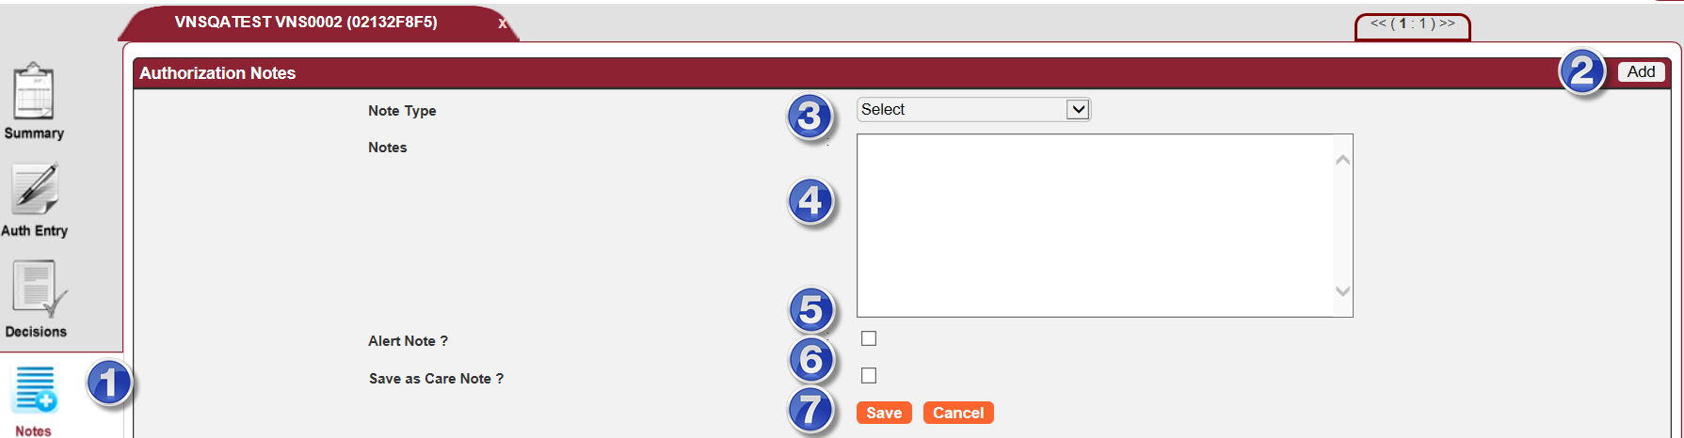 (Fig 21)

Select Notes tab on left panel

Select Add on upper right corner

Select Note Type from the dropdown menu

Enter Notes. You can type directly into this box or use copy/paste if you work of a template.

Alert Note. This function may not be turned on. Follow up within your department. When you select Alert Note it will send an Alert to the Primary Care Manager.

Save as Care Note. When selecting this box the note will appear in the CM Portal under Activity Record/Notes. Many departments use this option.

Select Save to complete the process

Re-Assigning Auth to Someone Else

If part of your workflow is to assign the authorization to another user, you will do this when the auth has all the information you can provide (see all above items).

Auth Entry tab
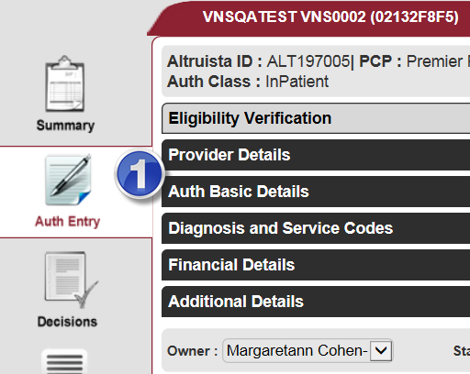 (Fig 22)

Go to the Auth Entry tab of the auth (Fig 22)

Changing the Owner

Located at the bottom of accordions (Fig 23) found in the Auth Entry tab (Fig 22)

(Fig 23)

Owner: Change the Owner of the auth from the dropdown menu.

Status: Select appropriate reason from the dropdown menu.

Status Reason: Select appropriate reason from the dropdown menu.

Save: Select Save to save the changes made to this section.

Note: When all the steps are completed, the assigned person will receive the authorization in the Request Received section of their dashboard.

The Auth will remain in your Open Authorization section of the dashboard until the new owner Accepts the request. It is your responsibility to monitor that auths are accepted in a timeframe set by your department workflow process.

