Solving Systems (Two) of Equations Fact Sheet:

Substitution Method:

- Step 1: Solve one or both equations for a variable (both x = … or both y = …)
- Step 2: Substitute the expression that represents the variable in one equation for that variable in the other equation
- Step 3: Solve the resulting equation for the remaining variable
- Step 4: Substitute the value from step 3 into one of the original equations and solve for the other variable

Addition Method:

- Step 1: Line up like terms in each equation vertically. If necessary, multiply one or both equations by constants so that the coefficients of one of the variables are opposites
- Step 2: Add the corresponding sides of the two equations (to eliminate a variable)
- Step 3: Solve the resulting equation for the remaining variable
- Step 4: Substitute the value from step 3 into one of the original equations and solve for the other variable

Graphical Method:

- Step 1: Solve both equations for y = …
- Step 2: Put into your calculator and graph (or graph by hand)
- Step 3: If the lines intersect, then the intersection point is the solution; if the lines are parallel, then there is no solution; and if the lines are the same, then there are an infinite number of solutions
- Step 4: Write the solution (intersection point) (use TRACE on your calculator to find it)

Activity 3.1: Business Checking Account

SOLs: None

Objectives: Students will be able to:
Solve a system of two linear equations numerically
Solve a system of two linear equations graphically
Solve a system of two linear equations using the substitution method
Recognize the connections between the three methods of solution
Interpret the solution to a system of two linear equations in terms of the problem’s content

Vocabulary:
System of linear equations – two equations that relate the same two variables
Numerical method – using a table of values to see with input results in the same output for the two equations
Graphical method – graph the functions and determine the coordinates of the point of intersection
Substitution method – an algebraic method using substitution to reduce the problem to one variable
Consistent – has exactly one solution (the graphs of the lines intersect)
Inconsistent – has no solutions (the graphs of the lines are parallel)

Key Concept: Solving a System of Two Linear Equations
Numerically – by completing a table and noting which x-value gives you the same y-value
Graphically – by graphing the equations and finding their point of intersection
Algebraically – by using properties of equality to solve the equations for one variable and then the other
Substitution method: (also known as elimination)
Solve for one variable; substitute what it’s equal to into the other equation (eliminating one variable); and then solve the equation for the remaining variable. Use its solution to find the value of the substituted variable
Addition method (the emphasis in lesson 3.3)

Activity: In setting up your part-time business, you have two choices for a checking account at the local bank.

 | MONTHLY FEE | TRANSACTION FEE
REGULAR | $11.00 | $0.17 for each transaction
BASIC | $8.50 | $0.22 for each transaction in excess of 20

1. If you anticipate making about 50 transactions each month, which checking account will be more economical?

2. Let x represent the number of transactions. Write an equation that expresses the total monthly cost, C, for the regular account.

3. Let x represent the number of transactions. Write an equation that expresses the total monthly cost, C, for the basic account. This is a more complicated equation because the transaction fee does not apply to the first twenty checks.

Use your two equations from above to fill in the table below:
Number of Transactions | 20 | 50 | 100 | 150 | 200 | 250 | 300
Cost of Regular ($)
Cost of Basic ($)

Use the table feature of your calculator to determine the x-value that produces two identical y-values

Graph the cost equations for each type of account: Regular (───) and Basic (- - - -)


4. Estimate the point where the lines intersect. What is the significance of that point? Check it with your calculator.

Given the following system of two linear equations: y = 3x – 10 and y = 5x + 14

5. Use substitution to find a single equation and solve the system of equations for x.

6. Use the x-value to find the y-value.

7. Write the solution as an ordered pair and check it with your calculator.

8. Use the substitution method to sol the following system of checking account cost functions:
C = 0.17x + 11 and C = 0.22x + 4.10

Concept Summary:
The solution of a system of equations is the set of all ordered pairs that satisfy both equations.
There are three standard methods for solving a system of equations:
Numerical method
Graphical method
Substitution method
A linear system is consistent if there is at least one solution, the point of intersection of the graphs.
A linear system is inconsistent if there is no solution -- that is, the lines are parallel.

Homework: page 305, problems 1-4, 7, 8
Lab 3.2: Modeling a Business

SOLs: None

Objectives: Students will be able to:
Solve a system of two linear equations by any method
Determine the break-even point of a linear system algebraically and graphically
Interpret break-even points in contextual situations

Vocabulary: none new

Activity:
You are employed by a company that manufactures solar collector panels. To remain competitive, the company must consider many variables and make many decisions. Two major concerns involve those variables and decisions affecting the cost of making the product, and those that affect the income from selling the product.

Costs such as rent, insurance, and utilities for the operation of the company are called fixed costs -- because they generally remain constant over a short time period, and they must be paid whether or not any items are manufactured. Other costs, such as materials and labor, are called variable costs because they depend directly upon the number of items produced.

Complete the worksheet during class and turn in for a grade

Concept Summary:
Lab exercise working material learned in lesson 3-1

Homework: page 313, problem 1

Activity 3.3: Healthy Lifestyle

SOLs: None

Objectives: Students will be able to:
Solve a 2x2 linear system algebraically using substitution method and the addition method
Solve equations containing parentheses

Vocabulary:
Addition method – combining multiples of equations to eliminate a variable

Activity: You are trying to maintain a healthy lifestyle. You eat a well-balanced diet and exercise regularly. One of your favorite exercise activities is a combination of walking and jogging in your nearby park.

One day, it takes you 1.3 hours to walk and jog a total of 5.5 miles in the park. You are curious about the amount of time you spent walking and the amount of time you spent jogging during the workout.

1. Write an equation using x and y, for the total time of your walk/jog workout in the park.

2. If you walk at 3 miles per hour, write an expression (not an equation) that represents the distance you walked.

3. If you jog at 5 miles per hour, write an expression that represents the distance you jogged.

4. Write an equation for the total distance you walked/jogged in the park.

5. Solve each of the equations (from 1 and 4) for y

6. Solve the system of equations from part 5 using the substitution method for last lesson

Check your answer using your calculator (Window: Xmin= -2.5, Xmax= 2.5, Ymin= -2.5 and Ymax=2.5)
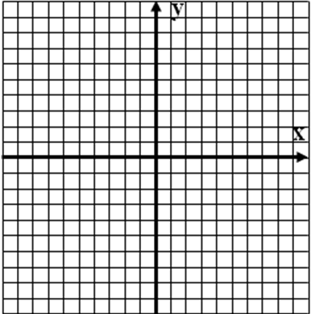
4. Solve the following system using the Addition method. Multiply the appropriate equation by the appropriate factor to eliminate x and solve for y first.
x + y = 1.3 and 3x + 5y = 5.5

5. Solve the following system with the addition method: -2x + 5y = -16 and 3x + 2y = 5

6. Solve the walk/jog problem from the activity using the addition method.

Concept Summary:
The two methods for solving a 2 x 2 system of linear equations algebraically:
The substitution method
The addition method

Homework: pg 319 problems 1 – 3
Activity 3.4: How Long Can You Live?

SOLs: None

Objectives: Students will be able to:
Solve linear inequalities in one variable numerically and graphically
Use properties of inequalities to solve linear inequalities in one variable algebraically
Solve compound inequalities in one variable algebraically and graphically
Use interval notation to represent a set of real numbers by an inequality

Vocabulary:
Inequality – a relationship in which one side can be greater or less than the other (equal as well)
Compound inequality – an inequality involving to inequality signs (like 3 < x < 9)
Closed interval – end points are included (≥ ≤)
Open interval – end points are not included ( > < )

Key Concepts:

Activity: Life expectancy in the United States is steadily increasing, and the number of Americans aged 100 or older will exceed 850,000 by the middle of this century. Medical advancements have been a primary reason for Americans living longer. Another factor has been the increased awareness of maintaining a healthy lifestyle.

The life expectancies at birth for women and men born after 1975 can be modeled by the following functions:
W(x) = 0.106x + 77.01
M(x) = 0.200x + 68.94
where W(x) represents the life expectancy for women, M(x) represents the life expectancy for men, and x represents the number of years since 1975 that the person was born. That is, x = 0 corresponds to the year 1975, x = 5 corresponds to 1980, and so forth.

1) Complete the following table:
 | 1975 | 1980 | 1985 | 1990 | 1995 | 2000
X, years since 75 | 0 | 5 | 10 | 15 | 20 | 25
W(x)
M(x)

2) When will men overtake women in life expectancies? When will M(x) > W(x)?

Table:

Graph:
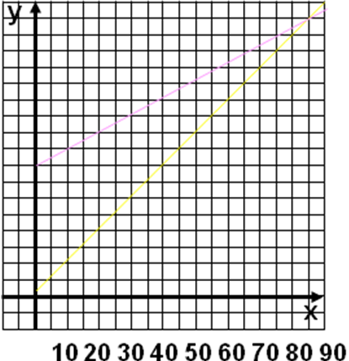
Algebraically:

Algebraic Examples:
- If x – 2 > 9

- If x + 6 ≤ 8

- If 6x < 24

- If ½x ≥ 3

- If -y > 5

Compound Inequalities:
Solve the following compound inequalities:
- 4 < 3x + 5 ≤ 11 1 < 3x – 2 < 4

Write the inequalities in interval notation:
1 < x < 2 -9 < x < 12 x ≤ 3

Write the interval notations as an inequality:
[-2 , 4) (2, 8) (5, ∞)

Concept Summary:
The solution set of an inequality in one variable is the set of all values of the variable that satisfy the inequality.
The direction of an inequality is not changed when
The same quantity is added to or subtracted from both sides of the inequality or
Both sides of an inequality are multiplied or divided by the same positive number.

Homework: pg 330 – 335; 4-8, 19, 20

Activity 3.5: Will Trees Grow?

SOLs: None

Objectives: Students will be able to:
Graph a linear inequality in two variables
Solve a system of linear inequalities in two variables graphically
Determine the corner points of the solution set of a system of linear inequalities

Vocabulary:
Half-plane – the set of all points on one side of a line.
System of linear inequalities – two or more linear inequalities in two variables.
Corner points – the points determined by the intersection of the boundary lines of the graph of a system of linear inequalities.

Key Concepts: Graphing Inequalities

Points to Remember:
- When the inequality is ≤ or ≥, then the line is included and is drawn as a solid line (equal included)
- When the inequality is < or >, then the line is not included and is drawn as a dashed line (line not included)
- All the area on one side of the line is feasible (meets the inequality constraint)
- All the area on the other side of the line is infeasible (does not satisfy the inequality constraint)
- If inequalities can be reduced to a slope-intercept form, then your calculator can help solve the problem

Inequalities written in slope-intercept form:
- y < mx + b or y ≤ mx + b
Below the line is a shaded region
- y > mx + b or y ≥ mx + b
Above the line is a shaded region
- Solution of a system of inequalities is the intersection (if any) of all solution regions (the shaded region)
The intersection of the boundary lines of the shaded region is called a corner point

If all else fails: Remember, we can plug in a point, above or below the line, and see if it satisfies the inequality. If it works, then that side of the line is shaded; and if it doesn’t work, then the other side of the line is shaded.

Activity: While researching a term paper on global climate change, you discover a mathematical model that gives the relationship between temperature and amount of precipitation that is necessary for trees to grow. If t represents the average annual temperature in °F, and p represents the annual precipitation in inches, then
t ≥ 35
5t - 7p < 70
[Source: Miller and Thompson, Elements of Meteorology]
These inequalities form a system of inequalities in two variables. The solution of the system is the set of all ordered pairs in the form (t, p) that make each of the inequalities in the system a true statement.

- Will trees grow in a region in which the average temperature is 22°F and the annual precipitation is 30 inches?

- Will trees grow if the average temperature is 55°F and the annual precipitation is 20 inches?

- In Sydney Australia, the average temperature is 64°F and the annual precipitation is 48 inches. Will trees grow in Sydney?

- Fill in the following table:
City | Temp | Precip | (t,p) | Conclusion
Baghdad, Iraq | 73 | 6 | (73, 6)
Fairbanks, AK | 29 | 14 | (29, 14)
Lima, Peru | 66 | 1 | (66, 1)
Aden, Yemen | 84 | 1.8 | (84, 2)
- Graph the solution space:

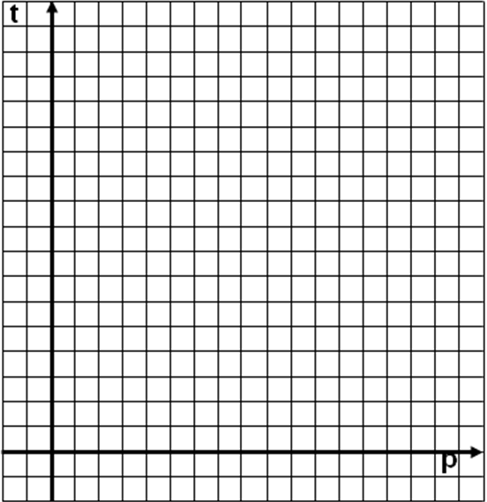

Steps for Solving Two Inequalities:
Given: Two Inequalities
Step 1: Solve for y
- Bring x terms to other side
- Divide through by constant in front of y
- Remember to switch inequality if dividing by a negative number
Step 2: Enter “equations” into calculator
- Change icons on far left
Step 3: Graph with an appropriate window
- Solution space is cross-hatched region

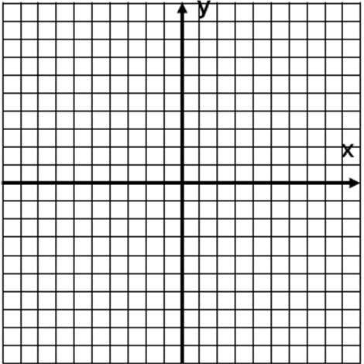
Example 1: Given: 4x – 2y ≥ 8 2x + 3y < 6

Example 2: Given: 3x + 2y ≥ 16 x – 2y ≤ 0

Concept Summary:
An inequality of the form Ax + By < C, where A and B cannot both equal zero, is called a linear inequality in two variables. The symbol < can be replaced by >, ≤ or ≥.
The solution set of a linear inequality in two variables x and y is the collection of all ordered pairs (x, y) whose coordinates satisfy the given inequality.
The solution set of a system of linear inequalities in two variables is the collection of all ordered pairs whose coordinates satisfy each linear inequality in the system.

Homework: pg 346-352; 1, 5-7, 11, 13
Activity 3.6: Helping Hurricane Victims

SOLs: None

Objectives: Students will be able to:
Determine the objective function in a situation where a quantity is to be maximized or minimized
Determine the constraints that place limitations on the quantities contained in the objective function
Translate the constraints into a system of linear inequalities
Use linear programming method to solve a problem in which a quantity is to be maximized or minimized subject to a set of constraints

Vocabulary:
Objective function – an equation that describes a quantity to be maximized or minimized in terms of two or more variables.
Constraints – the limitations or restrictions placed on the variables upon which the quantity to be maximized or minimized depends. Each constraint is written as a linear inequality.
Feasible region – the graph of the solution set of the system of linear inequalities representing the constraints.
Feasible points – the corner points determined by the intersection of the boundary lines of the feasible region in a linear programming problem.

Key Concepts:
Linear programming is a mathematical model used to determine the “best” way to attain a certain objective subject to a set of constraints
- Objectives are usually something like maximization of output or minimization of cost
- The optimal solution (“best”) to a problem is found at a corner point of the feasible region bounded by certain constraints
- Constraints are the inequalities

Activity: Food and clothing are being sent by commercial airplanes to hurricane victims in Florida. Each container of food is estimated to feed 12 people. Each container of clothing is intended to help 5 people. Organizers of the relief effort want to determine the number of containers of food and clothing that should be sent in each plane shipment that will maximize the number of victims helped.

What is the objective function?

Weight and space restrictions imposed by the airlines are summarized as follows:
- Total weight cannot exceed 19,000 pounds
- Total volume must be no more than 8,000 cubic feet
A container of food weighs 50 pounds and occupies 20 cubic feet.
A container of clothes weighs 20 pounds and occupies 10 cubic feet.
Write the constraints as a linear inequality:

Logical restrictions as follows:
- You can’t ship negative containers of food
- You can’t ship negative containers of clothes
Logical constraints help to limit the feasible region; after all we are trying to help the help and bringing nothing with you to help makes no sense.
Write these constraints as a linear inequality:

Graphical Method to Solve the LP problem:
- Graph the Constraints (inequalities)
- Determine the feasible region
- Locate corner points (need the values!)
Usually the intercepts and intersection
- Objective function is drawn and translated out until it is tangent (at a corner point) OR
Use a table to evaluate all the corner points

Maximize N = 12F + 5C
C1 = 950 – (5/2)F F>0 and C>0
C2 = 800 – 2F
Evaluating Objective Function at corner points:

Corner Point | F | C | N = 12F + 5C
(0, 0) | 0 | 0
(0, 800) | 0 | 800
(380, 0) | 380 | 0
(300, 200) | 300 | 200

Concept Summary:
Linear programming is a method used to determine the maximum or minimum values of a quantity that are dependent upon variable quantities that are restricted.
A linear programming problem consists of an objective function and a set of constraints.

Homework: pg 358 – 364; 1 and 2
Activity 3.7: Healthy Burgers

SOLs: None

Objectives: Students will be able to:
Determine the objective function in a situation where a quantity is to be minimized
Determine the constraints that place limitations on the quantities contained in the objective function
Translate the constraints into a system of linear inequalities in two variables
Use the linear programming method to solve a problem in which a quantity is to be minimized subject to a set of constraints

Vocabulary: none new

Activity: Almost everyone has become more health conscious these days. Changes in eating styles have reflected efforts to improve nutrition. Awareness of fat, fiber and protein content of many foods is closely studied by consumers at the grocery store.

A local food processing company is planning a new line of meatless burgers composed of two new protein products. The two protein ingredients are:

Megasoy, containing 6 grams of fiber and 8 grams of protein in each ounce, and
Numyco, containing 6 grams of fiber and 4 grams of protein in each ounce.

The company wishes to minimize their cost while meeting protein and fiber constraints set by their marketing department for each package of burgers: at least 36 grams of fiber and at least 32 grams of protein per package.

Writing all that we have figured out in a mathematical problem format:

- Minimize Objective Function

subject to the following constraints:

- Fiber constraint

- Protein constraint

- Megasoy constraint

- Numyco constraint

Graphical Solution Method:
- Graph the Constraints (inequalities)
- Determine the feasible region
- Locate corner points (need the values!)
Usually the intercepts and intersection
- Objective function is drawn and translated out until it is tangent (at a corner point) OR
Use a table to evaluate all the corner points

Corner Point | M | N | Cost =

Concept Summary:
A feasible region may be enclosed by a polygon or may be unbounded. The objective function may be minimized or maximized. In each case the solution will be at a corner point of the feasible region.
Sometimes there may be many solutions, represented by the points between two corner points of the feasible region.

Homework: pg 369 – 372; 1, 2
Lab 3.8: The Labor of Recycling

SOLs: None

Objectives: Students will be able to:
Solve a linear programming problem with integer solutions

Vocabulary: none new

Activity: Dwindling natural resources and space for disposing of waste have become major problems in the 21st century. Recycling of basic containers, whether plastic, glass or metal, has become an important business in recent years. In designing your recycling business for efficiency, you need to know how best to allocate your equipment budget. A part of this process is determining how many of each major piece of equipment should be purchased. Sorting, cleaning, grinding and packaging recyclable material requires very specialized equipment.

For this project you need to decide how many glass recycling machines and plastic recycling machines to buy. You need to consider each machine type's capacity, floor space requirements, and cost, as given in the following table:

 | Glass  Recycling  Machine | Plastic  Recycling  Machine
Capacity | 3.2 tons/hour | 1.6 tons/hour
Floor Space | 180 square feet | 205 square feet
Cost | $14,000.00 | $19,600.00

Concept Summary: N/A

Homework: finish up lab worksheet for turn-in quiz

