Activity 4.1: The Amazing Property of Gravity

SOLs: None

Objectives: Students will be able to:
Evaluate functions of the form: y = ax²
Graph functions of the form: y = ax²
Interpret the coordinates of points on the graph of y = ax² in context
Solve an equation of the form ax² = c graphically
Solve an equation of the form ax² = c algebraically by taking square roots
Note: a ≠ 0 in the objectives above

Vocabulary:
Parabola – a U-shaped curve derived from a quadratic equation
Quadratic equation – an equation in the form of y = ax² + bx + c

Key Concept: Solving an equation in the form of y = ax²
Graphically:
Use calculator to graph it (the same way we did with lines)
If a > 0 then the parabola opens up; if a < 0 then the parabola opens down
The larger the value |a| the steeper the parabola
Always crosses at (0, 0) because of the form y = ax²
Vertical line x = 0 is a line of symmetry
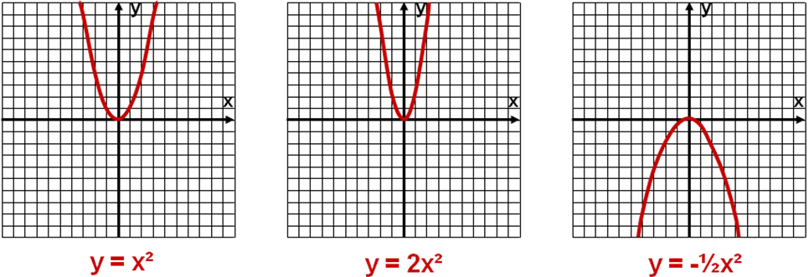

Algebraically: Given the form c = ax² (or solving for x given a particular y-value)
1. Divide both sides by a c/a = x²
2. If (c/a) > 0, ±√c/a = x
then take square root of both sides
(remember the ± aspects of the square root)
3. If (c/a) < 0, then solution is not real
4. There will be 2 solutions, 1 solution or no solutions

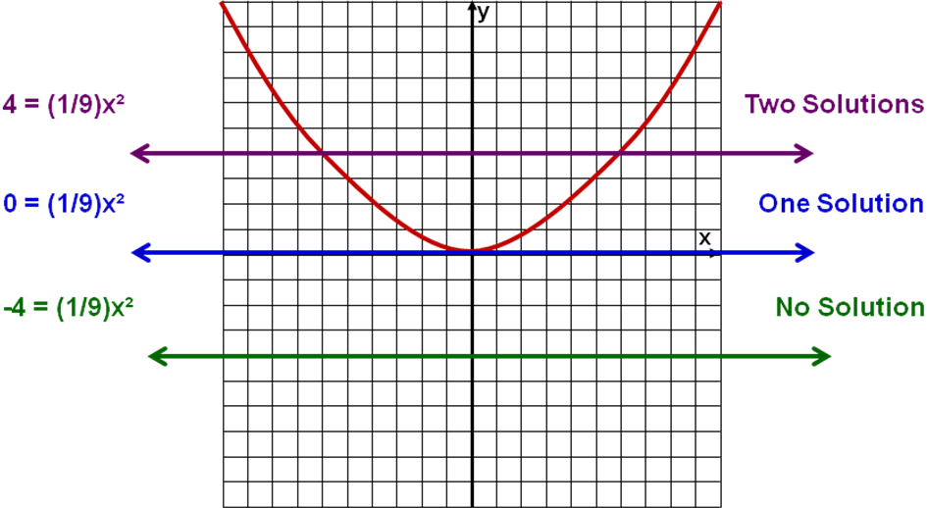
Activity: In the sixteenth century, scientists such as Galileo were experimenting with the physical laws of gravity. In a remarkable discovery, they learned that if the effects of air resistance are neglected, any two objects dropped from a height above the earth will fall at exactly the same speed. That is, if you drop a feather and a brick down a tube whose air has been removed, the feather and the brick will fall at the same speed. Surprisingly, the function that models the distance fallen by such an object in terms of elapsed time is a very simple one:
s = 16t²
where t represents seconds elapsed and s is feet fallen

- Fill in the table to the right:
t(sec) | s (ft)
0
1
2
3
- How many feet does the object fall in the first second?

- How many feet does the object fall in the first two seconds?

- What is the average rate of change of distance between t = 0 and t = 1?

- What is the average rate of change units of measure?

- What is the average rate of change between t = 1 and t = 2?

- What does the average rates of change tell us about the function?

- How far does it fall in 4 seconds?

- How many seconds would it take to fall 1296 feet (approximately the height of a 100 story building)?

- Solve 16x² = 256

- Solve -2x² = -98

- Solve 5x² = 50

- Solve -3x² = 12

Concept Summary:
The graph of a function of the form y = ax², a ≠ 0, is a U-shaped curve called a parabola
If a > 0 then the larger the value of a, the narrower the graph of y = ax²
An equation of the form ax² = c, a ≠ 0, is solved algebraically
Dividing both side of the equation by a
Taking the (positive and negative) square root of both sides

Homework: pg 405 – 408; problems 2 - 4
Activity 4.2: Baseball and the Sears Tower

SOLs: None

Objectives: Students will be able to:
Identify functions of the form y = ax² + bx + c as quadratic functions
Explore the role of a as it relates to the graph of y = ax² + bx + c
Explore the role of b as it relates to the graph of y = ax² + bx + c
Explore the role of c as it relates to the graph of y = ax² + bx + c
Note: a ≠ 0 in objectives above

Vocabulary:
Quadratic term – the term, ax², in the quadratic equation; determines the opening direction and steepness of the curve
Linear term – the term, bx, in the quadratic equation; helps determine the turning point
Constant term – the term, c, in the quadratic equation; also graphically the y-intercept
Coefficients – the numerical factors of the quadratic and linear terms (a and b)
Turning point – the maximum or minimum location on the parabola; where it turns back

Key Concept: Quadratic Equation
Standard form: y = ax² + bx + c
Quadratic term: ax²
Determines Direction
a > 0 then parabola opens up
a < 0 then parabola opens down
Determines Width: The bigger |a|, the narrower the graph
Linear term: bx
If b = 0, then turning point on y-axis
If b ≠ 0, then turning point not on y-axis

Constant term: c
y-intercept is at (0, c)

Activity:
Imagine yourself standing on the roof of the 1450-foot-high Sears Tower in Chicago. When you release and drop a baseball from the roof of the tower, the ball’s height above the ground, H (in feet), can be modeled as a function of the time (in seconds), since it was dropped. This height function is defined by:
H(t) = -16t² + 1450
Time, t (sec) | H = -16t² + 1450
0
1
2
3
4
5
6
7
8
9
10

Complete the table to the right:
How far does the ball fall in the first second?

How far does it fall during the 2nd second?

What is the average rate of change of H with respect to t in the first second?

During the 2nd second?



When does the ball hit the ground?

What is the practical domain of the height function?

What is the practical range of the height function?

Now graph the function using the table to the right
Is the shape of the curve the path of the ball?
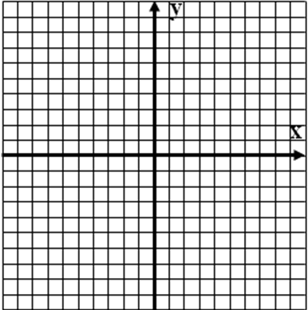
The Effects of a in y = ax² + bx + c
Graph the following quadratic functions:
- f(x) = x²
- g(x) = ½x²
- h(x) = 2x²
- j(x) = -2x²

The Effects of b in y = ax² + bx + c
Graph the following quadratic functions:
- f(x) = x²
- g(x) = x² - 4x
- h(x) = x² + 6x
- j(x) = -x² + 6x

The Effects of c in y = ax² + bx + c
Graph the following quadratic functions:
- f(x) = x²
- g(x) = x² - 4
- h(x) = x² + 3
- j(x) = -x² + 4

Match the graph and the equation:
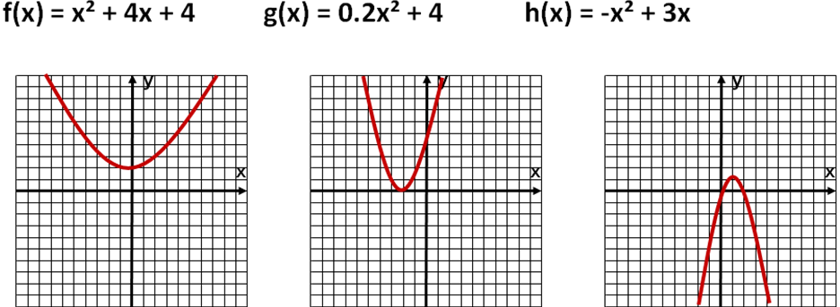

Concept Summary:
Quadratic function: y = ax² + bx + c
Graph of a quadratic function is a parabola
The a coefficient determines the width and direction of the parabola
If b = 0, then the turning point is on the y-axis;
if b ≠ 0, then the turning point won’t be on the y-axis
The c term is always the y-intercept of the parabola

Homework: page 416 – 420; problems 1-3, 7-11, 14
Activity 4.3: The Shot Put

SOLs: None

Objectives: Students will be able to:
Determine the vertex or turning point of a parabola
Identify the vertex as a maximum or a minimum
Determine the axis of symmetry of a parabola
Identify the domain and range
Determine the y-intercept of a parabola
Determine the x-intercept(s) of a parabola using technology
Interpret the practical meaning of the vertex and intercepts in a given problem
Identify the vertex from the standard form y = a(x – h)² + k of the equation of a parabola

Vocabulary:
Vertex – the turning point of a parabola (the maximum or the minimum)

Key Concepts:
Important Characteristics of a Parabola:
- Quadratic Form: y = f(x) = ax² + bx + c “a” determines if it opens up (a> 0) or down (a < 0)
- Vertex: (-b / [2a], -[b² – 4ac] / [4a]) y-value is the max or min of the range
- Y-intercept: c y-value when x = 0
- X-intercepts: formula coming when y = 0 in equation
- Axis of Symmetry: x = -b/(2a) (Vertical Line) divides parabola in halves
- Domain: x = all real numbers permissible values of input variable, x
- Range: y ≥ min or y ≤ max possible values of output variable, y
- Standard Form: y = f(x) = a(x – h)² + k where (h, k) is the vertex

Activity: Parabolas are good models for a variety of situations that you encounter in everyday life. Examples include the path of a golf ball after it is struck, the arch (cable system) of a bridge, the path of a baseball thrown from the outfield to home plate, the stream of water from a drinking fountain, and the path of a cliff diver.

Consider the 2000 men’s Olympic shot put event, which was won by Finland’s Arsi Harju with a throw of 69 feet 10¼ inches. The path of his winning throw can be approximately modeled by the quadratic function defined by
Y = -0.015545x² + x + 6
Where x is the horizontal distance in feet from the point of the throw and y is the vertical height in feet of the shot above the ground.

- Which way will the graph of the parabola open?

- What is the y-intercept of the graph of the parabola?

- What is the practical meaning of this value?

- What is the practical domain of the graph?

- What is the practical range of the graph?

Use the table feature of your calculator to complete the following table:
x | 10 | 20 | 30 | 40 | 50 | 60 | 70
y
Example 1:
Determine the vertex of y = -3x² + 12x + 5

Example 2:
Determine the axis of symmetry of y = -3x² + 12x + 5

Example 3:
a) Determine if y = -3x² + 12x + 5 has any x-intercepts?

b) Determine if y = x² + 12x + 6 has any x-intercepts?

Example 4:
Sketch y = 3x²

Sketch y = 3(x – 2)² à horizontal shift to the right

Sketch y = 3(x -2)² + 5 à vertical shift up

Where is the vertex for each?

Example 5:
a) Determine the domain and range of y = -3x² + 12x + 5

b) Determine the domain and range of y = x² + 12x + 6

Concept Summary:
- Quadratic Form: y = f(x) = ax² + bx + c
- Standard Form: y = f(x) = a(x – h)² + k
- Vertex: (-b / [2a], -[b² – 4ac] / [4a])
- Axis of Symmetry: x = -b/(2a) (Vertical Line)
- Domain: x = all real numbers
- Range: y ≥ min or y ≤ max
- a determines if it opens up (a> 0) or down (a < 0)

Homework: pg 430 – 434; problems 1 – 4, 9, 10
Quadratic and Parabola Summary Page

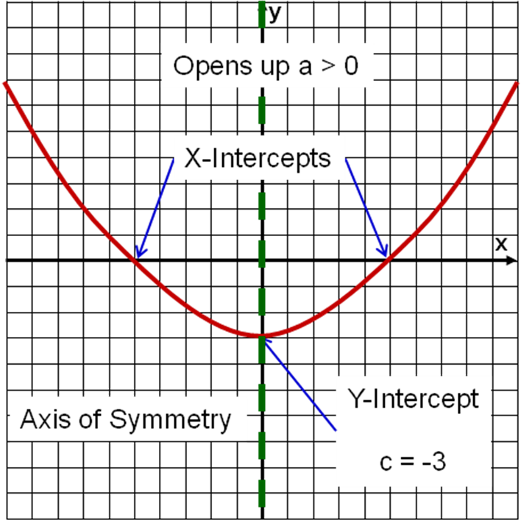
First conic section studied in algebra (circle is the second studied in Geometry)

Graph and identification of parts of the parabola:
Vertex (h, k)
Where h = (-b)/(2a) and k = (b² - 4ac)/(4a)
Vertex is a max if parabola opens down and can be found on calculator by using max (2nd TRACE)
Vertex is a min if parabola opens up and can be found on calculator by using min (2nd TRACE)
Graph function (Y1=); 2nd Trace, select minimum;
Move + so Left Bound on left side and enter
Move + so Right bound on right side and enter
Move + toward vertex and enter
Y-intercept – is the constant term, c in the quadratic form of the equation
X-intercepts – if they exist, then they represent the zeros of the function and can be found using the calculator, using factoring or using the quadratic formula (see below)
If a parabola opens up and the vertex is above the x-axis, then there are no x-intercepts
If a parabola opens down and the vertex is below the x-axis, then there are no x-intercepts
Axis of symmetry – a vertical line down the center of the parabola dividing it in halves; x = (-b)/(2a) (vertex x-value)
Domain of a parabolic function: D_{x} = {x | x is any real number} or -∞ < x < ∞
Range of a parabolic function:
If the parabola opens up, then y ≥ y-value of the vertex (vertex y-value is a minimum)
If the parabola opens down, then y ≤ y-value of the vertex (vertex y-value is a maximum)

Equations of a Parabola:

Quadratic form: y = f(x) = ax² + bx +c
Quadratic term: ax²
Determines Direction
a > 0 then parabola opens up
a < 0 then parabola opens down
Determines Width: The bigger |a|, the narrower the graph; 0< a < 1 then the wider the graph
Linear term: bx (helps determine the vertex location)
If b = 0, then turning point on y-axis
If b ≠ 0, then turning point not on y-axis
Constant term: c
Y-intercept is at (0, c)

Standard Conic form: y – k = a(x – h)² where (h, k) is the vertex (turning point)

Solving quadratic equations:
Algebraically:  -b ± √b² - 4ac  A. Quadratic Formula: x = ---------------------  2a  Solving equations using the quadratic formula:  1. Put quadratic into 0 = ax² + bx + c format  2. Identify the coefficients a, b and c in the equation  3. Substitute these values into the formula  4. Remember the ± and check your solutions  B. Trial and Error Factoring: | Graphically :  Either  1) put equation into 0 = ax² + bx +c format and use zero (2nd TRACE) function on calculator  2) set equation equal to value k = ax² + bx +c and graph y1 = ax² + bx +c and y2 = k; use intersection (2nd TRACE) function on you calculator

Activity 4.4: Per Capita Personal Income

SOLs: None

Objectives: Students will be able to:
Solve quadratic equations numerically
Solve quadratic equations graphically
Determine the zeros of a function using technology

Vocabulary:
Quadratic equation – a second order (x²) equation in form of ax² + bx + c = 0, a ≠ 0
Zero of the function – is the x-value of the x-intercepts of the function

Key Concepts:
x-intercept is called a zero of the function and is the solution to a quadratic equation

Activity:
According to statistics from the US Department of Commerce, the per capita personal income (or the average annual income) of each resident of the United States from 1960 to 2000 can be modeled by the equation:
P(x) = 15.1442x² + 98.7686x + 1831.6909

What is the practical domain of the function?
Complete the table
Year | 1960 | 1965 | 1970 | 1975 | 1980 | 1985 | 1990 | 1995 | 2000
X
P(x)

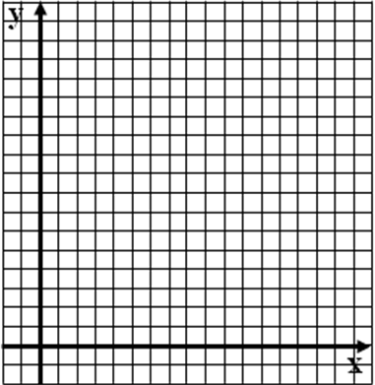
Sketch the graph with Window (x: -5, 45, y: -1000, 35000)

Estimate personal income in 1989 (x = 29)

Estimate when p(x) = 20,500

Example 1: Solve x² + 3x – 1 = 9 using tables of data

x | f(x) = x² + 3x – 1 | y = 9
0
1
2
3
4
5

Example 2:
a) Solve 2x² – 4x + 3 = 2

b) Solve 2x² – 4x + 1 = 0

Concept Summary:
- Quadratic equation is in form of ax² + bx + c = 0
- Solutions to quadratic equation f(x) = n
Numerically:
  - construct a table for y = f(x) and determine the x-values that produce n as a y-value
- Graphically:
  - Graph y1 = f(x) and y2 = n and determine points of intersection
  - Graph y1 = f(x) – n and determine the x-intercepts of the function (the zeros of the function)

Homework: pg 438; problems 9-13
Activity 4.5: Sir Isaac Newton

SOLs: None

Objectives: Students will be able to:
Factor expressions by removing the greatest common factor
Factor trinomials using trial and error
Use the zero-product principle to solve equations
Solve quadratic equations by factoring

Vocabulary:
Zero-product principle – if a∙b = 0, then either a = 0 or b = 0 or both equal 0.
Factoring – rewriting an expression as a product of two or more terms
Common factor – a factor that is multiplied in both terms
Greatest common factor – GCF, the largest common factor(s)

Key Concepts: Factoring
Reversing the FOIL method
- Break each term of trinomial down into its prime factors
- Remove the greatest common factor, GCF
- To factor the resulting trinomial into the product of two binomials, try combinations of factors for the first and last terms in two binomials
- Check the sum of the outer and inner products to match the middle term of the original trinomial
    - If the constant term, c, is positive, both of its factors are positive or both are negative
    - If the constant term is negative, one factor is positive and one is negative
- If the check fails, repeat steps 3 and 4

Activity:
Sir Isaac Newton XIV, a descendant of the famous physicist and mathematician, takes you to the top of a building to demonstrate a physics property discovered by his famous ancestor. He throws your math book straight up into the air. The book’s distance, s, above the ground as a function of time, x, is modeled by

s(x) = -16x² + 16x + 32 s(t) = ½ at² + v₀t + s₀ (general formula)

When the book strikes the ground, what is the value of s?

Write the equation you must solve to determine when.

How tall is the building you were on top of?

How fast did Newton throw the book up into the air?

Solve the equation above by factoring

At what time does the book hit the ground?

Zero-Product Principle:
Example: x(x – 5) = 0 (x + 2)(x – 4) = 0

Common Factors:
Examples: 3x – 6 = 0 2x² – 8x = 0

Factoring:
Factor 4x³ – 8x² – 32x

More Factoring:
- x² – 7x + 12

- x² – 8x – 9

- x² + 14x + 49

Concept Summary:
Factoring involves undoing the distributive property and breaking down into smaller products
Factoring trinomials undoes the FOIL method
- Break each term of trinomial down into its prime factors
- Remove the greatest common factor, GCF
- To factor the resulting trinomial into the product of two binomials, try combinations of factors for the first and last terms in two binomials
- Check the sum of the outer and inner products to match the middle term of the original trinomial
  - If the constant term, c, is positive, both of its factors are positive or both are negative
  - If the constant term is negative, one factor is positive and one is negative
- If the check fails, repeat steps 3 and 4
Solve quadratic equations by factoring

Homework: pg 445 – 446; problems 1, 2, 5, 8, 10, 14
Activity 4.6: Ups and Downs

SOLs: None

Objectives: Students will be able to:
Use the quadratic formula to solve quadratic equations
Identify solutions of a quadratic equation with points on the corresponding graph
Determine the zeros of a function

Vocabulary:
Quadratic formula – an equation that provides solutions to quadratic equations in standard form.

Key Concepts:
Activity:
Suppose a soccer goalie punted the ball in such a way as to kick the ball as far as possible down the field. The height of the ball above the field as a function of time can be approximated by

Y = -0.017x² + 0.98x + 0.33

Where y represents the height of the ball (in yards) and x represents the horizontal distance in yards down the field from where the goalie kicked the ball. In this situation, the graph of the function is the actual path of the flight of the soccer ball. The graph of this function appears below:
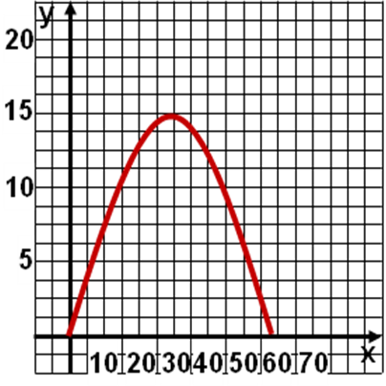
- Use the graph to estimate how far downfield from the point of contact the soccer ball in 10 yards above the ground. How often during its flight does this occur?

- Write a quadratic equation to determine when the ball is 10 yards above the ground.

- Put into Standard form for a quadratic:

- What does the graph indicate for the number of solutions?

- How can we solve this graphically on our calculator?
Example 1: Solve x² – x – 6 = 0

Example 2: Solve 6x² – x = 2

Example 3: Solve x² + x + 6 = 0

Activity Revisited: Solve -0.017x² + 0.98x + 0.33 = 10

Concept Summary:
- The quadratic equation will provide solutions to all quadratic equations in standard form
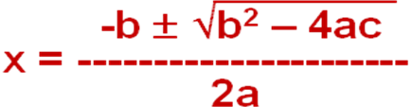
- If the value under the square root in negative, then the solutions are not real (complex #)

Homework: pg 449 – 453; problems 1-4, 6
Activity 4.7: Air Quality in Atlanta

SOLs: None

Objectives: Students will be able to:
Determine quadratic regression models using the graphing calculator
Solve problems using quadratic regression models

Vocabulary:
Coefficient of determination, R² – describes the percent of variability in y that is explained by the model.

Key Concepts:
Quadratic regression y = ax² + bx + c
Data Entry as before (x-values in L1 and y-values in L2)
STAT – CALC down to 5: QuadReg and return (defaults to L1, L2)
Read off output (coefficients) and put into model y = ax² + bx + c

The coefficient of determination, R², describes the percent of variability in y that is explained by the model.
Values of R² vary from 0 to 1.
The closer to 1, the better the likelihood of a good fit of the quadratic regression model (equation) to the data.

Activity:
The Air Quality Index (AQI) measures how polluted the air is by measuring five major pollutants: ground-level ozone, particulate matter, carbon monoxide, sulfur dioxide, and nitrogen oxide. Based on the amount of each pollutant in the air, the AQI assigns a numerical value to air quality, as follows:
Numerical Rating | Meaning
0 – 50 | Good
51 – 100 | Moderate
101 – 150 | Unhealthy for sensitive groups
151 – 200 | Unhealthy
201 – 300 | Very unhealthy
301 – 500 | Hazardous

The following table indicates the number of days in which the AQI was greater than 100 in the city of Atlanta, Georgia.
Year | 1990 | 1992 | 1994 | 1996 | 1998 | 1999
Days AQI > 100 | 42 | 20 | 15 | 25 | 50 | 61

Sketch a scatterplot of the data. Let t represent the number of years since 1990 (t in L1 and Days in L2). Therefore, t = 0 corresponds to the year 1990. What does the shape of the graph look like?

If the shape was linear, we used LinReg on our calculator to make a model of the data. Our calculator has several other regression models in the STAT, CALC menu. The one that fits parabolas is the QuadReg. What values come out of QuadReg?

A= ___________________ x² + B = ___________________ x + C = ___________________ = y

R² = ________________

Use the model to estimate the number of days the AQI exceeded 100 in Atlanta in each of the following years.
Year | 1988 | 1990 | 1992 | 1994 | 1996 | 1997 | 1998 | 1999 | 2002
Days AQI > 100 |  | 42 | 20 | 15 | 25 |  | 50 | 61

What is the “reliability” of the estimates?

Graph the model on our scatterplot of the data. Let Y1 = 1.75788x² – 13.3236x + 41.0083

We discovered that the number of days the AQI exceeded 100 in 1997 was 31 and added that to the model, how does the model change now? (Rerun QuadReg with new data added in L1 and L2)

A= ___________________ x² + B = ___________________ x + C = ___________________ = y
R² = ________________

How does R² change? Why?

Rerun the graph of the old model and the new scatterplot

Quadratic Regression Example:
The following data from the National Health and Nutrition Examination Survey shows the percentage of American adults who are overweight or obese.
Year | 1961 | 1972 | 1978 | 1991 | 1999
t | 1 | 12 | 18 | 31 | 39
% Overweight or Obese | 42 | 20 | 15 | 25 | 61

Let t represent the number of years since 1960 (t in L1 and Days in L2). Therefore, t = 1 corresponds to the year 1961. What is the model?

A= ___________________ x² + B = ___________________ x + C = ___________________ = y

R² = ________________

Concept Summary:
Parabolic data can be modeled by a quadratic regression model

Homework: pg 457 – 461; problems 1 and 2
Activity 4.8: A Thunderstorm

SOLs: None

Objectives: Students will be able to:
Recognize the equivalent forms of the direct variation statement
Determine the constant of proportionality in a direct variation problem
Solve direct variation problems

Vocabulary:
Vary Directly – if two variables both go up together or both go down together
Proportionality constant – also known as the constant of variation; represented by k

Key Concept: Direct Variation:
Direct variation is when the independent variable, x, and dependent variable, y, magnitudes (absolute values) are directly related (i.e., if k is positive then x goes up, y goes up and when x goes down, y goes down). Graph always goes through the origin.
The following statements are equivalent:
- y varies directly as x
- y is directly proportional to x
- y = kx for some constant k
k is called the constant of proportionality or variation and can be positive or negative

To solve problem involving direct variation:
- Write an equation of the form y = kx relating the variables and the constant of proportionality, k.
- Determine a value for k, using a known relationship between x and y (a fact given to us in the problem)
- Rewrite the equation in part a with the value from part b
- Substitute a know value for x or y and determine the unknown value

Activity:
One of nature’s more spectacular events is a thunderstorm. The skies light up, delighting your eyes, and seconds later your ears are bombarded with the boom of thunder. Because light travels much faster than sound, during a thunderstorm you see the lightening before you hear the thunder. The formula
d = 1080t
describes the distance, d in feet, you are from the storm’s center if it takes t seconds for you to hear the thunder.
Note: Light travels at d = 983,568,960t (a little faster!)

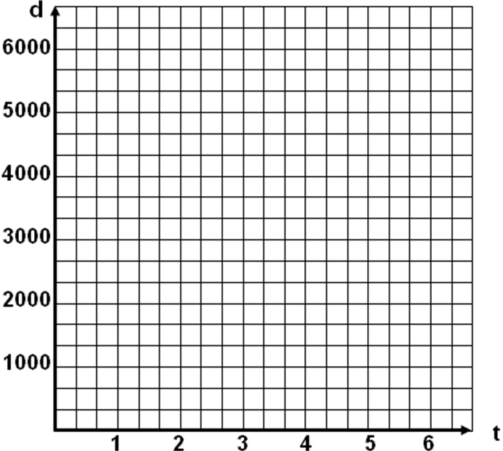
Complete the following table:

Seconds, t | 1 | 2 | 3 | 4 | 5
d, in feet

What does the ordered pair (5, 5400) from the above table mean a practical sense?

As t increases, what happens to the value of d?

Graph the distance, d, as a function of time, t, using the values in the previous table.

Example 1: The amount of garbage, G, varies directly with the population, P. The population of Grand Prairie, Texas, is 0.13 million and creates 2.6 million pounds of garbage each week. Determine the about of garbage produced by Houston with a population of 2 million.

Example 2: A worker’s gross wages, w, vary directly as the number of hours the worker works, h. The following table shows the relationship between wages and the hours worked.
Hours, h | 15 | 20 | 25 | 30 | 35
Wages, w | $172.50 | $230.00 | $287.50 | $345.00 | $402.50

Graph w(h)

Determine k in w = kh

What is k?

What is a worker’s wages for a 40-hour week?

Example 3: Direct variation can involve higher powers of x, like x², x³ or in general x^{n}.

The power P generated by a certain wind turbine varies directly as the square of the wind speed w. The turbine generates 750 watts of power in a 25 mph wind. Determine the power it generates in a 40 mph wind.

Concept Summary:
Two variables are said to vary directly if as the magnitude of one increases, the magnitude of the other does as well
Magnitudes are absolute values of the variables.
Constant of proportionality or constant of variation is represented by k
The following statements are equivalent
y varies directly as x
y is directly proportional to x
y = kx for some constant k

Homework: pg 476 – 479; problems 1, 2, 4, 5
Activity 4.9: The Power of Power Functions

SOLs: None

Objectives: Students will be able to:
Identify a direct variation function
Determine the constant of variation
Identify the properties of graphs of power functions defined by y = kx^{n}, where n is a positive integer, k ≠ 0
Graph transformations of power functions

Vocabulary:
Direct Variation – equations in the form of y = kx^{n};
Constant of variation – also called the constant of proportionality, k
Power Functions – another name for direct variation; when n is even they resemble parabolas; when k is odd, they resemble y = kx³

Key Concept:

Activity: You are traveling in a hot air balloon when suddenly your binoculars drop from the edge of the balloon’s basket. At that moment, the balloon is maintaining a constant height of 500. The distance of the binoculars from the edge of the basket is modeled by s = 16t² (like we have seen earlier in this chapter)

Fill in the following table:
Time, t | 0 | 1 | 2 | 3 | 4 | 5 | 6
Distance, s

How long till they hit the river?

As time triples from 1 to 3, what happens to s?

As time quadruples from 1 to 4, what happens to s?

In general, if y varies directly as the square of x, then when x becomes n times as large, the corresponding y-values become _____ times as large.

Volume of a Balloon: V = (4/3) π r³
Radius, r | 1 | 2 | 3 | 4 | 8
Volume, V

a) As r doubles from 2 to 4 and from 4 to 8, the corresponding V-values become ____ times as large.

b) In general, if y varies directly as the cube of x, then when x becomes n times as large, the corresponding y-values become _____ times as large.

Fill in the Tables, figure out the constant k of variation, and write the direct variation equation for each table.
a) y varies directly as x
x | 1 | 2 | 4 | 8 | 12
y |  | 12

b) y varies directly as x³
x | 1 | 2 | 3
y |  | 32

c) y varies directly as x
x | 1 | 2 | 3 | 4 | 5
y |  |  | 3

Skid Marks: The length, L, of skid distance left by a car varies directly as the square of the initial velocity, v (in mph), of the car. Suppose a car traveling at 40 mph leaves a skid distance of 60 feet.
a) Write the general equation

b) Solve for k

c) Estimate the skid length left by a car traveling at 60 mph

Concept Summary:
Equations of direct variation can be in the form of y = kx^{n}, where k ≠ 0 and n is a positive integer
These equations are also called power functions
Graphs of power functions where n is even resemble parabolas (U shaped graphs). As n increases in value, the graph flattens out more near the vertex. If k is positive, then the graph opens up; if k is negative, then it opens down.
Graphs of power functions where n is odd resemble the graph of y = kx³. If k is positive, then the graph is increasing; if k is negative, then decreasing.

Homework: pg 485 – 487; problems 1, 3-5, 12-14

Let’s look at each of the power functions on the previous slide with smaller x-windows to observe the behavior around the turning point. What is the basic shape of the graphs with n = even power n = odd power?

What happens to the graph around the turning point as n gets larger?

Activity 4.10: Speed Limits

SOLs: None

Objectives: Students will be able to:
Determine the domain and range of a function defined by y = k/x, where k is a nonzero, real number
Determine the vertical and horizontal asymptotes of the graph of y = k/x
Sketch and graph functions of the form y = k/x
Determine the properties of graphs having the equation y = k/x

Vocabulary:
Horizontal Asymptote – a horizontal line that the graph of the curve approaches but never touches as the input values get very large (approaches ∞) or very small (approaches -∞)
Vertical Asymptote – a vertical line that the graph of the curve approaches but never touches as the input value approaches a forbidden value in the domain (division by zero or negative under square root)

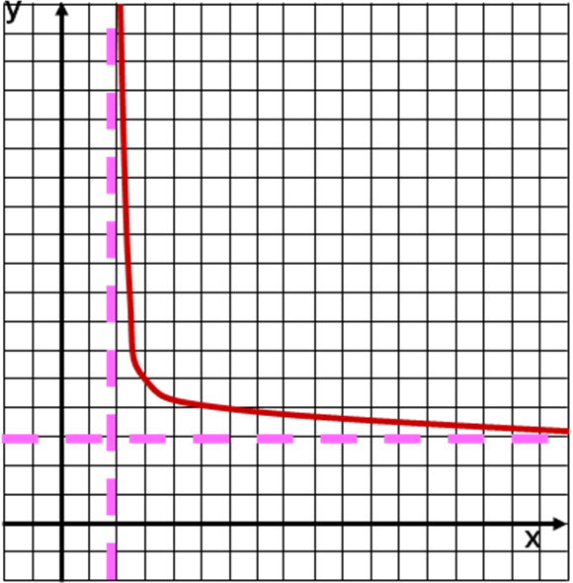
Key Concepts: Horizontal and Vertical Asymptotes
Horizontal asymptote is drawn as a dashed horizontal line. Has the equation y = c, where c is the value that the curve approaches but never reaches it.
Usually occurs when x gets very large (x à ∞) or when x get very small (x à -∞)

Vertical asymptote is drawn as a dashed vertical line. Has the equation x = c, where c is the value that the curve approaches but can never reach. (x = c is undefined)
Occurs when x approaches a value that is not in the domain (division by zero, or a negative under the square root)

Activity: The speed limit on the New York State thruway is 65 miles per hour. You are in an ambulance; if you maintained an average speed of 80 miles per hour, how long will it take you to make a 200 mile trip on the thruway?

It’s snowing and speeds are slowing down. Complete the following table:
Ave speed | 20 | 30 | 40 | 50 | 60 | 65 | 70
Time (hr)
Use the table to answer the following questions:
Write an equation that defines travel time, t, as a function of the average speed, r.

As the average speed, r, increases, what happened to travel time, t? What does this mean in practical terms?

The snow continues to get worse and travel really slows:
Ave speed | 10 | 7 | 5 | 3 | 2 | 1 | 0
Time (hr)

As the average speed r gets closer to zero, what happens to the travel time t? In practical terms, what does it mean?

Can zero be used as an input value? Explain

Using your calculator, graph the following functions:

1 5 10
f(x) = -------- g(x) = -------- h(x) = --------
x x x

using a window of Xmin = -5, Xmax = 5, Ymin = -25 and Ymax = 25

Answer the following questions using the graphs.
- What happens to the y-values as the x-values increase in magnitude infinitely (in either direction)?

- What is the horizontal asymptote?

- What happens to the y-values as the x-values get close to zero (from a positive direction)?

- What happens to the y-values as the x-values get close to zero (from a negative direction)?

- What is the vertical asymptote?

- Do the graphs of f, g or h have x or y-intercepts?

- Do the graphs of f, g or h have min’s or max’s?

- Are the functions continuous?

Concept Summary:
Functions in form of y = k/x, (k ≠ 0) have the following characteristics:
Domain and range of all real numbers except 0
Vertical line of x = 0 is the vertical asymptote
Horizontal line of y = 0 is the horizontal asymptote
No x or y-intercepts (graph does not intersect axes)
No maximum or minimum y-value
Function is not defined at zero (and discontinuous at x = 0)

Homework: pg 493 – 496; problems 2-4
Activity 4.11: Loudness of a Sound

SOLs: None

Objectives: Students will be able to:
Graph an inverse variation function defined by an equation of the form y = k/x^{n}, where n is any positive integer, x ≠ 0.
Describe the properties of graphs having equation y = k/x^{n}, x ≠ 0.
Determine the vertical and horizontal asymptotes of the graphs of y = k/x^{n}
Determine the constant of proportionality (also called the constant of variation, k)

Vocabulary:
Inverse variation functions – defined by y = k/x^{n}.
Constant of variation – also called the constant of proportionality, k

Key Concept:

Activity: The loudness (or intensity) of any sound is a function of the listener’s distance from the source of the sound. In general, the relationship between the intensity I and the distance d can be modeled by an equation of the form
I = k/d²
where I is measured in decibels, d is measured in feet, and k is a constant determined by the source of the sound and the surroundings.

The intensity, I, of a human voice can be given by I = 1500/d²
Complete the following table:

d (ft) | 0.1 | 0.5 | 1 | 2 | 5 | 10 | 20 | 30
I (dB)

What happens to the intensity as you move closer to the person speaking?

What happens to the intensity as you move away from the person speaking?

Graph the function
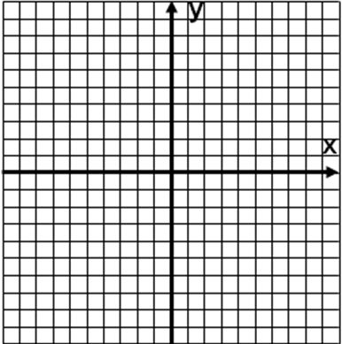
Y = k/x² family of functions

Complete the following table for f(x) = 1/x² and g(x) = 10/x²
x | -3 | -2 | 1 | -1/2 | -1/4 | 0 | 1/4 | 1/2 | 1 | 2 | 3
f(x)
g(x)

Sketch them both on same graph

What happens to the y-values as x gets very large or very small?

What happens to the y-values as x gets close to zero (from either side)?

Y = k/x³ family of functions

Complete the following table for j(x) = 1/x³ and k(x) = 10/x³
x | -3 | -2 | 1 | -1/2 | -1/4 | 0 | 1/4 | 1/2 | 1 | 2 | 3
j(x)
k(x)

Sketch them both on same graph

What happens to the y-values as x gets very large or very small?

What happens to the y-values as x gets close to zero (from either side)?

Example 1: y varies inversely as the square of x and y = 5 when x = 2. Determine the equation for y

Example 2: The intensity of the sound made by a heavy truck 60 feet away is 90 decibels. What is the intensity of the sound made by the truck when it is 100 feet away?

Concept Summary:
Inverse Variation Functions Characteristics:
No x or y-intercepts
No max or min y-values
Function is not continuous at x = 0 (undefined)
Domain: D_{x} = {x | x ≠ 0}
Range: R_{y} = {y | y ≠ 0} (y > 0 or y < 0 depending on k & n)
y is said to vary inversely as the n^{th} power of x

Homework: pg 504 – 509; problems 1, 3, 7, 8

