Activity 7.1: Visualizing Trends

SOLs: None

Objectives: Students will be able to:
Recognize how scaling of the axes of a graph can misrepresent the situation

Vocabulary:
Scale Factor – the values along the vertical or horizontal axis on a graph

Key Concept: Graphs can lie!
Common problems:
- Vertical Axis
  - Inconsistent vertical scaling
  - Incorrect vertical scaling
  - Vertical axis that doesn’t start at zero
- Scaling in pictures different than that reflected by the data
- Class widths
  - Values overlap
  - Class widths different

Characteristics of Good Graphics:
- Label the graphic clearly and provide explanations if needed
- Avoid distortion. Don’t lie about the data
- Avoid three-dimensions. Look nice, but often distract reader and result in misinterpretation
- Don’t use more than one design in the same graphic.
- Let the numbers speak for themselves
- Sometimes graphs use a different design in a portion of the graphic to call attention to it

Activity: Statistics is the science of gathering, analyzing, and making predictions from data (numerical information). Statistics has become an indispensable tool in the study of such diverse area as medicine and health issues, the economy, marketing, manufacturing, population trends and the environment.

An important part of a statistical study is organizing and displaying the data collected. Throughout this book, you have observed how useful graphs can be for identifying patterns and trends; however, graphs can be constructed to be misleading.
The following charts will examine how graphs can be misleading.

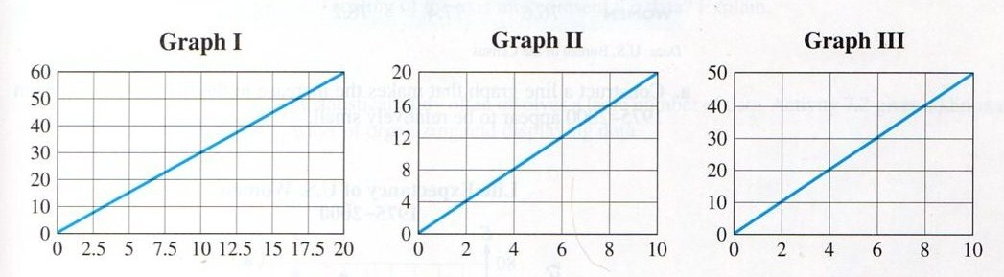
Compare the three graphs above. Do they look the same?

Calculate the slope of the line in Graph 1:

Calculate the slope of the line in Graph 2:

Calculate the slope of the line in Graph 3:

Now what do we say?
Example 1: The following graphs show the performance of two stocks over the first five months of the year.
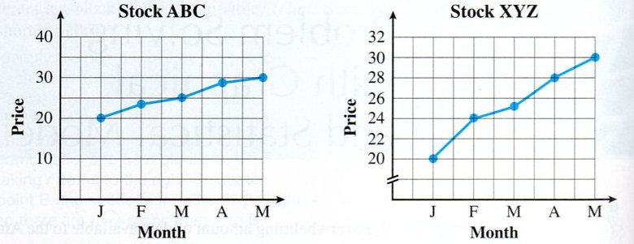

a) Which stock would you choose for your savings?

b) Which graph appears to show the best performance? Explain

c) The graphs have different scales along the y-axis. Which scale makes the graph appear to be rising more slowly?

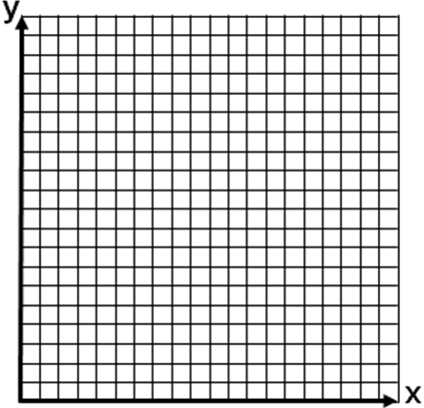

Example 2: Construct a line graph using the following US Census data:
Year | 1975 | 1980 | 1985 | 1990 | 1995 | 2000
Women | 76.6 | 77.4 | 78.2 | 78.8 | 78.9 | 80.0

a) If we wanted the change to appear to be small, how do we change the y-axis?

b) If we wanted the change to appear to be large, how do we change the y-axis?

Example 3: Using the bar graphs below, answer the following questions
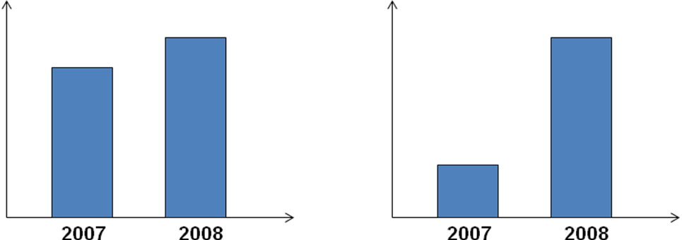
a) What do you concluded based on the left bar-graph?

b) What do you concluded based on the right bar-graph?

c) Now that the vertical scales for the graphs have been revealed, what are some of the differences in those scales?

Concept Summary:
Graphs can be misleading
Comparative graphs should have the same scale

Homework: none
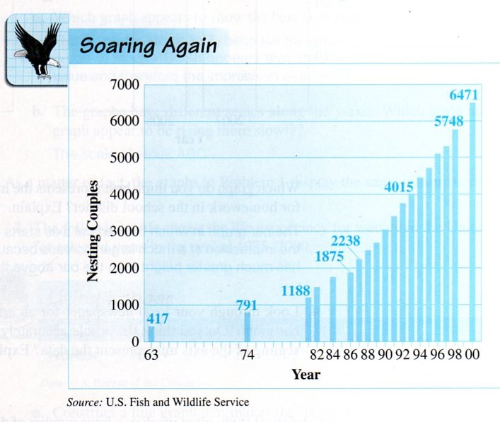
Activity 7.2: Bald Eagle Population

SOLs: None

Objectives: Students will be able to:
Read tables
Read and interpret bar graphs
Read and interpret circle graphs

Vocabulary: none new

Activity:
The bald eagle has been the national symbol of the United States since 1782, when its image with outspread wings was placed on the country’s Great Seal. Bald eagles were in danger of becoming extinct about thirty years ago, but efforts to protect them are working. In 1999, President Clinton announced a proposal to remove this majestic bird from the list of endangered species. The bald eagle was eventually declared recovered and was delisted in July 2007.

The above bar graph displays the number of nesting bald eagle couples in the lower 48 states for the years 1963 to 2000. The horizontal direction represents the years from 1963 to 2000 and the vertical direction represents the number of nesting pairs.

What was the number of nesting couples in 1963? In 1986? In 2000?

How did you locate these numbers on the bar graph?

Estimate the number of nesting couples in 1982, in 1988 and in 1996.

How did you estimate the numbers?

From 1986 to 1998, what do the bars indicate about the number of eagle couples?

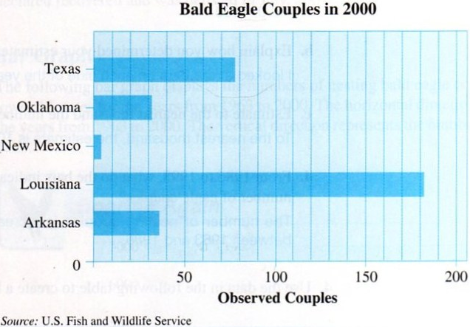
Estimate the number of bald eagle couples in Louisiana in 2000.

Estimate how many more bald eagle couples were observed in Louisiana compared to Texas in 2000

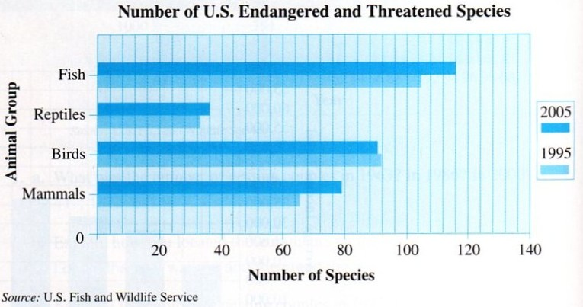
Which animal group actually saw a drop in the number of endangered and threatened species between 95 and 05?

Which animal group show the largest increase and by how many species?

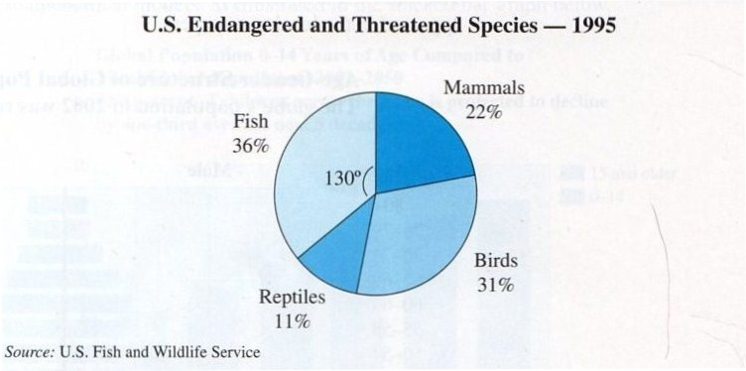
Which animal group had the largest number of endangered species in 1995?

Which animal group had the smallest number of endangered species in 1995?

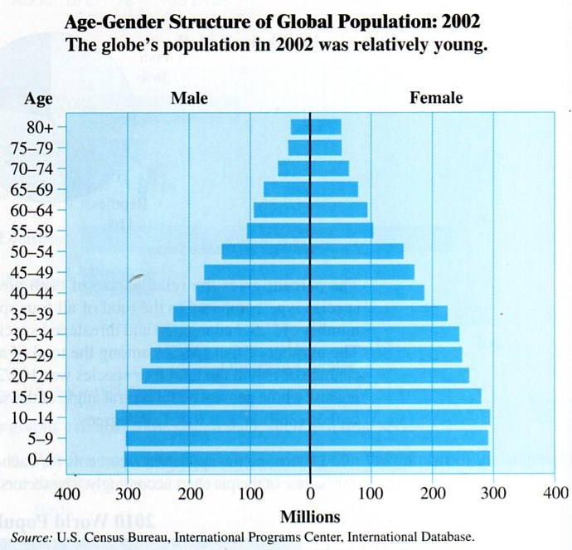

For each of the following statements give specific data from the bar graph that either supports of refutes the claim.
a) No matter what the age group, there are more females than males

b) The largest age group, regardless of gender, was 10-14 year olds

c) Males and females were very close in number for all age groups between 40 and 59

d) World-wide birthrate appears to have increased dramatically during 1988-2002 time period

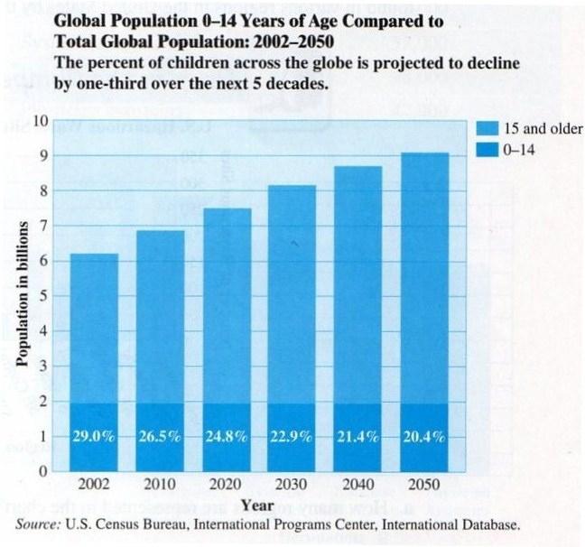
a) What will be the increase in global population from 2002 to 2050?

b) In 2030, what is the projected number of children?

c) In 2030, what is the projected number of adults?

Concept Summary:
Bar graph is a plot of categorical data where the number of data values is represented by the height or length of the bar
Pie chart (circle graph) displays the relative number (percentage) of each category of the data in a slice of the pie

Homework: page 798-803; problems 1, 3-6
Activity 7.3: Class Survey

SOLs: None

Objectives: Students will be able to:
Organize data with frequency tables, dotplots, and histograms
Organize data using stem-and-leaf plots

Vocabulary:
Frequency – the number of occurrences of each data value
Dotplot – a graph that represent each occurrence of a data value with a dot
Frequency Distributions – show how the data is distributed over all possible values
Classes – are frequency intervals (grouped data)
Class width – how wide a class is (upper limit – lower limit)
Stem – the digit or group of digits with the greatest place value
Leaf – the remaining digits

Key Concepts:

Activity: Decisions that are made in business, government, education, engineering, medicine, and many other professions depend on analyzing collections of data. As a result, data analysis has become an important topic in many mathematics classes. In this activity, you will collect and organize data from your class.
Gender | # of Siblings | Miles from School | Time doing Homework Yesterday
Using the data collected on the board, determine the following characteristics of your class:
- Most common number of siblings (mode)
- Average number of miles from school (mean)
- More females or males in class (mode)
- The most hours studied last night (max)

Draw dotplots for each of the four categories that we collected data on
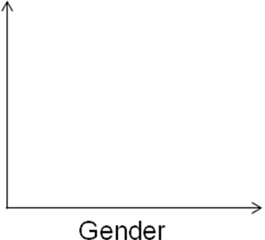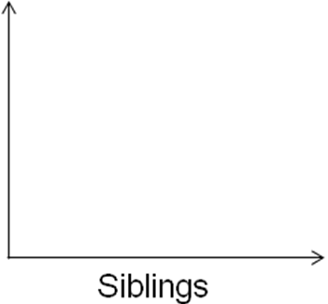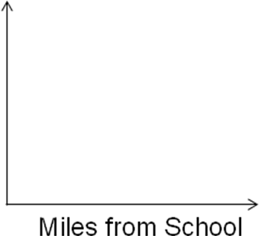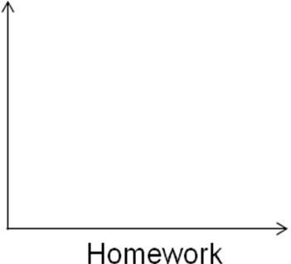
Example 1: Given the following values, draw a stem and leaf plot
20, 32, 45, 44, 26, 37, 51, 29, 34, 32, 25, 41, 56

Example 2: The ages (measured by last birthday) of the employees of Dewey, Cheatum and Howe are listed below.

Office A | 22 | 31 | 21 | 49 | 26 | 42
Office A | 42 | 30 | 28 | 31 | 39 | 39
Office B | 20 | 37 | 32 | 36 | 35 | 33
Office B | 45 | 47 | 49 | 38 | 28 | 48

- Construct a stem graph of the ages

- Construct a back-to-back comparing the offices

- Construct a histogram of the ages

Concept Summary:
Frequency Distribution describes how frequently each data value occurs:
Listed in a frequency table
Visually depicted in a dot-plot or histogram
Grouped histograms are useful for wide range of data by dividing groups in equal-width intervals
Stem-and-leaf organizes data by splitting each data value into two parts (usually tens digit and singles digit)

Homework: pg 811-814; problems 2, 3, 7
Activity 7.4: The Class Survey Continued

SOLs: None

Objectives: Students will be able to:
Determine measures of central tendency, including the mean, median, mode and midrange
Recognize symmetric and skewed frequency distributions
Distinguish between percentiles and quartiles

Vocabulary:
Central Tendency – a statistic that measures the “center” of a distribution
Mean – the average value
Median – the middle value (in an ordered list)
Midrange – the average of the largest and smallest observations
Mode – the most frequent data value
Resistant measure – a measure (statistic or parameter) that is not sensitive to the influence of extreme observations
Key Concepts:

Mean is the average

Mode is the most frequent

Median is the middle

Mid-range is (max+min) / 2

Activity:
In the previous activity the following data could have been representative of a class of 20 students.
Family sizes: 4, 6, 2, 8, 3, 5, 6, 4, 7, 2, 5, 6, 4, 6, 9, 4, 7, 5, 6, 3

The frequency distribution of the data was displayed graphically using a dotplot and a histogram.
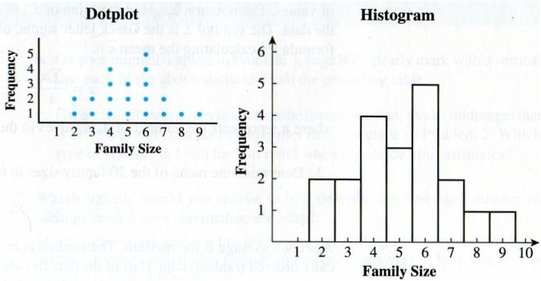

Where does the center of the distribution appear to be?

What is the mean, median and mode of the distribution?

Example 1: What is the mean of the following numbers: 1, 2, 2, 5, 8, 9, 99

Example 2: What is the median of the following numbers?
a) 1, 2, 2, 5, 8, 9, 99

b) 1, 2, 2, 8, 9, 99

Example 3: What is the mode of the following numbers?
a) 1, 2, 2, 5, 8, 9, 99

b) 1, 2, 2, 5, 8, 8, 99

Example 4: What is the midrange of the following numbers: 1, 2, 3, 5, 8, 9, 99

Example 5: In the following graphs which letter represents the mean, the median and the mode? Describe the distributions
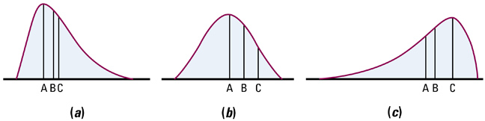

a) Mean:
Median:
Mode:

b) Description

Concept Summary:
- Frequency distribution describes the shape of the data
  - Listed in a frequency table
  - Visually depicted in dotplot, histogram or stem-leaf plot
- Four typical measures of central tendency
  - Mean (aka average)
  - Median (middle value in ordered list)
  - Mode (most frequent data value)
  - Midrange (average of max and min)

Homework: pg 820–822; problems 3, 5, 7, 8
Activity 7.5: Sampling a Population

SOLs: None

Objectives: Students will be able to:
Know the difference between a census and a sample
Identify the characteristics of a simple random sample
Know what bias in a sample means
Be able to select a simple random sample, when possible
Identify how the size of a sample affects the result

Vocabulary:
Census – when every individual in a population is measured
Sample – is a subset of the population (not the whole)
Sampling – the process of collecting data from some fraction of the population
Bias – simply means that some individuals are somehow favored over others in the population
Simple Random Sample (SRS – the result of a sampling method that assures every possible sample of the same size has an equal probability of being selected

Key Concepts:
Census versus a Sample
- Census
  - every member of a population is measured
  - expensive to do (and time consuming)
- Sample
  - subset of the population is measured (telephone polls usually sample about 1000 people)
  - inferences about the entire population are made from the measurements gathered in the sample
Simple random sampling (SRS)
- All possible samples of a given size must be equally likely
- Most important sampling technique and many of the inference techniques have it as a requirement
Bias – nonsampling error introduced by giving preference to selecting some individuals over others
- Undercoverage results from an incomplete frame on the surveyor’s part
- Nonresponse can be from either the surveyor (can’t find the person) or the person’s unwillingness to answer
- Response bias (lies) can result from either the respondent or the influence of the interviewer

Activity:
Suppose you have a need to know the average weight of adults in the United States, or the mean age of blue crabs in the Chesapeake Bay, or the median household income in the Commonwealth of Virginia. To determine such measures of central tendency, it is not usually practical to obtain the data for every individual in the population.
Why is it not possible to conduct a census on the populations described above?

Wt:

Crabs:

Income:

Since a sample can be of any size, how would you compare the practicality and usefulness of samples of size 1, 25, 2000, and 2 million when attempting to estimate the mean household income in Virginia?

Sampling Example: The table below shows the current grades for all 20 students in Mr. Horton’s economics class.
ID | Name | Grade |  | ID | Name | Grade
1 | Adams | 78 |  | 11 | Lee | 67
2 | Baker | 84 |  | 12 | Maloney | 91
3 | Cooper | 82 |  | 13 | Nelson | 69
4 | Davenport | 95 |  | 14 | O’Brien | 74
5 | Elacqua | 71 |  | 15 | Park | 81
6 | Flanagan | 83 |  | 16 | Reeves | 79
7 | Grant | 97 |  | 17 | Snider | 62
8 | Haught | 65 |  | 18 | Thoreson | 88
9 | Jacobs | 80 |  | 19 | Vilece | 93
10 | Kim | 78 |  | 20 | Whiting | 63

- Compute the mean and median for the class

- What do these values represent?

- Use your calculator to generate 10 random numbers

- Use the first 3 distinct (non repeating) as an SRS of Mr Horton’s class and calculate the mean and median

- Repeat steps b and c with a sample size of 5

- Repeat steps b and c with a sample size of 10 (note: you probably will have to generate 15 random numbers)

- What do you do if you get too many repeated numbers?

- What do we notice as sample size increases?

- Why did we all get the same “random” numbers?

Concept Summary:
- Census measures every individual in a population
- Sample is a fraction of the population
- Sampling is the process of collecting a sample from the population
- Bias occurs when some individuals have a better chance of being selected than other
- Simple Random Sample (SRS) is the best type of sample
- Populations have parameters (μ, σ)
- Samples have statistics (x-bar and s) that estimate parameters

Homework: pg 834 – 837; problems 1, 2, 5, 6
Activity 7.6: Highway Proposal: Yes or No

SOLs: None

Objectives: Students will be able to:
Identify the characteristics of a well defined sample survey
Know how to collect a stratified sample
Identify ways in which a sample might be biased

Vocabulary:
Sample survey – a methodical process of collecting a sample that is (hopefully) representative of the population
Sampling Frame– a list to select a random sample from
Nonrespondents – people who do not respond to the survey (potential source of bias)
Strata– a logical grouping within the population (male vs female)
Stratified Sampling– sample done by grouping first, then SRS within each group; removes potential bias
Self-selection – when people respond to a call -- also known as convenience sampling; strong potential for bias
Sampling plan – detailed step-by-step procedure to collect the data

Key Concepts:
- Types of Sampling:
  - Simple random sampling (SRS)
    - Everyone has an equal chance at selection
    - What statisticians strive for
  - Stratified sampling
    - Some of all
    - Divide into strata (groups), then SRS within groups
  - Cluster sampling
    - All of some
    - Divide into clusters (groups), then census within groups
  - Systematic sampling
    - Using an algorithm to determine who to sample
    - Getting every 3rd person coming to customer service

- Poor sampling methods can produce misleading conclusions
  - Voluntary Response Sampling -- people choose themselves by responding to a general appeal
  - Convenience Sampling -- choosing individuals who are easiest to reach

- Bias
  - Undercoverage results from an incomplete frame on the surveyor’s part
  - Nonresponse can be from either the surveyor (can’t find the person) or the person’s unwillingness to answer
  - Response bias (lies) can result from either the respondent or the influence of the interviewer

Activity: In your capacity as an administrative assistant for your county government, you need to assess the attitude of your community for a new highway proposal. Some people will favor the highway in the belief it will provide a greater mobility and promote business. Others will argue that it will bring even more congestion and will negatively impact the environment. You need to submit a preliminary report as soon as possible and someone suggests doing a sample from calling 50 random people from the phone book.

Describe how you would do it.

Do you think your method results in a simple random sample?

Why or Why not?
Example 1: Describe how a university can conduct a survey regarding its campus safety. The registrar of the university has determined that the community of the university consists of 6,204 students in residence, 13,304 nonresident students, and 2,401 staff for a total of 21,909 individuals. The president has funds for only 1000 surveys to be given and then analyzed. How should she conduct the survey?

Example 2: Sociologists want to gather data regarding the household income within Smyth County. They have come to the high schools for assistance. Describe a method which would disrupt the fewest classes and still gather the data needed.

Example 3: The manager of Ingles wants to measure the satisfaction of the store’s customers. Design a sampling technique that can be used to obtain a sample of 40 customers.

In the following example problems
- Determine is the survey design is flawed b) If flawed, is it due to the sampling method or the survey itself
- For flawed surveys, identify the cause of the error d) Suggest a remedy to the problem

Example 4: MSHS wants to conduct a study regarding the achievement of its students. The principal selects the first 50 students who enter the building on a given day and administers the survey.

Example 5: The Marion town council wishes to conduct a study regarding the income level of households in Marion. The town manager selects 10 homes in one neighborhood and sends an interviewer to the homes to determine household incomes.

Example 6: An anti-gun advocacy group wants to estimate the percentage of people who favor stricter gun laws. They conduct a nation-wide survey of 1,203 randomly selected adults 18 years old and older. The interviewer asks the respondents, “Do you favor harsher penalties for individuals who sell guns illegally?”

Example 7: Cold Stone Creamery is considering opening a new store in Marion. Before opening the store, the company would like to know the percentage of households in Marion that regularly visit an ice cream shop. The market researcher obtains a list of households in Marion and randomly selects 150 of them. He mails a questionnaire to households and ask about their ice cream eating habits and flavor preferences. Of the 150 questionnaires mailed, 14 are returned.

Example 8: The owner of shopping mail wishes to expand the number of shops available in the food court. She have a market researcher survey mall customers during weekday mornings to determine what types of food the shoppers would like to see added to the food court.

Example 9: The owner of radio station wants to know what their listeners think of the new format. He has the announcers invite the listeners to call in and voice their opinion.

Concept Summary:
- Statistical experiments manipulate a factor
- Sample surveys are observational studies
  - Sampling plans – how to do it
  - Sampling Frames – who to choose from
- Bias can be a problem
  - Nonrespondents – people are left out
  - Self-selection – gets only the extremes on an issue
- Stratified sampling divides frame into groups before doing SRS within each group

Homework: pg 842 – 846; problems 1, 2, 5
Activity 7.7: Statistical Survey

SOLs: None

Objectives: Students will be able to:
Design and execute a statistical survey

Vocabulary: none new

Key Concepts:
1. Formulate the problem and devise a plan
- State what you need to know
- Identify the population and what is to be measured
- Decide on an appropriate sampling method and sample size
- Think carefully about the exact form of all questions and responses
2. Execute the plan
- Follow the plan to gather the data
- Specify all the details of the methodology
3. Analyze and organize the results in a report
- Discuss all elements of the sampling process
- Interpret the results and state final conclusions

Activity:
Suppose you county executive decides that you should survey only registered voters in your community, to determine whether the majority of county residents favor a new highway proposal. You do have a complete list of registered voters, with their party affiliation (34% are Republicans, 45% are Democrats and 21% are independent). Use complete sentences to record your design for this sample survey. You can save money by using a sample of size 100, instead of doing a census. Record a plan for this sample survey
a) State what you need to know

b) Identify the population that is to be measured, and the sampling frame.

c) Which sampling method, simple random sample or stratified sample, do you think would be best? Give a reason for your choice.

d) How would do the sampling?

Concept Summary: Surveys take a lot of planning to do correctly

Homework: pg 848 – 849; problems 1-3
Activity 7.8: What’s the Cause?

SOLs: None

Objectives: Students will be able to:
Understand the purpose and principles of experimental design
Know when a causal relationship can be established
Understand the importance of randomization, control treatments and blinding

Vocabulary:
Experimental unit – an individual upon which an experiment is performed; (subject is term used for human beings)
Control Group – a group that does not receive a real treatment
Treatment – a specific experimental condition applied to the experimental units
Statistically significant – a term applied to an observed effect so large that it would rarely occur by chance
Double-blind – neither the subjects nor the observers know which treatments any of the subjects had received in an experiment
Design of Experiments – DOE, a course unto itself
Placebo – a treatment that has no effect
Placebo Effect – the ability of the human mind to respond positively to perceived medicine or attention
Replication – the number of units receiving the same treatment

Key Concept: Design of Experiments
Only a well-designed experiment can determine a cause and effect relationship
The three primary areas of an experimental design are
- Control
  - Overall effort to minimize variability in the way the experimental units are obtained and treated
  - Attempts to eliminate the confounding effects of extraneous variables (those not being measured or controlled in the experiment, aka lurking variables)
- Randomization
  - Rules used to assign the experimental units to the treatments
  - Uses impersonal chance to assign experimental units to treatments
  - Increases chances that there are no systematic differences between treatment groups
- Replication
  - Use enough subjects to reduce chance variation
  - Increases the sensitivity of the experiment to differences between treatments

Activity:
In an early activity, we learned to recognize a linear relationship between two variables. Recall that finding a correlation does not necessarily establish a cause-and-effect relationship between two variables. Suppose a survey of elementary school students in our county results in the following scatterplot of reading level versus shoe size.
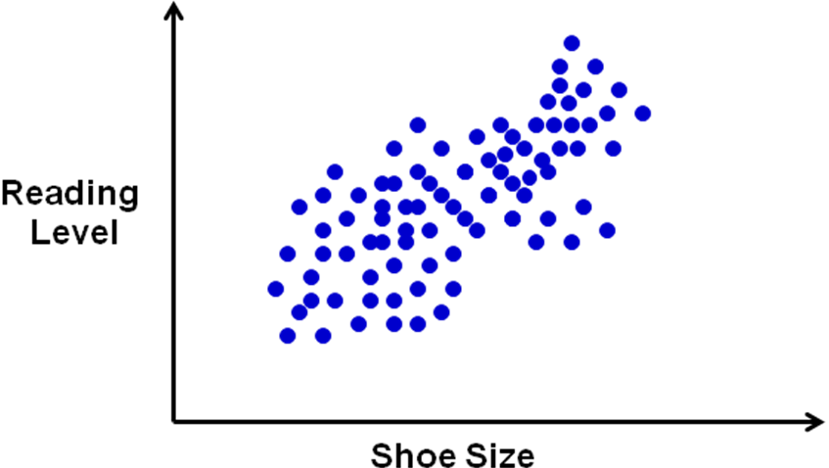

How would you describe the association between reading level
and shoe size?

Based upon your response above, would you be willing to conclude
that an increase in shoe size causes a higher reading level?
Why or why not?

If your answer was no, can you think of a lurking variable (one that mentioned) that might explain the correlation?

Example 1: Draw a picture detailing the following experiment:
A statistics class wants to know the effect of a certain fertilizer on tomato plants. They get 60 plants of the same type. They will have two levels of treatments, 2 and 4 teaspoons of fertilizer. Someone suggests that they should use a control group. The picture should include enough detail for someone unfamiliar with the problem to understand the problem and be able to duplicate the experiment.

Example 2: A baby-food producer claims that her product is superior to that of her leading competitor, in that babies gain weight faster with her product. As an experiment, 30 healthy babies are randomly selected. For two months, 15 are fed her product and 15 are feed the competitor’s product. Each baby’s weight gain (in ounces) was recorded.
A) How will subjects be assigned to treatments?

B) What is the response variable (y-variable)?

C) What is the explanatory variable (x-variable)?

Example 3: Two toothpastes are being studied for effectiveness in reducing the number of cavities in children. There are 100 children available for the study.
A) How do you assign the subjects?
B) What do you measure?
C) What baseline data should you know about?
D) What factors might confound this experiment?
E) What would be the purpose of a randomization in this problem?

Concept Summary:
- Experiments are necessary to establish cause-and-effect relationship
  - Control Group (no treatment applied)
    - Placebos are given for blinding
  - Randomization (in selection and for treatments)
  - Replication (inside experiment and of the experiment)
- A double-blind implementation of experiments reduces the amount of changes in behavior

Homework: pg 854-856; problems 1, 3, 4, 6
Activity 7.9: A Switch Decision

SOLs: None

Objectives: Students will be able to:
Measure the variability of a frequency distribution

Vocabulary:
Standard Deviation – measures how much the data deviates from the mean
Boxplot – statistical graph that helps visualize the variability of a distribution
Five-number Summary – the min, quartile 1, 2 and 3 and the max of the data set

Key Concept: How much data varies about the mean is called the variance. The square root of variance is called the standard deviation and is used in many statistical calculations and tests.

Activity: The following sets of data are the result of testing two different switches that can be used in the life-support system on a submarine. Two hundred of each type of switch were placed under continuous stress until they failed, the recorded in hours. Switch A and B have approximately the same means and medians, as displayed by the following histograms.
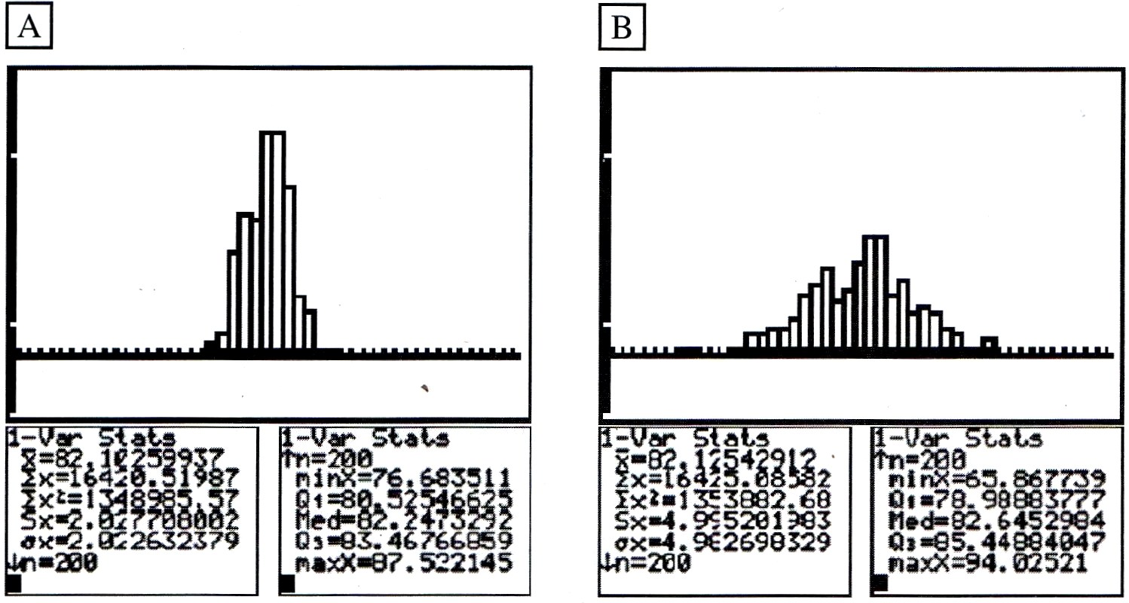
1. What does the means and medians being the same tell us about the distributions?

2. Which distribution is most spread out?

3. Which distribution is packed more closely together around its center?

4. Which of these two switches would you choose and why?

5. Determine the range of the two switches:

6. Determine the IQR (interquartile range), which is Q3 – Q1 for each switch

7. Write down s_{x} for each switch (this is something we will call the standard deviation)
Example 1: Which of the following measures of spread are resistant?
- Range
- Variance
- Standard Deviation

Example 2: Given the following set of data:
19 | 22 | 23 | 23 | 23 | 26 | 26 | 27 | 28 | 29 | 30 | 31 | 32
What is the range?
What is the standard deviation?
What is the variance?

Example 3: Consumer Reports did a study of ice cream bars (sigh, only vanilla flavored) in their August 1989 issue. Twenty-seven bars having a taste-test rating of at least “fair” were listed, and calories per bar was included. Calories vary quite a bit partly because bars are not of uniform size. Just how many calories should an ice cream bar contain?

342 | 377 | 319 | 353 | 295 | 234 | 294 | 286 | 209 | 190 | 131
377 | 182 | 310 | 439 | 111 | 201 | 182 | 197 | 147 | 151 | 151
Construct a boxplot for the data above.

Example 4: The weights of 20 randomly selected juniors at MSHS are recorded below:

121 | 126 | 130 | 132 | 143 | 137 | 141 | 144 | 148 | 205
125 | 128 | 131 | 133 | 135 | 139 | 141 | 147 | 153 | 213

a) Construct a boxplot of the data

b) Determine if there are any outliers

c) Comment on the distribution

Concept Summary:
- Variability of a frequency distribution refers to how spread out the data is, away from center
- Range is the max – the min of the data
- Deviation of a data value is how far away from the mean it is
- Standard deviation is a measure of how spread out all of the data is
- Boxplot is a graph of the 5-number summary

Homework: pg 861 – 863; problems 1, 4, 6, 7
Activity 7.10: What is Normal?

SOLs: None

Objectives: Students will be able to:
Identify a normal distribution
List the properties of a normal curve
Determine the z-score of a given numerical data value in a normal distribution
Identify the properties of a standard normal curve
Solve problems using z-scores of a standardized normal curve

Vocabulary:
Normal Distribution – an important distribution in the study of probability and statistics
Normal Curve – is a bell-shaped curve with specific properties
z-scores – a standardized score based on how many standard deviations a data point is away from the mean
z = (data value – mean) / (standard deviation) or z = (x – μ) / σ

Key Concepts:

Activity:
The following collection of data gives the heights, in inches, of 35 randomly selected 11th grade male students. The measurements were made to the nearest inch. Type them into L1 in your calculator and it can help you with parts b and d.
63 | 64 | 65 | 65 | 66 | 66 | 66
67 | 67 | 67 | 67 | 67 | 68 | 68
68 | 68 | 68 | 68 | 69 | 69 | 69
69 | 69 | 70 | 70 | 70 | 70 | 71
71 | 72 | 72 | 73 | 74 | 75 | 76

a) Complete the following frequency distribution table
Number
Height

b) Construct a histogram from the frequency distribution in part a

c) Does the distribution appear to be skewed or symmetrical? Explain

d) Determine the mean, median and mode of the given data set. Do your results verify your conclusion above?

e) Is this distribution Normal?

Example 1: A random variable x is normally distributed with μ=10 and σ=3.

- Compute Z for x₁ = 8

- Compute Z for x₂ = 12

- Compute Z for x₃ = 10

Example 2: The heights of 16-year old males are normally distributed as N(68,2)

- Compute Z for 71 inches

- Compute Z for 64 inches

- Compute Z for 62 inches

Example 3: A random variable x is normally distributed with μ=10 and σ=3. Given the z-scores, find the original value.

- Find x for z = 2

- Find x for z = -1

- Find x for z = -0.5

Example 4: What do the following z-scores mean?

- z = -1

- z = 2

- z = 0

Concept Summary:
- Normal curves are bell-shaped and symmetric about its mean (which is equal to mode and median)
  - Mean, μ, has 50% of data above it and below it
  - Empirical Rule: 68-95-99.7% of the data lies within plus or minus 1-2-3 standard deviations of the mean
- Standard normal curve has μ = 0 and σ = 1
- Z-scores are a measure of standard deviations
  - Base on standard normal curve
  - Positive values above mean; negative values below mean

Homework: pg 871 – 873; problems 1- 5
Activity 7.11: Part-time Jobs

SOLs: None

Objectives: Students will be able to:
Determine the area under the standard normal curve using the z-table
Standardize a normal curve
Determine the area under the standard normal curve using a calculator

Vocabulary:
Cumulative Probability Density Function – the sum of the area under a density curve from the left

Key Concept:

Activity:
Many high school students have part-time jobs after school and on weekends. Suppose the number of hours students spend working per week is approximately normally distributed, with a mean of 16 hours and a standard deviation of 4 hours. If a student is randomly selected, what is the probability that the student works between 12 and 18 hours per week?

1. Draw a normal curve to represent the situation:

2. Convert 12 and 18 into z-values:

3. Look up those z-values in Appendix C (at the back of the book)

4. Calculate z₁₈ – z₁₂

5. P(12 < x < 18) =
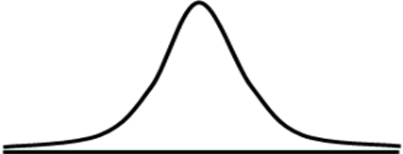
Example 1: Determine the area under the standard normal curve that lies to the left of
- Z = -3.49

- Z = 1.99

Example 2: Determine the area under the standard normal curve that lies to the right of
- Z = -3.49

- Z = -0.55

Example 3: Find the indicated probability of the standard normal random variable Z
- P(-2.55 < Z < 2.55)

Example 4: Determine the area under the standard normal curve that lies to the left of
- Z = 0.92

- Z = 2.90

Example 5: Determine the area under the standard normal curve that lies to the right of
- Z = 2.23

- Z = 3.45

Example 6: Find the indicated probability of the standard normal random variable Z
- P(-0.55 < Z < 0)

- P(-1.04 < Z < 2.76)

Concept Summary:
- Normal Curve Properties
  - Area under a normal curve sums to 1
  - Area between two points under the normal curve represents the probability of x being between those two points
- Standard Normal Curves
  - Appendix C has z-tables for cumulative areas
  - Calculator can find the area quicker and easier
- TI-83 Help for Normalcdf(LB,UB,μ,σ)
  - LB is lower bound; UB is upper bound
  - μ is the mean and σ is the standard deviation

Homework: pg 881-883; problems 1, 3-5
Activity 7.12: Who Did Better?

SOLs: None

Objectives: Students will be able to:
Compare different x-values in normal distributions using z-scores.
Determine the percent of data between any two values of the normal distribution
Determine the percentile of a given x-value in a normal distribution
Compare different x-values using percentiles
Determine x-value given it percentile in a normal distribution

Vocabulary:
Percentile – the percentage of data values to the left of a given value

Key Concept:

Activity: You and your friend are enrolled in two different sections of AFDA. Recently, different midterm tests were given in each section. Since the high school has large class sizes, the test scores in both sections are approximately normally distributed. In your section, the mean was 80 with a standard deviation of 6.7 and your score was 92. In your friend’s section the mean was 71 with a standard deviation of 6.1 and her score was 83. Is it possible to determine who did better? You claim you did.

What bolsters your claim? What lessens your claim?

How far above the mean were you? How far above the mean was your friend?

Compare your corresponding z-scores

What were yours and your friend’s percentiles?

If your section was not curved,
- What percentage got A’s?

- What percentage got F’s?
Example 1: In a national survey, it was determined that the number of hours high school students watch TV per year is was ~N(1500, 100). Determine the percentages of students that watch TV
- less than 1600 hours per year

- more than 1700 hours per year

- between 1400 and 1650 hours per year

Example 2: Suppose Virginia Tech’s engineering program will only accept high school seniors with a math SAT score in the top 10% (above the 90th percentile). The SAT scores in math are ~N(500,100). What is the minimum SAT score in math for acceptance into the engineering program?

Concept Summary:
- Z-scores can be used to compare relative positions from two different distributions
- Area under the normal curve is a graphical representation of both percentage and probability
  - Cumulative probability function is the area under the curve to the left of the given x-value
- Use invNorm function on calculator to get the x-value corresponding to a given percentile
  - invNorm (percentile, μ, σ) (percentile is a decimal)

Homework: pg 889 – 892; problems 1-3, 5-8

5 Minute Reviews

Activity 7-1:
- What are the three parts of the science of statistics involving data?

- What can make comparisons of graphs misleading?

- Besides scaling, what else can make a graph misleading?

- Name two things to avoid in good graphs.

Activity 7-2:
- What were the graphs examined in the last lesson?

- What type of graph was the Age-Gender Population graph?

- Are pie-charts the same as a relative frequency chart?

- What is a pareto chart?

Activity 7-3:
- What types of graphs were discussed in the previous lesson?

- What types of graphs can our calculator do?

- What two types of data are graphed?

- What are the disadvantages of stem-and-leaf plots?

- What is an advantage of back-to-back stem-and-leaf plots?

Activity 7-4:
Given the following data: 8, 1, 9, 2, 3, 4, 4, 5, 5, 6, 7, 8, 8
- Find the mean

- Find the median

- Find the mid-range

- Find the mode

- What are the four descriptors of a distribution?

- What are the three types of shape?

- Which measures of center are resistant?
A Mean B Median C Mid-range D Mode

Activity 7-5:
- Name two problems associated with census

- Name two types of bias typically encountered in surveys

- Two population parameters are

- The two sample statistics that estimate the population parameters:

- Name at least two sources of non-sampling error

Activity 7-6:
Identify the types of surveys and any problems used in the following:
- Radio call-in survey on the state of the economy

- Forty workers are selected randomly at the Wytheville Pepsi plant

- All teachers in Smyth county are surveyed on a pay issue

- Twenty students from each graduating class at MSHS are surveyed

- Every 10th customer at Food City is surveyed about food prices

- Two English classes are random selected from each grade and every student in that class is surveyed on school uniforms

Activity 7-8:
- What type of an experiment is it when neither the patient nor the doctor knows what type of pill is being given?

- List the three major components of any experimental design

- A “sugar pill” is also known as a ________________.

- What is the only thing that can establish cause and effect?

- What do we call a group in the experiment which treatments are measured against?

Activity 7-9:
- What population parameter is a measure of spread?

- What measure of spread is resistant?

- Given the following data: IQR = 10, Q1 = 20 and Q3 = 30; determine the upper and lower fences and if 6 and 56 are outliers

- What 5 numbers are in the 5-number summary?

- Label the box-plot below:

Activity 7-10:
- State the Empirical Rule:

- What is the shape of a normal distribution?

- Compute a z-score for x = 14, if μ = 10 and σ = 2

- What does a z-score represent?

- Which will have a taller distribution: one with σ = 2 or σ = 4

Activity 7-11:
- What is the mean and standard deviation for a standard normal?

Find the following probabilities:
- P(z < -0.45)

- P(z > 0.79)

- P(0.13 < z < 2.34)

- If the P(z < a) = 0.24, then what is P(z > a)?

