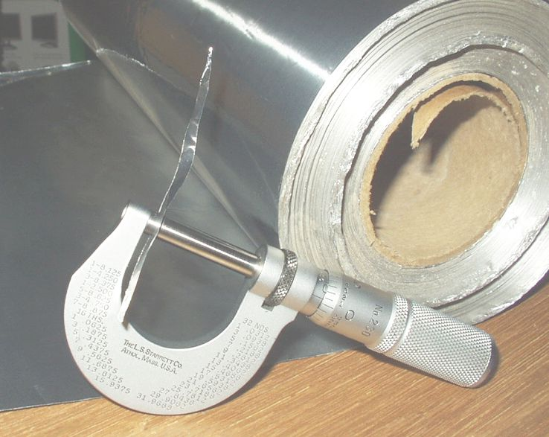
Lab #6 Thickness Determination of Aluminum Foil
and Aluminum Cans
USE PENCIL ONLY

Purpose:
The purpose of this experiment is to determine the thickness of three types of aluminum foil via calculation.
(i.e. how do you improvise when your instrumentation is limited... ingenuity!)
Background:
Sometimes it is not easy or possible to measure a quantity directly. In this experiment you will determine the thickness of aluminum foil. To do so directly is not possible with a regular ruler. Engineers and machinists use very fine instruments called micrometers to measure thicknesses of very thin things to high degrees of accuracy and precision. Some of these instruments are capable of measuring thickness to a tolerance of ± 0.001 mm or finer. This is 1/1000th of a millimeter or 1 ______________ . But using a micrometer to measure the thickness of the foil...well that would just be too easy, plus we don't have any, so we must use another technique.
$\text{Density }=\frac{\text{mass}}{\text{volume}}$ Instead of measuring the thickness of the foil directly we are going to calculate it. So by the use of the formulas for volume and density, the thickness (height) of the foil can be measured easily and accurately. You have used the formula The mass can be found on the balance and the density of aluminum is a constant. By rearranging the equation, the volume of the foil can be found by plugging in a samples density and mass, and solving for volume.
The volume of a regular rectangular solid can be found from the equation V = L x W x H. The length and width of the foil can be measured by a ruler. Our ruler allows us to record measurements down to ___________ (insert precision of ruler). Since the volume of the foil was found from the density, the only variable left unknown is the height or thickness of the foil. In other words we have volume, we have length, and we have width.
Materials:
metric ruler
balance
Aluminum foil (Standard Duty)
Aluminum foil (Heavy Duty)
Aluminum soda can "foil"

Procedure:
1. Obtain four rectangular pieces of regular duty aluminum foil.

2. Using a metric ruler carefully measure the length and width of each piece of foil. Record the measurements on your data sheet. These values should be recorded to the proper number of significant figures. Keep track of which sheet is which because you need to match the mass with the length and the width for each one.

3. Using the balance, find the mass of each piece of aluminum foil. Record the masses on the data sheet.

4. Repeat the procedure for the heavy duty foil and the aluminum can foil.
Caution: The Aluminum Can foil has very sharp corners and edges, handle with care.
Data
Data Table #1 Dimensions and Mass of Standard Duty Aluminum Foil
Name:_________________________
Sheet Number | Length ( ) | Width ( ) | Mass ( )
1
2
3
4
Data Table #2 Dimensions and Mass of Heavy Duty Aluminum Foil
Sheet Number | Length ( ) | Width ( ) | Mass ( )
1
2
3
4
Data Table #3 Dimensions and Mass of Aluminum Beverage Can Foil
Sheet Number | Length ( ) | Width ( ) | Mass ( )
1
2
3
4
Calculations
$\text{Density }=\frac{\text{mass}}{\text{volume}}$
1. Show one sample calculation (5 points) using as your base equation to solve for volume. Hint: to make sure you don't screw up the Algebra do the re-arrangement in two steps. First get volume out of the denominator, and then in the next step isolate volume. Make sure you show all the steps required in a sample calculation. (See "what is a sample calculation reference" if required.)
Record Aluminum's accepted Density from your periodic table here ______________ (include unit)

Data Table #4 Volume of Standard Duty Aluminum Foil sheets from their mass & Aluminums density
Sheet Number | Mass ( ) | Density ( ) | Volume ( )
1
2
3
4
Data Table #5 Volume of Heavy Duty Aluminum Foil sheets from their mass & Aluminums density
Sheet Number | Mass ( ) | Density ( ) | Volume ( )
1
2
3
4

Data Table #6 Volume of Aluminum Can "Foil" sheets from their mass & Aluminums density
Name:_________________________
Sheet Number | Mass ( ) | Density ( ) | Volume ( )
1
2
3
4
2. Starting with equation for the volume of a regular rectangular solid V= L x W x H, show one sample calculation for Height (or thickness as we tend to think of when describing thin foils). Report thickness and average thickness, absolute and average deviation in Tables 7 -9.

Show one sample absolute deviation calculation:
Absolute Deviation: (this tells you the variance between each element and the mean. It allows you to easily identify "outliers" or "wingers" i.e trials that don't fit in and quantify how different they are from the rest)
Absolute Deviation= l Individual Trial Answer – Mean of all Trials l

Show one sample Percent Deviation Calculation:
Percent Deviation: (this gives you an indication of the precision of your data, it is the average distance (deviation) between each element and the mean. Low percent deviation means high precision, high percent deviation means low precision)
% Dev = (ave. dev.)/ mean x 100

Data Table #7 Thickness of Standard Duty Aluminum Foil from Volume, Length, and Height
Sheet Number | Volume  ( ) | Length  ( ) | Width  ( ) | Height (thickness)  ( ) | Absolute deviation ( )
1
2
3
4
Average
Average Deviation
Data Table #8 Thickness of Heavy Duty Aluminum Foil from Volume, Length, and Height
Sheet Number | Volume  ( ) | Length  ( ) | Width  ( ) | Height (thickness)  ( ) | Absolute deviation ( )
1
2
3
4
Average
Data Table #9 Thickness of Soda Can Foil from Volume, Length, and Height
Name:_________________________
Sheet Number | Volume  ( ) | Length  ( ) | Width  ( ) | Height (thickness)  ( ) | Absolute deviation ( )
1
2
3
4
Average
Data Table #10 Accepted Values, Experimental Values Compared with Percent Error & Percent Dev.
Sheet Type | Average  Thickness ( ) | Accepted  Thickness (cm) | Percent  Deviation | Percent  Error
Regular Foil |  | 0.00153
Heavy Duty Foil |  | 0.00238
Soda Can Foil |  | 0.00988
Show one sample percent error calculation:

Questions:
1.) Aluminum cans for beverages made their debut in the 1960's. Previous to this beverage cans were made out of steel and tin, but Aluminum offered several advantages over these old designs. In the late 1800's aluminum was as valuable as silver due to the difficulty in separating out pure metallic aluminum from its ores. But as a new manufacturing process was discovered it became economical to produce bulk quantities of aluminum. One advantage aluminum has over steel and tin cans is the fact the aluminum is a very _________-weight metal. In producing bulk goods weight is a primary concern for cost of shipping. When the aluminum cans made their first appearance on the U.S. market their thickness was about 0.051 cm in 1965. Believe it or not, simple aluminum beverage cans have been radically re-engineered and redesigned nearly 20 times since 1965. Although Aluminum has become cheaper why do you think a company would spend hundreds of thousands of dollar and countless hours of computer modeling and engineering time in redesigning an aluminum can to make it thinner (excluding shipping costs, think about bulk raw materials from a production point of view.)

2. List a few assumptions we made about the aluminum foil when we calculated its thickness.

3. There is a particularly flawed assumption when you consider the beverage can. Look at the outside, it obviously has what on it? As it turns out they also have a polymer lining in them too. Do you think the procedure gave a decent amount of accuracy in estimating its thickness? By 1993 the figured a way of making cans only 0.030 cm thick. How does your thickness compare to that value?

4. How does the thickness of a piece of foil compare to the size of the grad
http://www.alcoa.com/reynoldskitchens/en/faq_detail.asp?info_page_id=743&prod_id=1789&cat_id=1337
Why is aluminum foil sometimes called tin foil?
In 1919, the U.S. Foil Company, parent of Reynolds Metals Company was founded in Louisville, Kentucky to produce lead and tin foil. Then in 1926, the company entered the aluminum business, rolling aluminum foil for packaging. Today, Reynolds Wrap is made from 8111 alloy aluminum, at the thickest gauge specifications available in the marketplace. Reynolds Wrap® Aluminum Foil is 98.5% aluminum. The balance is primarily iron and silicon. These are added to give the strength and puncture resistance obtained only in the alloy used in Reynolds Wrap® Aluminum Foil.

Aluminum Foil Extra Standard Roll, 12x500'
16 micron thickness. One roll in cutter box per case.

Aluminum Foil Paper Roll, Standard, 18x500'
14 micron thickness. One roll in cutter box per case.

Aluminum Foil Roll, Heavy Duty, 18x1000'
20 micron thickness. One roll in cutter box per case.

Aluminum Foil Paper, Extra Heavy Duty, 12x500'
24 micron thickness. One roll in cutter box per case.

