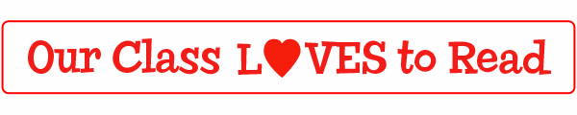

Online Ordering Information
Web address: scholastic.com/bookclubs
Class Activation Code: GR849

Dear Parent,

Now it's easier than ever to find the right books for your child and help us earn FREE books for our classroom library at the same time!

With new online ordering from Scholastic Book Clubs, you can choose from a much wider selection of books than in the printed flyer. Plus, you can send your orders directly to me online and use your credit card.

Best of all, our class earns a FREE book every time a parent places their order online.

It's so simple! Here's how it works:
- SIGN UP at www.Scholastic.com/bookclubs. On the parent page, click the "Don't have a User Name and Password?" link, then register for your own username and password. When prompted, enter the one-time Class Activation Code shown above. This code ensures that your order is sent to me.
- SELECT the books you'd like to order from over 500 titles available online...and take advantage of online-only specials and discounts.
- SEND your order to me online by the due date. Books will be delivered directly to our classroom, as always.

Of course, you can still order using the form from the printed flyer. These flyers are available in Mrs. Sammon's room (245) and Mrs. Brown's room (145). But why not experience for yourself how convenient it is to order online?

Ordering online is fast, easy, and secure. Plus our whole class benefits thanks to the FREE books we'll earn with every parent online order.

Go to www.Scholastic.com/bookclubs now to get started.

Thank you,

Mrs. Sammon and Mrs. Brown

