HPC
Larson
6th edition

Honors Precalculus
4.4-4.6

Assignment # | Section | Problems
1 | 4.4 | 11, 14, 20, 24, 26, 28, 30, 48 - 58 even, 72 - 76 even
2 | 4.4 | 80 - 84 even, 92 - 102 even, 103 - 108 all, 1 23
3 | 4.5 | 12-28 even, 49, 55, 57, 62, 64, 65, 67, 69  (graph all problems by hand)
4 | 4.5  4.6 | 58, 59, 70  9, 12, 21, 22  (graph all problems by hand)  WS #1 – Graphing
5 |  | WS #2 – Writing Trig Equations  Review WS
6 |  | Study
7 |  | Test
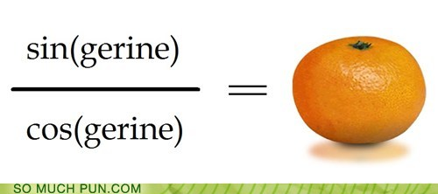
ALL graphs go on graph paper

****NOTE - FOR ALL GRAPHS****

1) WRITE: P, QP, PS, VS, AMP

2) LABEL: 5 POINTS ON X AXIS (QP POINTS) AND 3 VALUES ON Y AXIS
Show one full period – starting at PS

3) GRAPH: USE GRAPH PAPER AND SHOW 5 DISTINCT (QP) POINTS.

