HPC
Larson
6th edition

Honors Precalculus
4.7-5.1-5.2

Assignment # | Section | Problems
1 | 4.7 | 5, 9-13, 17, 18, 23-29, 45, 47, 100
2 | 4.7 | WS #1 (In Class)  53-60, 65, 67, 73-81odd, 102
3 | 5.1 | Read 5.1  21-32, 33-69odd
4 | 5.2 | 13-19odd, 29, 35-45odd, 69
5 | 5.2 | 47-50, 53-57odd, 63-67
6 | 5.2 | WS #2 – Trig ID’s
7 |  | Study
8 |  | Group Test  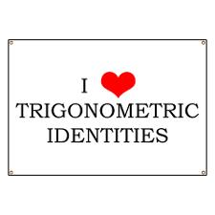

ALL graphs go on graph paper
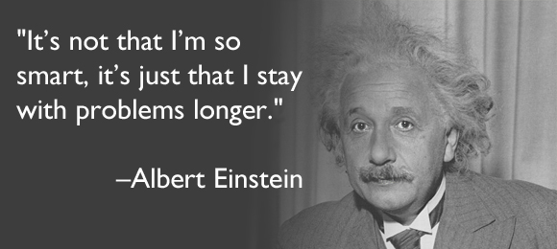

Trig identities…..
They’re so easy…..
She gives you the answer!!!


