HPC
Larson
6th edition

Honors Precalculus
3.1-3.2

Assignment # | Section | Problems
1 | 3.1 | WS #1
2 | 3.1 | 5 - 8; 21 - 24; 31, 32,  57 (for n = 1,2,365, continuous)  61 (for t = 1, 10, 50)  71, 72, 74,
3 | 3.1 | 9 - 12; 46, 48 ----Graph by Hand  17 - 20; 49, 55, 70, 73
4 | 3.2 | 7 – 12; 15 – 20 ; 23 - 26;  61, 62, 69, 75
5 | 3.2 | 41, 48, 50, 51 - 54; 89-92
6 |  | WS #3
7 |  | Study
8 |  | Test

ALL graphs go on graph paper
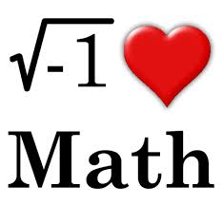

Just for fun:

Teenager: Dad, I’m going to a party tonight. Can you do my math homework for me?
Dad: I’m sorry, son, it just wouldn’t be right.
Son: That’s okay. Can you give it a try anyway?
