Discussion Topics:

Theodore Roosevelt’s “Square Deal”

TR’s “bully pulpit”

What is meant by the phrase “speak softly and carry a big stick; you will go far” ?

Woodrow Wilson’s “New Freedom”

Impact of a tariff

Main Purpose of Federal Reserve Banks

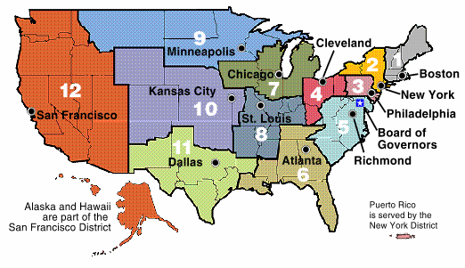

* Dollar diplomacy
* Explain and provide an example
* <http://www.harwich.edu/depts/history/pp/imperialism/img057.jpg>
* The first era of a true “global economy”

**Latin America**

* Spanish American War
* How does the U.S. become involved?
* What is the role of Hearst & Pulitzer? (Define yellow journalism.)
* What are the Rough Riders? Who leads them?
* Picture of the Maine explosion: <http://www.homeofheroes.com/wallofhonor/spanish_am/images/02_maine_explosion.jpg>
* As a result of the Spanish American War, what territories does the U.S. now control?
* Explain the relationship between the U.S. and Cuba after the war. How is it an example of imperialism?
* Create a cartoon strip that explains the main points of the Spanish-American War. The cartoon strip should be about 8 frames in length.

**Panama Canal**

* Panama Canal and the role of Theodore Roosevelt
* How did the U.S. acquire the rights to build the Panama Canal?
* How can this be seen as an example of imperialism?
* Know the geographic location of the canal (link below).
* Explain the importance of the Panama Canal (Why such an interest to build it?)
* Panama Canal: <http://www.pancanal.com/eng/persona/ed/index.html>

**Creation of international markets**

**China**

* Open Door Policy
* Who was responsible for negotiated the Open Door Policy?
* What is the importance of this policy, particularly to the U.S.?
* What are spheres of influence?
* Map#1: <http://www.thelatinlibrary.com/imperialism/maps/chinaspheres.jpg>
* Map#2: <http://sun.menloschool.org/~sportman/westernstudies/second/24/2003/eblock/kristinb/index_files/image004.jpg>

**Asia and the Pacific (U.S. Expansion)**

* Hawaii
* Philippines
* Open Door Policy
* What areas today are territories of the U.S.?
* Map of U.S. Territories in Pacific:
  + Find a map and include it in your porfolio
* May of Showing Guam: <http://archives.cnn.com/1999/TECH/computing/12/31/y2k.reports.roundup.01/map.guam.gif>
* May showing territories in the Caribbean: <http://www.caribpro.com/Caribbean_Map/!Caribbean_MAP.gif>